Silent world under COVID-19 — a comprehensive impact analysis based on human mobility

Shaobin Wang¹, Yun Tong², Yupeng Fan¹, Haimeng Liu^{1*}, Jun Wu³, Zheye Wang⁴, Chuanglin Fang¹
1 Institute of Geographic Sciences and Natural Resources Research, Chinese Academy of Sciences,
Beijing, China
2 School of Tourism, Hainan University, Haikou, China
3 Program in Public Health, Susan and Henry Samueli College of Health Sciences, University of California, Irvine, USA
4 Kinder Institute for Urban Research, Rice University, Houston, USA
* Corresponding author
Email: liuhm@igsnrr.ac.cn

Supplemental Information

Supplemental Figures
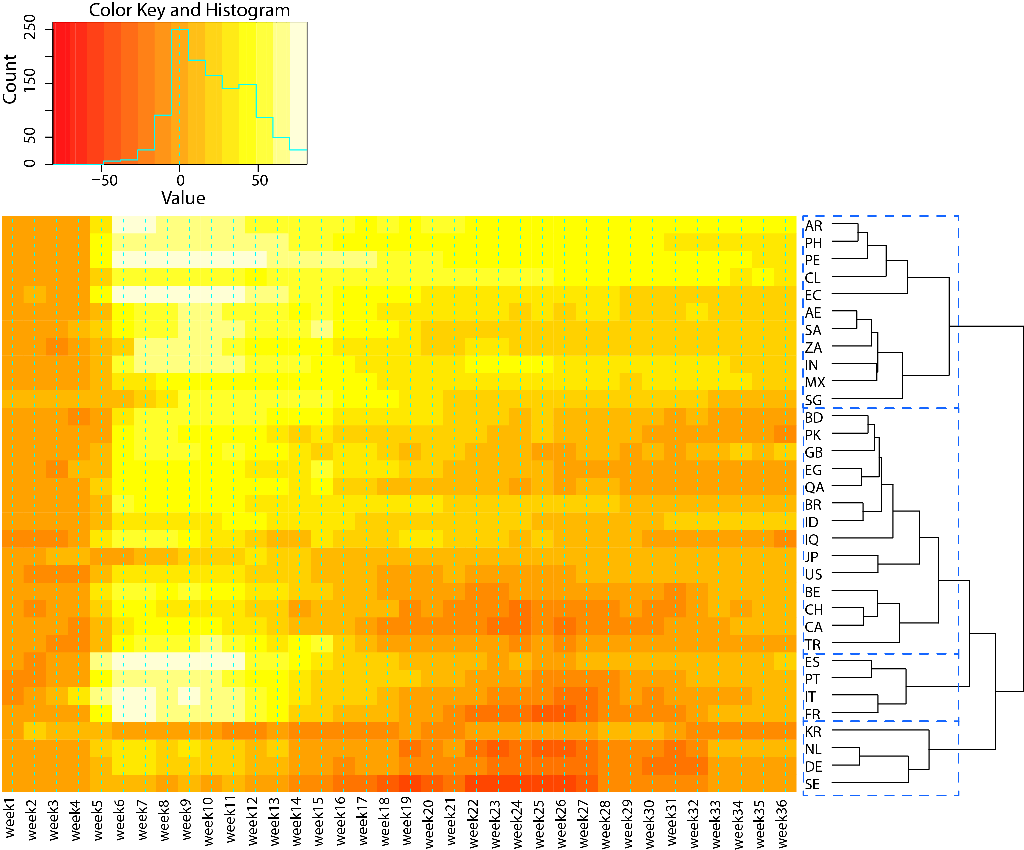
Figure S1. Hierarchical clustering results of SI variation from the baseline day to middle October 2020 based on the dendrogram in the heatmap of 33 selected countries. The order of the rows is determined by performing hierarchical cluster analyses of the rows, which tend to position similar rows together on the plot. After comparing different number of clusters from 2 to 5, we think the results based on four clusters are most reasonable and best to visualize.

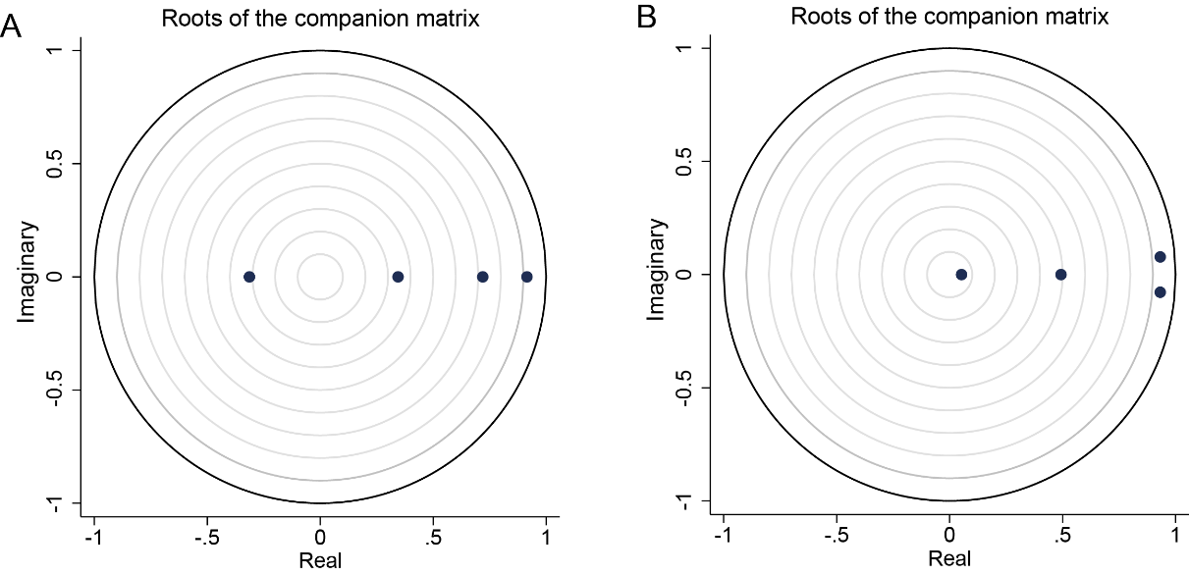
Figure S2. Stability condition test. The black points represent the reciprocal of the root of the AR characteristic polynomial. All points in the stability test diagram of the two PVAR models are distributed in the unit circle, that is, the reciprocal of the roots of all characteristic polynomials is less than 1, indicating a good model fitting.

Supplemental Tables
Table S1. Abbreviations of countries and regions in this study
Country code | Country
AE | United Arab Emirates
AT | Austria
BD | Bangladesh
BE | Belgium
BR | Brazil
BY | Belarus
CA | Canada
CH | Switzerland
CL | Chile
DE | Germany
EC | Ecuador
EG | Egypt
ES | Spain
FR | France
GB | the United Kingdom
IE | Ireland
IN | India
IT | Italy
JP | Japan
KR | South Korea
MX | Mexico
NL | Netherlands
PE | Peru
PK | Pakistan
PT | Portugal
QA | Qatar
SA | Saudi Arabia
SE | Sweden
SG | Singapore
TR | Turkey
US | United States
ZA | South Africa

Table S2. Indicators and flag values of policy stringency index
Indicator | Max value (N_{k}) | Flag? (F_{k})
School closing (C1) | 3 (0, 1, 2, 3) | Yes=1
Workplace closing (C2) | 3 (0, 1, 2, 3) | Yes=1
Cancel public events (C3) | 2 (0, 1, 2) | Yes=1
Restrictions on gathering size (C4) | 4 (0, 1, 2, 3, 4) | Yes=1
Close public transport (C5) | 2 (0, 1, 2) | Yes=1
Stay at home requirements (C6) | 3 (0, 1, 2, 3) | Yes=1
Restrictions on internal movement (C7) | 2 (0, 1, 2) | Yes=1
Restrictions on international travel (C8) | 4 (0, 1, 2, 3, 4) | No=0
Public information campaign (H1) | 2 (0, 1, 2) | Yes=1
The coding of each indicator (0-4) can be found in the OxCGRT documentation (www.bsg.ox.ac.uk/covidtracker).

Table S3. Unit root test result
 | LLC |  | IPS
Variable | Statistics | P-Value | Statistics | P-Value
D.addcase | -4.3063*** | 0.0000 | -10.0355*** | 0.0000
SI | -3.7652*** | 0.0001 | -1.2918* | 0.0982
PI | -10.6877*** | 0.0000 | -7.9558*** | 0.0000
*** p<0.01, ** p<0.05, * p<0.1

Table S4. Lag-order selection statistics between SI and COVID-19 cases
Lag | MBIC | MAIC | MQIC
1 | -120.0545* | 13.91033 | -37.30919
2 | -111.5786 | 3.248379* | -40.65407*
3 | -87.85461 | 7.834534 | -28.75084
4 | -71.52466 | 5.026655 | -24.24164
* Indicates that the criterion which lags order is determined. We find two of the three test indicators reveal an optimal lag order of 2.

Table S5. Lag-order selection statistics between SI and PI
Lag | MBIC | MAIC | MQIC
1 | -93.14911 | 41.87242 | -9.657751
2 | -104.1114* | 11.62135 | -32.54737*
3 | -84.60945 | 11.8345 | -24.97277
4 | -75.53623 | 1.618925* | -27.82689
* Indicates that the criterion which lags order is determined. We find two of the three test indicators reveal an optimal lag order of 2.

