SUPPLEMENTARY MATERIALS

Words Pseudo-words
aeroplane | aerobrise
alligator | alibodo
ambulance | ambairston
apricot | aprodin
astronaut | astorbol
badminton | badresmit
balcony | balzipor
ballerina | ballenodo
banana | barazo
binoculars | binitozart
broccoli | brotifa
buffalo | buffishie
calendar | kalipros
caravan | karalom
casserole | kasiveen
caterpillar | caterpozie
cauliflower | caulibeon
computer | compingle
crocodile | crozigeri
cucumber | cubingi
daffodil | daforon
dandelion | dandisomo
dinosaur | dinepi
elephant | eletrop
flamingo | flasompie
gorilla | gewano
helicopter | helneseepo
hurricane | hurorbive
kangaroo | kapmisi
macaroni | makorteemo
marshmallow | marshpiena
mayonnaise | mayvetor
mosquito | mosgumi
pelican | pelonog
potato | pehoili
pyjamas | perigin
pyramid | pyrobam
raspberry | rarzwipa
rectangle | rectossen
scorpion | skorlaior
skeleton | skepinel
spaghetti | spaligo
tambourine | tagriboof
tarantula | tariksonot
television | telijuvo
umbrella | umponot
vanilla | vapoko
vegetable | vegeroon
vinegar | vizigad
vitamin | vipient

Table SM1. Stimuli.

 | Syll. | Phon. | UP | Phon.  After UP | Freq. | AoA | Concrete | Phon. prob
Mean | 3.2 | 7.6 | 4.0 | 3.7 | 10.5 | 6.1 | 4.9 | 1.3
Min. | 3 | 6 | 3 | 2 | 1 | 3.8 | 4.4 | 1.2
Max. | 4 | 10 | 6 | 6 | 114 | 10.9 | 5.0 | 1.4
Table SM2. Characteristics of Word stimuli: the number of Syllables and Phonemes; the number of phonemes before the uniqueness point (UP), the number of Phonemes After UP; Frequency of occurrence per million using the SUBTLEX-US frequency norms of Brysbaert & New, 2009; Age of acquisition (AoA ) from Kuperman et al., 2012; Concreteness ratings from Brysbaert, Warriner & Kuperman, (2014); and mean Phonotactic Probability for the items, using an online calculator by Vitevitch, and Luce (2004).

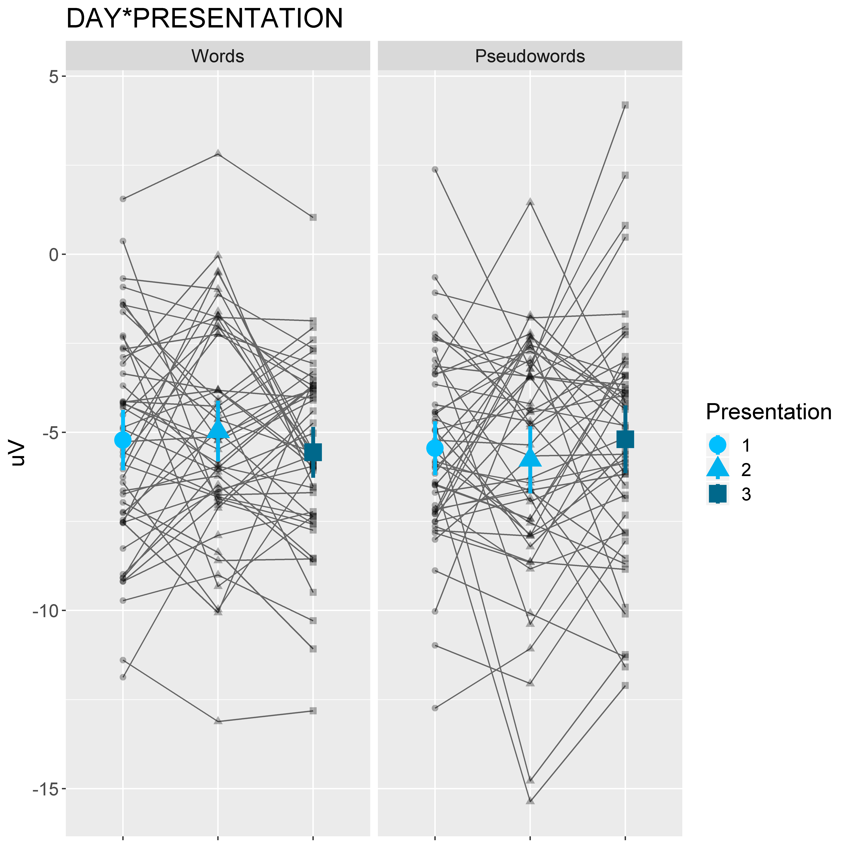
Figure SM1. Interactions between Lexicality and Presentation, with mean values given; error bars show 95% CI.

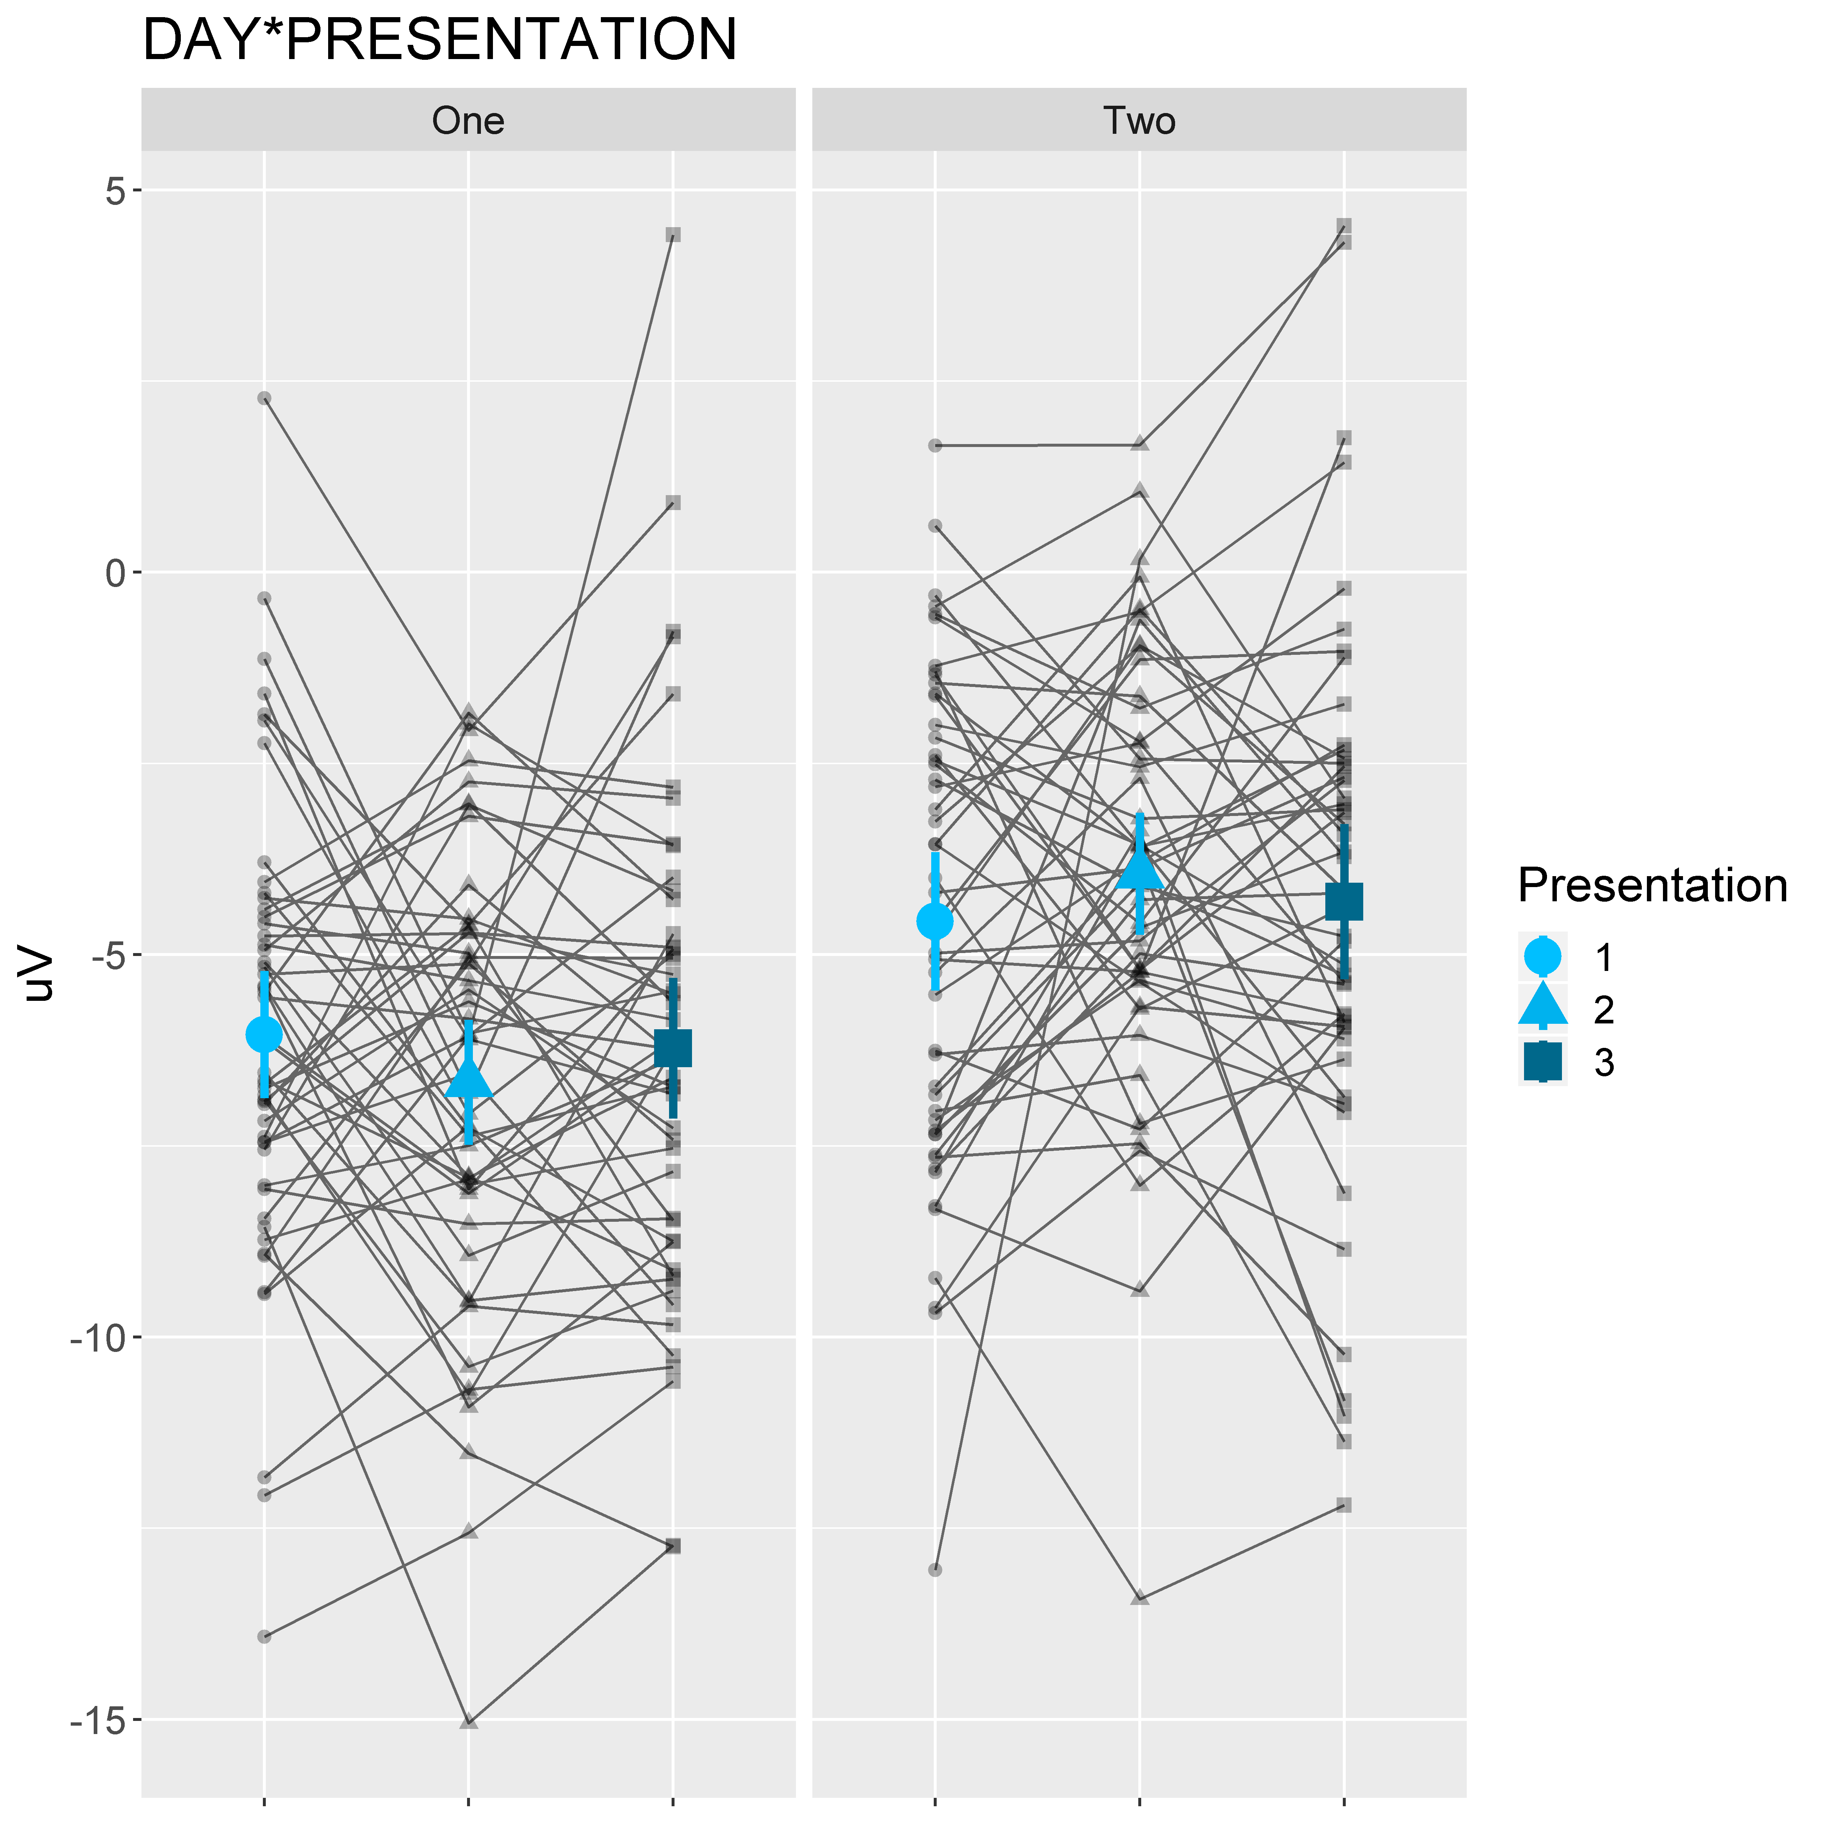

Figure SM2. Interactions between Day and Presentation, with mean values given; error bars show 95% CI.

