Appendices
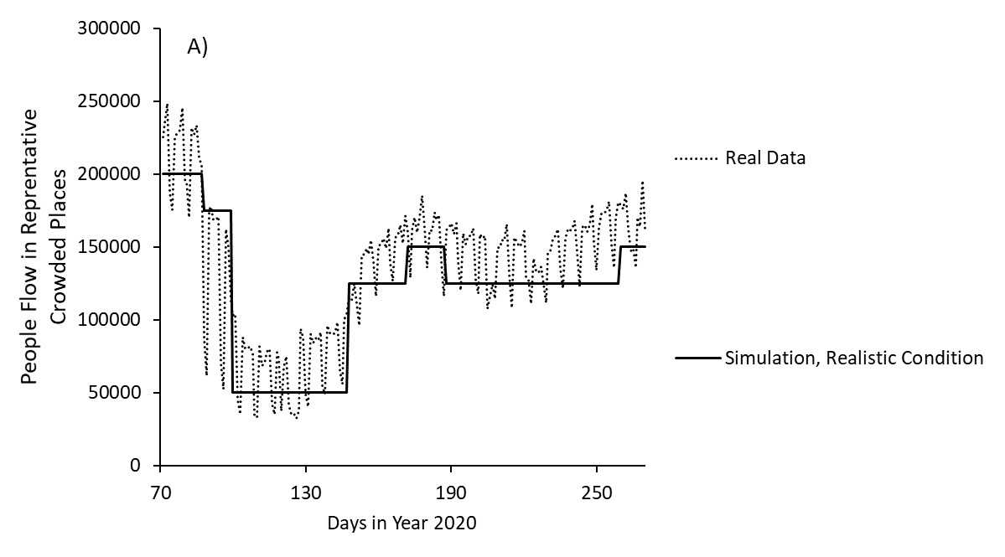
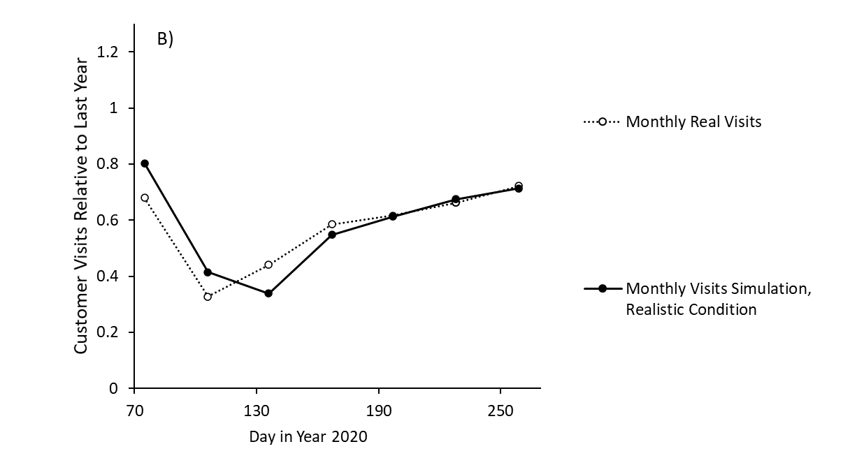
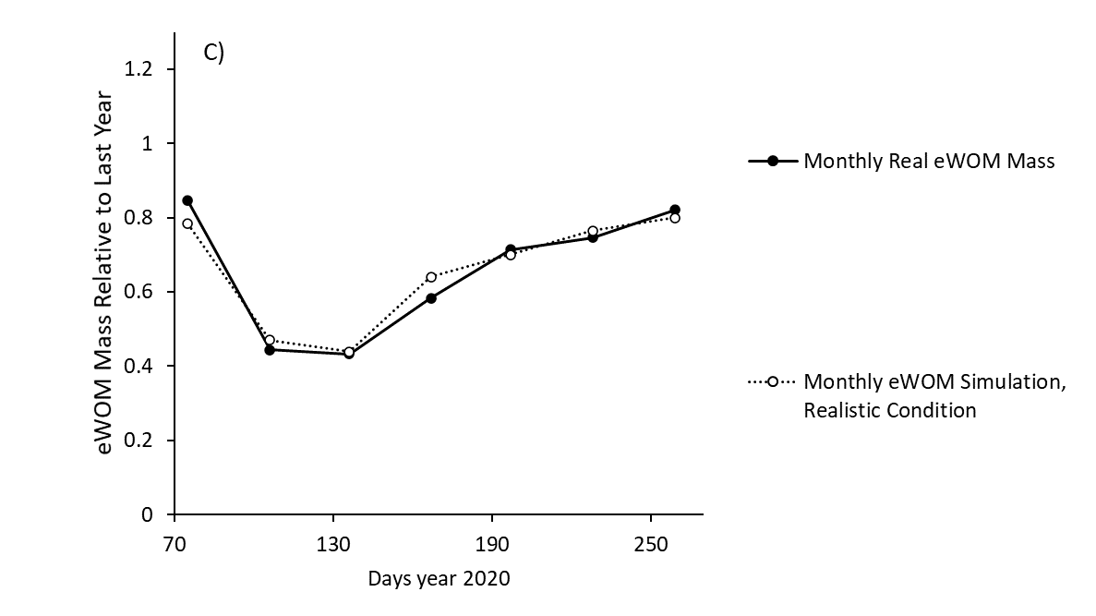
Appendix Figure 1. Simulation outcomes for (A) people flow, (B) people dining out, and (C) eWOM mass compared to real metrics

Appendix Table 1. Parametrisation of quantitative model
Parameter | Meaning | Initial value | Equations | Comments
Disease Spreading Part
Susceptible | Susceptible (not immunised) people | 1.40  x 10 ⁷ | -Infection | Whole Tokyo metropolitan population
Infected | People newly infected on a given day | 149 | infection-apparent Infection-inapparent infection | Initial value: calculated from actual confirmed positives after incubation period, apparent ratio, and testing policy
Apparent | People who newly appeared to be symptomatic | 60 | apparent Infection-not tested-virus testing symptomatic | Initial value: calculated from actual confirmed positives and testing policy
Inapparent | People inapparently infected and acting as virus carriers | 664 | inapparent infection-inapparent recovery | Initial value: calculated from actual confirmed positives, apparent ratio, and testing policy
Confirmed positives | People tested and confirmed as positive | 5 | virus testing symptomatic-hospitalisation | Initial value: actual confirmed positives
Not tested positives | People who are symptomatic and treated at home but not virus tested | 50 | not tested-not tested recovery | Initial value: calculated from actual confirmed positives and testing policy
Susceptible ratio | Effect of probability for a carrier to meet susceptible people | - | Susceptible/1.40  x 10 ⁷ | -
Reproduction rate | Standard reproduction rate (2.9 / occasion) calibrated to a unit time (day) | 0.207 | - | 2.9: median of reported R₀ [33]
Temperature effect | Transmission affected by wet balb temperature [15] | 1.0 | 15 May 2020: 1.2  15 Jun 2020: 1.6  15 Jul 2020: 1.1  15 Sep 2020: 1.6 | Monthly average temperature was used
Apparent ratio |  | 0.375 | - | [34]
Incubation time |  | 5 | - | [34]
Apparent infection |  |  | Infected*apparent ratio/incubation time | -
Inapparent infection |  |  | Infected*(1-apparent ratio)/incubation time | -
Inapparent virus clearance period |  | 8 | - | Tentative turnover 14 days minus infection day and incubation period
Testing policy | Initially, testing frequency was limited | 0.5 | Raised to 1.0 after 10 May 2020 | Half of the fevers are early onset [35]
People Flow and Behavior Part
Baseline People Flow | Baseline in representative crowded place | 250000 | - | 250,000 per representative traffic node
Daily Maximum People Flow | Maximum people flow in crowded places represented by station | 0 | Baseline People Flow*(1-0.2 x school closure commuting effect-0.1 x stay-at-home request -0.1 x short-term epidemic consciousness - 0.4 x new normal lifestyle effect | -
Behaviour guidance | Exclusive guidance from Government | 0 | 15 Apr 2020: 1 | Recognition at this time point was suggested by LINE survey [23]
Distancing and protective behaviour facto | Reduced risk by individual protective behaviour (wearing masks, distancing) | 0.5 | - | [11]
Protective behaviour under epidemic condition | Probability for each person to act ideal protective behaviour | 0.6 | - | Estimated from the finding that about 60% of survey respondents thought more stringent measures were necessary in June 2020 [28]
Protective behaviour under normal condition | Probability for each person to act according to ideal protective behaviours | 0.3 | - | Half probability of epidemic condition
Restaurant Industry Part
Customer Staying home |  | 1.07  x 10 ⁷ | dining out to home-dining out | Initial value: population of Tokyo consisting of individuals 15 to 74 years of age
Customer Dining Out |  | 0 | dining out-dining out to home
Dining Out | Movement to dining out | 0 | baseline dining out x  (1-0.2 x school-closure psychological effect-0.1 x stay-at-home request -0.1 x mid-term epidemic consciousness -0.1 x focused intervention effect -0.3 x long-term epidemic consciousness
eWOM Mass | Relative daily eWOM mass | 0 | (1-0.2 x school-closure psychological effect -0.2 x long-term epidemic consciousness - 0.1 x stay-at-home request -0.1 x focused intervention effect - 0.1 x mid-term epidemic consciousness)

Appendix Table 2. Parametrisation in each scenario
Parameter | Realistic | Second Emergency | Pre-Emptive Shorter Emergency | Exhaustive Emergency
Short-term epidemic consciousness | Initial: 0  27 Mar 2020: 1  30 May 2020: 0  05 Jul 2020: 1  15 Sep 2020: 0 | Initial: 0  27 Mar 2020: 1  30 May 2020: 0  05 Jul 2020: 1  01 Sep 2020: 0 | Initial: 0  27 Mar 2020: 1  30 May 2020: 0  28 Jun 2020: 1  28 Jul 2020: 0 | Initial: 0  27 Mar 2020: 1  30 May 2020: 0  03 Jul 2020: 1  01 Sep 2020: 0
Mid-term epidemic consciousness | Initial: 0  27 Mar 2020: 1  30 May 2020: 0 | Initial: 0  27 Mar 2020: 1  30 May 2020: 0 | Initial: 0  27 Mar 2020: 1  30 May 2020: 0 | Initial: 0  27 Mar 2020: 1  30 May 2020: 0
Long-term epidemic consciousness | Initial: 0  27 Mar 2020: 1 | Initial: 0  27 Mar 2020: 1 | Initial: 0  27 Mar 2020: 1 | Initial: 0  27 Mar 2020: 1
School closure, psychological effect | Initial: 1  26 May 2020: 0 | Initial: 1  26 May 2020: 0 | Initial: 1  26 May 2020: 0 | Initial: 1  26 May 2020: 0
Stay-at-home request | Initial: 0  08 Apr 2020: 1  26 May 2020: 0 | Initial: 0  08 Apr 2020: 1  26 May 2020:0  19 Jul 2020: 1  01 Sep 2020 :0 | Initial: 0  08 Apr 2020: 1  26 May 2020: 0  28 Jun 2020: 1  28 Jul 2020: 0 | Initial: 0  29 Mar 2020: 1  30 May 2020: 0  03 Jun 2020: 1  01 Sep 2020: 0

