Appendices
Figure S1. Risk of bias graph
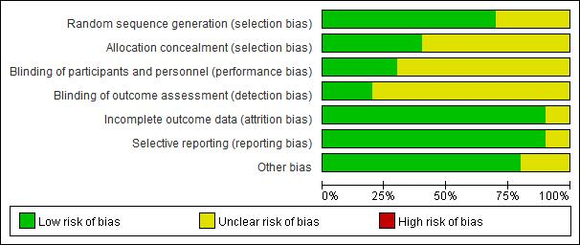

Figure S2. Risk of bias summary
