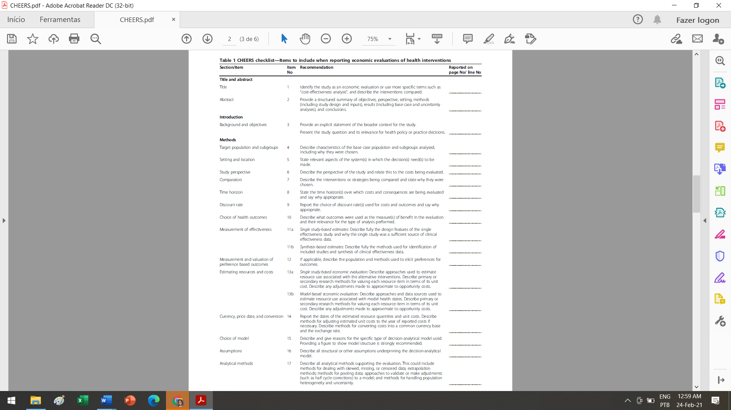

16-17

16-17

N/A

N/A

10-12

13-14

12

14

10-12

12

9

9

8

9

7

8

5

1

3

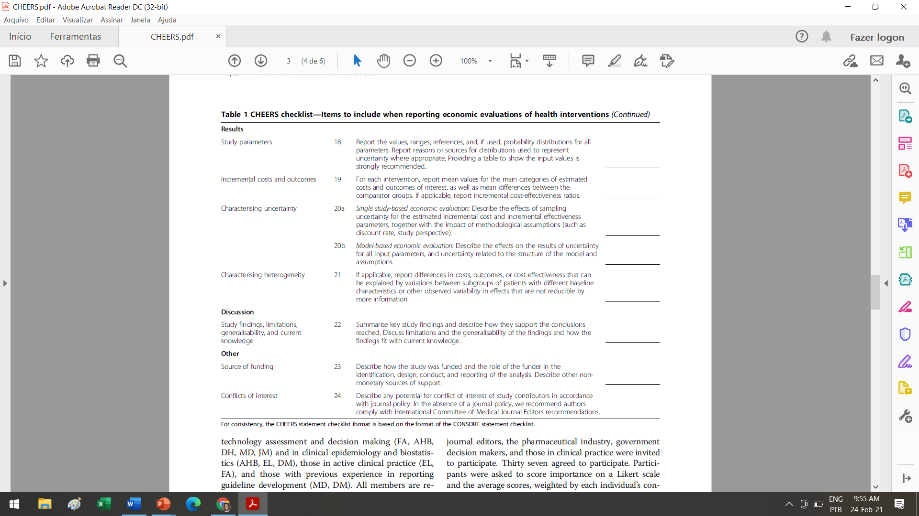

21

21

17-20

N/A

N/A

N/A

N/A

N/A