Supporting Information

Prediction of higher thermoelectric performance in BiOCuSe by weakening electron-polar optical phonon scattering
Tianqi Zhao^{*,1}, Quinn D. Gibson², Luke M. Daniels², Ben Slater¹, Furio Corà^{*,1}

¹Department of Chemistry, University College London, Gower Street, London, WC1E 6BT, United Kingdom

²Department of Chemistry, University of Liverpool, Crown Street, Liverpool, L69 7ZD, United Kingdom

*Corresponding author: E-mail address: tianqi.zhao@ucl.ac.uk (T. Zhao), f.cora@ucl.ac.uk (F. Corà)

Supplementary Figures

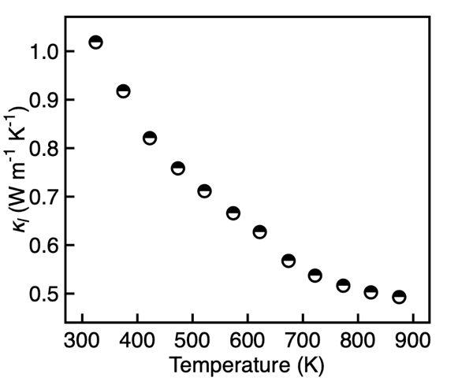
Supplementary Figure 1 | Lattice thermal conductivity of BiOCuSe as reproduced from literature,¹ which is used to calculate thermoelectric figure of merit ZT of BiOCuSe in this work.

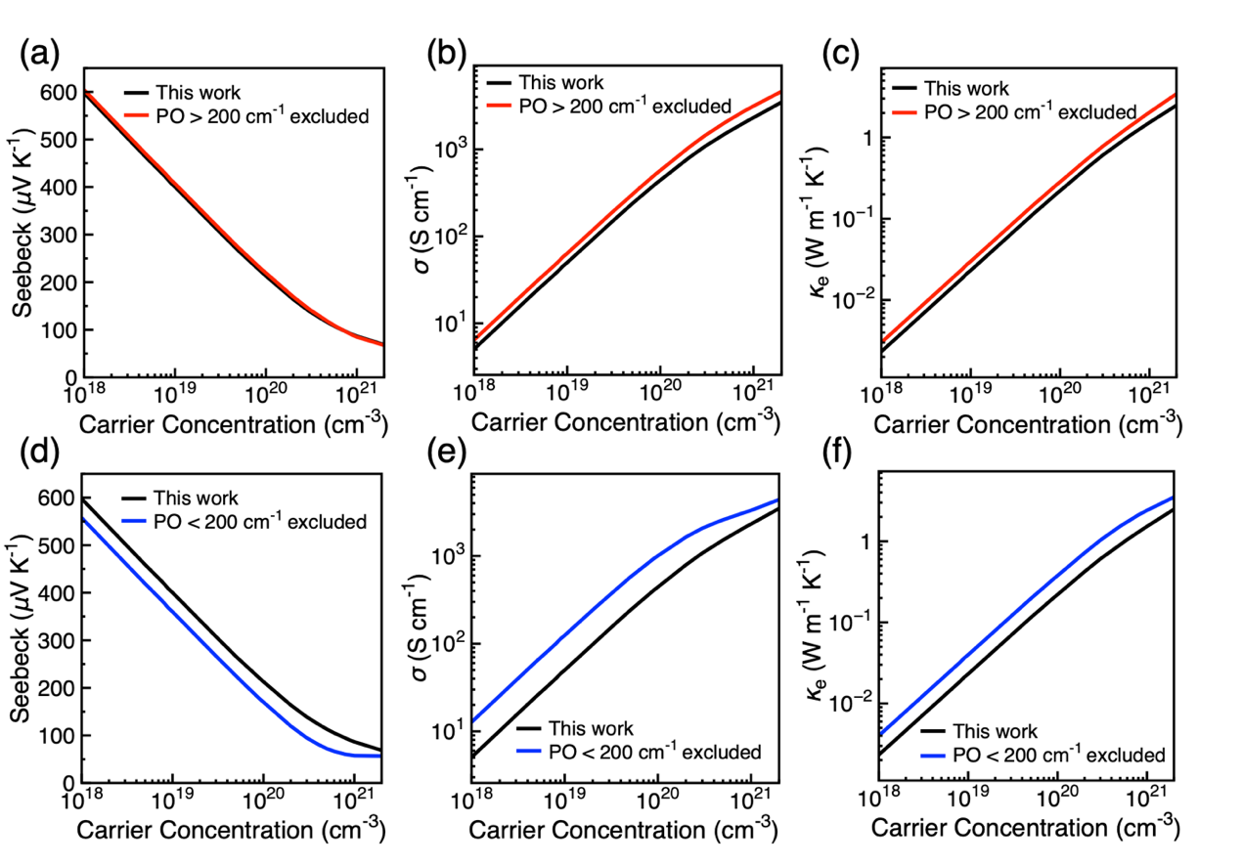
Supplementary Figure 2 | The variation of thermoelectric charge transport properties with carrier concentration. The calculated results as compared to that by excluding PF with frequency > 200 cm⁻¹ of (a) Seebeck coefficient, (b) electrical conductivity, (c) electrical thermal conductivity. The calculated results as compared to that by excluding PF with frequency < 200 cm⁻¹ of (d) Seebeck coefficient, (e) electrical conductivity, (f) electrical thermal conductivity.

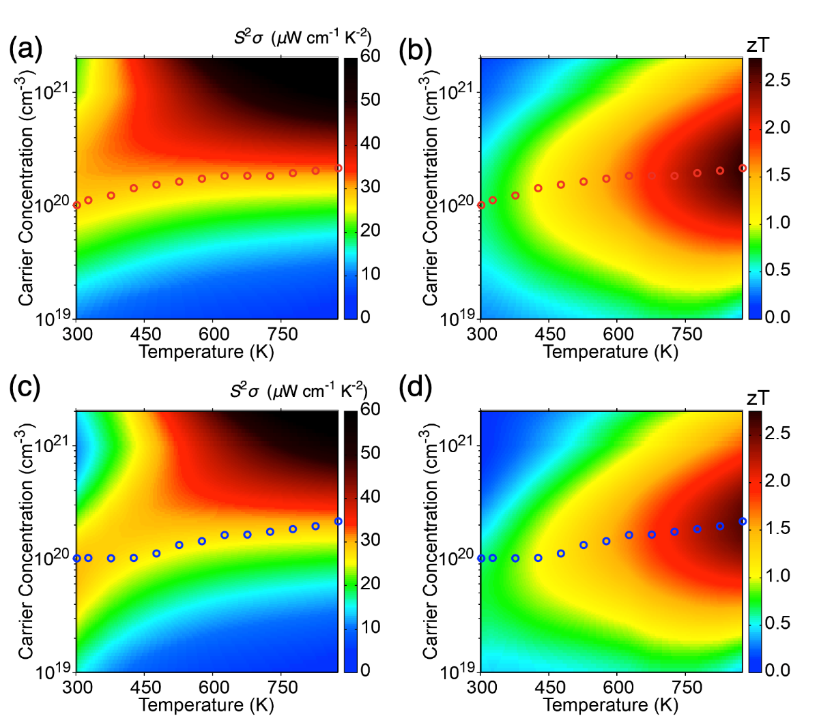
Supplementary Figure 3 | The variation of (a) power factor and (b) ZT of BiOCuSe as a function of carrier concentration and temperature after excluding the scattering effects of PO phonon with frequency > 200 cm⁻¹. The variation of (c) power factor and (d) ZT of BiOCuSe as a function of carrier concentration and temperature after excluding the scattering effects of PO phonon with frequency < 200 cm⁻¹.

Supplementary Tables

Supplementary Table 1 | Longitudinal optic phonon frequencies of BiOCuSe in cm⁻¹
LO Modes | This work | Literature² | Experiment³
E_{u} | 56.2 | 61.2
A_{2u} | 91.4 | 89.4 | 92.0
E_{u} | 135.9 | 142.7
A_{2u} | 175.2 | 178.6
E_{u} | 341.9 | 347.7
A_{2u} | 472.9 | 473.7 | 475.0

Supplementary Table 2 | Born effective charge of BiOCuSe
 |  | This work | Literature²
$$Z_{Bi}^{*}$$ | In plane | 6.50 | 6.46
 | Out of plane | 5.94 | 5.93
$$Z_{O}^{*}$$ | In plane | -4.28 | -4.28
 | Out of plane | -4.36 | -4.42
$$Z_{Cu}^{*}$$ | In plane | 1.46 | 1.44
 | Out of plane | 1.09 | 1.06
$$Z_{Se}^{*}$$ | In plane | -3.67 | -3.67
 | Out of plane | -2.67 | -2.70
$$k_{∞}$$ | In plane | 17.61 | 18.01
 | Out of plane | 13.25 | 13.79

Supplementary References
1. Ren, G. K. et al. Enhanced thermoelectric properties in Pb-doped BiCuSeO oxyselenides prepared by ultrafast synthesis. RSC Adv. 5, 69878–69885 (2015).
2. Saha, S. K. Exploring the origin of ultralow thermal conductivity in layered BiOCuSe. Phys. Rev. B 92, 041202 (2015).
3. Berdonosov, P. S. Powder X-Ray and IR Studies of the New Oxyselenides MOCuSe (M = Bi, Gd, Dy). J. Solid State Chem. 118, 74 (1995).

