SUPPLEMENTAL INFORMATION
Supplemental figures
Figure. 1 Imaging flow cytometry of intracellular Aβ₁₋₄₂ uptake by monocyte subsets. a-c Monocytes were stained with APC-conjugated anti-CD14 mAb (red) and PE-conjugated anti-CD16 mAb (yellow), and FITC-conjugated Aβ₁₋₄₂ is shown in green. Images of FITC-labelled Aβ₁₋₄₂ intracellular uptake by the classical CD14⁺CD16⁻ monocyte subset, intermediate CD14⁺CD16⁺ monocyte subset and the non-classical CD14^{dim}CD16⁺ monocyte subset were collected.

Figure. 2 Association of Aβ₁₋₄₂ uptake by monocytes with plasma Aβ₁₋₄₂/Aβ₁₋₄₀ level. a-d Correlations between plasma Aβ₁₋₄₂/ Aβ₁₋₄₀ and uptake of Aβ₁₋₄₂ by all monocytes, by the CD14⁺CD16⁻ subset, by the CD14⁺CD16⁺ subset, and by the CD14^{dim}CD16⁺ subset. MONO monocytes, Aβ amyloid β-protein.

Figure. 3 Association of Aβ₁₋₄₂ uptake by monocytes with CSF Aβ₁₋₄₂ level. a-d Correlations between CSF Aβ₁₋₄₂ level and uptake of Aβ₁₋₄₂ by all monocytes, by the CD14⁺CD16⁻ subset, by the CD14⁺CD16⁺ subset, and by the CD14^{dim}CD16⁺ subset. MONO monocytes, CSF cerebrospinal fluid, Aβ amyloid β-protein.

Figure. 4 Association of Aβ₁₋₄₂ uptake by monocytes with CSF Aβ₁₋₄₀ levels. a-d Correlations between CSF Aβ₁₋₄₀ and uptake of Aβ₁₋₄₂ by all monocytes, by the CD14⁺CD16⁻ subset, by the CD14⁺CD16⁺ subset, and by the CD14^{dim}CD16⁺ subset. MONO monocytes, CSF cerebrospinal fluid, Aβ amyloid β-protein.

Figure. 5 Association of Aβ₁₋₄₂ uptake by monocytes with CSF Aβ₁₋₄₂/Aβ₁₋₄₀ level. a-d Correlations between CSF Aβ₁₋₄₂/ Aβ₁₋₄₀ and uptake of Aβ₁₋₄₂ by all monocytes, by the CD14⁺CD16⁻ subset, by the CD14⁺CD16⁺ subset, and by the CD14^{dim}CD16⁺ subset. MONO monocytes, CSF cerebrospinal fluid, Aβ amyloid β-protein.

Figure. 6 Association of Aβ₁₋₄₂, Aβ₁₋₄₀, Aβ₁₋₄₂/ Aβ₁₋₄₀ and T-tau/ Aβ₁₋₄₂ levels in the plasma with those in the CSF. a-d Correlations between CSF Aβ₁₋₄₂ and plasma Aβ₁₋₄₂, CSF Aβ₁₋₄₀ and plasma Aβ₁₋₄₀, CSF Aβ₁₋₄₂/ Aβ₁₋₄₀ and plasma Aβ₁₋₄₂/ Aβ₁₋₄₀, CSF T-tau/Aβ₁₋₄₂ and plasma T-tau/Aβ₁₋₄₂. MONO monocytes, CSF cerebrospinal fluid, Aβ amyloid β-protein, T-tau total tau.
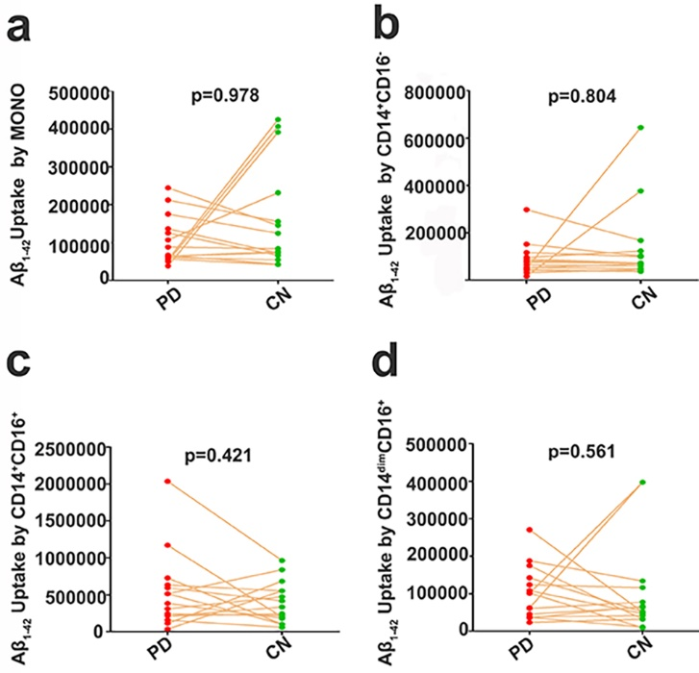

Figure. 7 Comparison of Aβ₁₋₄₂ uptake by monocyte subsets between PD patients and CN subjects. a-d There were no significant differences between PD patients (n=15) and the age- and sex-matched CN controls (n=15) in Aβ₁₋₄₂ uptake by total monocytes, the CD14⁺CD16⁻ subset, the CD14⁺CD16⁺ subset and the CD14^{dim}CD16⁻ subset. PD Parkinson’s disease, CN cognitively normal control, MONO monocytes, Aβ amyloid-β protein.

Table. 1 Characteristics of cognitively normal subjects
Age range | <= 30 years  (n=10) | 31-45 years  (n=25) | 46-60 years  (n=25) | 61-75 years  (n=32) | > 75 year  (n=12) | P value
Age, y [mean (SD)] | 25.0 (2.9) | 39.8 (4.0) | 57.2 (3.0) | 69.6 (4.0) | 83.0 (5.0) | <0.0001
Female, n(%) | 5 (50.0) | 13 (52.0) | 12 (48.0) | 15 (46.9) | 5 (41.7) | 0.98
Comorbidities
Hypertension, n (%) | 0 (0.0) | 2 (8.0) | 2 (8.0) | 4 (12.5) | 2 (16.7) | 0.70
Diabetes mellitus, n (%) | 0 (0.0) | 1 (4.0) | 1 (4.0) | 2 (6.3) | 1 (8.3) | 0.90
Hyperlipidemia, n (%) | 1 (10.0) | 2 (8.0) | 2 (8.0) | 2 (6.25) | 1 (8.3) | 1.00

Data are expressed as the means (standard deviation) P value, two-independent test, Mann–Whitney U test or chi-squared test as appropriate. AD Alzheimer’s disease,
CN cognitively normal control, SD standard deviation.
Table. 2 Demographic data of AD patients and age- and sex-matched CN controls
 | AD  (n=22) | CN  (n=22) | P value
Age, y [mean (SD)] | 69.5 (8.8) | 69.5 (8.8) | >0.9999
Male, n (%) | 10 (45.5) | 10 (45.5) | 1.00
Years of education, mean (SD) | 9.36 (3.5) | 9.41 (2.5) | 0.96
APOE ε4 carriers, n (%) | 7 (31.8) | 2 (9.1) | 0.14
MMSE, mean (SD) | 10.2 (8.2) | 28.0 (1.1) | <0.0001
CDR, mean (SD) | 2.0 (0.9) | 0.0 | <0.0001
ADL, mean (SD) | 45.3 (18.1) | 20.8 (1.1) | <0.0001
Comorbidities
Hypertension, n (%) | 6 (27.3) | 3 (13.6) | 0.46
Diabetes mellitus, n (%) | 1 (4.5) | 3 (13.6) | 0.60
Hyperlipidemia, n (%) | 2 (9.1) | 1 (4.5) | 1.00
Medication, n (%)
Hypertension | 5 (22.7) | 2 (9.1) | 0.41
Diabetes mellitus | 1 (4.5) | 3 (13.6) | 0.60
Hyperlipidemia | 1 (4.5) | 1 (4.5) | 1.00
Data are expressed as the means (standard deviation) P value, two-independent test, Mann–Whitney U test or chi-squared test as appropriate.
AD Alzheimer’s disease, CN cognitively normal control, SD standard deviation, MMSE Mental State Examination, ADL Activities of Daily Living, CDR Clinical Dementia Rating.

 | PD  (n= 20) | CN  (n= 20) | P values
Age, y [mean (SD)] | 65.8 (10.8) | 67.3 (10.0) | 0.70
Male, n (%) | 8 (53.3) | 8 (53.3) | 1.00
Years of education, mean (SD) | 9.2 (2.1) | 9.1 (2.7) | 0.88
APOE ε4 carriers, n (%) | 2 (13.3) | 1 (6.7) | 1.00
Comorbidities
Hypertension, n (%) | 0 (0.0) | 1 (6.7) | 1.00
Diabetes mellitus, n (%) | 0 (0.0) | 1 (6.7) | 1.00
Hyperlipidemia, n (%) | 1 (6.7) | 0 (0.0) | 1.00
Medication, n (%)
Hypertension | 0 (0.0) | 1 (5.0) | 1.00
Diabetes mellitus | 0 (0.0) | 1 (5.0) | 1.00
Hyperlipidemia | 0 (0.0) | 0 (0.0) | /
Table. 3 Demographic data of PD patients and age- and sex-matched CN controls

Data are expressed as the means (standard deviation) P value, two-independent test, Mann–Whitney U test or chi-squared test as appropriate.
AD Parkinson’s disease, CN cognitively normal control, SD standard deviation.

