Supplementary Figure 1
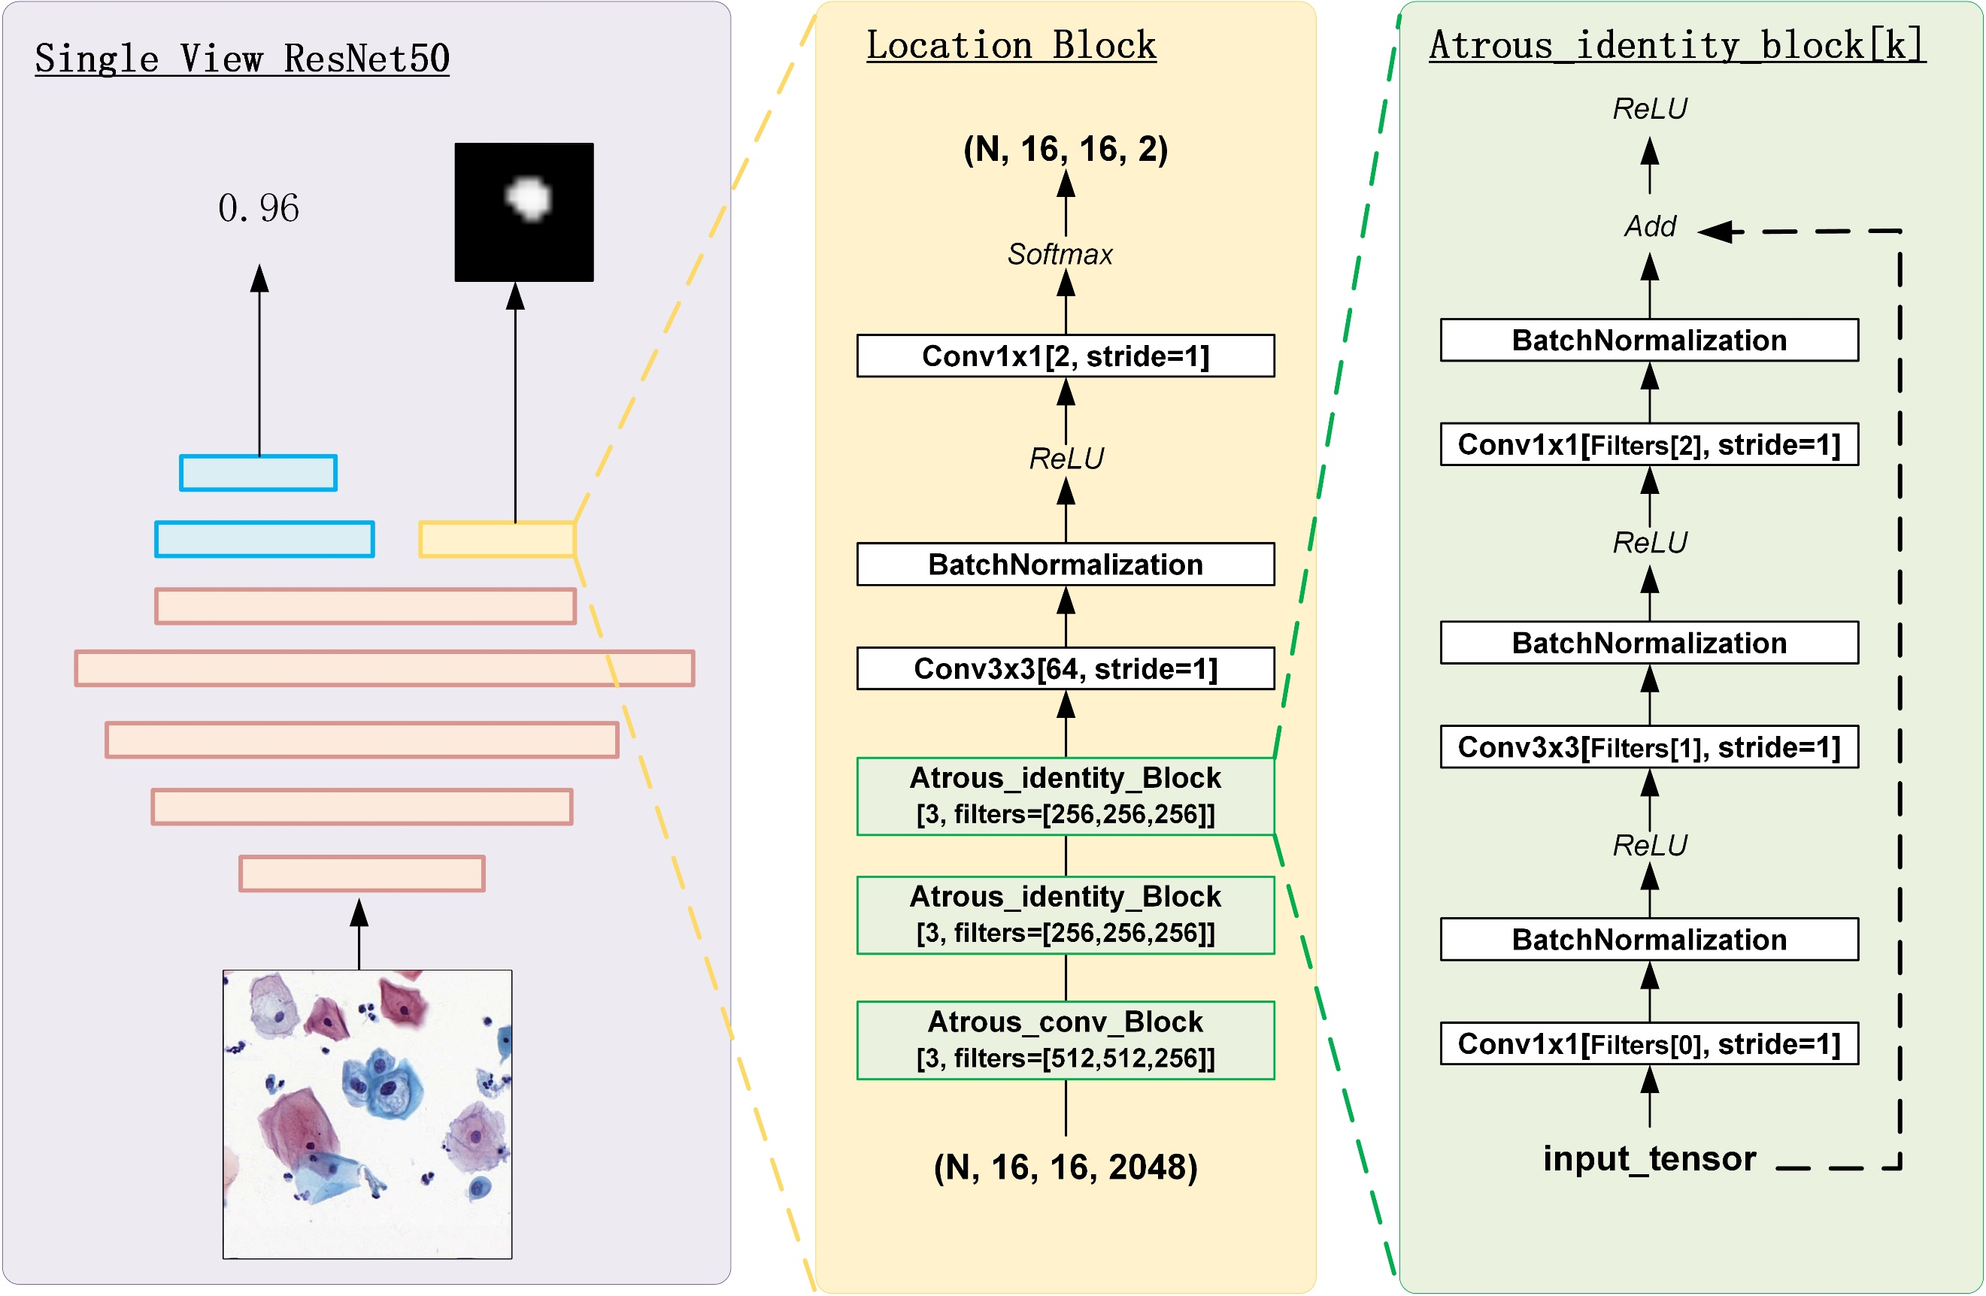
Supplementary Figure 1 | The architecture of the LR model. We modified the fully connected layer of the original ResNet50 and add a semantic segmentation branch for generating rough location mask. The semantic segmentation branch is constructed with residual blocks of dilated convolutions. The LR model accepts an image tile of 512 × 512 pixels (0.486 μm/pixel) as input and outputs a lesion probability and a location heatmap.
Supplementary Figure 2
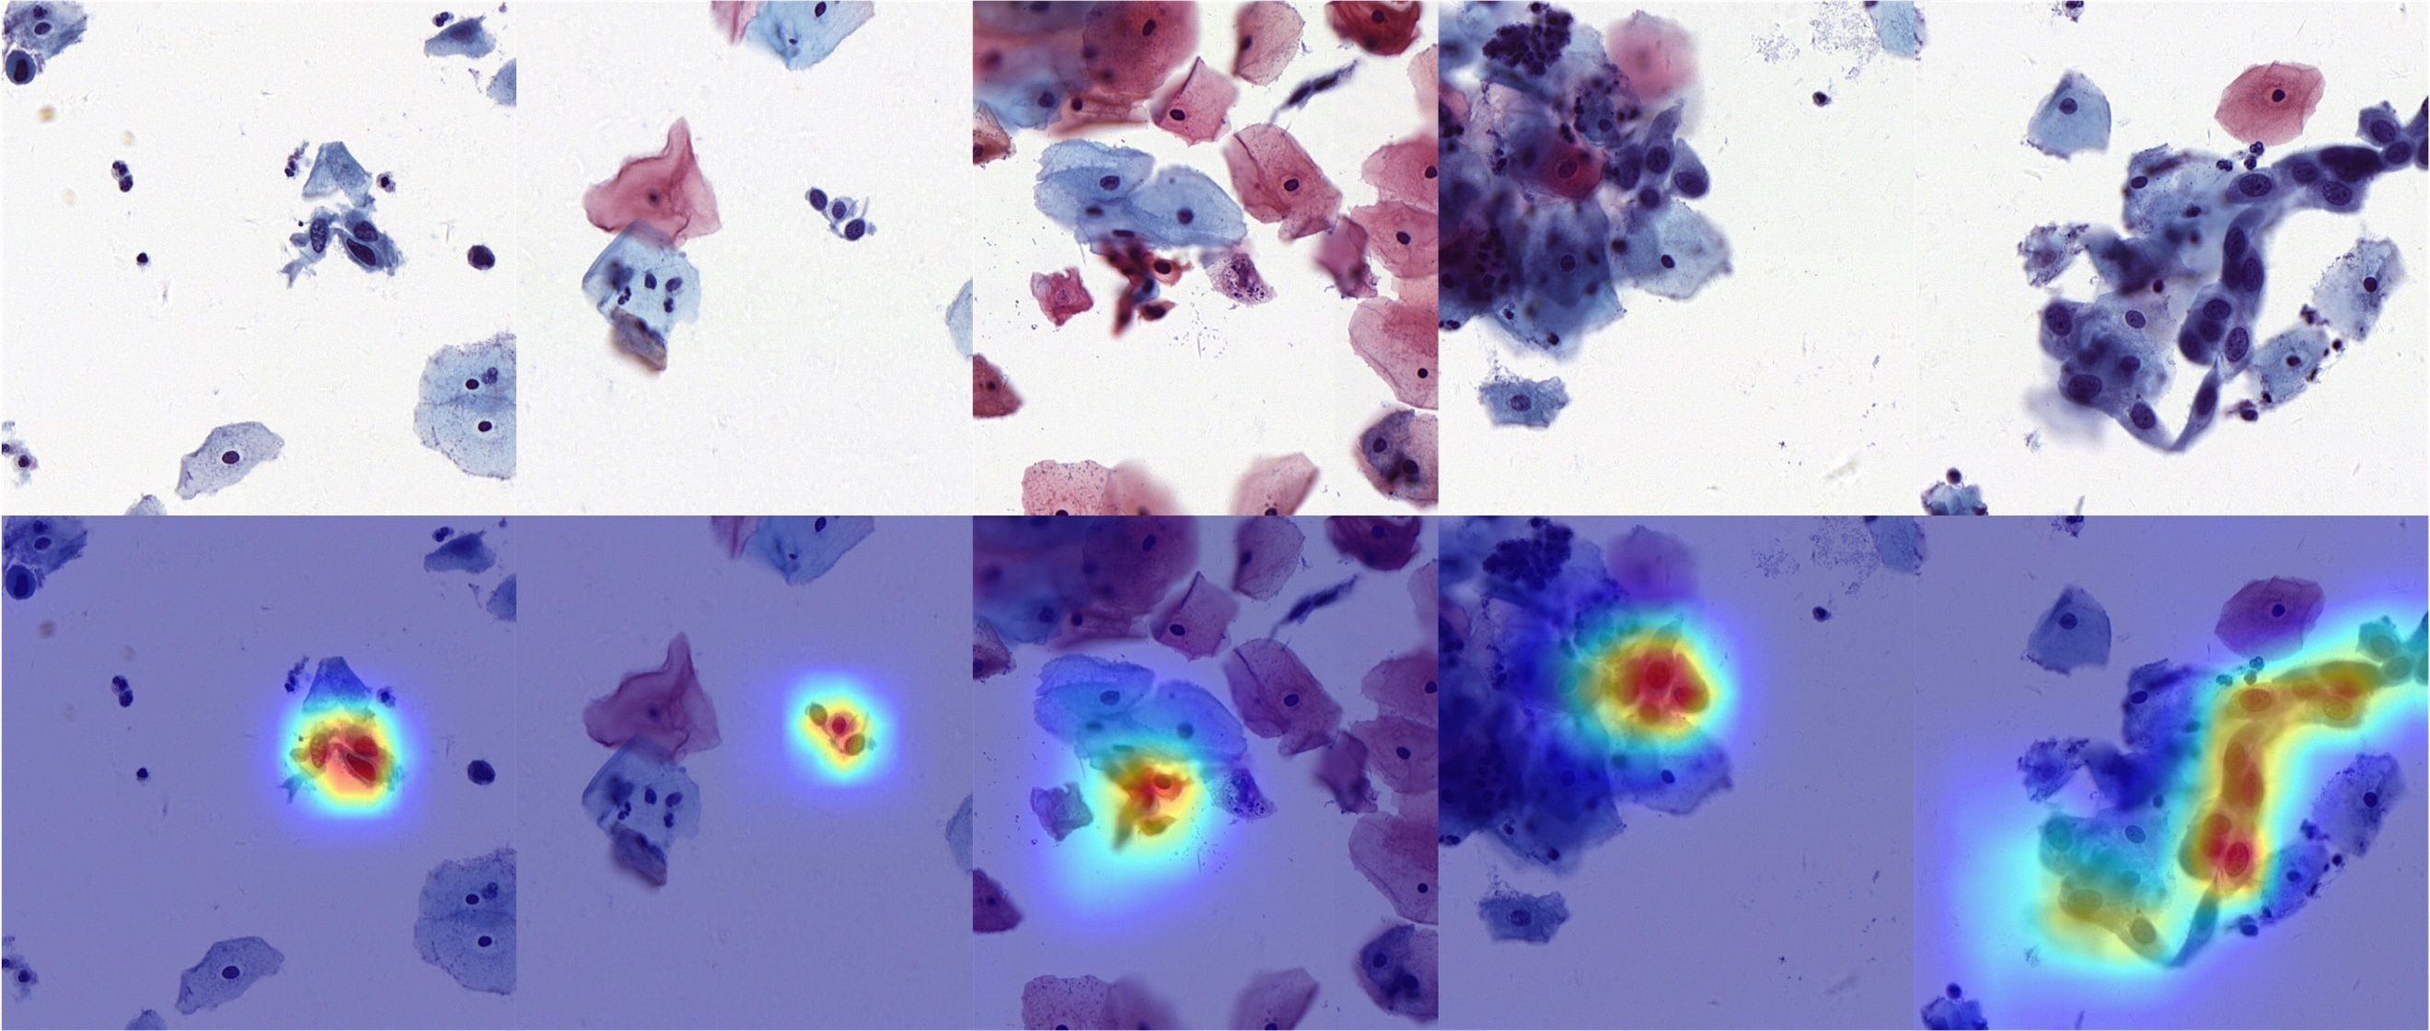
Supplementary Figure 2 | Visualization of heatmaps generated by the LR model. The above are cervical cell image tiles of 512 × 512 pixels (0.486 μm/pixel). The below are the merged images with the cervical cell images and corresponding location heatmaps. Notably, the redder, the higher the lesion probability.

