Supplementary materials

Luteorhabdos pelagi gen. nov., sp. nov., a novel member of the family Flavobacteriaceae, isolated from the West Pacific Ocean
Wen-Ting Ren^{1,2}, Fan-Xu Meng¹, Li-Li Guo^{1,3}, Li Sun⁴, Xue-Wei Xu^{1,2}, Peng Zhou^{1,*}, Yue-Hong Wu^{1,2,*}

¹Key Laboratory of Marine Ecosystem Dynamics, Ministry of Natural Resources & Second Institute of Oceanography, Ministry of Natural Resources, Hangzhou 310012, PR China
²School of Oceanography, Shanghai Jiao Tong University, Shanghai 200240, PR China
³College of Life and Environmental Science, Hunan University of Arts and Science, Changde 415000, PR China
⁴State Research Center of Island Exploitation and Management & Second Institute of Oceanography, Ministry of Natural Resources, Hangzhou 310012, PR China

*Corresponding authors: yuehongwu@sio.org.cn; hockeyextremophiles@yahoo.com.
Supplementary Table S1 Genomic features of A3-108^{T} and its reference strains.
Strains/species: 1, strain A3-108^{T}; 2, Marinirhabdus gelatinilytica NH83^{T}; 3, Galbibacter mesophilus CGMCC 1.15663^{T}; 4, Marixanthomonas ophiurae JCM 14121^{T}.
 | 1 | 2 | 3 | 4
Size (Mb) | 3.40 | 3.29 | 3.77 | 3.30
Contigs | 99 | 24 | 10 | 6
G+C (%) | 41.0 | 41.3 | 37.3 | 35.9
Coding genes | 3250 | 3146 | 3362 | 3097
Protein | 3208 | 3111 | 3318 | 3060
rRNA | 5 | 2 | 3 | 1
tRNA | 37 | 33 | 41 | 36
Accession | JAECMS01 | QRAO01 | JAERQH01 | QVID01

Supplementary Table S2 The ANI, DDH and AAI values among the genomes of strain A3-108^{T} with the reference strains.
 | ANIb | OrthoANI | in silico DDH | AAI | Accession number
1, strain A3-108^{T} | / | / | / | / | JAECMS01
2, Marinirhabdus gelatinilytica NH83^{T} | 69.5 | 70.1 | 22.1 | 68.0 | QRAO01
3, Galbibacter mesophilus CGMCC 1.15663^{T} | 67.3 | 67.7 | 18.7 | 58.8 | JAERQH01
4, Marixanthomonas ophiurae JCM 14121^{T} | 71.1 | 71.5 | 18.9 | 71.4 | QVID01

Supplementary Fig. S1. Transmission electron micrographs showing the cell morphology and ultrastructure of strain A3-108^{T} (a and b). Bars, 0.2 μm (a) and 0.5 μm (b).
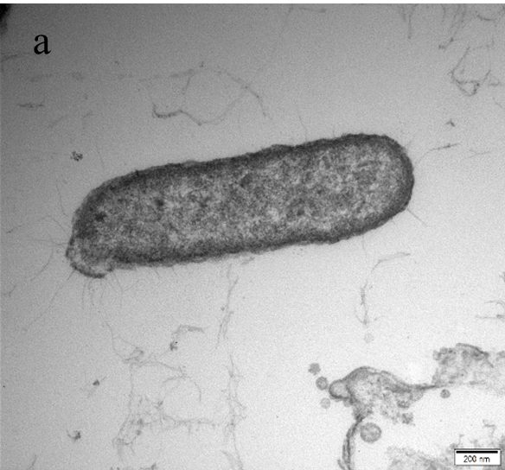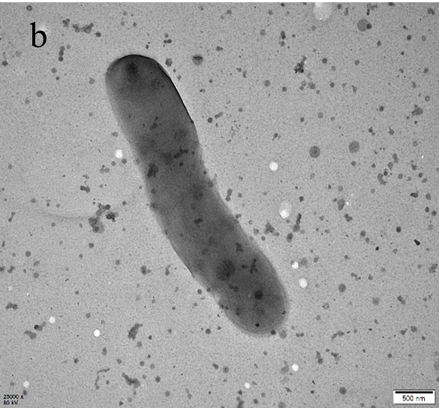

Supplementary Fig. S2. The growth curve of strain A3-18^{T} (a) and the curve of log₁₀(OD₆₀₀) (b), showing that the lag phase, the exponential and the stationary phases were 0-16 h, 16-40 h and exceed 40 h, respectively. On the basis of formulas, the doubling time and specific growth rate for strain A3-108^{T} were 6.2 h and 0.16 h⁻¹, respectively. Doubling time (t_{d}/h) = ln2/k; k represents relative growth rate (slope of the curve); specific growth rate (μ/h⁻¹) = 1/t_{d}.
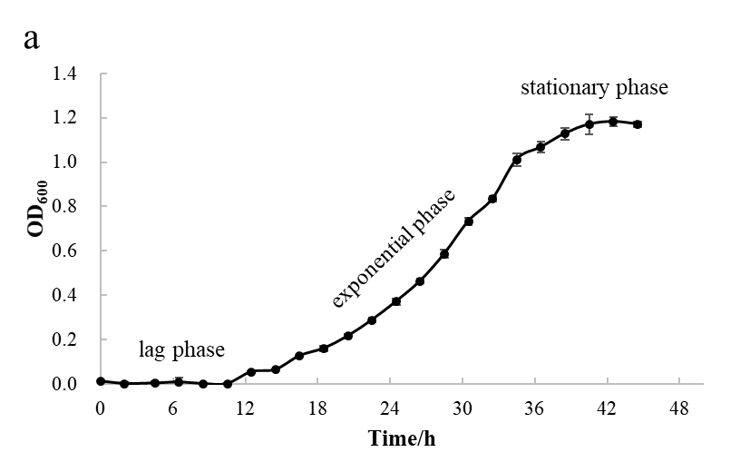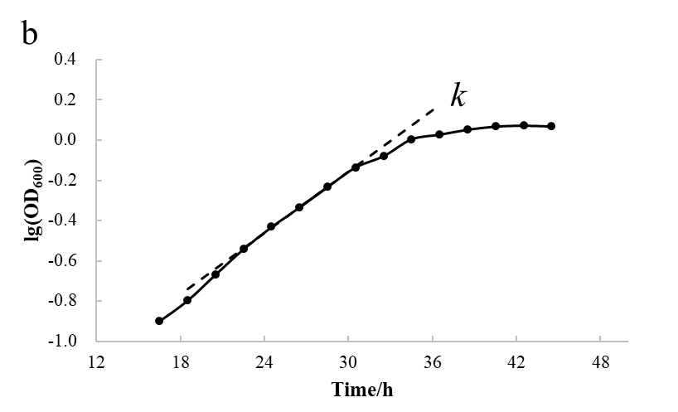

Supplementary Fig. S3. Absorption profiles of carotenoids produced by strain A3-108^{T}. UV-visible absorption spectrum of crude extract indicate strain A3-108^{T} comprised carotenoids through typical absorption peaks around 470 nm detection wavelength.
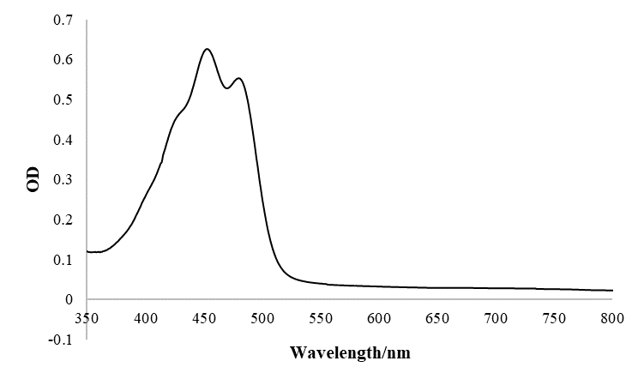
Supplementary Fig. S4. Thin-layer chromatograms of strain A3-108^{T} after staining with molybdatophosphoric acid, molybdenum blue reagent, ninhydrin reagent and α-naphthol reagent (a-d). APL, aminophospholipid; AGL, aminoglycolipid; PE, phosphatidylethanolamine; AL, aminolipid; GL, glycolipid; L, lipid.
