- Epitope-based Immunoinformatics Approach on Nucleocapsid Protein of Severe Acute Respiratory Syndrome-Coronavirus-2
- Running title: In silico vaccine design against SARS-CoV-2 nucleocapsid protein
- Abstract: 244 words, main text: 5245 words, 09 figures, 04 tables, 01 supplementary data file
Ahmed Rakib¹, Saad Ahmed Sami¹, Md. Ashiqul Islam^{1,2}, Shahriar Ahmed¹, Farhana Binta Faiz¹, Bibi Humayra Khanam¹, Kay Kay Shain Marma¹, Maksuda Rahman¹, Mir Muhammad Nasir Uddin¹, Talha Bin Emran^{3,4*}, Jesus Simal-Gandara^{5*}
¹Department of Pharmacy, Faculty of Biological Sciences, University of Chittagong, Chittagong-4331, Bangladesh
²Department of Pharmacy, Mawlana Bhashani Science & Technology University, Santosh, Tangail-1902, Bangladesh
³Drug Discovery, GUSTO A Research Group, Chittagong-4000, Bangladesh
⁴Department of Pharmacy, BGC Trust University Bangladesh, Chittagong-4381, Bangladesh
⁵Nutrition and Bromatology Group, Department of Analytical and Food Chemistry, Faculty of Food Science and Technology, University of Vigo–Ourense Campus, E32004 Ourense, Spain
*Correspondence:
Dr. T.B. Emran (talhabmb@bgctub.ac.bd)
Prof. J. Simal-Gandara (jsimal@uvigo.es)

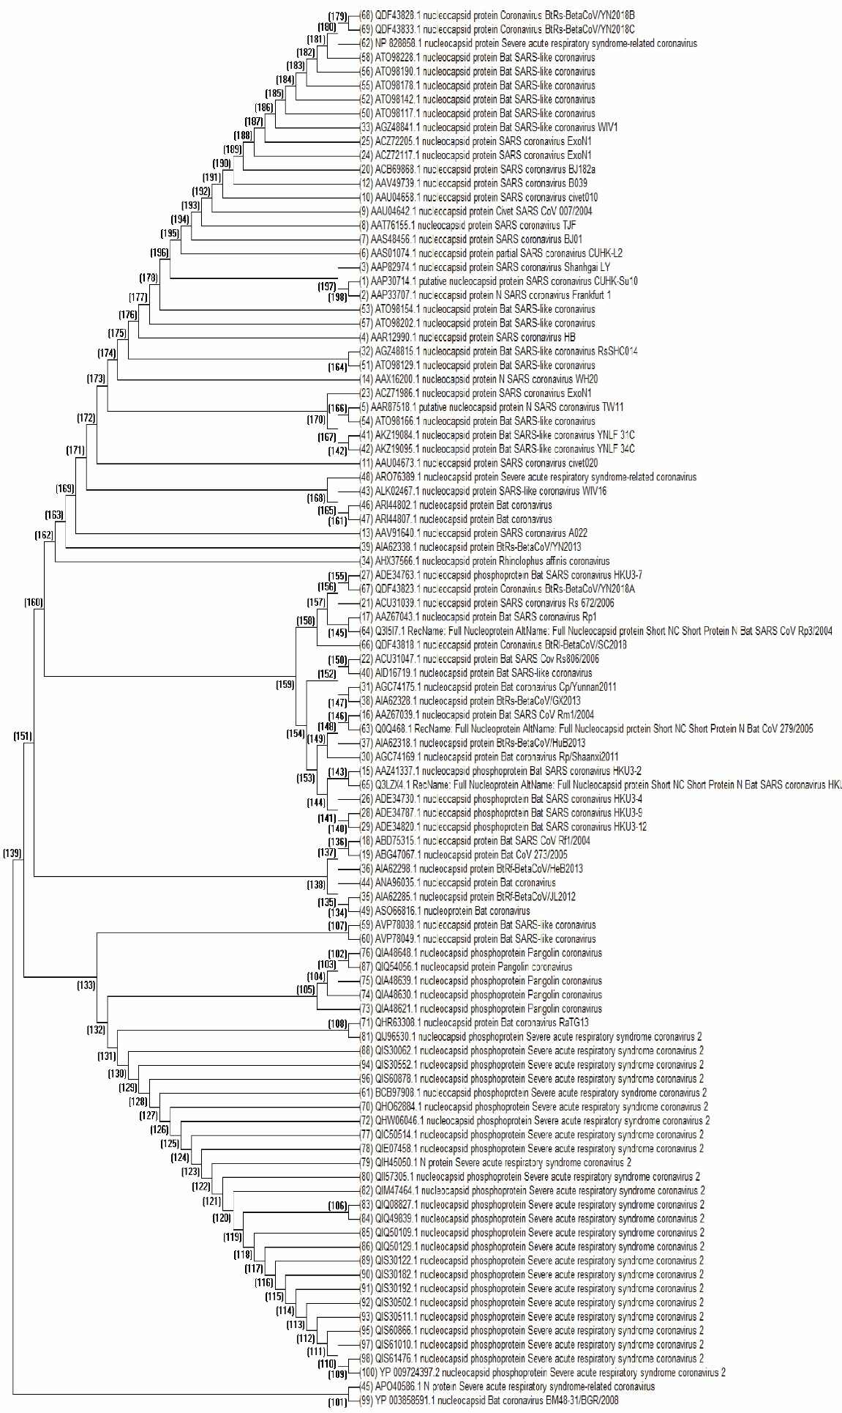
Suppl. Fig. S1
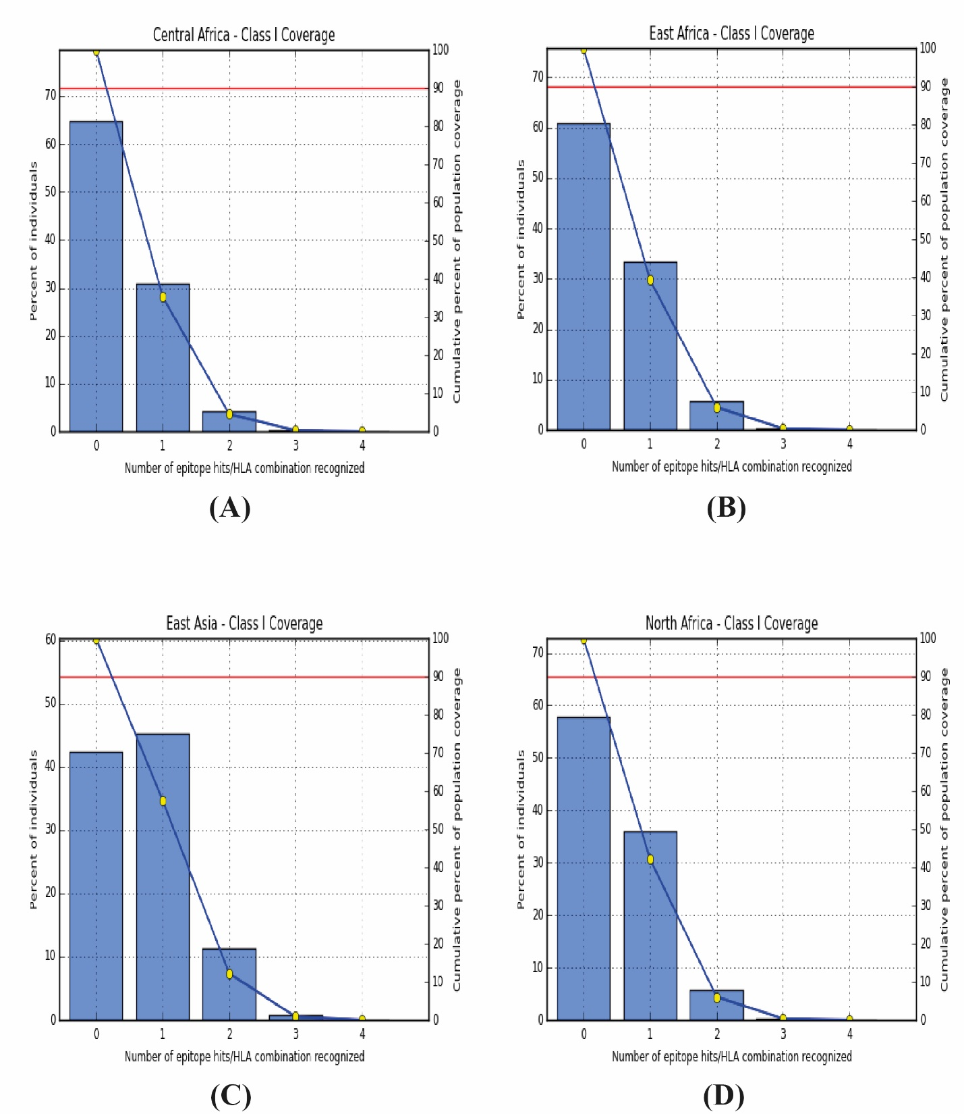
Suppl. Fig. S2

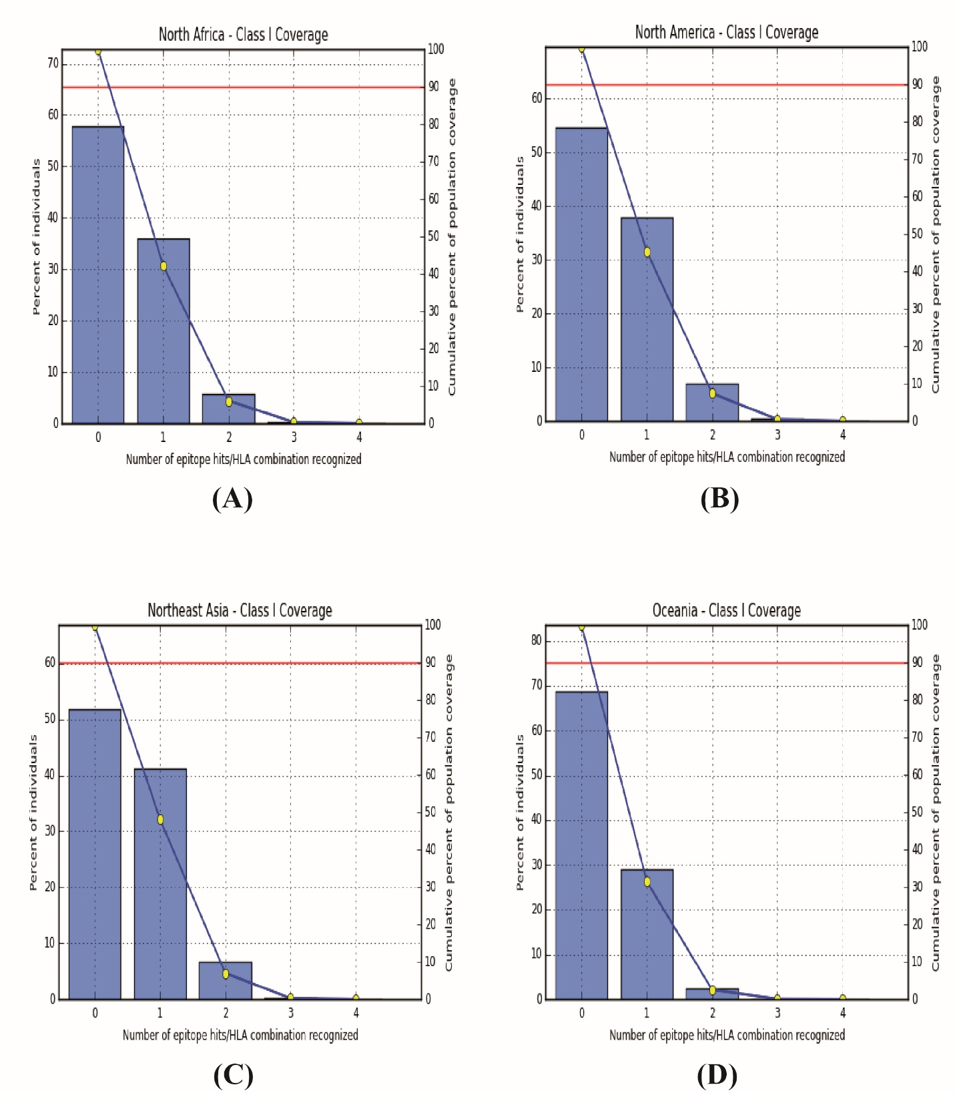
Suppl. Fig. S3

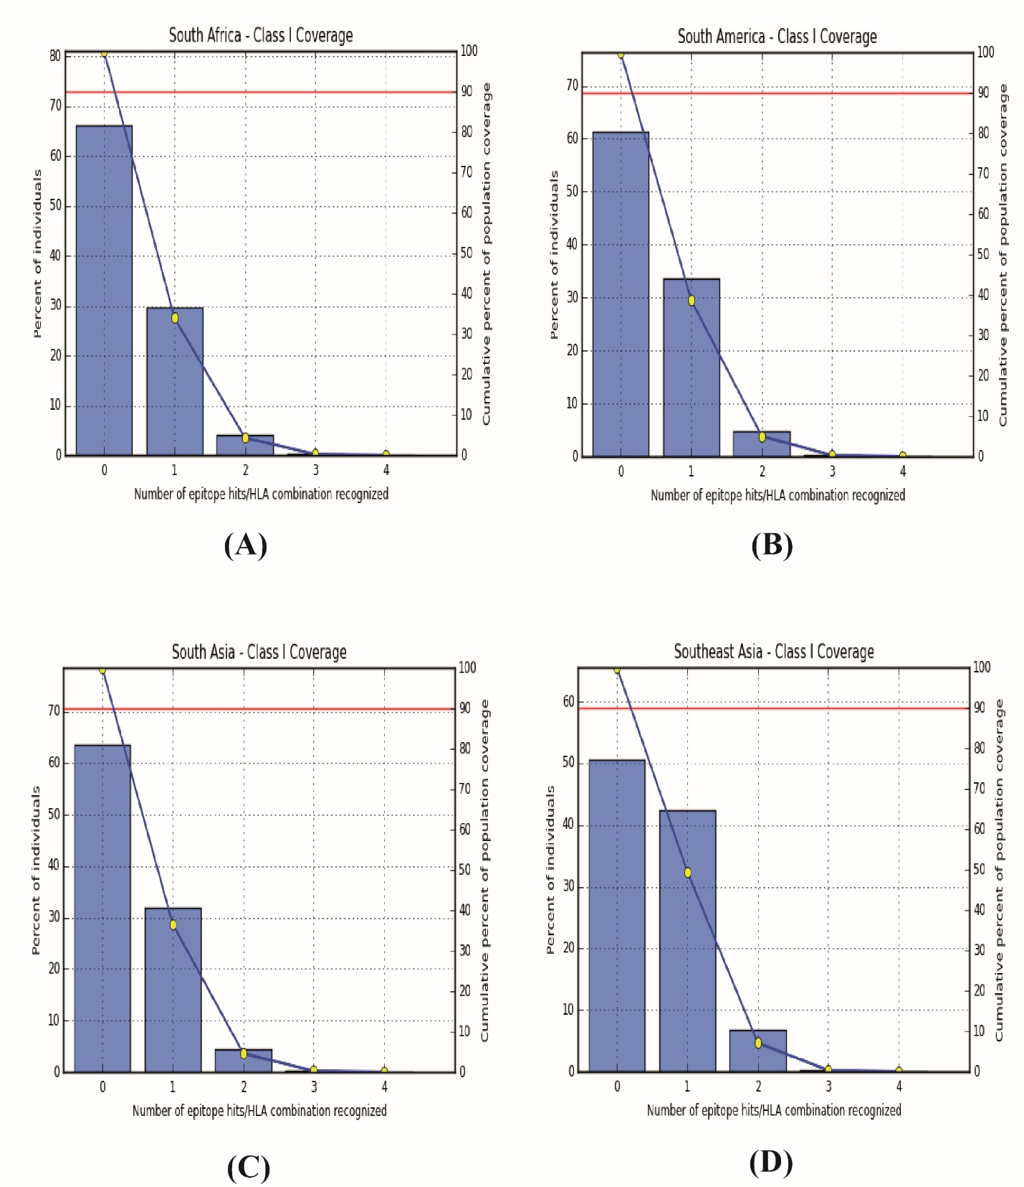
Suppl. Fig. S4

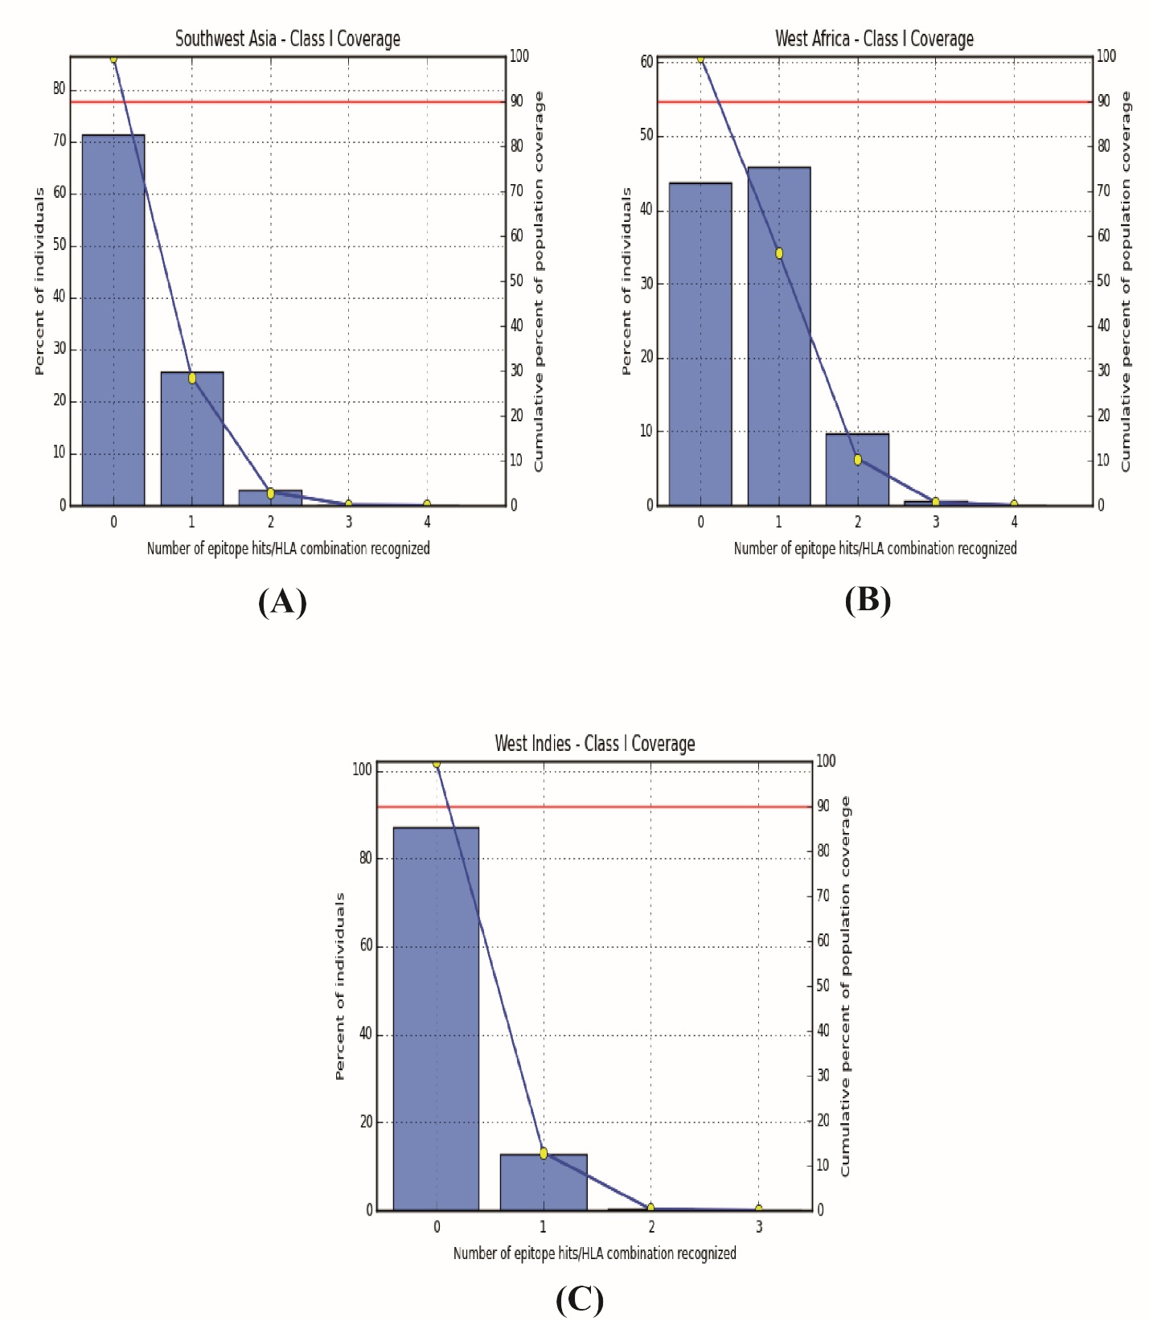
Suppl. Fig. S5

