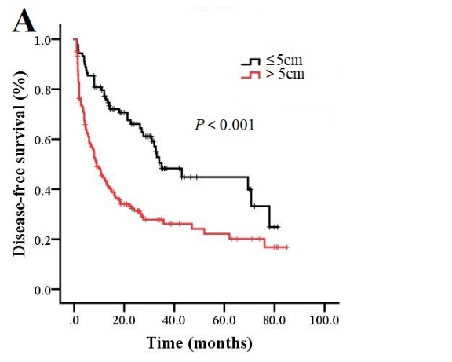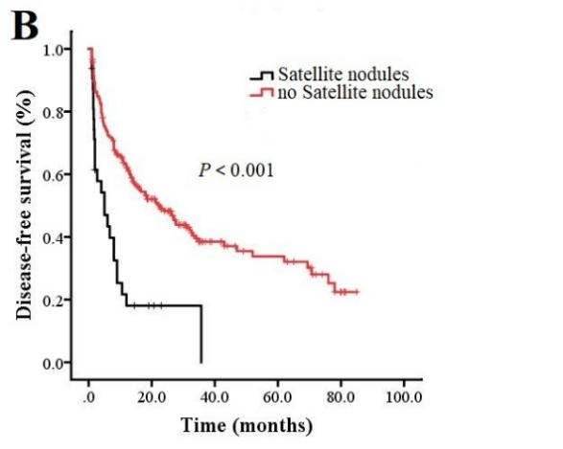
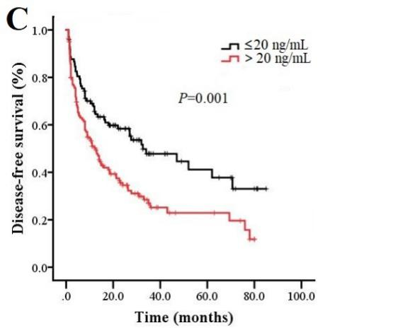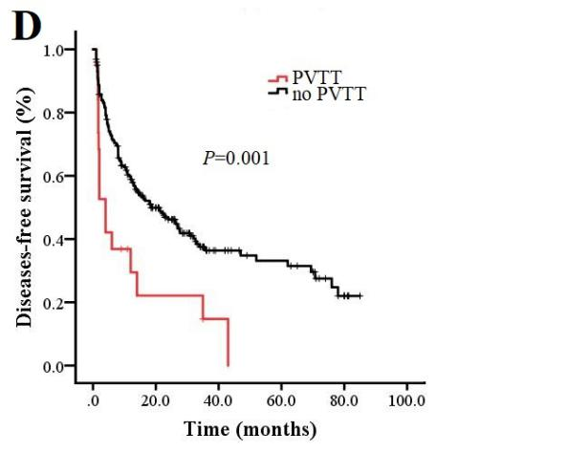
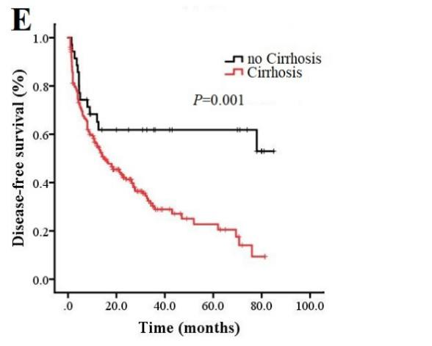
Supplementary Fig. 1 (A) Disease-free survival of HCC patients with clear cell carcinoma who had the indicated tumor diameters. (B) Disease-free survival of HCC patients with clear cell carcinoma who had satellite nodules or not. (C) Disease-free survival of HCC patients with clear cell carcinoma whose alpha-fetoprotein levels were ≤20 or >20 ng/mL. (D) Disease-free survival of HCC patients with clear cell carcinoma who had PVTT or not. (E) Disease-free survival of HCC patients with clear cell carcinoma who had cirrhosis or not.
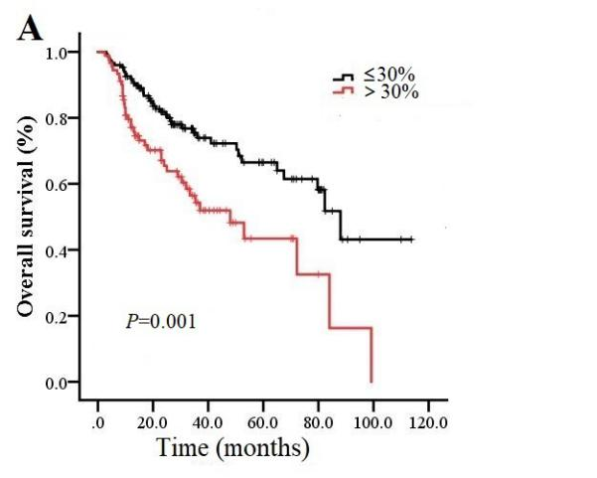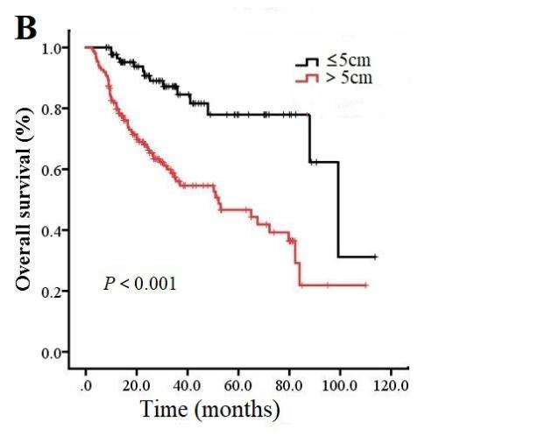
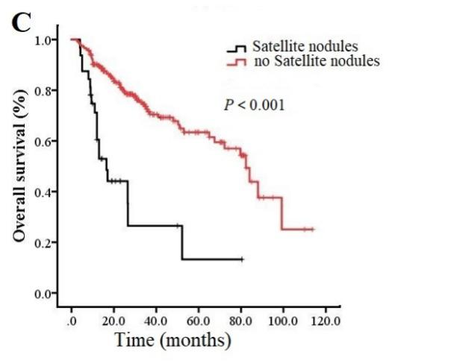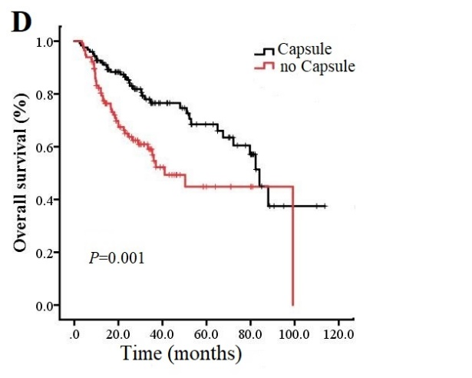
Supplementary Fig. 2 (A) Comparison of the overall survival curves between Ki-67≤30% and Ki-67＞30%. (B) Comparison of the overall survival curves between tumor diameter ≤5 or >5 cm. (C) Comparison of the overall survival curves for patents with or without satellite nodules. (D) Comparison of the overall survival curves for patients with or without a tumor capsule.

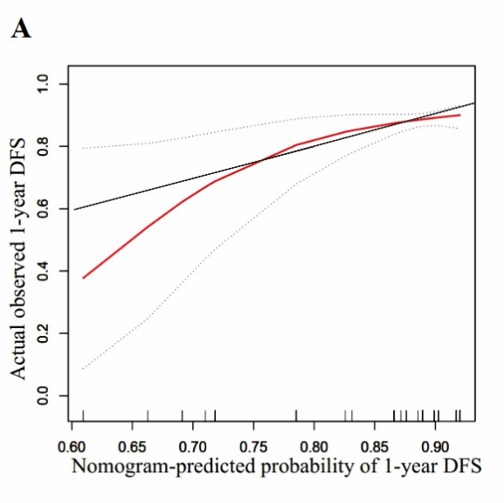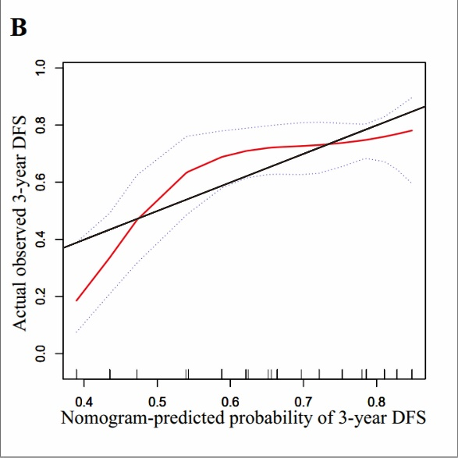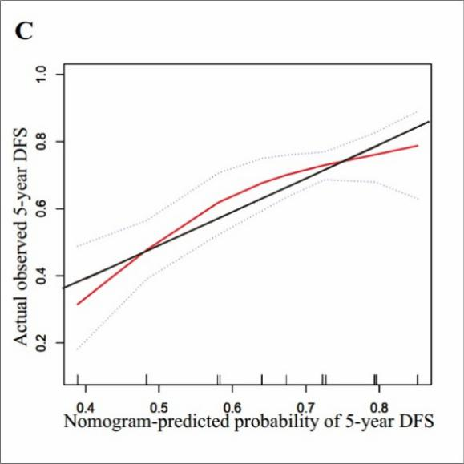
Supplementary Fig. 3 (A) Validation of the nomogram’s prediction of 1-year disease-free survival (DFS) of HCC patients with clear cell carcinoma. (B) The calibration curve for predicting 3-year DFS of HCC patients with clear cell carcinoma. (C) The calibration curve for predicting 5-year DFS of HCC patients with clear cell carcinoma.

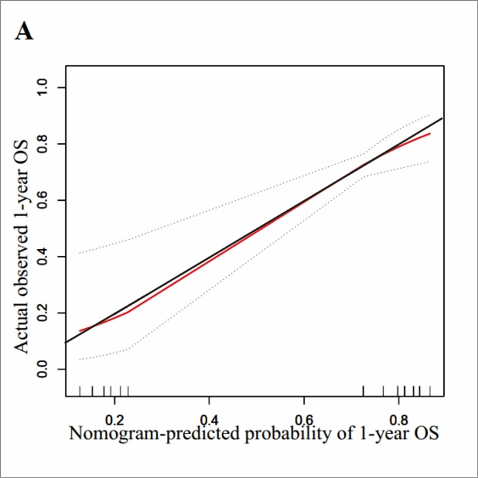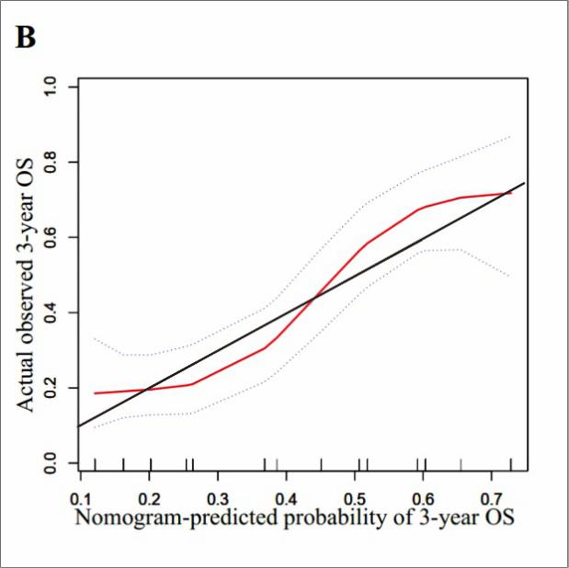
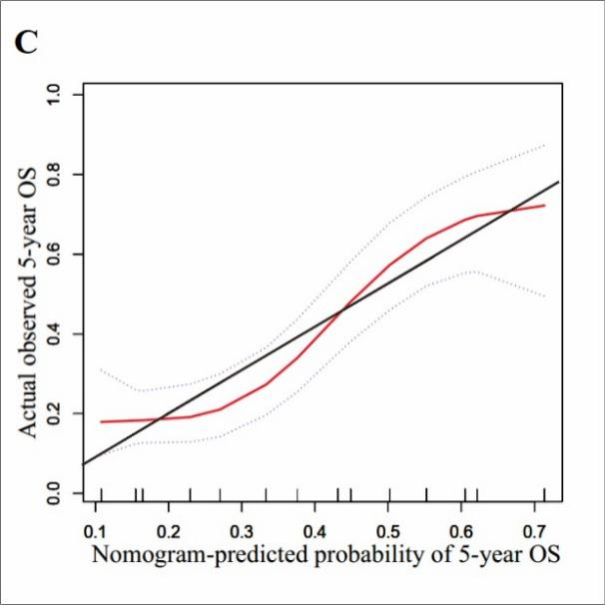
Supplementary Fig. 4 (A) Validation of the nomogram’s prediction of 1-year overall survival (OS) of HCC patients with clear cell carcinoma. (B) The calibration curve for predicting 3-year OS of HCC patients with clear cell carcinoma. (C) The calibration curve for predicting 5-year OS of HCC patients with clear cell carcinoma.

Supplementary Table 1 Clinicopathologic characteristics of hepatocellular carcinoma patients in our study
Characteristic | with clear cell carcinoma（n=239） | without clear cell carcinoma (n=231) | P-value
Age (years) | 52.4±11.4 | 49.1±11.2 | 0.001
Sex  Male  Female | 207 (87)  32 (13) | 180 (78)  51 (22) | 0.014
AFP (ng/mL)  ≤20  ＞20 | 98 (41)  141 (59) | 54 (23)  177 (77) | ＜0.001
Cirrhosis  Presence  Absence | 35 (15)  204 (85) | 47 (20)  184 (80) | 0.103
HBsAg  Positive  Negative | 198 (83)  41 (17) | 206 (89)  25 (11) | 0.048
Child-Pugh class  A  B | 226 (95)  13 (5) | 225 (97)  6 (3) | 0.118
Tumor number  Single  Multiple | 191 (80)  48 (20) | 168 (73)  63 (27) | 0.067
Tumor size (cm)  ≤5  ＞5 | 89 (37)  150 (63) | 47 (20)  184 (80) | ＜0.001
Satellite nodules  Presence  Absence | 32 (13)  207 (87) | 53 (23)  178 (77) | 0.007
MVI  Presence  Absence | 80(33)  159(67) | 121(52)  110(48) | ＜0.001
Capsule formation  Presence  Absence | 124 (52)  115 (48) | 117 (51)  114 (49) | 0.789
PVTT  Present  Absent | 23 (10)  216 (90) | 44 (19)  187 (81) | 0.003
Transfusion  Yes  No | 54 (23)  185 (77) | 78 (34)  153 (66) | 0.007
BCLC  A  B  C | 17 1 (71)  42 (18)  26 (11) | 144 (62)  44 (19)  43 (19) | 0.040
Edmondson grade  Ⅰ-Ⅱ  Ⅲ-Ⅳ | 129 (54)  110 (46) | 114 (49)  117 (51) | 0.316
Ki-67（%）  ≤30  ＞30 | 149 (62)  90 (38) | 116 (50)  115 (50) | 0.008
Values are n (%) unless otherwise noted.
Abbreviations: AFP, alpha-fetoprotein level; BCLC, Barcelona Clinic Liver Cancer; HBsAg, serum hepatitis B surface antigen; MVI, microvascular invasion; PVTT, portal vein tumor thrombosis.

