Supplementary Information
Modulating Inherent Lewis Acidity at the Intergrowth Interface of Mortise-Tenon Zeolite Catalyst
Huiqiu Wang^{1,2}, Boyuan Shen^{1,2}, Xiao Chen¹*, Hao Xiong¹, Hongmei Wang¹, Wenlong Song¹, Chaojie Cui¹, Fei Wei¹*, Weizhong Qian¹*
Affiliations:
¹Beijing Key Laboratory of Green Chemical Reaction Engineering and Technology, Department of Chemical Engineering, Tsinghua University, Beijing 100084, China.
²These authors contributed equally to this work.

*Corresponding author:
Email: chenx123@tsinghua.edu.cn (X.C.); wf-dce@tsinghua.edu.cn (F.W.); qianwz@tsinghua.edu.cn (W.Q.)

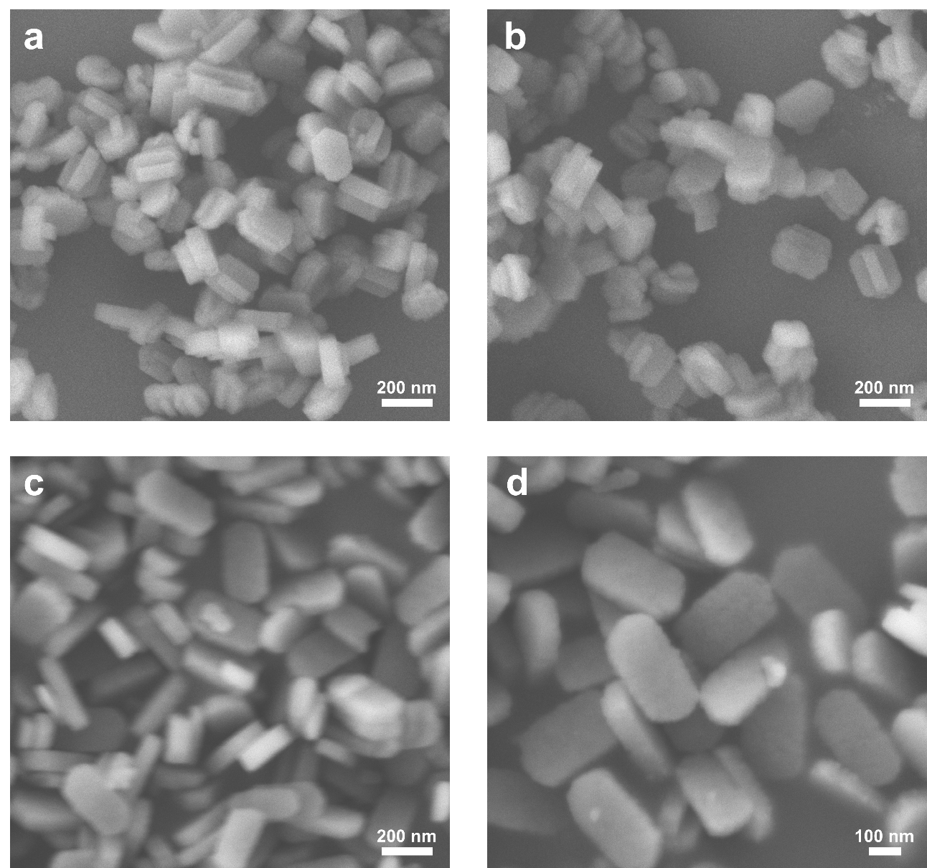
Supplementary Figure 1. The SEM images of ZSM-5-MT (a, b) and ZSM-5-Sb (c, d) samples. The ZSM-5-MT nanocrystals exhibit a mortise-tenon morphology, while the ZSM-5-Sb nanocrystals show a coffin shape with clean (010) surface.

Supplementary Figure 2. XRD patterns for ZSM-5-MT and ZSM-5-Sb samples. Both ZSM-5-MT and ZSM-5-Sb show a pure MFI zeolite phase with excellent crystallinity.

Supplementary Table 1. Chemical, textural properties of the ZSM-5-MT and ZSM-5-Sb samples.
Sample name | Si/Al atomic ratioª | BET surface area (m²/g) | Micropore surface area^{b} (cm³/g) | Total pore volume (cm³/g) | Micropore volume (cm³/g) | Mesopore volume^{c} (cm³/g)
ZSM-5-MT | 61 | 416.7 | 374.8 | 0.243 | 0.136 | 0.107
ZSM-5-Sb | 71 | 446.2 | 409.1 | 0.268 | 0.147 | 0.121
ªMeasured by ICP-OES.
^{b}t-plot method.
^{c}V_{meso}=V_{tot}-V_{micro}

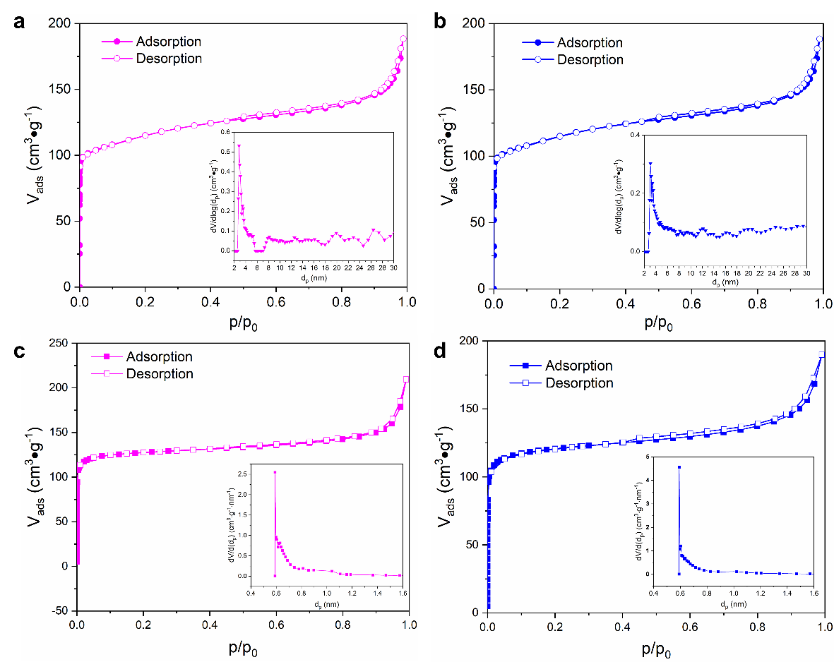
Supplementary Figure 3. Gas adsorption-desorption isotherms. N₂ adsorption-desorption isotherm for the ZSM-5-Sb (a) and ZSM-5-MT (b) samples. The insets are corresponding mesopore size distributions. Ar adsorption-desorption isotherms for the ZSM-5-Sb (c) and ZSM-5-MT (d) samples. The insets are corresponding micropore size distributions.

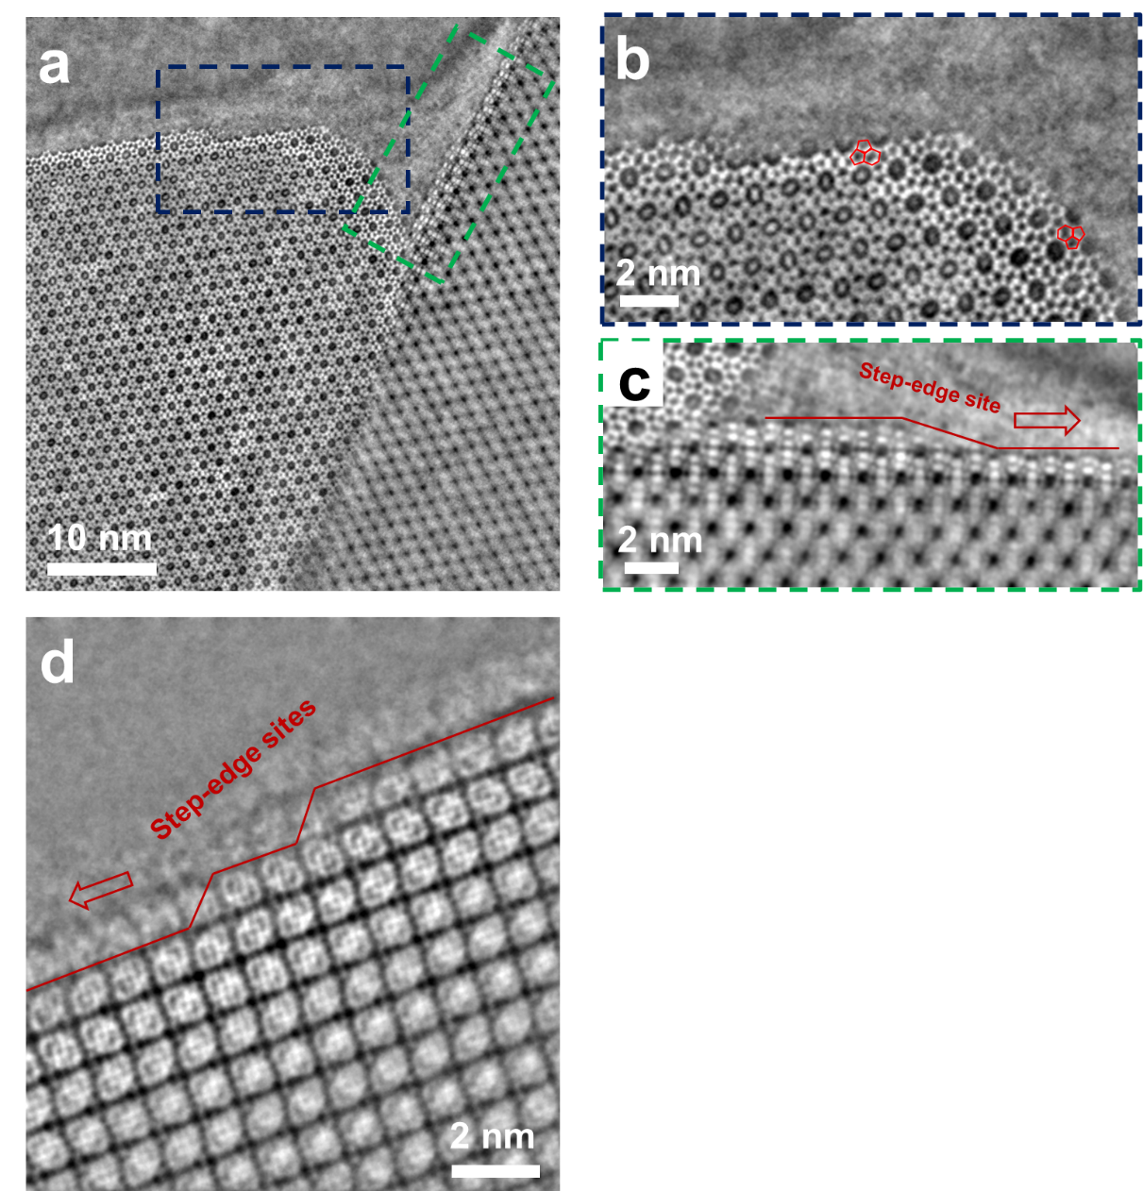
Supplementary Figure 4. Imaging the surface terminations by iDPC-STEM. a The surface terminations of mortise ZSM-5 crystal from the lateral direction. b, c The magnified iDPC-STEM images in the areas marked in a. d The surface terminations of mortise ZSM-5 crystal from the [001] direction.

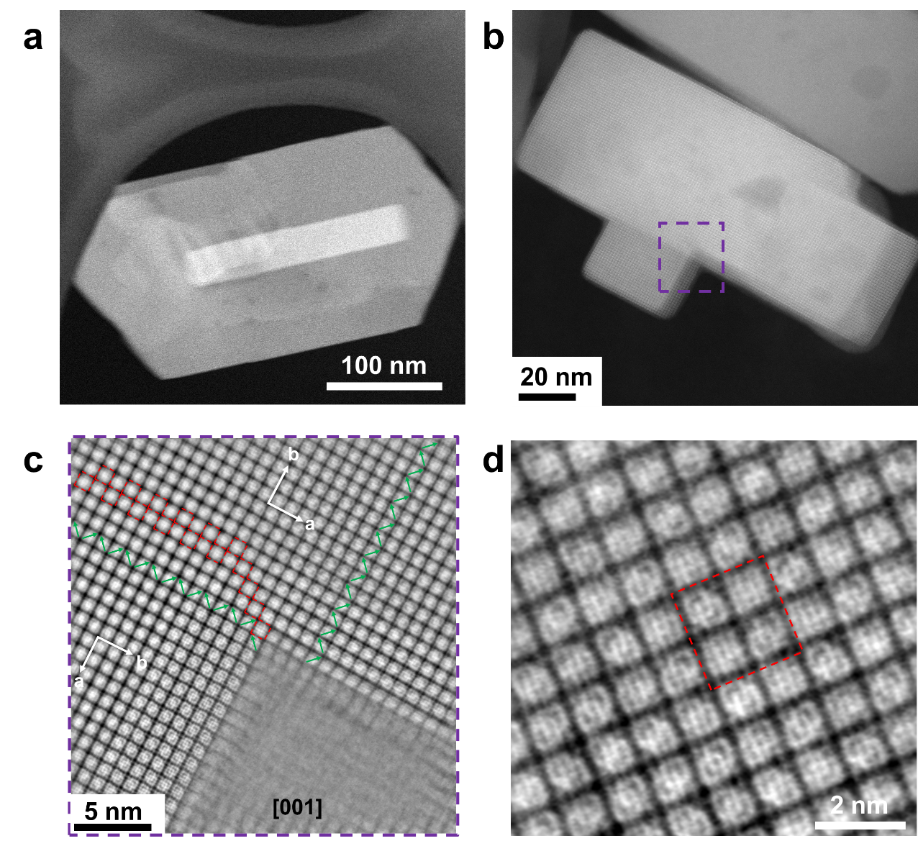

Supplementary Figure 5. The ADF-STEM images of ZSM-5-MT nanocrystals (a, b). c The magnified iDPC-STEM image of the area marked as purple frame in b. d The iDPC-STEM image of the intergrown area from the [001] direction. The magnified iDPC-STEM image Fig. 2 was obtained from the dash red frame in Supplementary Figure 5d.

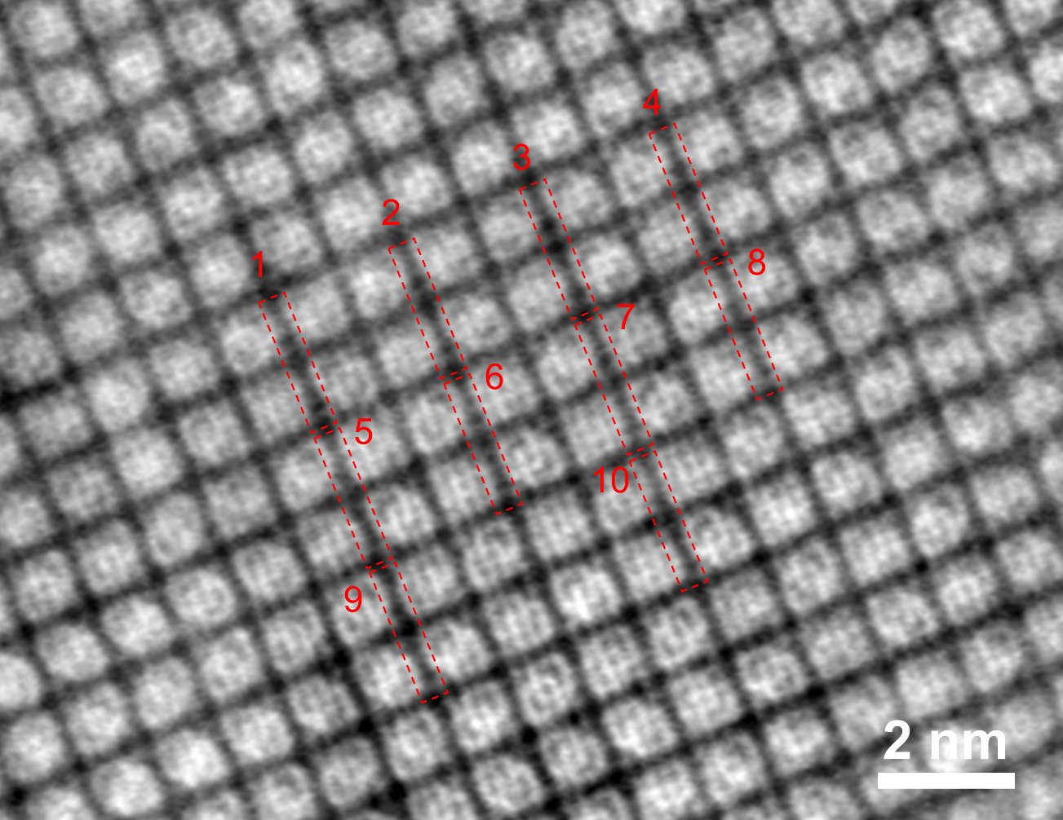
Supplementary Figure 6. The iDPC-STEM imaging of an intergrown area in ZSM-5-MT crystal from the [001] projection. To analysis the contrast of bridged O atom columns, we selected ten different sections in intergrowth areas.

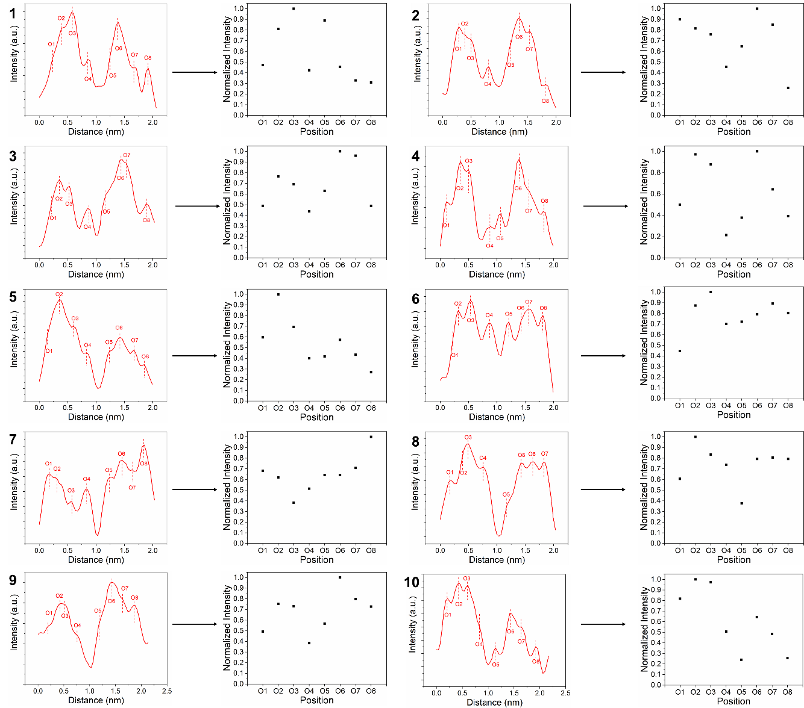
Supplementary Figure 7. The corresponding profile analysis as marked in Supplementary Figure 6.

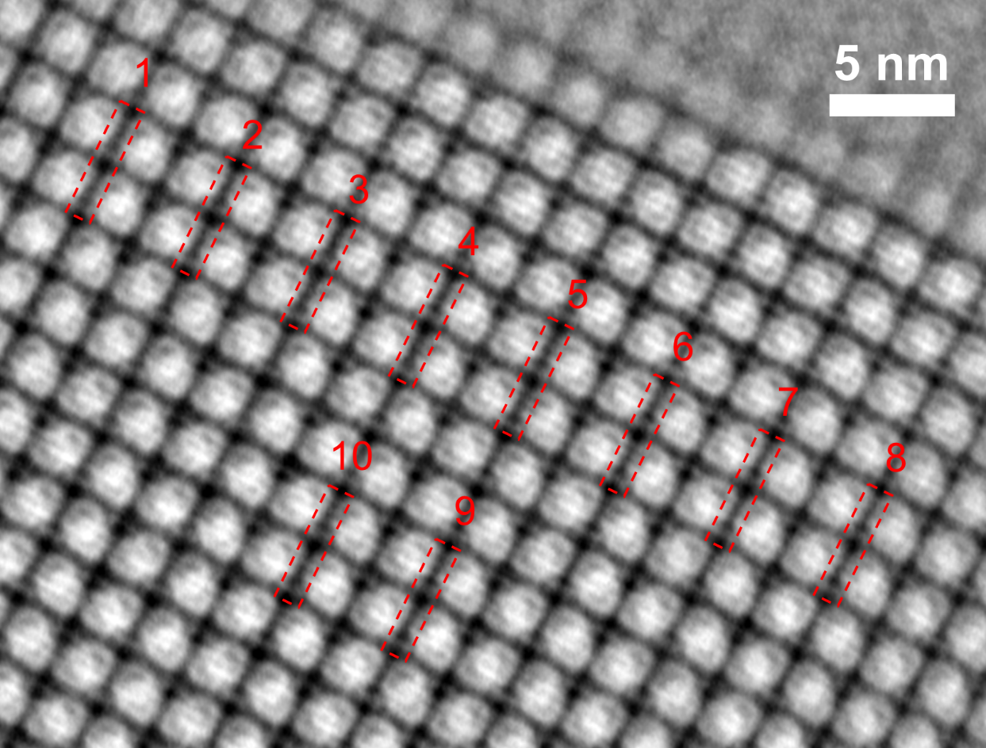
Supplementary Figure 8. The iDPC-STEM imaging of an area without intergrown structure in ZSM-5-MT crystal from the [001] projection.

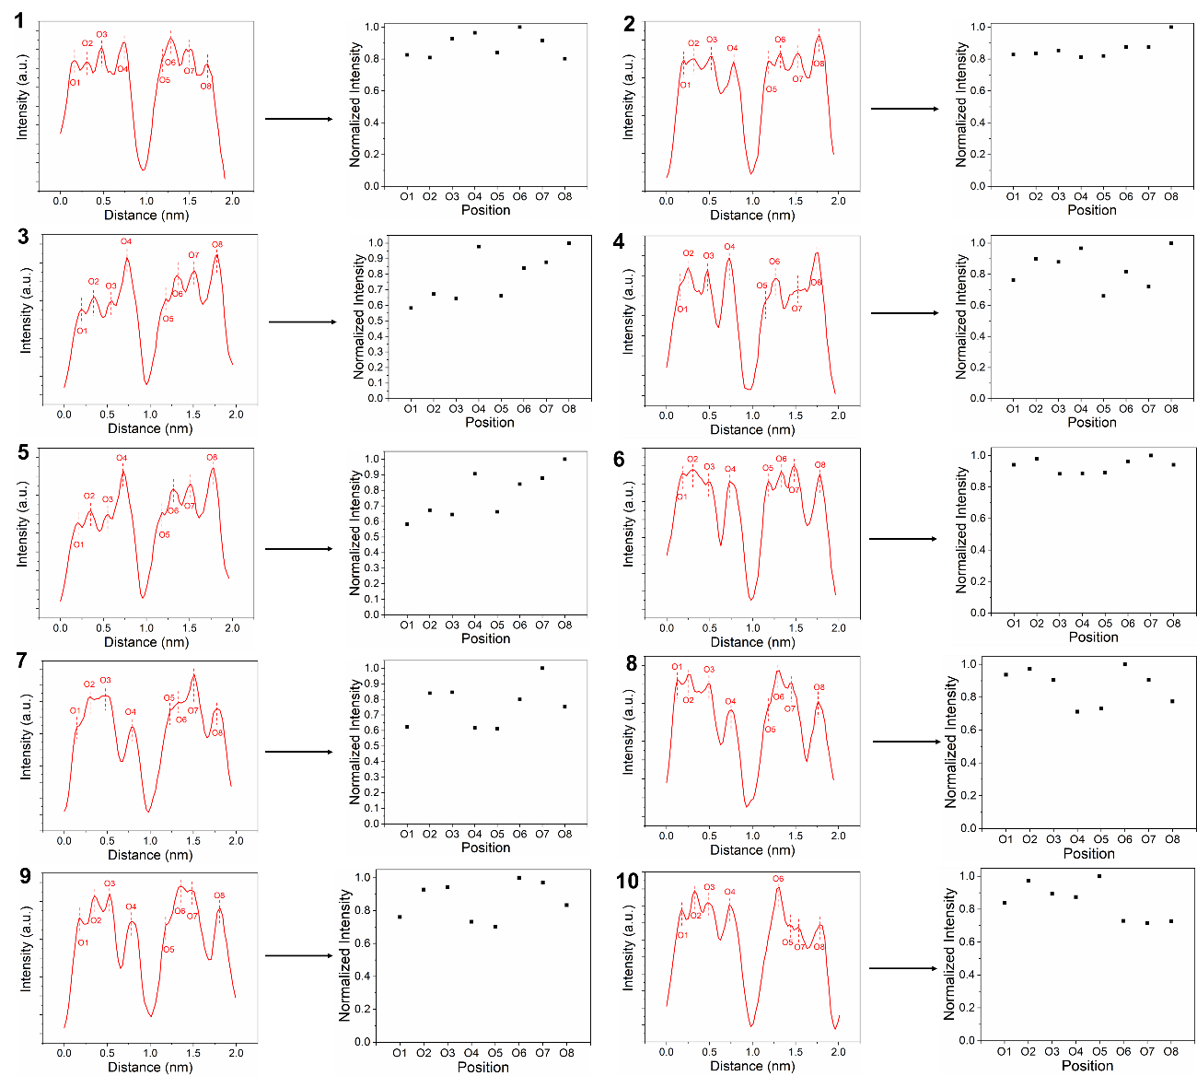
Supplementary Figure 9. The corresponding profile analysis as marked in Supplementary Figure 8.

Supplementary Figure 10. NH₃ temperature-programmed desorption (TPD) profiles for ZSM-5-Sb and ZSM-5-MT samples.

Supplementary Table 2. The acid site concentrations of ZSM-5-MT and ZSM-5-Sb determined from FT-IR spectra of adsorbed pyridine.
Sample | Acid site concentration (μmol/g)
 | LAS | BAS
ZSM-5-MT | 160.93 | 148.52
ZSM-5-Sb | 14.76 | 143.26

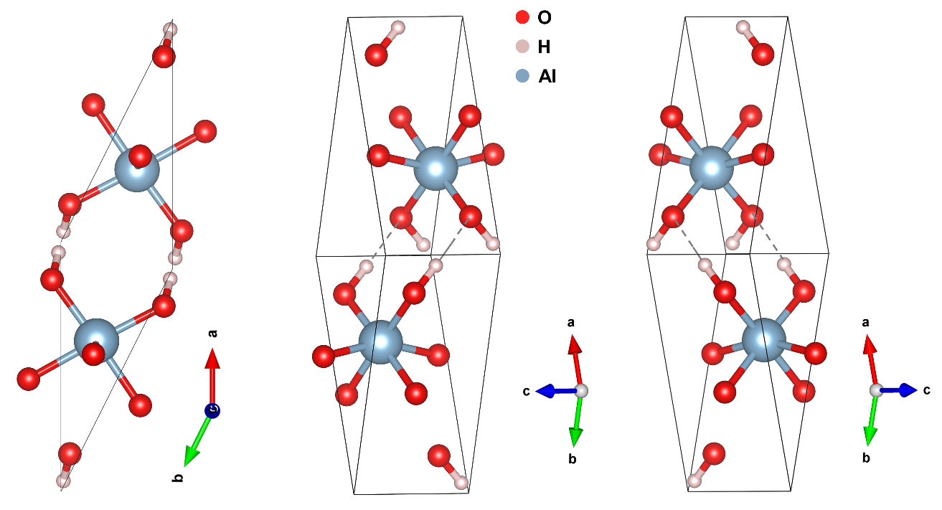
Supplementary Figure 11. The structure model of the boehmite (γ-AlOOH) from three different lattice directions.

Supplementary Figure 12. Selectivities of hydrocarbon products in MTH over ZSM-5-MT and ZSM-5-Sb catalysts at different times on stream (TOS). Test conditions: complete methanol conversion (≥ 99%), 475 ℃, weight hourly space velocity (WHSV) of 5 h⁻¹).

Supplementary Figure 13. Hydrogen transfer index of C4 (C4-HTI, black) and C5 (C5-HTI, red) species as a function of time on steam for MTH over ZSM-5-MT (solid) and ZSM-5-Sb (hollow) (reaction conditions: 475 ℃, atmospheric pressure and WHSV = 5 h^{–1}).

