Additional Figure 1 Distribution of current Hb levels
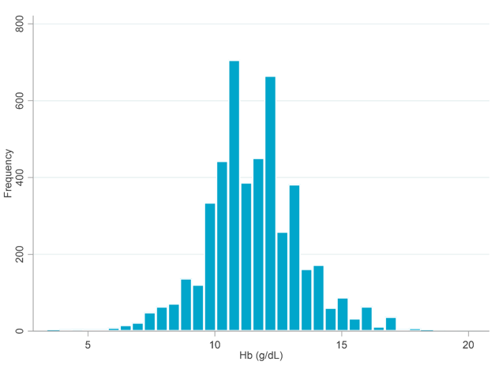
Hb, hemoglobin

