Tumour suppressor gene methylation and renal cell carcinoma risk: a comprehensively systematic review and meta-analysis
Yupeng Liu, Lin Ma, Yuxue Zhang, ZhiGang Wu, Xiaodong Liu

Supplementary Information

Correspondence to:
Professor XiaoDong Liu, M.D.
Department of Preventive Medicine
School of Public Health and Management
Wenzhou Medical University
112 Nanliu Road, ChaShan High Education Zone
Wenzhou 325035, Zhejiang Province, China
Tel/Fax: +86 (0)577-8669 9182
E-mail: liuxd2014@126.com

Table of Contents |  | Pages
Supplementary Methods
1 | Retrieval strategy in details. | 2-3
Supplementary Tables
2 | Table S1. | 4
3 | Table S2. | 5
Supplementary Figures
4 | Figure S1. | 6
5 | Figure S2. | 7-8
6 | Figure S3. | 9
7 | Figure S4. | 10-14
8 | Figure S5. | 15

SUPPLEMENTARY METHODS

Search strategy in details
PubMed database:
#1. (((((((((((((((((kidney neoplasms[MeSH Terms]) OR kidney neoplasm[Title/Abstract]) OR kidney cancer[Title/Abstract]) OR renal cancer[Title/Abstract]) OR nephric cancer[Title/Abstract]) OR cancer of kidney[Title/Abstract]) OR kidney tumour[Title/Abstract]) OR renal tumour[Title/Abstract]) OR nephric tumour[Title/Abstract]) OR tumour of kidney[Title/Abstract]) OR kidney carcinoma[Title/Abstract]) OR renal carcinoma[Title/Abstract]) OR nephric carcinoma[Title/Abstract]) OR carcinoma of kidney[Title/Abstract]) OR renal neoplasm[Title/Abstract]) OR nephric neoplasm[Title/Abstract]))
#2. (((DNA methylation[MeSH Terms]) OR DNA methylation[Title/Abstract]) OR DNA methylations[Title/Abstract])
#3. #1 AND #2
EMBASE database:
#1. 'kidney neoplasm':ti,ab,kw OR 'kidney cancer':ti,ab,kw OR 'kidney tumor':ti,ab,kw OR 'kidney tumour':ti,ab,kw OR 'kidney carcinoma':ti,ab,kw OR 'renal neoplasm':ti,ab,kw OR 'renal cancer':ti,ab,kw OR 'renal tumor':ti,ab,kw OR 'renal tumour':ti,ab,kw OR 'renal carcinoma':ti,ab,kw OR 'renal cell cancer':ti,ab,kw OR 'renal cell tumor':ti,ab,kw OR 'renal cell carcinoma':ti,ab,kw
#2. 'dna methylation':ti,ab,kw OR 'dna methylations':ti,ab,kw
#3. #1 AND #2
CNKI database:
#1. kidney neoplasm[Subject] OR kidney cancer[Subject] OR kidney tumor[Subject] OR kidney tumour[Subject] OR kidney carcinoma[Subject] OR renal neoplasm[Subject] OR renal cancer[Subject] OR renal tumor[Subject] OR renal tumour[Subject] OR renal carcinoma[Subject] OR renal cell cancer[Subject] OR renal cell tumor[Subject] OR renal cell carcinoma[Subject]
#2. DNA methylation[Subject] OR DNA methylations[Subject]
#3. #1 AND #2
SUPPLEMENTARY TABLE

Table S1. Detailed quality scores of individual studies assessed with the Newcastle-Ottawa Quality Assessment Scale (NOS).
Studies | Selection |  |  |  | Comparability |  | Exposure |  |  | Total Score
 | Is the case definition adequate? | Representativeness of the cases | Selection of controls | Definition of controls | Study controls for the most important factor | Study controls for any additional factor | Ascertainment of exposure | Same method of ascertainment for cases and controls | Non-Response rate
Jung-Hoon Yoon,2001 | * | * |  |  |  | * | * | * | * | 6
Koen Dreijerink,2001 |  |  | * | * |  |  | * | * | * | 5
Catherine Morrisey,2001 | * | * |  |  | * | * | * | * | * | 7
Paul Cairrns,2003 |  |  | * |  |  |  | * | * | * | 4
Mark L. Gonzalgo,2004 | * | * | * |  | * | * | * | * | * | 8
Loginov VI,2004 | * | * | * |  |  | * | * | * | * | 7
KenJi Tokinaga,2004 | * | * | * |  |  | * | * | * | * | 7
Essel Dulaimi,2004 | * | * | * |  | * | * | * | * | * | 8
Duan jianmin,2007 | * | * | * | * |  |  | * | * | * | 7
Inga Peters,2007 | * | * | * |  |  |  | * | * | * | 6
Vera L Costa,2007 | * | * | * |  |  | * | * | * | * | 7
Michelle L. Gumz, 2007 | * | * | * |  |  |  | * | * | * | 6
Yasuo Awakura, 2008 | * | * | * |  | * | * | * | * | * | 8
Zhang Jian-Ying,2008 | * | * | * |  |  |  | * | * | * | 6
Huseyin Onay,2008 | * | * | * | * |  | * | * | * | * | 8
Jorg Ellinger,2010 | * | * | * |  | * | * | * | * | * | 8
Liu bin,2010 | * | * | * |  | * | * | * | * | * | 8
Yin fengchao, 2010 | * | * | * | * | * | * | * | * | * | 9
Zheng fufu,2011 | * | * | * | * |  |  | * | * | * | 7
Faranaz Atschekzei, 2012 | * | * | * | * | * |  | * | * | * | 8
Yin fengchao, 2018 | * | * | * | * |  | * | * | * | * | 8

Table S2. Publication bias analysis.
Gene | P-value |  | Pooled ORs (95% CIs)Trim and fill method
 | Begg’s test | Egger’s test | Unadjusted | Adjusted with  the Trim and fill method
RASSF1A (n=14) | 0.743 | 0.691 | 6.612 (1.926-22.697) | 5.156 (1.480-17.966)
SFRP1 (n=5) | 0.221 | 0.006 | 3.995 (1.607-9.934) | 1.478 (0.631-3.462)
TIMP3 (n=5) | 0.806 | 0.037 | 2.895 (0.684-12.240) | 0.802 (0.201-3.196)
APC (n=4) | 0.734 | 0.547 | 2.052 (0.837-5.031) | 1.954 (0.829-4.602)
CDH1 (n=4) | 0.734 | 0.854 | 2.745 (0.303-24.874) | 0.584 (0.047-7.164)
GSTP1 (n=3) | 1.000 | 0.823 | 4.508 (1.004-20.239) | 4.508 (1.004-20.239)
MGMT (n=3) | 1.000 | 0.828 | 0.679 (0.099-4.650) | 0.679 (0.099-4.650)
RARβ2 (n=3) | 1.000 | 0.188 | 1.232 (0.296-5.126) | 0.632 (0.192-2.074)
P16 (n=3) | 1.000 | 0.599 | 1.968 (0.669-5.787) | 1.968 (0.669-5.787)

SUPPLEMENTARY FIGURES

Figure S1 Sensitivity analyses for the association of RASSF1A methylation and RCC risk by omitting each individual study
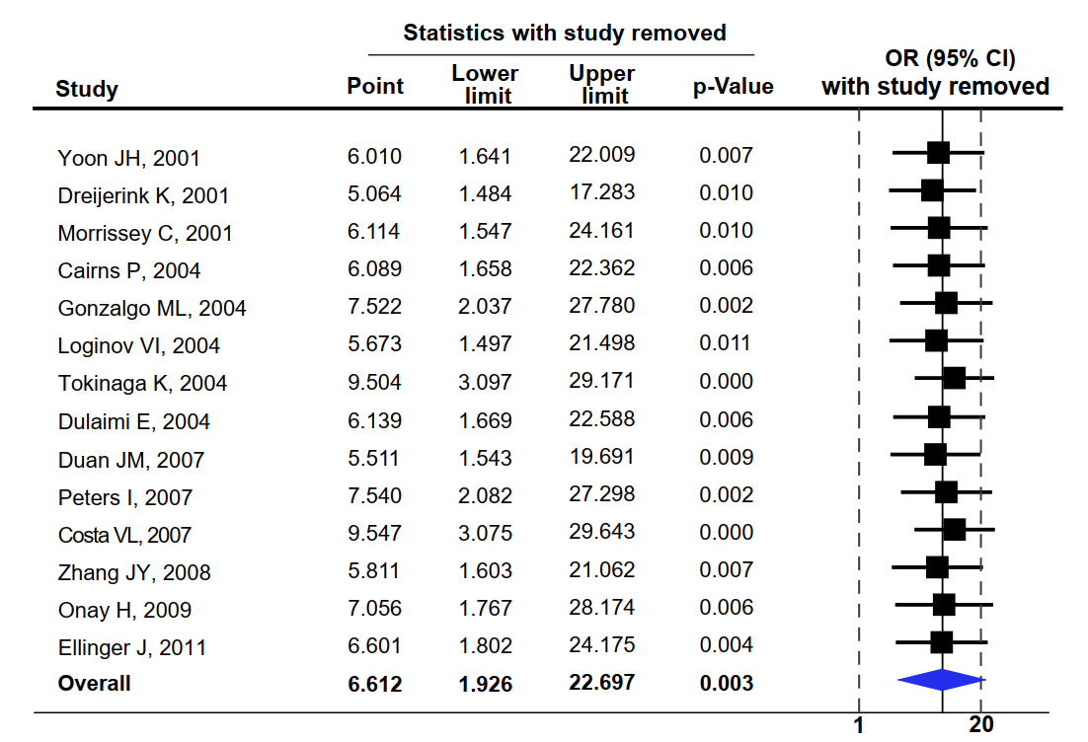

Figure S2 Sensitivity analyses for the association of SFRP1 methylation and RCC risk by omitting each individual study
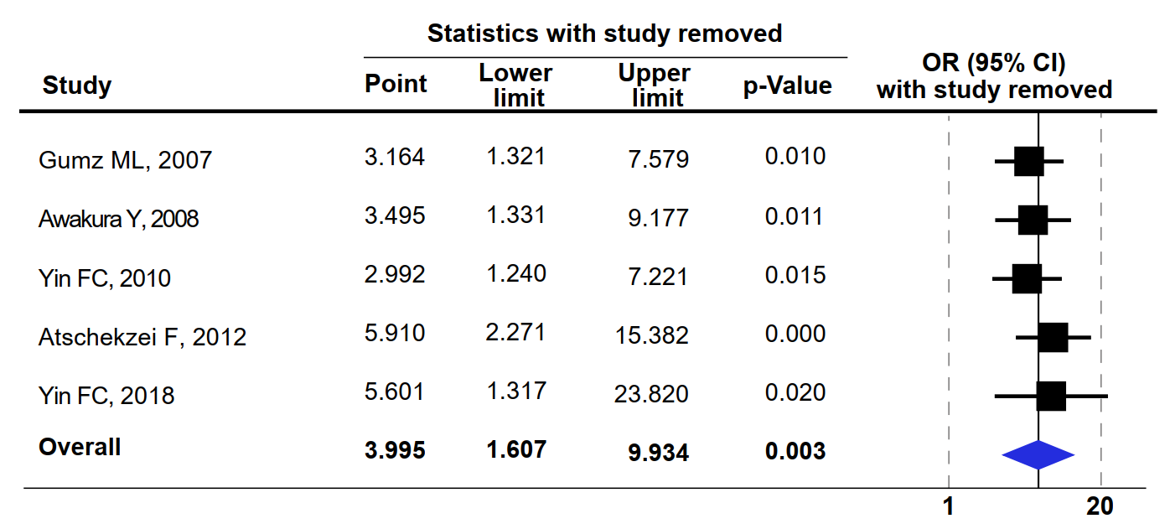

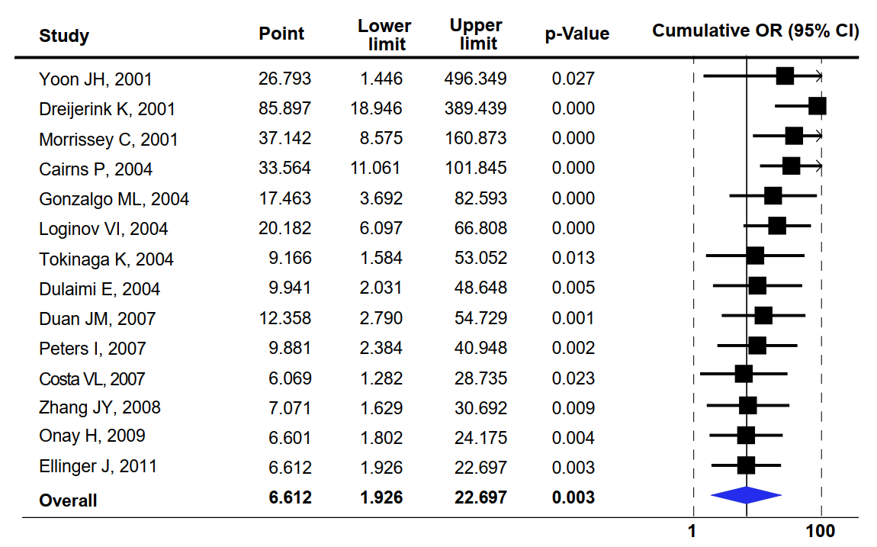
Figure S3 Cumulative meta-analysis by publication year of original studies for the association between RASSF1A methylation and RCC risk.

Figure S4 Cumulative meta-analysis by quality assessment score of original studies for the association between RASSF1A methylation and RCC risk.
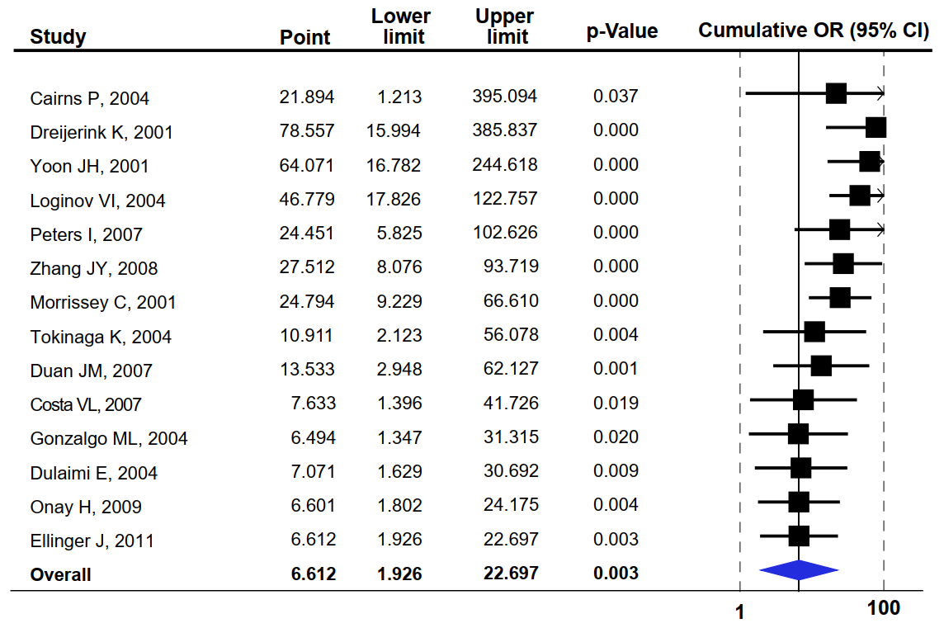

Figure S5 Cumulative meta-analysis by sample size of original studies for the association between RASSF1A methylation and RCC risk.
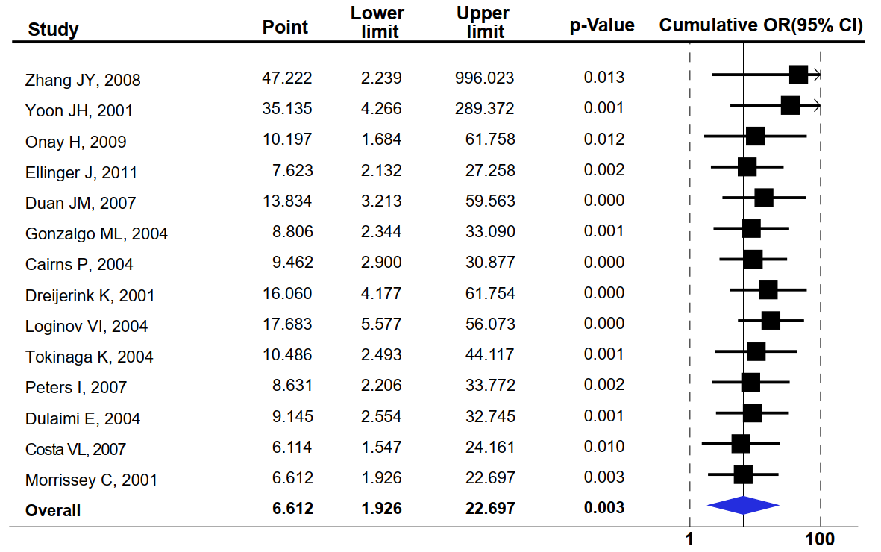

Figure S6 Cumulative meta-analysis by publication year of original studies for the association between SFRP1 methylation and RCC risk
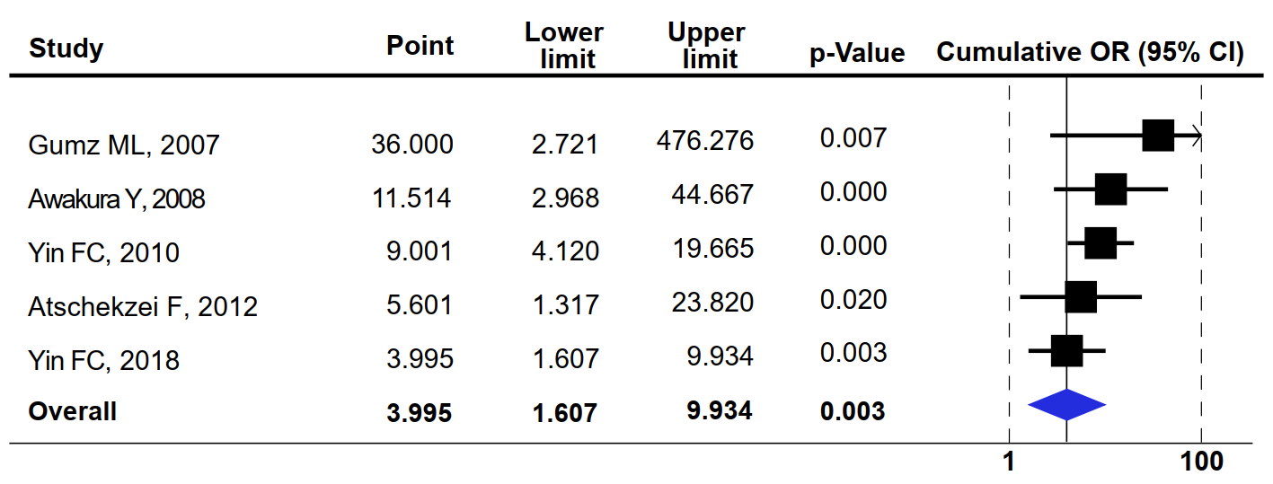

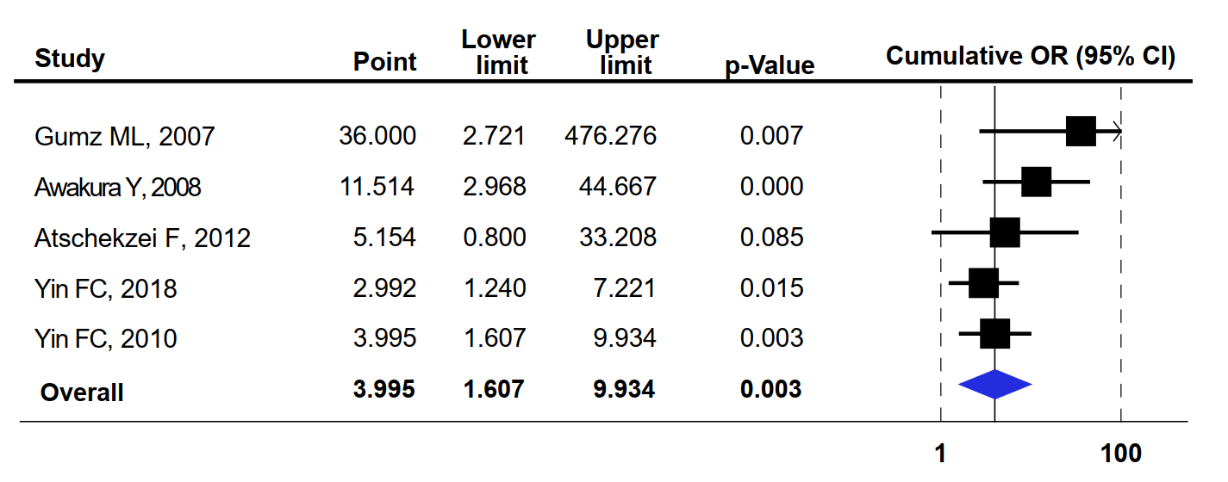
Figure S7 Cumulative meta-analysis by quality assessment score of original studies for the association between SFRP1 methylation and RCC risk

Figure S8 Cumulative meta-analysis by sample size of original studies for the association between SFRP1 methylation and RCC risk
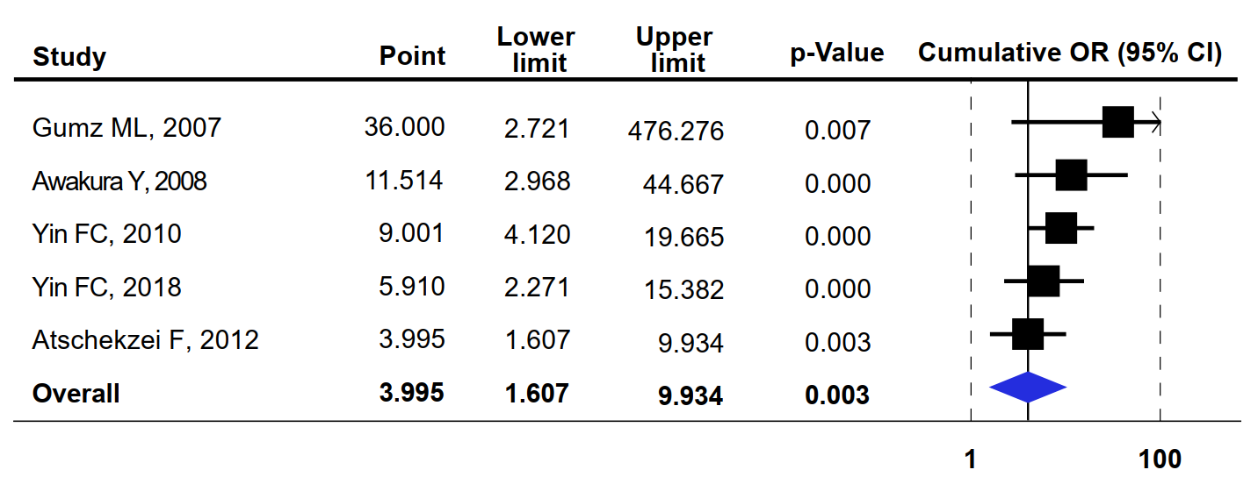

Figure S4. Funnel plots of potential publication bias for meta-analyses of (A) RASSF1A, (B) SFRP1, (C) TIMP3, (D) APC, (E) CDH1, (F) GSTP1, (G) MGMT, (H) RARβ2, (I) p16.
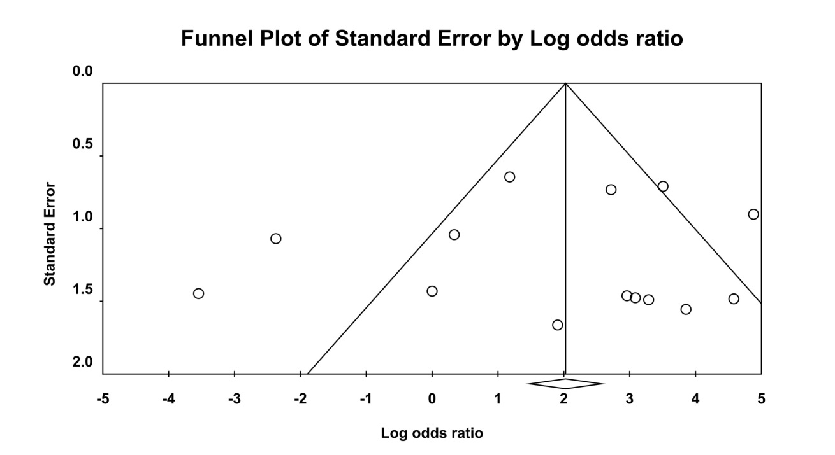
Figure S4A. RASSF1A

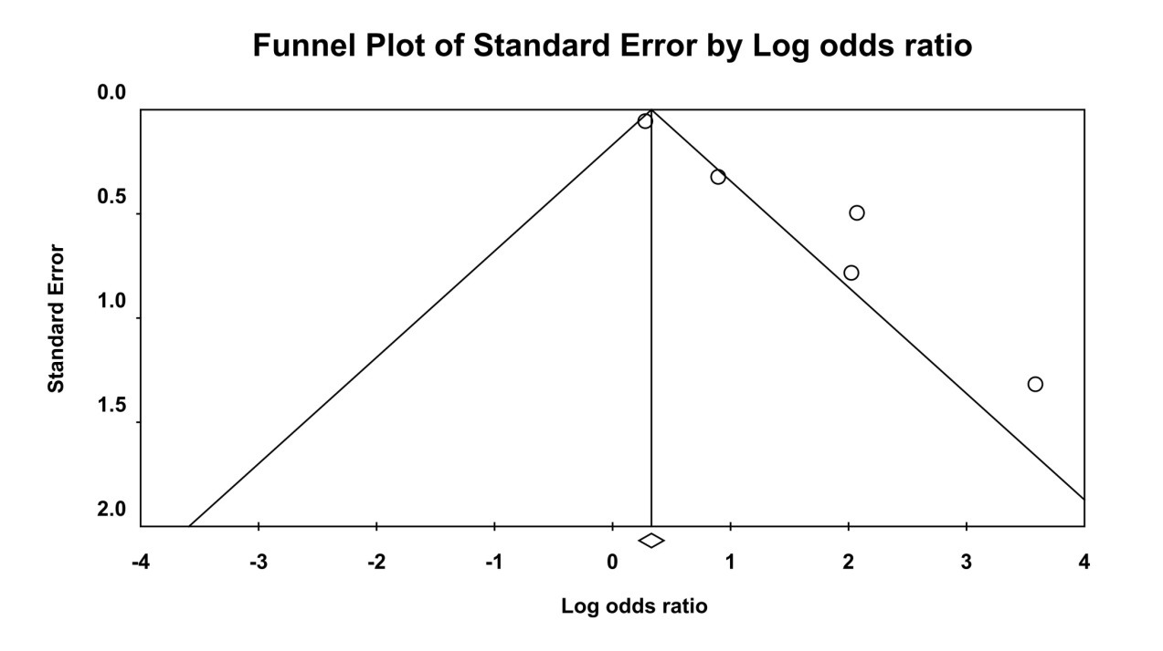
Figure S4B. SFRP1

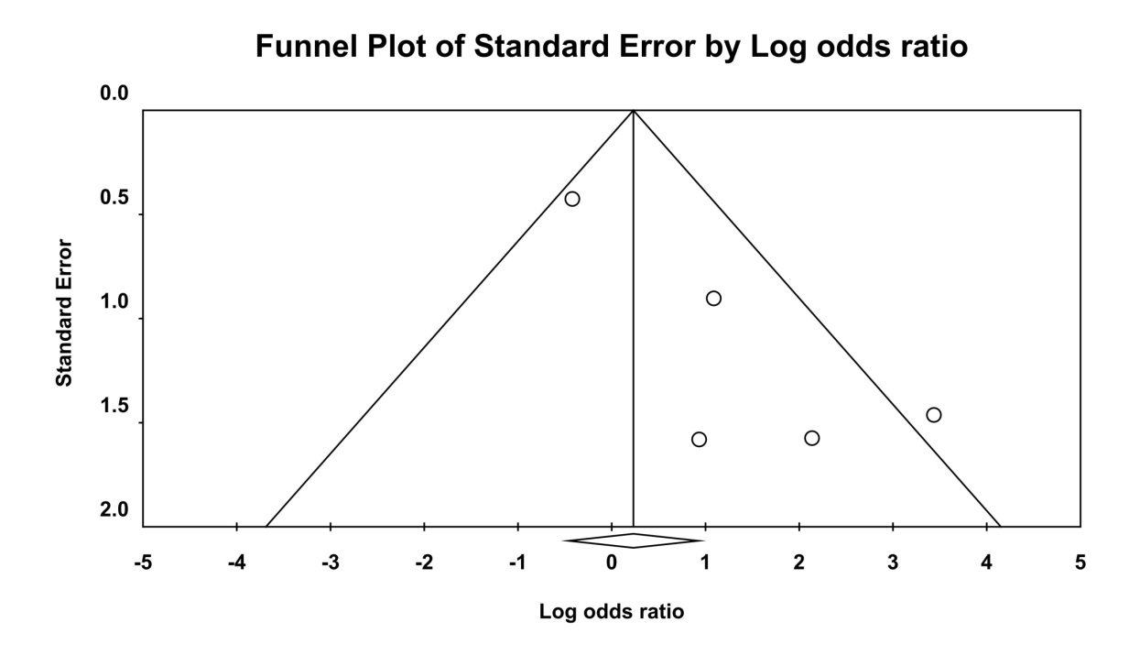
Figure S4C. TIMP3

Figure S4D. APC
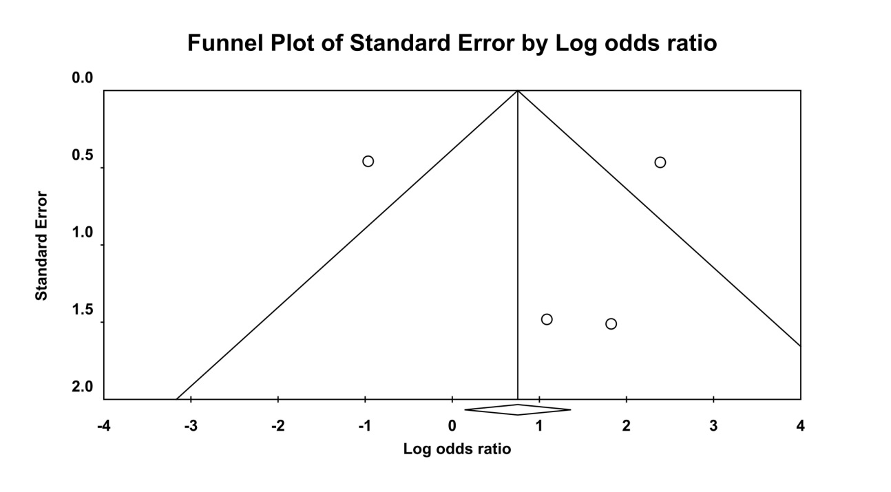

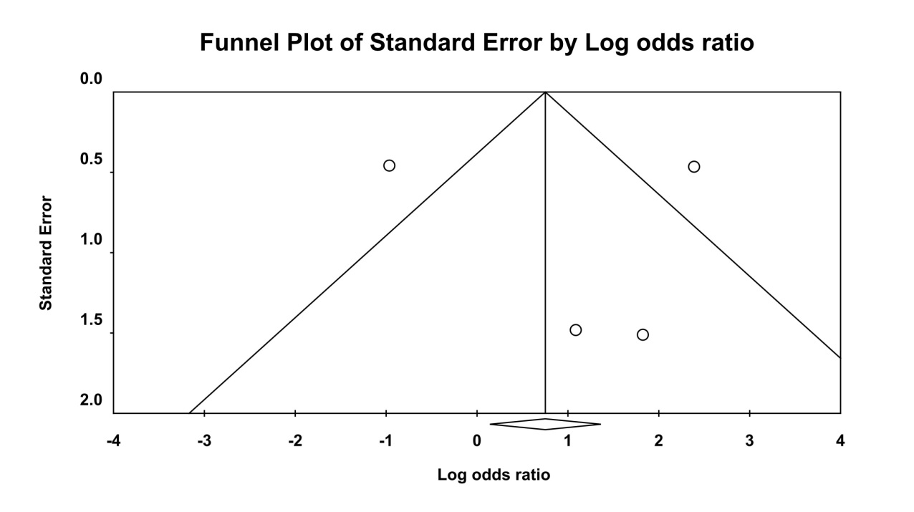
Figure S4E. CDH1

Figure S4F. GSTP1
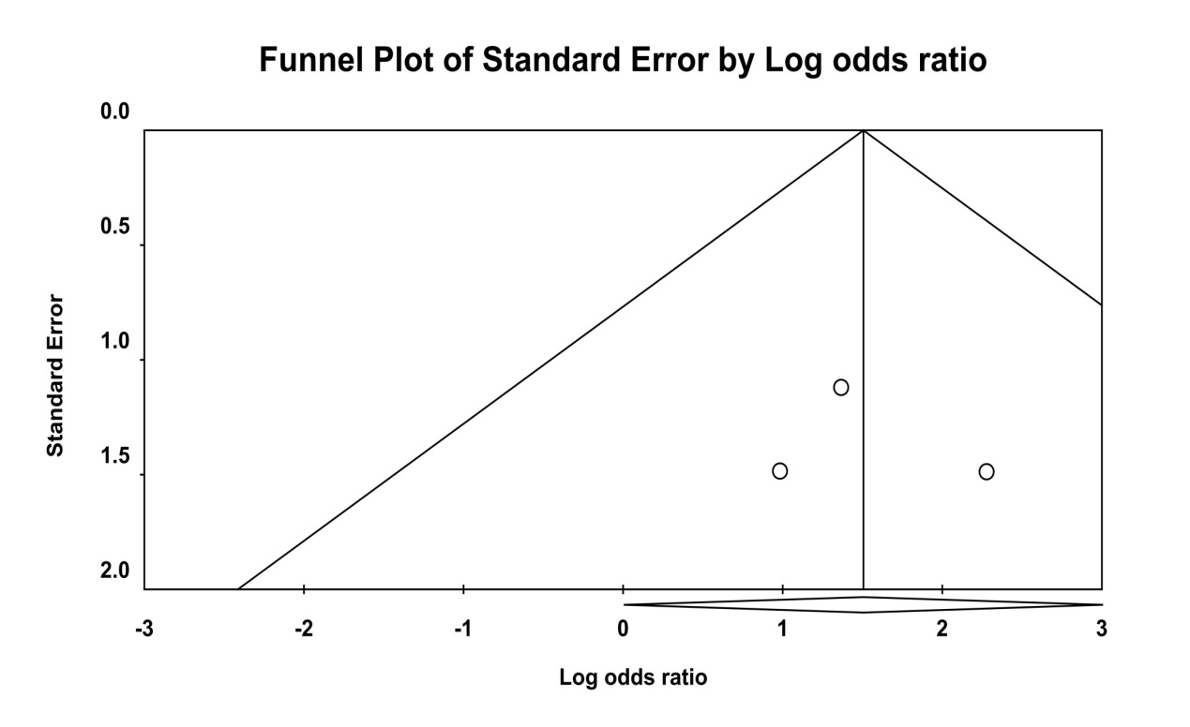

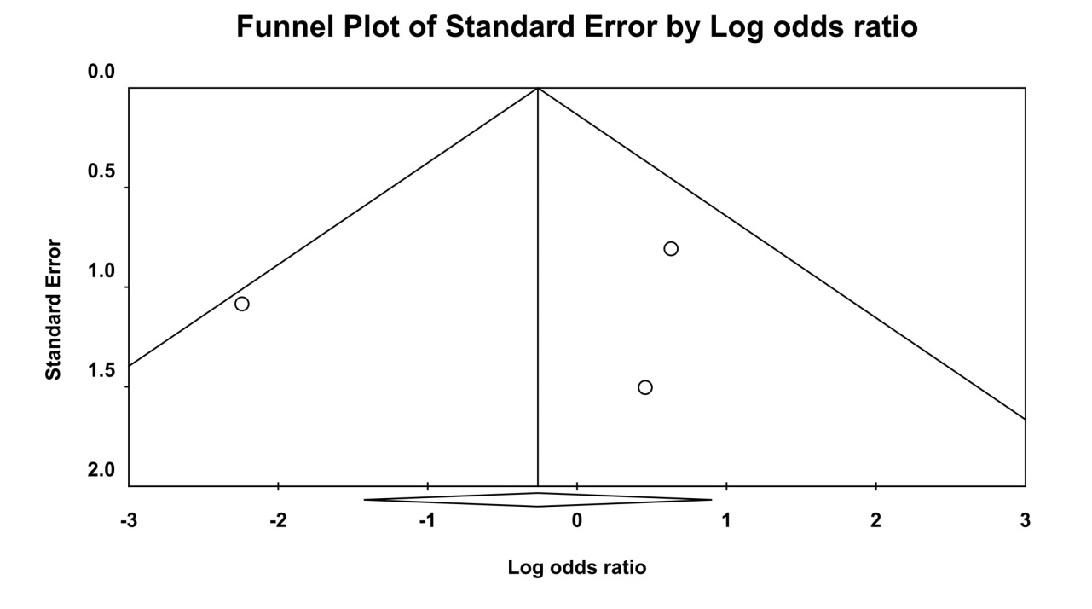
Figure S4G. MGMT

Figure S4H. RARβ2
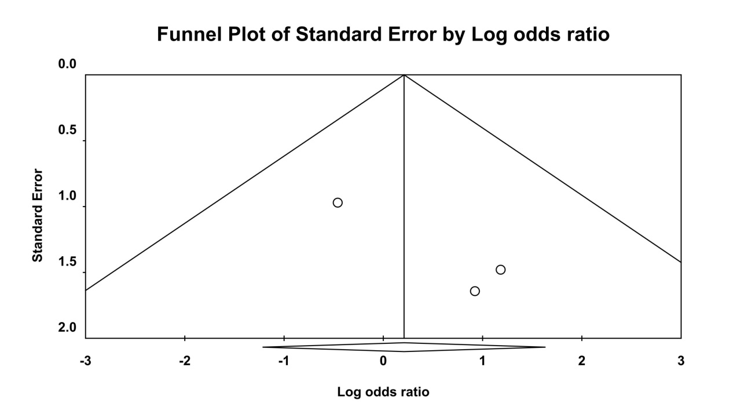

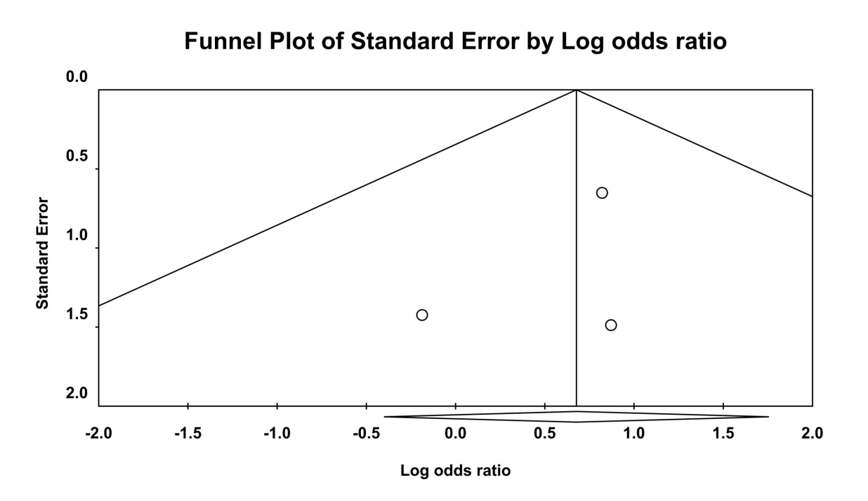
Figure S4I. p16

Figure S5. Meta-regression analyses by sample size of original studies for the associations of RCC risk with (A) RASSF1A or (B) SFRP1.
Figure S5A. RASSF1A
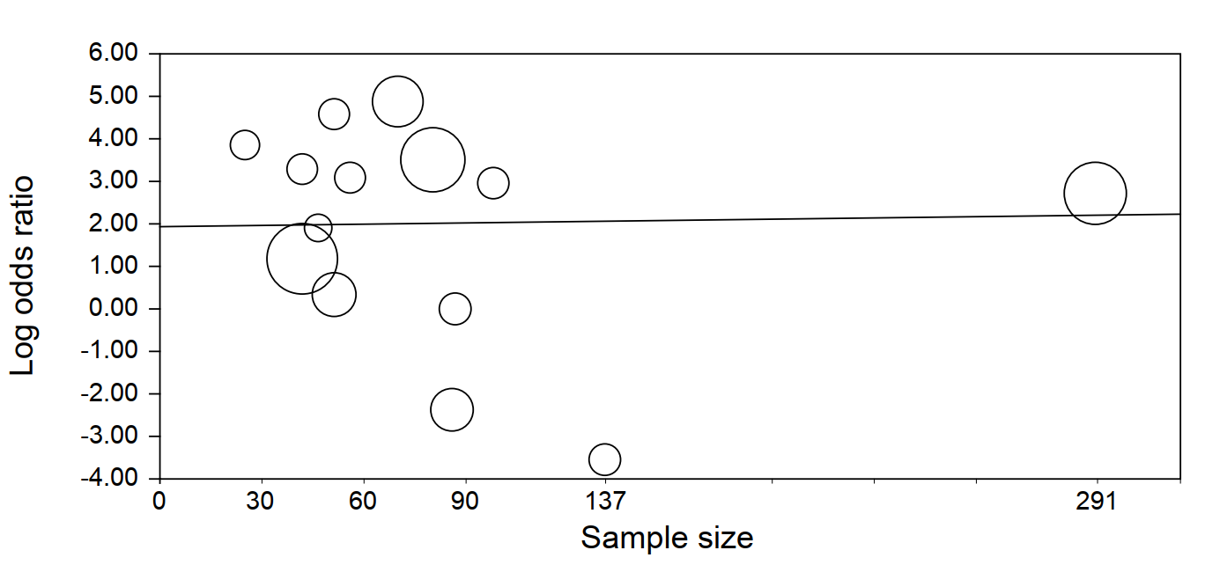

Figure S5B. SFRP1
