Appendix:
Appendix A. Nutritional pattern
Factor analysis was used to obtain a nutritional pattern. Four main dietary patterns were identified, including: "western", "Mediterranean", "animal fat", and "fast food". the "Western diet," which included fried foods, potatoes, legumes, hydrogenated vegetable oils, red meat, pickles, and rice. The Mediterranean diet included consumption of non-hydrogenated vegetable oils, fruits, poultry, fish, vegetables, and olive oil. "Animal fat diet" which was characterized by a high intake of cream, whole milk, butter, and meat. And the "fast food diet" which contains lots of burgers, sausages, pizzas, sweets, and carbonated drinks.

Table A. Factor loading matrix for dietary patterns
Food | Western diet | Mediterranean diet | Animal fat diet | Fast food diet
Fried food | 0.56 | - | - | -
Potato | 0.56 | - | - | -
Legumes | 0.52 | - | - | -
Hydrogenated | 0.51 | -0.44 | - | -
Red meat | 0.50 | - | - | -
Pickle | 0.45 | - | - | -
Rice | 0.45 | - | - | -
Non-hydrogenated vegetable oil | - | 0.59 | - | -
Fruits | 0.40 | 0.58 | - | -
Poultry | - | 0.55 | - | -
Fish | - | 0.54 | - | -
Vegetables | 0.47 | 0.49 | - | -
Olive oil |  | 0.41 | - | -
Bread | 0.26 | -0.34 | - | -
Cream | - | - | 0.69 | -
Whole milk | - | - | 0.59 | -
Ghee | - | - | 0.45 | -
Butter | 0.22 | - | 0.45 | 0.21
Organ meat | - | - | 0.45 | -
Liver | - | - | 0.37 | 0.32
Tallow | - | - | 0.33 | -
Dry fruits | 0.25 | - | 0.31 | -
Jam | 0.24 | - | 0.28 | 0.25
Soy protein | - | - | - | -
Industrial fruit juice | - | - | - | -
Hamburger | - | - | - | 0.67
Sausages | - | - | - | 0.66
Pizza | -- | - | - | 0.47
Sweet | - | - | - | 0.46
Carbonated  beverages | - | - | - | 0.42
Nuts | 0.22 | - | - | 0.36
Canned foods | - | - | 0.21 | 0.27

Appendix B. WinBUGS code BSEM

model{
for( i in 1 : N ) {
for( j in 1 : 22 ) {
y[i , j] <- yy[i , j]
}
x1[i] <- yy[i , 20]
x2[i] <- yy[i , 21]
x3[i] <- yy[i , 22]
for( j in 1 : 1 ) {
y[i , j] ~ dnorm(mu[i , j], 1)C(y[i , j],y[i , j])
}
for( j in 2 : 19 ) {
y[i , j] ~ dnorm(mu[i , j], psi[j])
ephat[i , j] <- y[i , j] - mu[i , j]
}
mu[i , 1] <- u[1] + beta[1] * x1[i] + ta[1] * x2[i] + eta[i]
mu[i , 2] <- u[2] + beta[2] * x1[i] + ta[2] * x2[i] + xi[i , 1]
mu[i , 3] <- u[3] + beta[3] * x1[i] + ta[3] * x2[i] + lam[1] * xi[i , 1]
mu[i , 4] <- u[4] + beta[4] * x1[i] + ta[4] * x2[i] + lam[2] * xi[i , 1]
mu[i , 5] <- u[5] + beta[5] * x1[i] + ta[5] * x2[i] + lam[3] * xi[i , 1]
mu[i , 6] <- u[6] + beta[6] * x1[i] + ta[6] * x2[i] + xi[i , 2]
mu[i , 7] <- u[7] + beta[7] * x1[i] + ta[7] * x2[i] + lam[4] * xi[i , 2]
mu[i , 8] <- u[8] + beta[8] * x1[i] + ta[8] * x2[i] + lam[5] * xi[i , 2]
mu[i , 9] <- u[9] + beta[9] * x1[i] + ta[9] * x2[i] + xi[i , 3]
mu[i , 10] <- u[10] + beta[10] * x1[i] + ta[10] * x2[i] + lam[6] * xi[i , 3]
mu[i , 11] <- u[11] + beta[11] * x1[i] + ta[11] * x2[i] + lam[7] * xi[i , 3]
mu[i , 12] <- u[12] + beta[12] * x1[i] + ta[12] * x2[i] + xi[i , 4]
mu[i , 13] <- u[13] + beta[13] * x1[i] + ta[13] * x2[i] + lam[8] * xi[i , 4]
mu[i , 14] <- u[14] + beta[14] * x1[i] + ta[14] * x2[i] + xi[i , 5]
mu[i , 15] <- u[15] + beta[15] * x1[i] + ta[15] * x2[i] + lam[9] * xi[i , 5]
mu[i , 16] <- u[16] + beta[16] * x1[i] + ta[16] * x2[i] + lam[10] * xi[i , 5]
mu[i , 17] <- u[17] + beta[17] * x1[i] + ta[17] * x2[i] + lam[11] * xi[i , 5]
mu[i , 18] <- u[18] + beta[18] * x1[i] + ta[18] * x2[i] + xi[i , 6]
mu[i , 19] <- u[19] + beta[19] * x1[i] + ta[19] * x2[i] + lam[12] * xi[i , 6]
xi[i , 1:6] ~ dmnorm(u0[1:6], phi[1:6 , 1:6])
eta[i] ~ dnorm(nu[i], psd)
nu[i] <- ta1[1] * x1[i] + ta1[2] * x2[i] + ta1[3] * x3[i] + gam[4] * xi[i , 1] + gam[5] * xi[i , 2] + gam[6] * xi[i , 3] + gam[7] * xi[i , 4] + gam[8] * xi[i , 5] + gam[9] * xi[i , 6]
dthat[i] <- eta[i] - nu[i]
}
for( j in 1 : 19 ) {
u[j] ~ dnorm(0, 4)
}
lam[1] ~ dnorm(0, 4)
lam[2] ~ dnorm(0, 4)
lam[3] ~ dnorm(0, 4)
lam[4] ~ dnorm(0, 4)
lam[5] ~ dnorm(0, 4)
lam[6] ~ dnorm(0, 4)
lam[7] ~ dnorm(0, 4)
lam[8] ~ dnorm(0, 4)
lam[9] ~ dnorm(0, 4)
lam[10] ~ dnorm(0, 4)
lam[11] ~ dnorm(0, 4)
lam[12] ~ dnorm(0, 4)
gam[1] ~ dnorm(0, psd)
gam[2] ~ dnorm(0, psd)
gam[3] ~ dnorm(0, psd)
gam[4] ~ dnorm(0, psd)
gam[5] ~ dnorm(0, psd)
gam[6] ~ dnorm(0, psd)
gam[7] ~ dnorm(0, psd)
gam[8] ~ dnorm(0, psd)
gam[9] ~ dnorm(0, psd)
for( j in 1 : 19 ) {
psi[j] ~ dgamma(0.01, 0.01)
sigma[j] <- 1 / psi[j]
}
psd ~ dgamma(0.01, 0.01)
sigd <- 1 / psd
phi[1:6 , 1:6] ~ dwish(R[1:6 , 1:6], 8)
phx[1:6 , 1:6] <- inverse(phi[1:6 , 1:6])
ta1[1] <- gam[1]
ta1[2] <- gam[2]
ta1[3] <- gam[3]
for( j in 1 : 6 ) {
gamma[j] <- gam[3 + j]
}
for( j in 1 : 19 ) {
psiepsilon[j] <- sigma[j]
}
psidelta <- sigd
}
Appendix C: An example of Golman Robin test, convergence diagrams, and Monte Carlo error
C1: Golman Robin test

----------------------------80% interval----------------------------
Unnormalized Normalized as plotted
iteration range of pooled mean within of pooled mean within BGR ratio
chains chain chains chain
1051—1100 0.1829 0.1665 0.7949 0.7234 1.099
1101—1200 0.1949 0.1899 0.8468 0.825 1.026
1151—1300 0.2206 0.2212 0.9584 0.9611 0.9972
1201—1400 0.2301 0.2277 1.0 0.9895 1.011
1251—1500 0.2062 0.1926 0.8961 0.8368 1.071
1301—1600 0.1882 0.1714 0.8177 0.7449 1.098
1351—1700 0.1582 0.1464 0.6875 0.636 1.081
1401—1800 0.1688 0.1592 0.7334 0.6919 1.06
1451—1900 0.1783 0.1682 0.7749 0.7311 1.06
1501—2000 0.181 0.1663 0.7864 0.7225 1.088

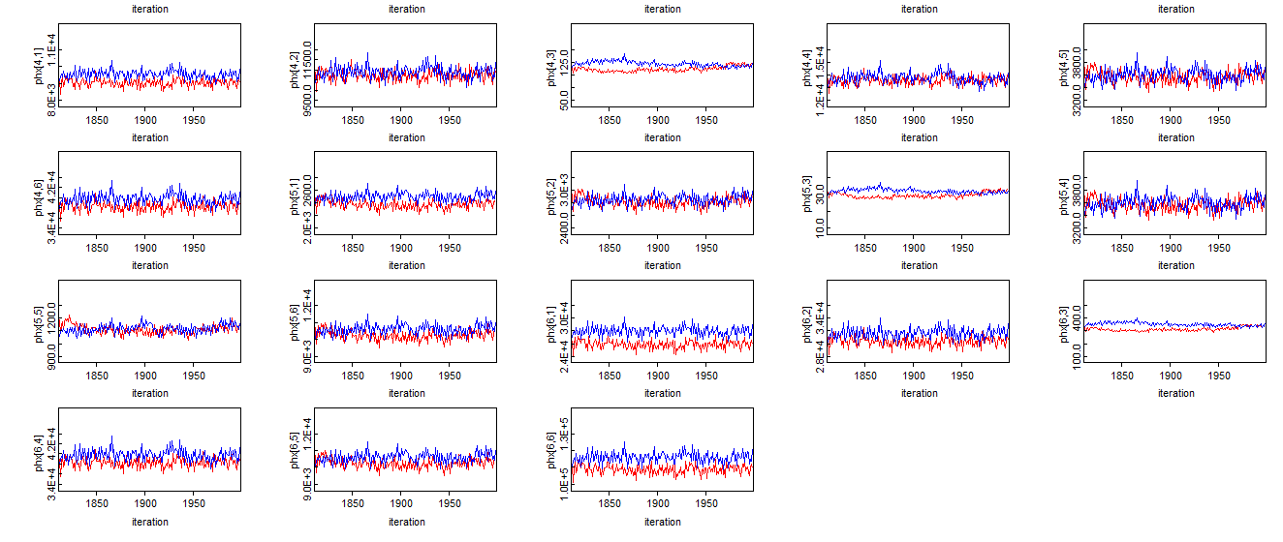
C2: onvergence diagrams for the first 1000 updates (trace plot)

Model
MC error |  | MC error
Age-> total CVD | 5.30E-05 | Lipids-> HDL  Lipids-> LDL  Lipids-> Tg  Lipids-> Cho | -  1.15E-03  1.66E-03  1.91E-03
Family history -> total CVD | 1.40E-03 | Anthropometric-> HC  Anthropometric-> WC  Anthropometric-> BMI | -  1.95E-04  1.12E-04
Sex -> total CVD | 2.04E-03 | Unhealthy life style-> smoking  Risky behavior -> depression and anxiety  Risky behavior -> unhealthy diet behavior | -  5.87E-03  5.58E-03
Lipids -> total CVD | 2.15E-03 | Comorbidities-> Blood sugar  Comorbidities-> Blood pressure | -  8.99E-05
Anthropometric -> total CVD | 1.93E-03 | Quality of life-> Environmental Heath  Quality of life-> Social Relationship  Quality of life-> Mental Health  Quality of life-> Physical Health | -  2.96E-04  2.50E-04  2.76E-04
risky behavior-> total CVD | 4.38E-03 | Healthy lifestyle component-> physical activity  Healthy lifestyle component-> Healthy diet behavior | -  9.92E-04
Comorbidities -> total CVD ->Cvd | 2.44E-04 | Lipids<-> Anthropometric  Lipids<-> Risky behavior  Lipids<-> Comorbidities  Lipids<-> Quality of life  Lipids<->healthy lifestyle component | 8.93E-02  8.18E-02  4.98E-02  7.13E-02  6.79E-02
Quality of life -> total CVD | 1.48E-03 | Anthropometric<-> Risky behavior  Anthropometric<-> Comorbidities  Anthropometric<-> Quality of life  Anthropometric<-> healthy lifestyle component | 7.57E-02  4.94E-02  6.93E-02  6.65E-02
Healthy  lifestyle -> total CVD | 1.14E-03 | Risky behavior <-> Comorbidities  Risky behavior <-> Quality of life  Risky behavior <-> healthy lifestyle component | 4.40E-02  6.39E-02  6.13E-02
 |  | Comorbidities  <-> Quality of life  Comorbidities  <-> healthy lifestyle component | 4.00E-02  4.03E-02
 |  | Quality of life<-> healthy lifestyle component | 5.32E-02

C3:Table B. Monte Carlo error for total CVD

