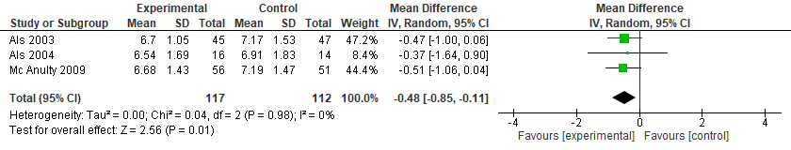
Figure 3S. NIDCAP vs. Standard Care for the Neurobehavioral Development (attention- interaction system - APIB)

