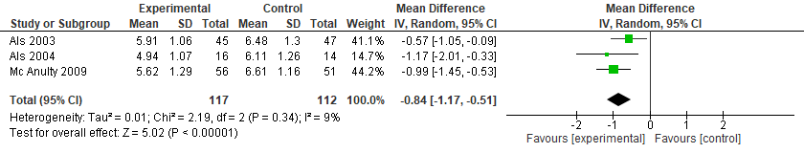
Figure S4. NIDCAP vs. Standard Care for the Neurobehavioral Development (self-regulation system - APIB)

