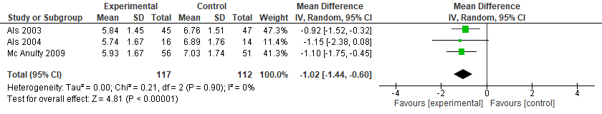
Figure 5S. NIDCAP vs. Standard Care for the Neurobehavioral Development (examiner facilitation - APIB)

