In-vitro and In-silico approach for characterization of antimicrobial-peptide from probiotics against Staphylococcus aureus and Escherichia coli
Amrutha Bindu and *Lakshmidevi N
DOS in Microbiology, Manasa Gangothri, University of Mysore, Mysore
*Corresponding Author:
Dr. Lakshmidevi N
Professor
DOS in Microbiology, Manasa Gangothri, University of Mysore, Mysore-570 005
Phone: 080 2419735; Mobile: +91 9008177435

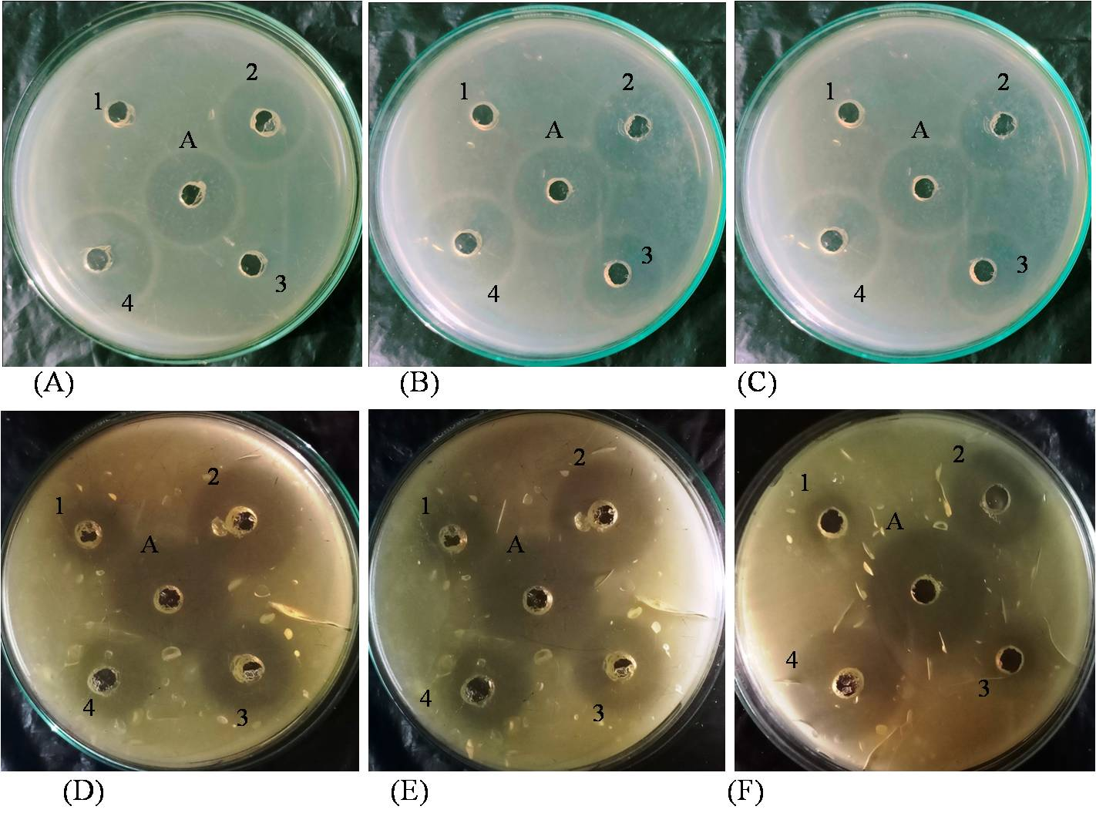
Fig. S1 Antimicrobial activity of bacteriocin extracted with different methods. (1) Ethanol precipitation; (2) Chloroform extraction; (3) Butanol extraction; (4) Ammonium sulphate precipitation and dialysis. Inhibitory activity against S. aureus by (A) DB-1aa; (B) Cu2-PM7; (C) Cu3-PM8. Inhibitory activity against E. coli by (D) DB-1aa; (E) Cu2-PM7; (F) Cu3-PM8. ‘A’ indicate positive control (Chlorampenicol-1 mg/ml).

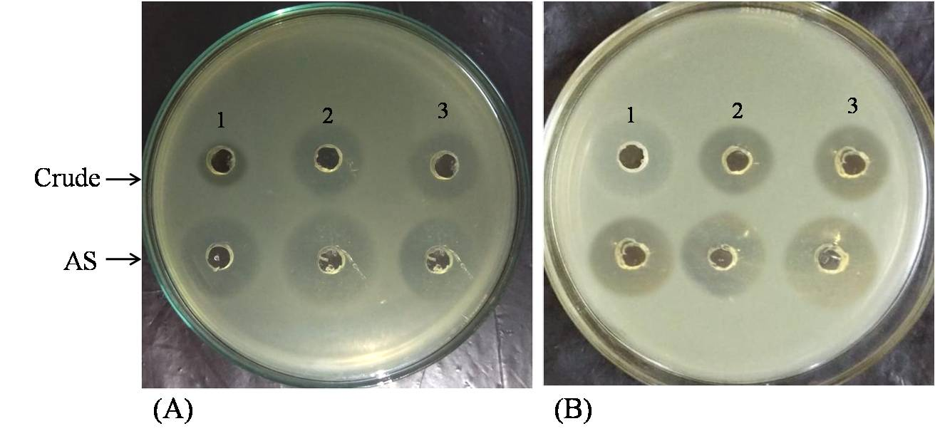
Fig. S2 Inhibitory activity of crude and Ammonium sulphate precipitated (AS) against (A) S. aureus; (B) E. coli. (1) E. durans DB-1aa; (2) L. plantarum Cu2-PM7; (3) L. fermentum Cu3-PM8

