Supporting information of Durability Improvement of Concentrated Polymer Brushes by Multiscale Texturing

Seiya Watanabe1*, Eri Kodama1, Chiharu Tadokoro2, Keita Sakakibara3, Ken Nakano4, Shinya Sasaki1, Yoshinobu Tsujii5

1 Dept. of Mechanical Engineering, Tokyo University of Science, 6-3-1 Niijyuku, Katsushika, Tokyo, 125-8585, Japan

2 Dept. of Mechanical Engineering, Saitama University, 255 Shimo-Okubo, Sakura-ku, Saitama 338-8570, Japan

3AIST

4 Faculty of Environment and Information Sciences, Yokohama National University, 79-7 Tokiwadai, Hodogaya, Yokohama 240-8501, Japan

5 Institute for Chemical Research, Kyoto University, Gokasho Uji, Kyoto, 611-0011, Japan

*e-mail:s-watanabe@rs.tus.ac.jp

S-1. Friction behavior for each textured and non-textured sample

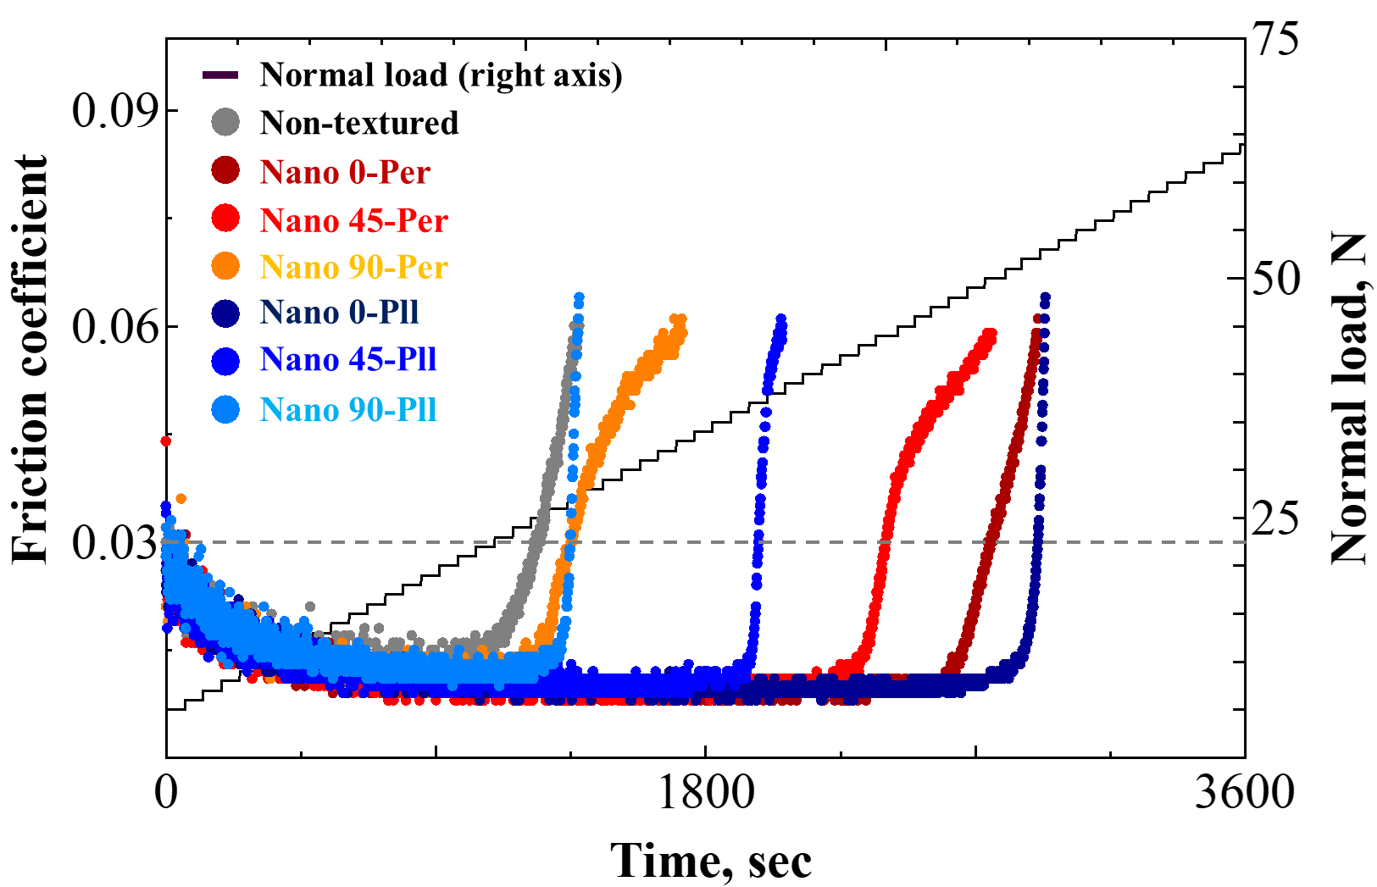

Fig. S-1 Friction behavior for each textured and non-textured sample.

S-2. Topographic image of the surface when the friction coefficient exceeded 0.06

|  |  |
| --- | --- |
|  |  |
| (a-1) Nano 0-Per | (a-2) Nano 0-Pll |
|  |  |
| (b-1) Nano 45-Per | (b-2) Nano 45-Pll |
|  |  |
| (c-1) Nano 90-Per | (c-2) Nano 90-Pll |

Fig. S-2 Topographic images of wear track of (a-1) Nano 0-Per, (a-2) Nano 0-Pll, (b-1) Nano 45-Per, (b-2) Nano 45-Pll, (c-1) Nano 90-Per and (c-2) Nano 90-Pll when the friction coefficient exceeded 0.06

S-3. Estimation of radius of nanoperiodic structure

We estimated the radius of nanoperiodic structure based on the value pitch 400 nm and Ra 0.02 μm. Based on the SEM image shown in Fig. 1 and 2 where the area of lighter part is larger than that of darker part, we consider that the shape of nanoperiodic structure is convex upward. Therefore, we approximate the shape of nanoperiodic structure by following equation S1.

$H=\left|R_{z}\sin{\frac{π}{T}d}\right|$ (S1)

Where H and d are the height and distance of nanoperiodic structure. T is the period of the nanoperidic structure corresponding to the pitch of 400 nm. Rz is the maximum height of the nanoperiodic structure estimated by quadruple of the Ra. Fig. S-3 shows the approximated shape of the nanoperiodic structure. The radius of the head of the curve of Fig. S1 can be calculated by eq. S2, and the calculated radius was 202 nm.

$r=\frac{1}{R_{z}×{\left(\frac{π}{T}\right)}^{2}}$ (S2)



Fig. S-3 An approximated shape of the nanoperiodic structure