Table 3 Specifications of combination of nano-periodic structures and groove texture and sliding direction

Texture patterns | Schematic
Non-textured
Nano 0-Per  (nano-periodic structure is applied along groove texture and slid to perpendicular direction) | 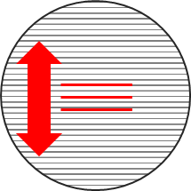
Nano 45-Per  (nano-periodic structure is applied diagonal to groove texture and slid to perpendicular direction) | 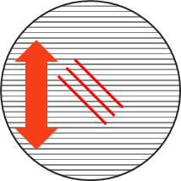
Nano 90-Per  (nano-periodic structure is applied orthogonal to groove texture and slid to perpendicular direction) | 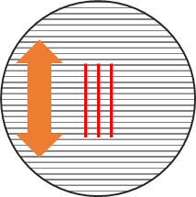
Nano 0-Pll  (nano-periodic structure is applied along groove texture and slid to parallel direction) | 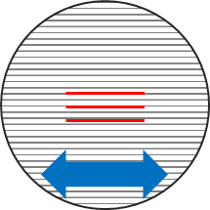
Nano 45-Pll  (nano-periodic structure is applied diagonal to groove texture and slid to parallel direction) | 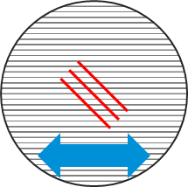
Nano 90-Pll  (nano-periodic structure is applied orthogonal to groove texture and slid to parallel direction) | 