Extended Data Figures: Case I, United States

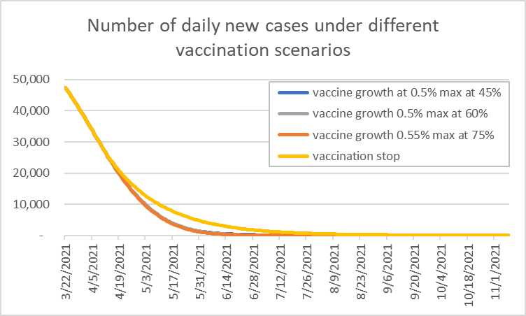
Extend Data Figure 1: Numbers of daily new cases under different vaccination program scenarios.

Supplement materials: Case study I, United States

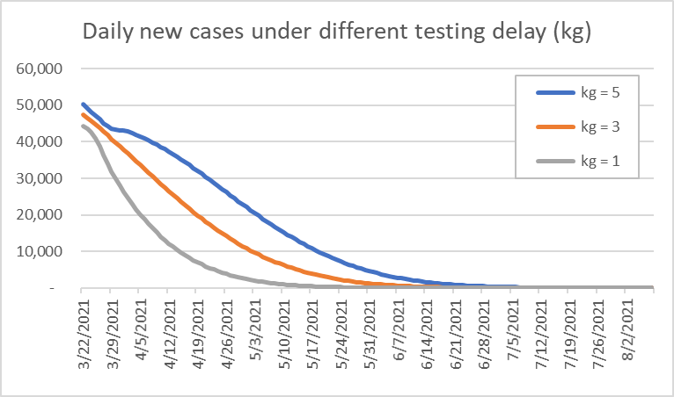
Supplement Figure 1: Number of daily new cases under different lag days from symptom onset to isolation (testing delay, k_{g})
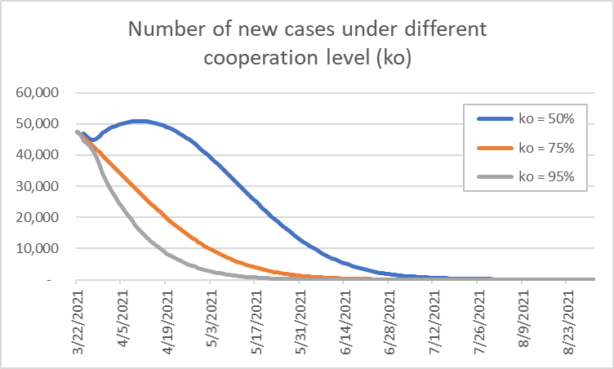
Supplement Figure 2: Number of daily new cases under different cooperation levels (k_{o})

Supplement materials: Case II, Thailand

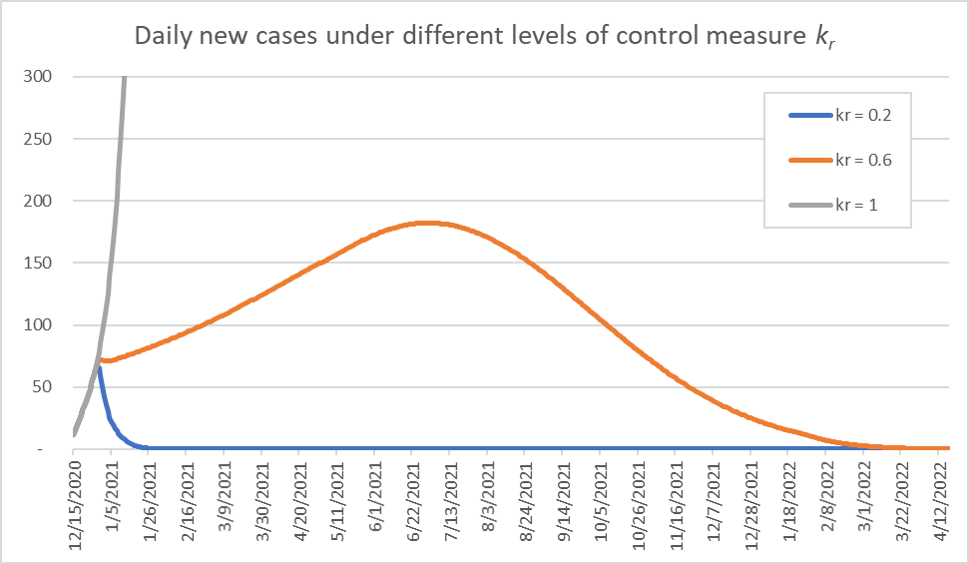
Supplement Figure 3: Daily new cases under different levels of control measure k_{r}
Sup Fig. 3 shows daily new case numbers under three scenarios of control measures, k_{r}(t) = 0.2, 0.6, and 1, which was implemented on 23 December 2020. If no new additional measures were implemented besides the ones implemented before the second wave (i.e., k_{r}(t) = 1 scenario), then the number of hospitalized patients will dramatically increases up to 2,200,000 in late April, which is far beyond the level that the Thailand healthcare system could handle. Thus, this scenario is unacceptable.
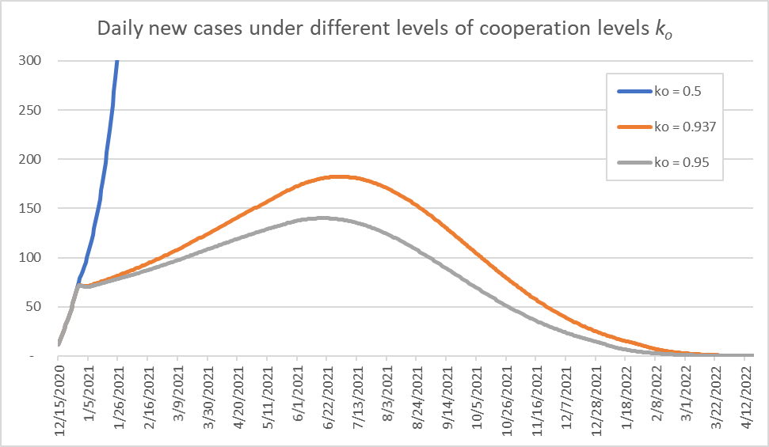
Supplement Figure 4: Daily new cases under different levels of cooperation level k_{o}
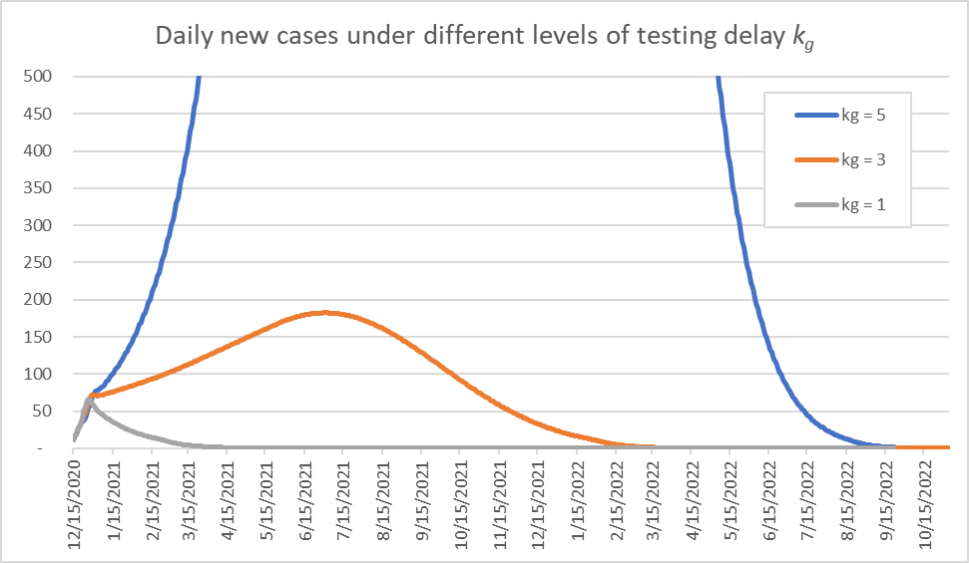
Supplement Figure 5: Daily new cases under different levels of testing delay k_{g}: When k_{g} = 5, the peak hospitalized patients (severe and critical symptom) reach 30,000 and daily new cases reach 10,589 around the second half of October 2021.

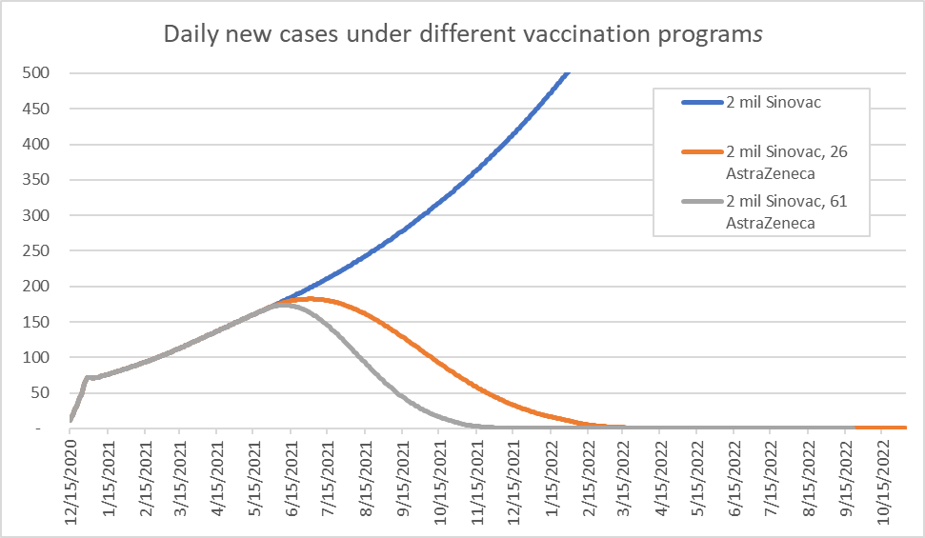
Supplement Figure 6: Daily new cases under three vaccination program scenarios

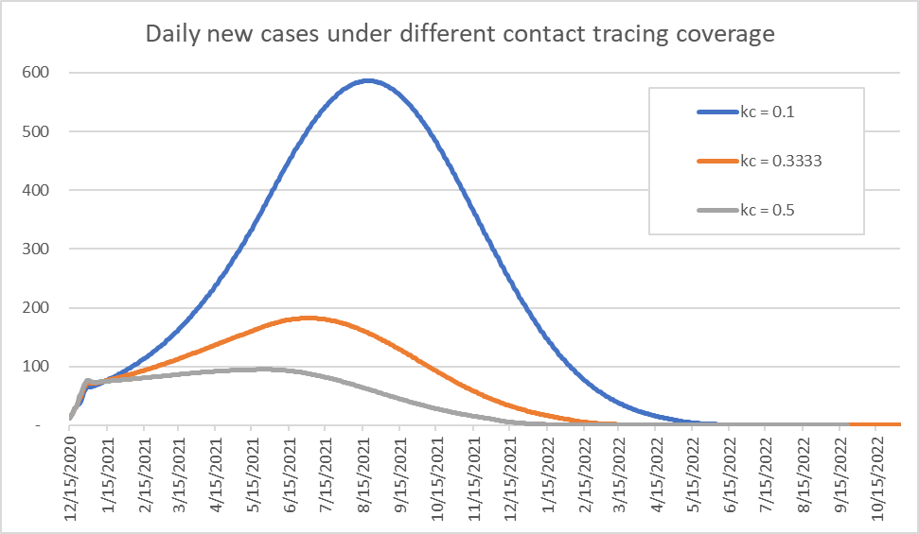
Supplement Figure 7: Daily new cases under different contact tracing coverage k_{c}
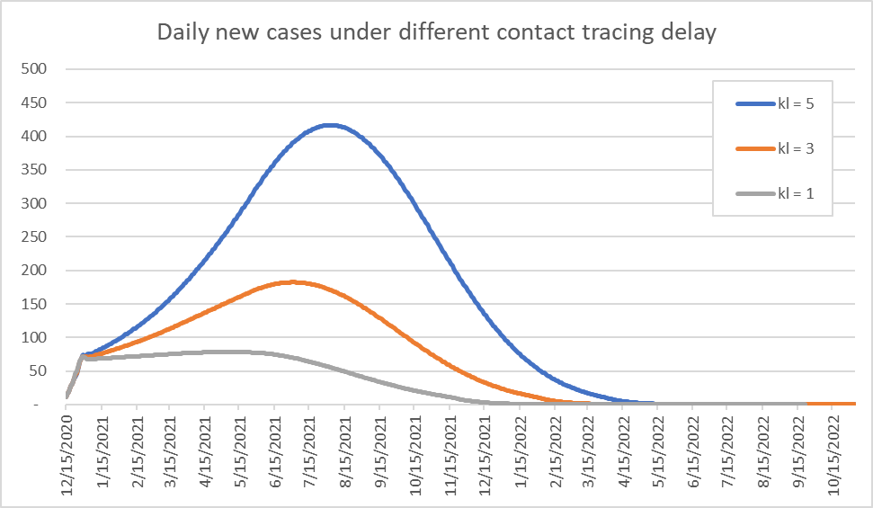
Supplement Figure 8: Daily new cases under different levels of contact tracing delay k_{l}

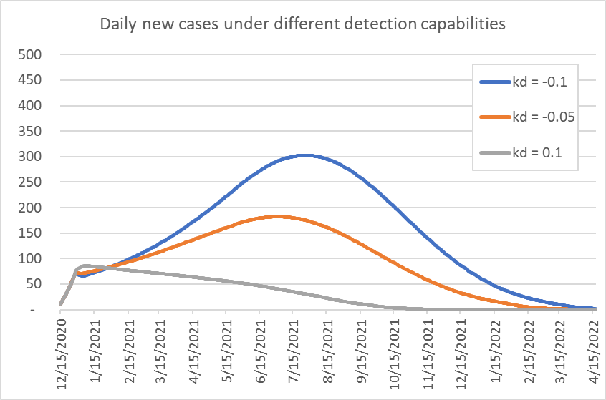
Supplement Figure 9: Daily new cases under different asymptomatic detection capabilities k_{d}

