Supplementary Information
Unveiling the SEI Formation in a Potassium Ion Battery Using Distribution of Relaxation Time
Chuanchao Sheng¹, Fengjiao Yu¹, Chunmei Li², Heng Zhang², Jun Huang³, Yuping Wu¹, Michel Armand²* and Yuhui Chen¹*

¹ State Key Laboratory of Materials-oriented Chemical Engineering, College of Chemical Engineering and School of Energy, Nanjing Tech University, Nanjing, Jiangsu, 211816 China
² Electrical Energy Storage Department, CIC Energigune, Parque Tecnológico de Álava, Albert Einstein 48, 01510 Miñano, Álava, Spain
³ Institute of Theoretical Chemistry, Ulm University, Ulm, 89069, Germany
Corresponding authors:
cheny@njtech.edu.cn ; marmand@cicenergigune.com

Experimental Section
Material synthesis.
All chemical reagents were used as received without any further purification. The SnS₂/N-rGO composite was prepared in our previous work, as described below. 120 mg of graphene oxide (GO) powder was diluted in 100 ml deionized water and kept under magnetic stirring 30 min then ultrasonicated for 2h. A uniformly dispersed solution was obtained. 1.4 g of SnCl₄•5H₂O (4 mmol) and 0.6 g of thioacetamide (TAA) (8 mmol) were added to the dispersed solution and further magnetically stirred for 2h. Then 120 µl of ethylenediamine (EDA) was added into the above solution. After stirring for 30 min, the brown mixture was poured into a Teflon-lined stainless steel autoclave and heated at 100 ºC for 10 h on air-drying oven. When the reaction finished, the precipitate was centrifuged and rinsed with deionized water and ethyl alcohol in turn for three times until the pH became neutral. The precipitate was freeze-dried for 72 h prior to use.

Material characterization.
The crystal structure of the composite was determined by X-ray diffraction (XRD) on a Rigaku SmartLab using Cu K_{α} radiation. The XRD pattern of the composite in Figure S1a is consistent with the standard XRD pattern of hexagonal SnS₂ (JCPDS card No. 23-0677). Scanning electron microscope (SEM) was recorded by a Hitachi S4800 (Tokyo, Japan). Transmission electron microscopy (TEM) images, high-angle annular dark-field scanning TEM (HAADF-STEM) images, and elemental maps were obtained using a JEOL JEM-ARM 200F. The interplanar spacings of SnS₂ are 0.32 nm and 0.27 nm, which can be assigned to (100) and (101) lattice planes of the hexagonal SnS₂ lamellar phase. X-ray photoelectron spectroscopy (XPS) spectra were obtained by an ESCALAB 250Xi (ThermoFisher Scientific). The EDX mapping of SnS₂/N-rGO shows that Sn, S, C, and N elements are evenly dispersed.

Electrochemical measurements.
Electrochemical tests were carried out using Swagelok type three-electrode cells. The cell consists of the composite as working electrode and two pieces of potassium metal as counter and reference electrode, respectively, separated by two glass fiber membranes (Whatman GF/D). The composite electrodes were prepared with active materials (80%), super P carbon (10%) and CMC (10%) dissolved in deionized water to make a black slurry. The obtained slurry was cast on a Cu foil and dried under vacuum at 90 ºC for overnight. The cell assembly was performed in an argon-filled glovebox with a Argon atmosphere (H₂O < 0.1 ppm, O₂ < 0.1 ppm). The electrolytes used in this work consisted of different salts (1 M KFSI/KTFSI/KPF₆) in a mixture of ethylene carbonate (EC) and diethyl carbonate (DEC) (50/50, V/V). Galvanostatic cycling was performed in a LANHE battery testing system. Cyclic voltammetry (CV) and electrochemical impedance spectroscopy (EIS) were performed under a potentiostat (VMP3, Biologic).

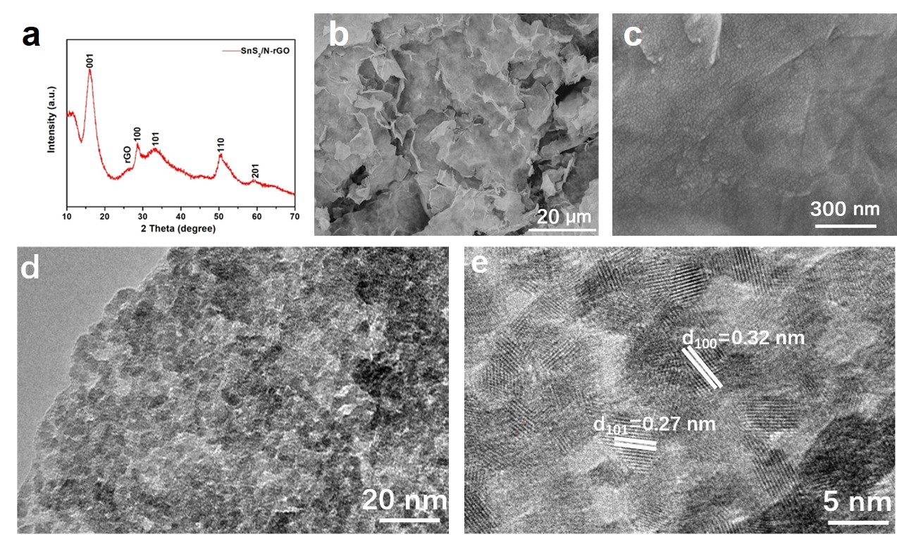
Figure S1 Characterization of SnS₂/N-rGO. (a) XRD patterns of SnS₂/N-rGO; (b-c) SEM images of SnS₂/N-rGO, (d-e) TEM of SnS₂/N-rGO.

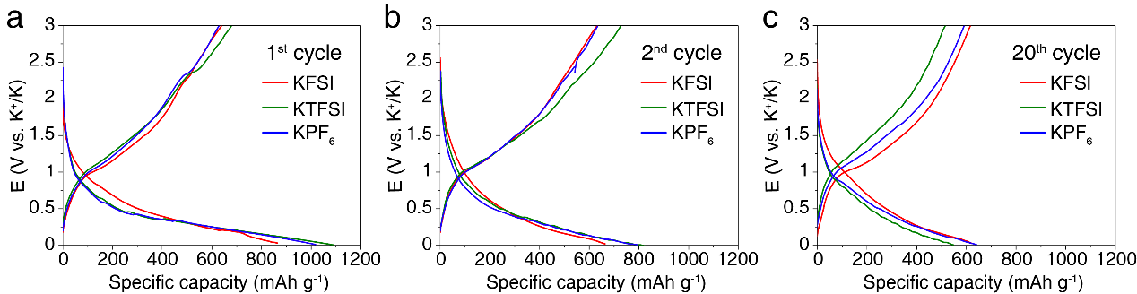
Figure S2 Load curves of discharge and charge for SnS₂/N-rGO in electrolytes containing various K salts. (a) 1st cycle, (b) 2nd cycle, and (c) 20th cycle.

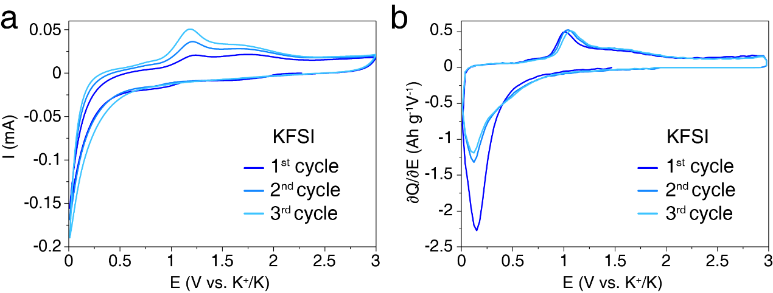
Figure S3 electrochemical test of the SnS2N-rGO in KFSI-EC-DEC. (a) CV curves and (b) dQ/dV curves of the first three cycles of SnS2-N-rGO in KFSI in EC/DEC.

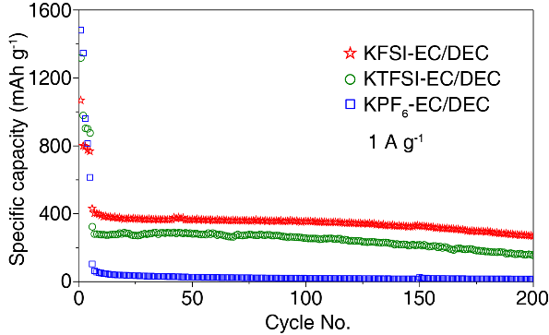
Figure S4 Electrochemical performance of the SnS₂/N-rGO in EC-DEC electrolytes containing various K⁺ salts at a current density of 1 A g⁻¹.

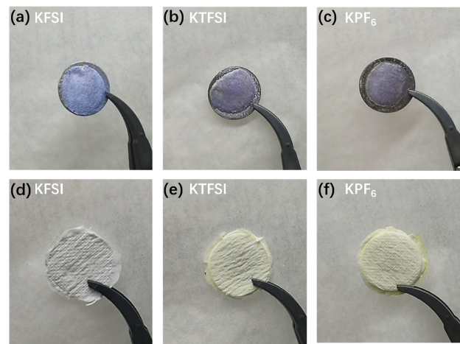
Figure S5 Photos of K anodes and separators of the cells after cycling in various electrolytes. The separators from cells using KTFSI and KPF6 show yellowing but the separator in the KFSI cell is still white. The metallic K anodes in the cells with KTFSI and KPF₆ react with polysulfide species and display a black color. In contrast, the K anode in KFSI cell still remains white and shinning
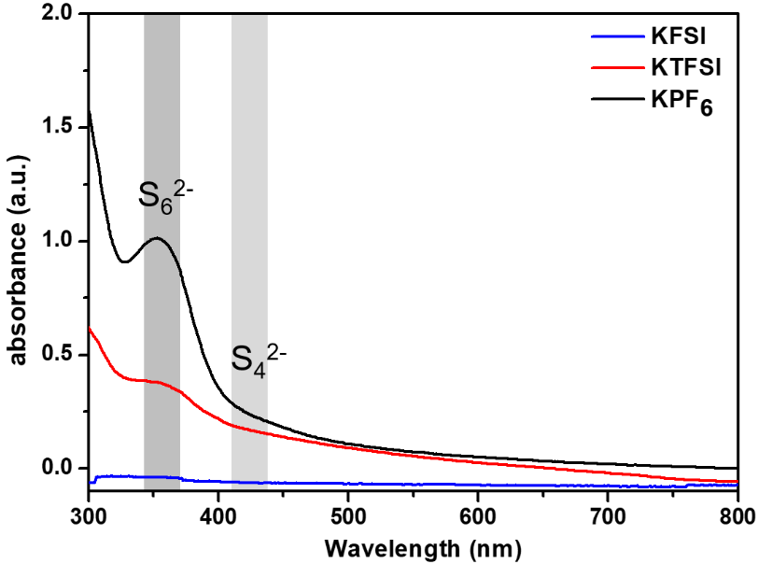
Figure S6 UV-vis spectra of the DME extract from separators from cell after cycling. Polysulfide species were identified in the extracts from cells using KTFSI and KPF₆, but hardly in the cell using KFSI.
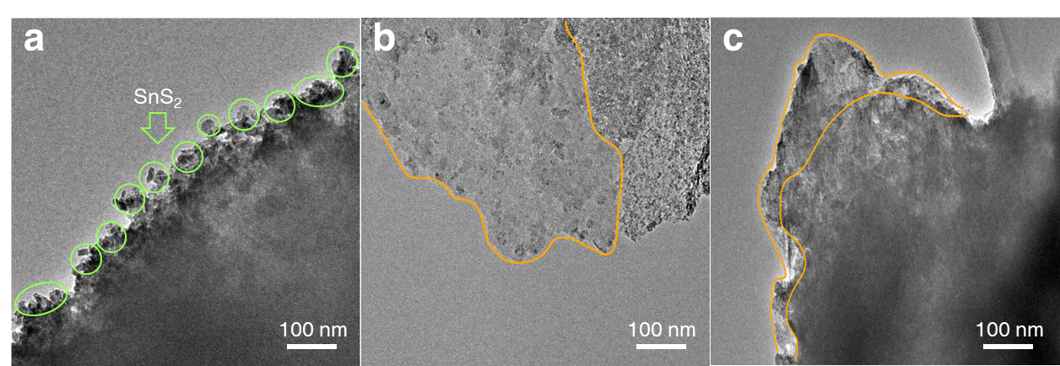
Figure S7 TEM images of the SnS₂/N-rGO composites after cycling in various electrolyte containing (a) KFSI; (b) KTFSI; (c) KPF₆.

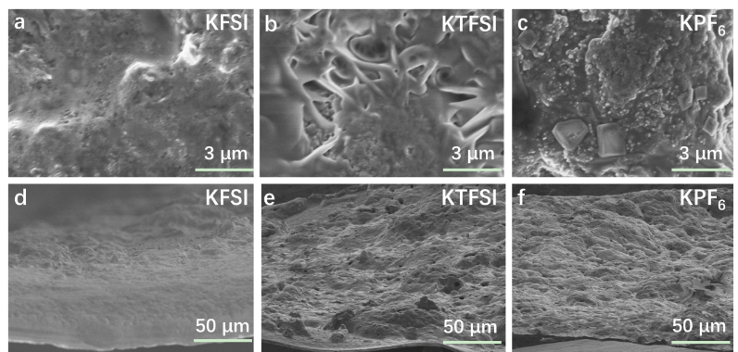
Figure S8 SEM images of the SnS₂ cathode after cycling in electrolytes containing (a,d) KFSI, (b,e) KTFSI and (c,f) KPF₆. (a-c) top views, (d-f) side views.

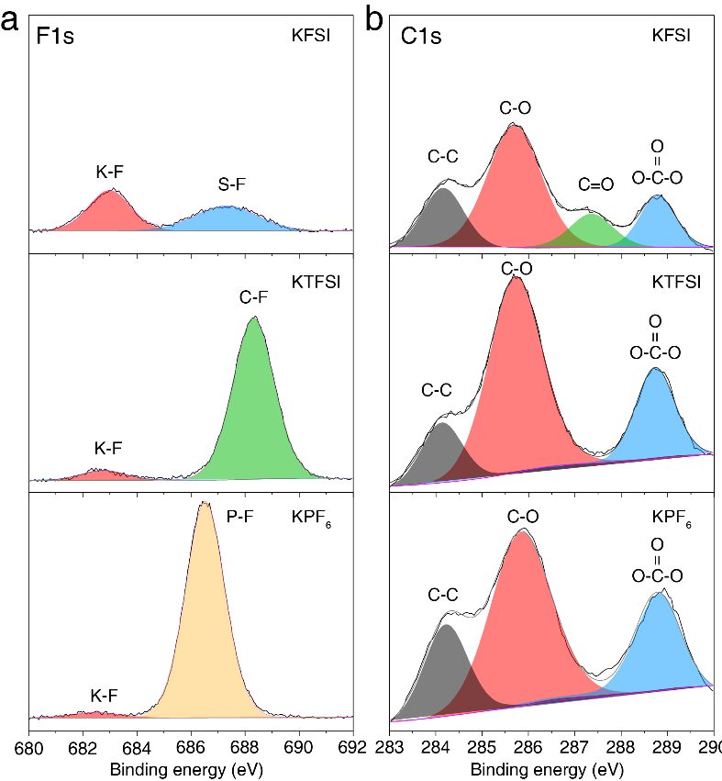
Figure S9 XPS results of the SnS₂/N-rGO electrodes after cycling in electrolyte containing various K salts. (a) F1s spectra, (b) C1s sepctra.

