Supporting Information

Fabrication and Characterization of Zeolite ZSM-12@MOF-74 Nanoporous Coordination Polymer Nanocomposite for removal of environmental toxic substances
Azita Albouyeh, Afshin Pourahmad*, Hassan Kefayati
Department of Chemistry, Rasht Branch, Islamic Azad University, Rasht, Iran
* Corresponding author E-mail: pourahmad@iaurasht.ac.ir; afshinpourahmad@yahoo.com

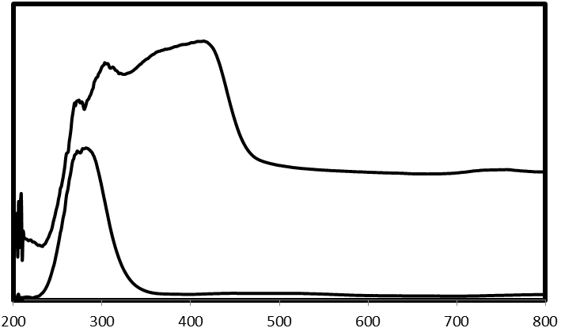
Wavelength (nm)
Absorbance (a.u)
a
b
A

B
b
a

Fig. S1. (A) Diffuse reflectance spectra of the (a) ZSM-12, (b) ZSM-12@MOF core@shell. (B) N₂ adsorption-desorption isotherm of the (a) MOF-74 and (b) ZSM-12@MOF-74(Zn) samples.

a
Removal (%)

Recycle times

b
Intensity (a.u)

*

*
*
*MOF-74

*

2Ɵ

Fig. S2. (a) Effect of recycle times of ZSM-12@MOF-74 on the MB adsorption capacity (room temperature, C₀ = 10 mg/L, catalyst amount = 0.4 g/l, pH = 9, contact time = 30 min) and (b) XRD pattern of ZSM-12@MOF-74 core@shell after visible light irradiation.

