Supplementary Information and Supplementary Figure Legends

The aging whole blood transcriptome reveals a potential role of FASLG in COVID-19

Luiz Gustavo de Almeida Chuffa^{1#}, Paula Paccielli Freire², Jeferson dos Santos Souza¹, Mariana Costa de Mello³, Mario de Oliveira Neto³, Robson Francisco Carvalho^{1#}
¹ Department of Structural and Functional Biology, UNESP - São Paulo State University, Institute of Biosciences, Botucatu, 18618-689, São Paulo, Brazil.
² Department of Immunology, Institute of Biomedical Sciences, University of São Paulo, São Paulo, Brazil.
³ Department of Biophysics and Pharmacology, UNESP - São Paulo State University, Institute of Biosciences, Botucatu, 18618-689, São Paulo, Brazil.

# These authors contributed equally to this work

Running-title: SARS-CoV interaction in aged blood

*Corresponding author:
Luiz Gustavo de Almeida Chuffa, Department of Structural and Functional Biology, Institute of Biosciences of Botucatu, UNESP - São Paulo State University, Botucatu, São Paulo, Brazil, Zip Code: 510; P.O Box: 18618-689, Rubião Júnior, s/n, Botucatu, SP – Brazil, Phone: +55 (14) 3880-0027, Fax: +55 (14) 3811-6361. Email: luiz-gustavo.chuffa@unesp.br

Figure S1. Heatmap of the whole blood samples distributed by age after PPI virus-host interaction prediction. Data showing the mean expression of differentially expressed genes, normalized by the trimmed mean of M-values (TMM) and visualized as Z-score. Two factors (A and B) were used for age clustering.

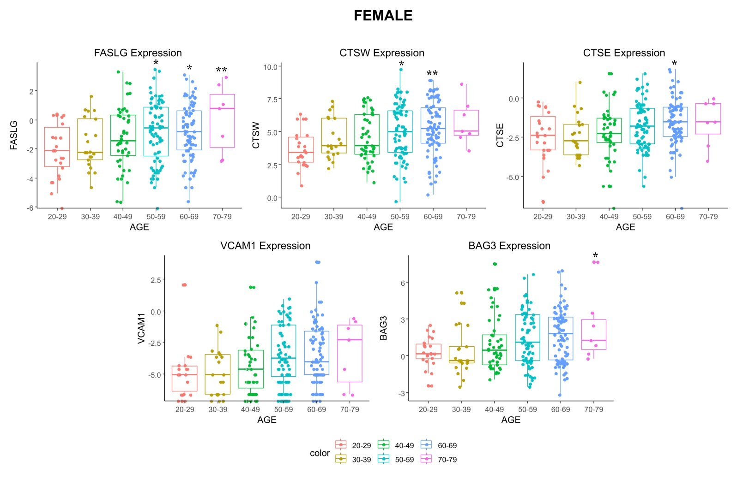

Figure S2. Gene expression levels (TMM) of common targets in female blood samples over aging. Data are represented in boxplot by mean ± SD. * P < 0.05, ** P < 0.001, and *** P < 0.0001 vs. young adult individuals (20-29 years old). ANOVA complemented by Tukey's test. FASLG: tumor necrosis factor ligand superfamily member 6; CTSE: cathepsin E; CTSW: cathepsin W; VCAM1: vascular cell adhesion molecule 1; BAG3: BAG family molecular chaperone regulator 3.

Figure S3. Gene expression levels (TMM) of common targets in male blood samples over aging. Data are represented in boxplot by mean ± SD. * P < 0.05, ** P < 0.001 vs. young adult individuals (20-29 years old). ANOVA complemented by Tukey's test. FASLG: tumor necrosis factor ligand superfamily member 6; CTSE: cathepsin E; CTSW: cathepsin W; VCAM1: vascular cell adhesion molecule 1; BAG3: BAG family molecular chaperone regulator 3.

