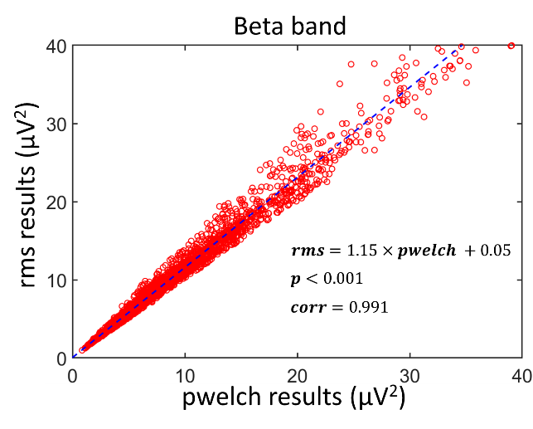
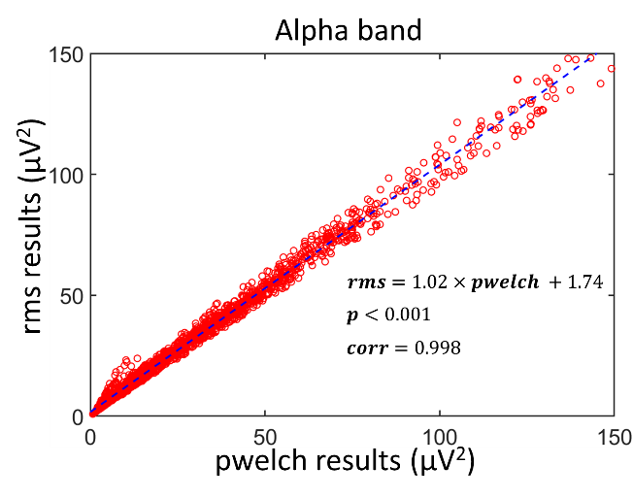
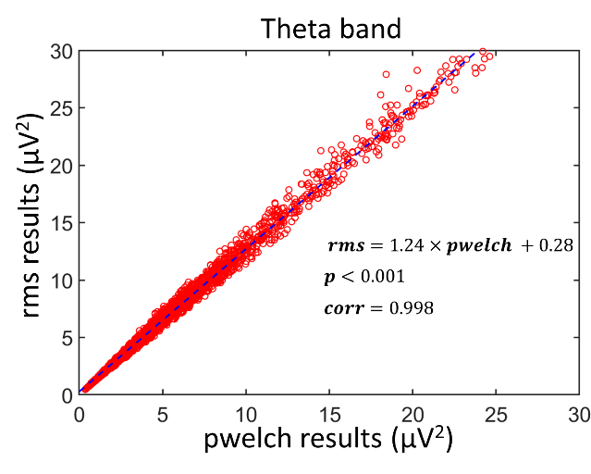
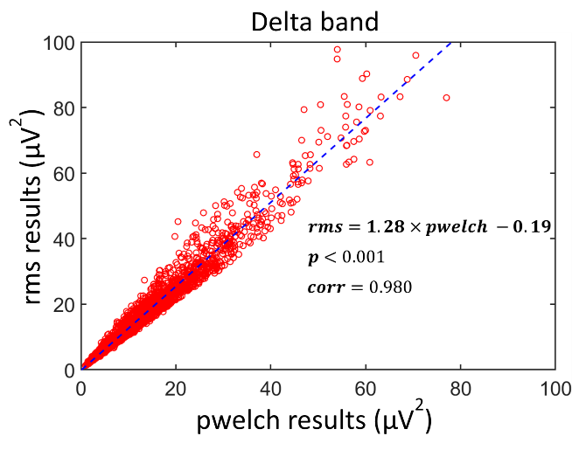
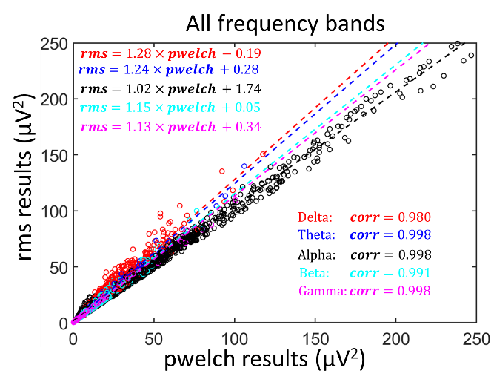
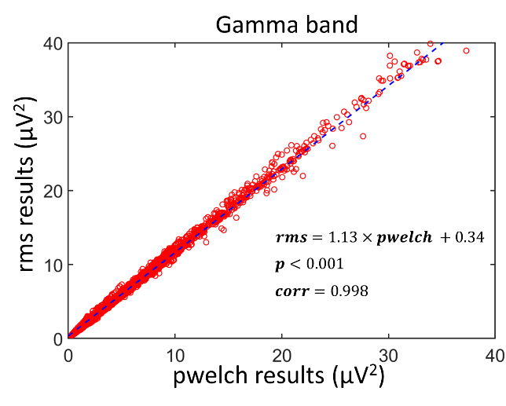
- (b)
(c) (d)
(e) (f)
Fig. S1 Scatter plots (red circles) between the EEG powers quantified using the ‘rms’ versus the ‘pwelch’ methods in (a) delta; (b) theta; (c) alpha; (d) beta; and (e) gamma bands. For each graph panel, the correlation coefficient (corr), linearly fitted equation, and the corresponding p-value were computed and shown to demonstrate the linear relationship and consistency in EEG powers obtained with ‘rms’ and ‘pwelch’ calcuations. (f) it shows a summary for all frequency bands together.

