Supplementary Materials
Supplementary Figure 1 Construction of protein–protein interaction(PPI) network of differentially expressed genes (DEGs).
Supplementary Figure 2. Construction of protein–protein interaction(PPI) network of genes included in blue module.
Supplementary Figure 3. Construction of protein–protein interaction(PPI) network of genes included in brown module.
Supplementary Figure 4. Construction of protein–protein interaction(PPI) network of genes included in yellow module.
Supplementary Table S1. Top 100 upregulated and 100 downregulated genes altly expressed in tubulointerstitial of CKD patients
Supplementary Table S2. Gene Ontology(GO) and pathway term of differentially expressed genes significantly enriched (FDR < 0.05).
Supplementary Table S3. Gene ontology(GO) biological process(BP) term of genes in each module
Supplementary Table S4. KEGG pathway term of genes in each module
Supplementary Table S5. A complete list of hub genes in each module constructed by weighted gene correlation network analysis (WGCNA)
Supplementary Table S6. The expression levels and clinical significance of PLG in chronic kidney diseases(CKD)
Supplementary Table S7. The expression levels and clinical significance of ITGB2 in chronic kidney diseases(CKD)
Supplementary Table S8. The expression levels and clinical significance of CTSS in chronic kidney diseases(CKD)
Supplementary Table S9. The expression levels and clinical significance of CCL5 in chronic kidney diseases(CKD)

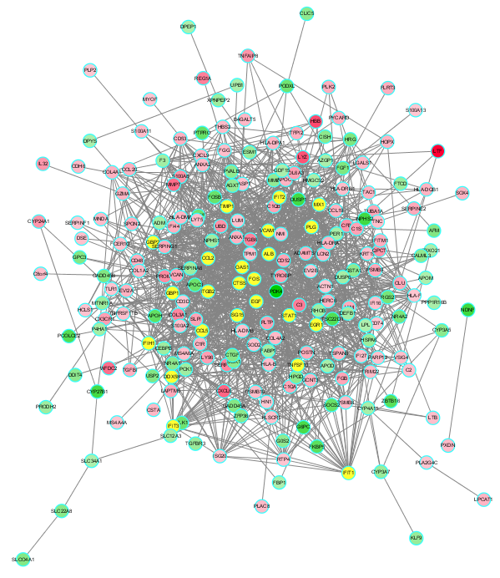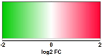
Supplementary Figure 1 Construction of protein–protein interaction(PPI) network of differentially expressed genes (DEGs). the yellow nodes denote the top 10% genes with the highest degree. the other colours represent the log2fold chang value of each gene.

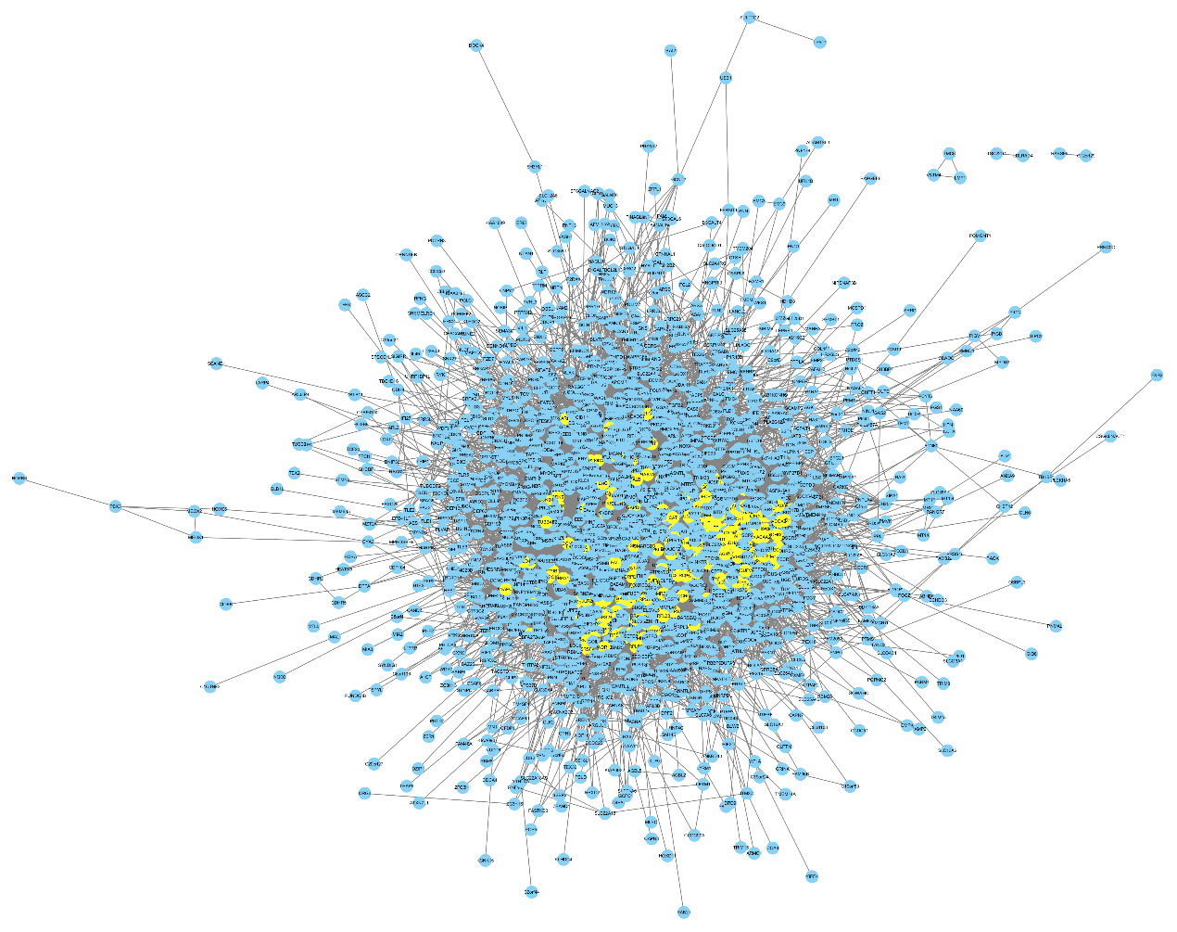
Supplementary Figure 2 Construction of protein–protein interaction(PPI) network of genes included in blue module. the yellow nodes denote the top 10% genes with the highest degree.

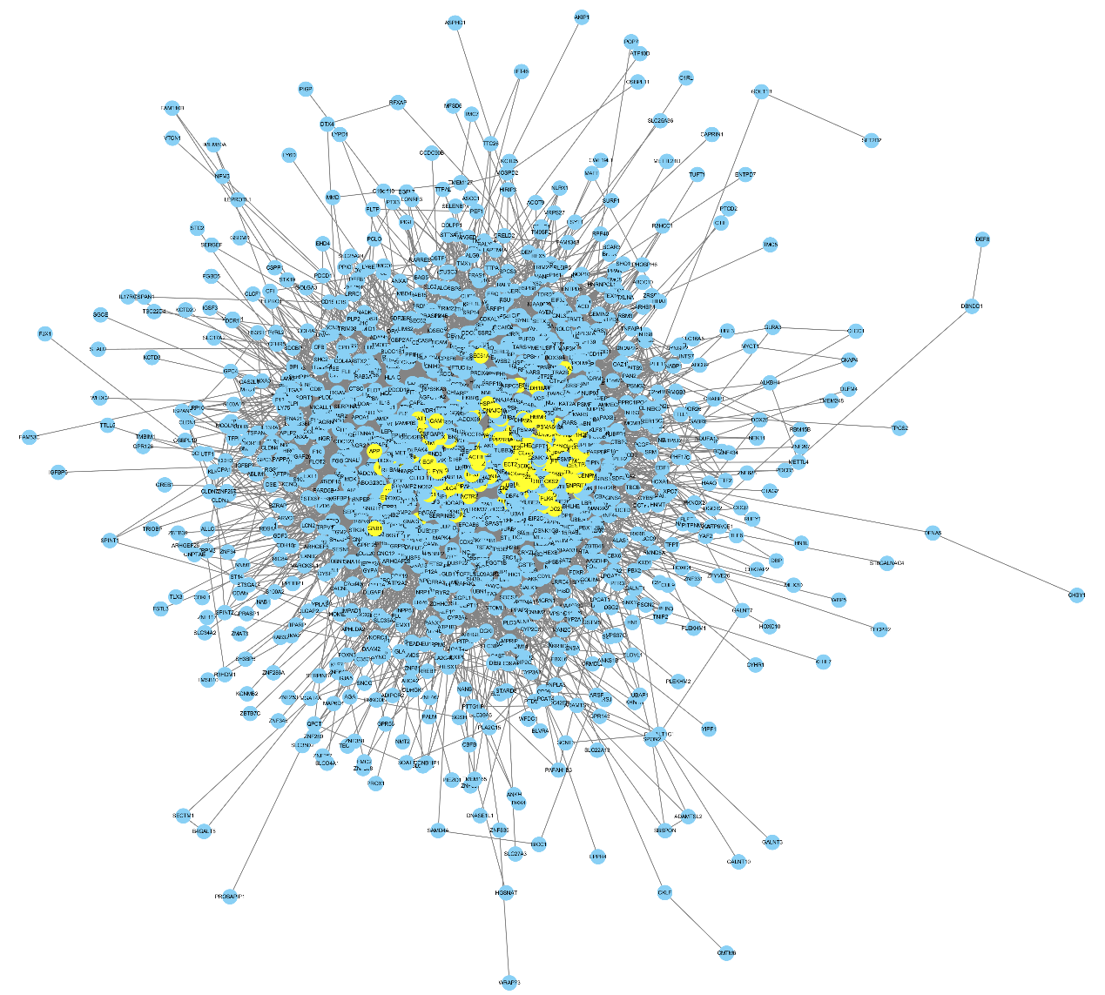
Supplementary Figure 3 Construction of protein–protein interaction(PPI) network of genes included in brown module. the yellow nodes denote the top 10% genes with the highest degree.
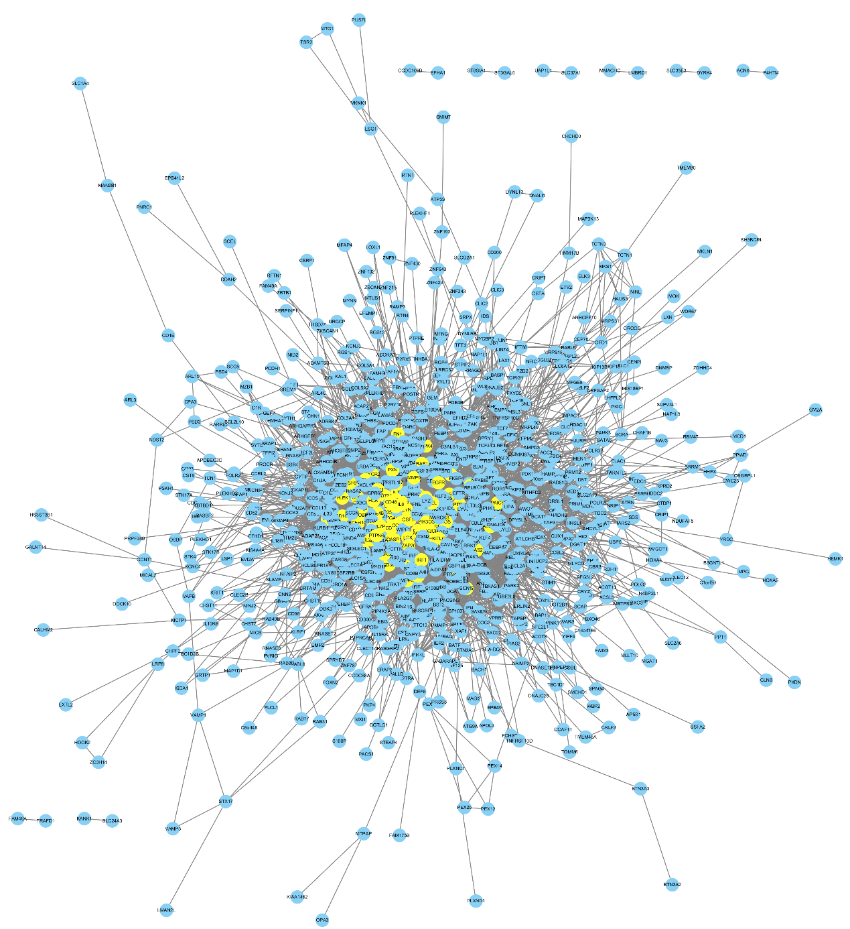
Supplementary Figure 4 Construction of protein–protein interaction(PPI) network of genes included in yellow module. the yellow nodes denote the top 10% genes with the highest degree.

Supplementary Figure 5 The correlation between estimated glomerular filtration rate(eGFR) and the expression of hub genes validated in series of datasets. (A-D) The expression level of tubulointerstitial FBP1 is significantly positively correlated with eGFR of patients with multiple chronic kidney disease(CKD)(A), nephritic syndrome(NS)(B), receiving kidney transplants(C), Diabetic Nephropathy(DN)(D); (E-L) the expression level of tubulointerstitial TMSB10(E-H), and CD53(I-L) is significantly negatively correlated with the eGFR of patients with CKD(E, I), NS(G, J), (H, L, P), receiving kidney transplants(C) (G,K) and DN(H, L).

Supplementary Table S1. Top 100 upregulated and 100 downregulated genes altly expressed in tubulointerstitial of CKD patients

Up-regulated genes |  |  | Down-regulated genes
Gene | logFC | AveExpr | adj.P.Val | Gene | logFC
LTF | 2.679 | 8.359 | 2.02E-06 | PDK4 | -1.854
HBB | 1.908 | 9.495 | 1.51E-05 | ALB | -1.516
LYZ | 1.810 | 6.569 | 3.07E-05 | FOS | -1.442
CXCL6 | 1.615 | 4.917 | 5.12E-05 | NDNF | -1.402
MMP7 | 1.538 | 9.600 | 9.77E-05 | NPHS2 | -1.372
WFDC2 | 1.511 | 9.688 | 5.66E-06 | TIPARP | -1.372
C3 | 1.381 | 8.536 | 1.04E-04 | CYP27B1 | -1.361
IGKC | 1.352 | 10.547 | 1.01E-02 | DUSP1 | -1.358
REG1A | 1.332 | 5.735 | 2.54E-04 | G6PC | -1.314
ITGB6 | 1.319 | 5.522 | 7.97E-06 | TSC22D3 | -1.248
NNMT | 1.312 | 7.203 | 2.55E-03 | PCOLCE2 | -1.245
SERPINA3 | 1.294 | 8.206 | 2.82E-04 | ZBTB16 | -1.191
COL3A1 | 1.270 | 7.498 | 1.08E-04 | FKBP5 | -1.182
TIMP1 | 1.234 | 8.489 | 1.60E-04 | APOH | -1.134
PROM1 | 1.209 | 8.030 | 1.83E-04 | PTPRO | -1.112
OLFM4 | 1.190 | 5.418 | 3.35E-03 | LEFTY1 | -1.100
S100A8 | 1.150 | 6.348 | 5.91E-03 | SOCS2 | -1.099
CFB | 1.147 | 7.600 | 2.76E-06 | FOSB | -1.080
UBD | 1.139 | 7.704 | 7.25E-06 | APOC3 | -1.071
QPCT | 1.131 | 5.314 | 5.88E-07 | MAFF | -1.056
TNFAIP8 | 1.125 | 7.061 | 2.02E-10 | KLK1 | -1.036
CYP24A1 | 1.095 | 7.024 | 5.13E-04 | PODXL | -1.035
IL32 | 1.089 | 7.877 | 1.66E-05 | EGR1 | -1.008
TTC39A | 1.026 | 6.419 | 4.52E-08 | RGS2 | -0.978
TYROBP | 1.022 | 6.988 | 3.54E-04 | NR4A2 | -0.962
PLTP | 1.019 | 7.527 | 8.88E-05 | TMEM100 | -0.948
LY96 | 1.016 | 5.133 | 3.68E-04 | FGF1 | -0.923
COL6A3 | 1.011 | 6.401 | 4.86E-04 | HRG | -0.914
IGHM | 1.010 | 6.434 | 7.71E-03 | GADD45B | -0.911
CX3CR1 | 1.004 | 6.081 | 4.48E-06 | ZFAND5 | -0.908
IGLL3P | 0.999 | 5.727 | 4.53E-02 | CHI3L1 | -0.906
RARRES1 | 0.993 | 5.885 | 2.38E-04 | AFM | -0.896
C1S | 0.991 | 7.609 | 1.60E-04 | USP2 | -0.895
GUSBP11 | 0.982 | 7.518 | 4.56E-02 | EGF | -0.893
C1QB | 0.975 | 6.142 | 1.46E-03 | SLCO4A1 | -0.889
SLPI | 0.975 | 8.013 | 1.62E-03 | GADD45A | -0.889
VCAN | 0.960 | 4.992 | 1.24E-04 | GPC3 | -0.885
CD52 | 0.955 | 5.760 | 5.47E-04 | MT1X | -0.872
TUBA1A | 0.953 | 9.738 | 6.14E-05 | HPD | -0.870
C1QA | 0.947 | 6.643 | 4.56E-04 | PTGDS | -0.864
FGB | 0.946 | 6.074 | 2.54E-02 | CTGF | -0.860
PSMB9 | 0.923 | 7.053 | 3.92E-05 | SLC22A8 | -0.853
CLU | 0.921 | 9.006 | 5.32E-05 | ZFP36 | -0.839
LAPTM5 | 0.915 | 7.351 | 1.27E-03 | APOLD1 | -0.838
VCAM1 | 0.910 | 10.574 | 1.63E-05 | CISH | -0.831
SERPINE2 | 0.907 | 9.838 | 8.44E-08 | CYP3A5 | -0.827
ADAMTS1 | 0.901 | 6.709 | 4.75E-04 | NR4A1 | -0.823
SERPING1 | 0.897 | 8.319 | 5.54E-05 | ELL2 | -0.822
TNFSF10 | 0.893 | 9.857 | 7.20E-10 | DDIT4 | -0.820
VIM | 0.891 | 10.729 | 6.35E-05 | CLIC5 | -0.816
IGHV3-21 | 0.889 | 4.432 | 9.48E-03 | HPGD | -0.813
TMSB10 | 0.884 | 11.597 | 2.04E-05 | SGK1 | -0.812
POSTN | 0.875 | 6.170 | 5.91E-03 | SLC19A2 | -0.808
PLK2 | 0.851 | 4.820 | 1.08E-07 | PVALB | -0.807
FLRT3 | 0.851 | 8.539 | 2.26E-10 | CALML3 | -0.804
IFI44 | 0.849 | 5.792 | 6.50E-04 | G0S2 | -0.802
SPON2 | 0.846 | 7.418 | 2.09E-04 | GSTA1 | -0.797
IFITM1 | 0.846 | 9.022 | 7.44E-04 | CTSV | -0.797
IGHV4-28 | 0.845 | 4.459 | 1.89E-02 | RHCG | -0.785
CD48 | 0.844 | 6.521 | 2.48E-03 | MME | -0.781
CCL20 | 0.843 | 4.924 | 8.83E-04 | AGXT | -0.755
TGFBI | 0.838 | 7.597 | 1.75E-04 | KLF9 | -0.744
TFPI2 | 0.838 | 5.370 | 3.27E-04 | TGFBR3 | -0.730
RRM2 | 0.824 | 4.867 | 5.79E-05 | CYP3A7 | -0.728
GCNT3 | 0.823 | 6.141 | 1.49E-07 | TREH | -0.727
IFIT3 | 0.820 | 7.514 | 6.45E-08 | PLG | -0.727
CD53 | 0.820 | 7.798 | 7.41E-04 | ESM1 | -0.722
COL4A1 | 0.816 | 8.418 | 5.12E-06 | MTNR1A | -0.713
APOBEC3B | 0.815 | 4.531 | 1.61E-05 | HSPA6 | -0.711
ANXA1 | 0.814 | 7.183 | 1.01E-03 | FTCD | -0.708
LCN2 | 0.814 | 5.888 | 2.46E-03 | XPNPEP2 | -0.704
EVI2A | 0.813 | 5.350 | 1.17E-03 | METTL21B | -0.704
PYCARD | 0.812 | 5.375 | 1.33E-05 | SERPINA6 | -0.690
CCL19 | 0.810 | 5.488 | 1.07E-02 | PRODH2 | -0.689
APOC1 | 0.801 | 8.351 | 3.93E-03 | PCK1 | -0.685
GZMA | 0.800 | 5.231 | 3.83E-04 | CEBPB | -0.684
C1R | 0.799 | 7.606 | 4.70E-04 | ZNF331 | -0.680
HLA-DRA | 0.797 | 10.016 | 4.23E-04 | ETNK2 | -0.679
HOPX | 0.795 | 6.065 | 1.36E-03 | NPHS1 | -0.678
TAC1 | 0.795 | 4.486 | 1.63E-03 | RHOB | -0.672
HLA-DQB1 | 0.795 | 6.562 | 4.43E-03 | F3 | -0.664
HERC6 | 0.795 | 6.506 | 1.83E-05 | SLC12A3 | -0.658
ISG15 | 0.792 | 7.328 | 6.99E-03 | DEFB1 | -0.657
SOX4 | 0.784 | 7.286 | 2.64E-06 | FABP1 | -0.655
HLA-DMA | 0.779 | 8.337 | 9.47E-05 | PQLC1 | -0.654
LPCAT1 | 0.779 | 6.600 | 3.27E-08 | RNF186 | -0.654
MX1 | 0.778 | 7.318 | 8.50E-04 | DUSP6 | -0.649
CTSS | 0.777 | 5.290 | 1.51E-04 | ADM | -0.647
HLA-DPA1 | 0.770 | 9.756 | 2.13E-03 | CHP2 | -0.644
CXCL9 | 0.768 | 5.937 | 4.72E-03 | P4HA1 | -0.644
TSPAN8 | 0.761 | 7.995 | 2.74E-03 | PER1 | -0.639
CSTA | 0.756 | 4.775 | 4.37E-04 | APOD | -0.626
LGALS1 | 0.754 | 8.521 | 4.75E-04 | TKFC | -0.626
B4GALT5 | 0.753 | 8.267 | 3.91E-11 | PPP1R16B | -0.626
COL4A2 | 0.749 | 7.773 | 8.32E-06 | CYP4A11 | -0.623
COL1A2 | 0.745 | 6.743 | 2.42E-03 | UPB1 | -0.613
ANXA2 | 0.743 | 10.488 | 6.26E-04 | ADIRF | -0.613
CDH6 | 0.741 | 7.080 | 3.96E-05 | AZGP1 | -0.611
CKLF | 0.736 | 6.647 | 4.00E-04 | GDF15 | -0.607
PSMB8 | 0.734 | 7.480 | 3.34E-05 | DPYS | -0.606

Supplementary Table S2. Gene ontology(GO) and pathway term of differentially expressed genes signifcantly enriched (FDR < 0.05).
NO. | Biological Process ( BP ) Term | Count | % | FDR
GO:0006955 | immune response | 37 | 12.6 | 9.44E-13
GO:0060337 | type I interferon signaling pathway | 15 | 5.1 | 3.10E-09
GO:0045087 | innate immune response | 29 | 9.9 | 1.08E-06
GO:0045071 | negative regulation of viral genome replication | 11 | 3.7 | 1.18E-06
GO:0060333 | interferon-gamma-mediated signaling pathway | 13 | 4.4 | 2.93E-06
GO:0051607 | defense response to virus | 18 | 6.1 | 3.46E-06
GO:0009615 | response to virus | 15 | 5.1 | 6.04E-06
GO:0006954 | inflammatory response | 26 | 8.8 | 7.23E-06
GO:0030198 | extracellular matrix organization | 18 | 6.1 | 4.70E-05
GO:0006956 | complement activation | 12 | 4.1 | 3.17E-04
GO:0019882 | antigen processing and presentation | 10 | 3.4 | 4.42E-04
GO:0006958 | complement activation, classical pathway | 12 | 4.1 | 1.20E-03
GO:0010951 | negative regulation of endopeptidase activity | 13 | 4.4 | 1.29E-03
GO:0002576 | platelet degranulation | 12 | 4.1 | 1.79E-03
GO:0071347 | cellular response to interleukin-1 | 10 | 3.4 | 4.11E-03
GO:0032496 | response to lipopolysaccharide | 14 | 4.8 | 5.72E-03
GO:0002504 | antigen processing and presentation of peptide or polysaccharide antigen via MHC class II | 6 | 2.0 | 1.05E-02
GO:0016525 | negative regulation of angiogenesis | 9 | 3.1 | 1.32E-02
GO:0050776 | regulation of immune response | 14 | 4.8 | 1.41E-02
GO:0006508 | proteolysis | 24 | 8.2 | 1.65E-02
GO:0071356 | cellular response to tumor necrosis factor | 11 | 3.7 | 2.37E-02
GO:0007568 | aging | 13 | 4.4 | 3.27E-02
GO:0042730 | fibrinolysis | 6 | 2.0 | 3.28E-02
GO:0019886 | antigen processing and presentation of exogenous peptide antigen via MHC class II | 10 | 3.4 | 3.55E-02
NO. | cellular component ( CC ) term | Count | % | FDR
GO:0070062 | extracellular exosome | 130 | 44.2 | 1.96E-30
GO:0005615 | extracellular space | 82 | 27.9 | 4.43E-24
GO:0005576 | extracellular region | 81 | 27.6 | 2.11E-18
GO:0031012 | extracellular matrix | 27 | 9.2 | 1.57E-09
GO:0072562 | blood microparticle | 19 | 6.5 | 3.76E-08
GO:0005578 | proteinaceous extracellular matrix | 21 | 7.1 | 1.16E-05
GO:0031093 | platelet alpha granule lumen | 11 | 3.7 | 1.54E-05
GO:0009986 | cell surface | 28 | 9.5 | 1.61E-04
GO:0042613 | MHC class II protein complex | 7 | 2.4 | 1.10E-03
GO:0071556 | integral component of lumenal side of endoplasmic reticulum membrane | 7 | 2.4 | 6.37E-03
NO. | molecular function ( MF ) term | Count | % | FDR
GO:0008201 | heparin binding | 16 | 5.4 | 7.66E-05
GO:0004252 | serine-type endopeptidase activity | 18 | 6.1 | 1.38E-03
GO:0005201 | extracellular matrix structural constituent | 9 | 3.1 | 1.78E-02
GO:0004867 | serine-type endopeptidase inhibitor activity | 10 | 3.4 | 4.04E-02
NO. | pathway term | Count | % | FDR
hsa05150 | Staphylococcus aureus infection | 16 | 5.4 | 2.63E-10
hsa05133 | Pertussis | 14 | 4.8 | 6.50E-06
hsa05168 | Herpes simplex infection | 19 | 6.5 | 7.63E-05
hsa05164 | Influenza A | 18 | 6.1 | 2.02E-04
hsa04610 | Complement and coagulation cascades | 12 | 4.1 | 2.54E-04
hsa05323 | Rheumatoid arthritis | 13 | 4.4 | 4.09E-04
hsa04612 | Antigen processing and presentation | 11 | 3.7 | 5.70E-03
hsa05332 | Graft-versus-host disease | 8 | 2.7 | 6.31E-03
hsa05152 | Tuberculosis | 16 | 5.4 | 6.82E-03
hsa05330 | Allograft rejection | 8 | 2.7 | 1.42E-02
hsa05140 | Leishmaniasis | 10 | 3.4 | 2.37E-02
hsa04145 | Phagosome | 14 | 4.8 | 2.89E-02
hsa05416 | Viral myocarditis | 9 | 3.1 | 3.29E-02
hsa04940 | Type I diabetes mellitus | 8 | 2.7 | 3.39E-02
hsa05322 | Systemic lupus erythematosus | 13 | 4.4 | 3.58E-02
hsa05310 | Asthma | 7 | 2.4 | 4.42E-02

Supplementary Table S3. Gene ontology(GO) biological process(BP) term of genes in each module
GO No. | turquoise biological process (BP) Term | Count | % | FDR
GO:0007268 | chemical synaptic transmission | 120 | 4.01 | 2.96E-31
GO:0007187 | G-protein coupled receptor signaling pathway, coupled to cyclic nucleotide second messenger | 33 | 1.10 | 1.08E-12
GO:0007601 | visual perception | 74 | 2.47 | 2.15E-09
GO:0045944 | positive regulation of transcription from RNA polymerase II promoter | 234 | 7.82 | 5.82E-08
GO:0006366 | transcription from RNA polymerase II promoter | 139 | 4.64 | 1.52E-07
GO:0007267 | cell-cell signaling | 82 | 2.74 | 2.71E-07
GO:0071805 | potassium ion transmembrane transport | 49 | 1.64 | 4.89E-07
GO:0034765 | regulation of ion transmembrane transport | 45 | 1.50 | 2.78E-06
GO:0007200 | phospholipase C-activating G-protein coupled receptor signaling pathway | 31 | 1.04 | 2.71E-05
GO:0006813 | potassium ion transport | 35 | 1.17 | 5.29E-05
GO:0042391 | regulation of membrane potential | 33 | 1.10 | 5.93E-05
GO:0007218 | neuropeptide signaling pathway | 39 | 1.30 | 1.86E-04
GO:0035094 | response to nicotine | 21 | 0.70 | 1.95E-04
GO:0007204 | positive regulation of cytosolic calcium ion concentration | 47 | 1.57 | 2.24E-04
GO:0035235 | ionotropic glutamate receptor signaling pathway | 16 | 0.53 | 6.07E-04
GO:0045165 | cell fate commitment | 23 | 0.77 | 7.63E-04
GO:0006810 | transport | 92 | 3.07 | 1.02E-03
GO:0007188 | adenylate cyclase-modulating G-protein coupled receptor signaling pathway | 20 | 0.67 | 1.17E-03
GO:0007271 | synaptic transmission, cholinergic | 20 | 0.67 | 1.17E-03
GO:0007399 | nervous system development | 78 | 2.61 | 2.61E-03
GO:0007411 | axon guidance | 49 | 1.64 | 8.34E-03
GO:0086010 | membrane depolarization during action potential | 16 | 0.53 | 9.19E-03
GO:0007626 | locomotory behavior | 31 | 1.04 | 1.39E-02
GO:0006936 | muscle contraction | 36 | 1.20 | 2.38E-02
GO:0007417 | central nervous system development | 39 | 1.30 | 2.41E-02
GO:0045893 | positive regulation of transcription, DNA-templated | 119 | 3.98 | 3.07E-02
GO:0007586 | digestion | 25 | 0.84 | 3.24E-02
GO:0019233 | sensory perception of pain | 22 | 0.74 | 3.83E-02
GO:0034220 | ion transmembrane transport | 58 | 1.94 | 4.08E-02
GO:0007631 | feeding behavior | 18 | 0.60 | 4.83E-02
GO:0070588 | calcium ion transmembrane transport | 38 | 1.27 | 4.91E-02
GO No. | blue biological process (BP) Term | Count | % | FDR
GO:0055114 | oxidation-reduction process | 155 | 6.85 | 1.58E-17
GO:0006635 | fatty acid beta-oxidation | 25 | 1.10 | 3.43E-08
GO:0033539 | fatty acid beta-oxidation using acyl-CoA dehydrogenase | 14 | 0.62 | 1.25E-05
GO:0008152 | metabolic process | 49 | 2.16 | 1.99E-05
GO:0009083 | branched-chain amino acid catabolic process | 14 | 0.62 | 3.50E-05
GO:0006099 | tricarboxylic acid cycle | 17 | 0.75 | 6.73E-05
GO:0006094 | gluconeogenesis | 21 | 0.93 | 9.81E-05
GO:0055088 | lipid homeostasis | 17 | 0.75 | 1.12E-02
GO:0005975 | carbohydrate metabolic process | 43 | 1.90 | 2.04E-02
GO:0051289 | protein homotetramerization | 21 | 0.93 | 3.32E-02
GO:0046487 | glyoxylate metabolic process | 13 | 0.57 | 3.96E-02
GO No. | brown biological process (BP) Term | Count | % | FDR
GO:0051301 | cell division | 89 | 5.10 | 2.70E-14
GO:0007067 | mitotic nuclear division | 68 | 3.90 | 6.34E-12
GO:0098609 | cell-cell adhesion | 67 | 3.84 | 2.04E-09
GO:0008283 | cell proliferation | 77 | 4.41 | 1.87E-07
GO:0031145 | anaphase-promoting complex-dependent catabolic process | 28 | 1.60 | 4.48E-06
GO:0051437 | positive regulation of ubiquitin-protein ligase activity involved in regulation of mitotic cell cycle transition | 27 | 1.55 | 8.63E-06
GO:0051436 | negative regulation of ubiquitin-protein ligase activity involved in mitotic cell cycle | 26 | 1.49 | 8.65E-06
GO:0006260 | DNA replication | 41 | 2.35 | 9.94E-06
GO:0043161 | proteasome-mediated ubiquitin-dependent protein catabolic process | 48 | 2.75 | 2.10E-05
GO:0000086 | G2/M transition of mitotic cell cycle | 37 | 2.12 | 3.44E-05
GO:0007052 | mitotic spindle organization | 16 | 0.92 | 4.19E-05
GO:0002479 | antigen processing and presentation of exogenous peptide antigen via MHC class I, TAP-dependent | 22 | 1.26 | 4.32E-04
GO:0016032 | viral process | 58 | 3.32 | 8.68E-04
GO:0006928 | movement of cell or subcellular component | 25 | 1.43 | 2.46E-03
GO:0000082 | G1/S transition of mitotic cell cycle | 27 | 1.55 | 5.91E-03
GO:0006521 | regulation of cellular amino acid metabolic process | 18 | 1.03 | 6.07E-03
GO:0048013 | ephrin receptor signaling pathway | 24 | 1.38 | 9.03E-03
GO:0060071 | Wnt signaling pathway, planar cell polarity pathway | 25 | 1.43 | 9.07E-03
GO:0006915 | apoptotic process | 89 | 5.10 | 1.02E-02
GO:0043066 | negative regulation of apoptotic process | 75 | 4.30 | 1.08E-02
GO:0097193 | intrinsic apoptotic signaling pathway | 13 | 0.74 | 2.04E-02
GO:0042493 | response to drug | 54 | 3.09 | 3.25E-02
GO:0002223 | stimulatory C-type lectin receptor signaling pathway | 26 | 1.49 | 3.29E-02
GO:0007093 | mitotic cell cycle checkpoint | 13 | 0.74 | 4.43E-02
GO No. | yellow biological process (BP) Term | Count | % | FDR
GO:0006955 | immune response | 117 | 0.07 | 2.11E-42
GO:0006954 | inflammatory response | 91 | 0.06 | 7.51E-27
GO:0050776 | regulation of immune response | 50 | 0.03 | 1.54E-16
GO:0045087 | innate immune response | 79 | 0.05 | 2.39E-15
GO:0007165 | signal transduction | 148 | 0.09 | 4.28E-15
GO:0002250 | adaptive immune response | 43 | 0.03 | 1.97E-14
GO:0070098 | chemokine-mediated signaling pathway | 26 | 0.02 | 3.88E-10
GO:0032496 | response to lipopolysaccharide | 39 | 0.02 | 9.97E-10
GO:0006935 | chemotaxis | 33 | 0.02 | 1.89E-09
GO:0031295 | T cell costimulation | 26 | 0.02 | 4.41E-09
GO:0006968 | cellular defense response | 23 | 0.01 | 9.04E-09
GO:0060333 | interferon-gamma-mediated signaling pathway | 24 | 0.01 | 2.60E-08
GO:0051607 | defense response to virus | 37 | 0.02 | 2.66E-08
GO:0050853 | B cell receptor signaling pathway | 21 | 0.01 | 3.39E-08
GO:0030593 | neutrophil chemotaxis | 23 | 0.01 | 3.80E-08
GO:0050900 | leukocyte migration | 31 | 0.02 | 5.69E-08
GO:0050852 | T cell receptor signaling pathway | 34 | 0.02 | 1.02E-07
GO:0007155 | cell adhesion | 67 | 0.04 | 1.03E-07
GO:0090023 | positive regulation of neutrophil chemotaxis | 13 | 0.01 | 1.67E-06
GO:0042110 | T cell activation | 17 | 0.01 | 1.49E-05
GO:0032760 | positive regulation of tumor necrosis factor production | 17 | 0.01 | 1.49E-05
GO:0002407 | dendritic cell chemotaxis | 11 | 0.01 | 1.64E-05
GO:0007166 | cell surface receptor signaling pathway | 44 | 0.03 | 1.82E-05
GO:0030168 | platelet activation | 26 | 0.02 | 3.73E-05
GO:0043123 | positive regulation of I-kappaB kinase/NF-kappaB signaling | 31 | 0.02 | 6.46E-05
GO:0007169 | transmembrane receptor protein tyrosine kinase signaling pathway | 23 | 0.01 | 9.61E-05
GO:0060337 | type I interferon signaling pathway | 18 | 0.01 | 3.23E-04
GO:0002504 | antigen processing and presentation of peptide or polysaccharide antigen via MHC class II | 10 | 0.01 | 3.23E-04
GO:0031663 | lipopolysaccharide-mediated signaling pathway | 13 | 0.01 | 3.29E-04
GO:0060326 | cell chemotaxis | 18 | 0.01 | 4.12E-04
GO:0050729 | positive regulation of inflammatory response | 19 | 0.01 | 4.82E-04
GO:0071222 | cellular response to lipopolysaccharide | 24 | 0.01 | 4.87E-04
GO:0051092 | positive regulation of NF-kappaB transcription factor activity | 26 | 0.02 | 7.41E-04
GO:0009615 | response to virus | 23 | 0.01 | 1.21E-03
GO:0007267 | cell-cell signaling | 38 | 0.02 | 1.31E-03
GO:0030217 | T cell differentiation | 12 | 0.01 | 1.41E-03
GO:0070374 | positive regulation of ERK1 and ERK2 cascade | 30 | 0.02 | 1.45E-03
GO:0001816 | cytokine production | 11 | 0.01 | 1.76E-03
GO:0050850 | positive regulation of calcium-mediated signaling | 10 | 0.01 | 1.89E-03
GO:0006952 | defense response | 17 | 0.01 | 3.51E-03
GO:0042102 | positive regulation of T cell proliferation | 16 | 0.01 | 3.95E-03
GO:0002755 | MyD88-dependent toll-like receptor signaling pathway | 12 | 0.01 | 4.21E-03
GO:0038095 | Fc-epsilon receptor signaling pathway | 29 | 0.02 | 6.44E-03
GO:0019882 | antigen processing and presentation | 15 | 0.01 | 6.83E-03
GO:0042113 | B cell activation | 11 | 0.01 | 8.63E-03
GO:0043547 | positive regulation of GTPase activity | 63 | 0.04 | 8.77E-03
GO:0031623 | receptor internalization | 13 | 0.01 | 1.20E-02
GO:0035556 | intracellular signal transduction | 49 | 0.03 | 1.22E-02
GO:0038096 | Fc-gamma receptor signaling pathway involved in phagocytosis | 23 | 0.01 | 1.46E-02
GO:0006898 | receptor-mediated endocytosis | 29 | 0.02 | 1.53E-02
GO:0007507 | heart development | 28 | 0.02 | 3.20E-02
GO:0038083 | peptidyl-tyrosine autophosphorylation | 12 | 0.01 | 3.39E-02
GO:0006915 | apoptotic process | 61 | 0.04 | 3.83E-02
GO No. | green biological process (BP) Term | Count | % | FDR
-
GO No. | red biological process (BP) Term | Count | % | FDR
GO:0000122 | negative regulation of transcription from RNA polymerase II promoter | 25 | 11.96 | 3.72E-03
GO:0045892 | negative regulation of transcription, DNA-templated | 19 | 9.09 | 2.62E-02
GO:0006351 | transcription, DNA-templated | 43 | 20.57 | 5.18E-02
GO No. | black biological process (BP) Term | Count | % | FDR
GO:0007588 | excretion | 7 | 0.04 | 2.97E-04
GO No. | pink biological process (BP) Term | Count | % | FDR
GO:0002250 | adaptive immune response | 9 | 0.06 | 8.84E-03
GO:0006955 | immune response | 13 | 0.09 | 3.09E-02
GO No. | magenta biological process (BP) Term | Count | % | FDR
-
GO No. | purple biological process (BP) Term | Count | % | FDR
GO:0042776 | mitochondrial ATP synthesis coupled proton transport | 12 | 0.08 | 8.97E-17
GO:0006120 | mitochondrial electron transport, NADH to ubiquinone | 12 | 0.08 | 6.61E-12
GO:0006754 | ATP biosynthetic process | 10 | 0.06 | 8.38E-11
GO:0015986 | ATP synthesis coupled proton transport | 9 | 0.06 | 5.03E-10
GO:0032981 | mitochondrial respiratory chain complex I assembly | 11 | 0.07 | 4.93E-09
GO:0006123 | mitochondrial electron transport, cytochrome c to oxygen | 8 | 0.05 | 2.21E-08
GO:1902600 | hydrogen ion transmembrane transport | 10 | 0.06 | 1.24E-07
GO:0015991 | ATP hydrolysis coupled proton transport | 7 | 0.04 | 4.34E-05
GO:0032543 | mitochondrial translation | 7 | 0.04 | 9.15E-05
GO:0070125 | mitochondrial translational elongation | 8 | 0.05 | 1.03E-03
GO:0070126 | mitochondrial translational termination | 8 | 0.05 | 1.11E-03
GO No. | greenyellow biological process (BP) Term | Count | % | FDR
-
GO No. | tan biological process (BP) Term | Count | % | FDR
-
GO No. | salmon biological process (BP) Term | Count | % | FDR
-
GO No. | cyan biological process (BP) Term | Count | % | FDR
-
GO No. | midnightblue biological process (BP) Term | Count | % | FDR
-

Supplementary Table S4. KEGG pathway term of genes in each module
KEGG NO. | turquoise pathway term | Count | % | FDR
hsa04080 | Neuroactive ligand-receptor interaction | 155 | 5.18 | 9.16E-46
hsa05033 | Nicotine addiction | 27 | 0.90 | 3.98E-08
hsa04020 | Calcium signaling pathway | 69 | 2.31 | 4.36E-08
hsa04024 | cAMP signaling pathway | 71 | 2.37 | 9.51E-07
hsa04723 | Retrograde endocannabinoid signaling | 42 | 1.40 | 4.22E-05
hsa04724 | Glutamatergic synapse | 43 | 1.44 | 7.11E-04
hsa04727 | GABAergic synapse | 35 | 1.17 | 9.55E-04
hsa05031 | Amphetamine addiction | 29 | 0.97 | 2.27E-03
hsa05032 | Morphine addiction | 35 | 1.17 | 5.94E-03
hsa04725 | Cholinergic synapse | 40 | 1.34 | 6.96E-03
hsa04911 | Insulin secretion | 33 | 1.10 | 9.38E-03
hsa04972 | Pancreatic secretion | 35 | 1.17 | 1.04E-02
hsa05030 | Cocaine addiction | 22 | 0.74 | 3.72E-02
hsa04726 | Serotonergic synapse | 38 | 1.27 | 4.63E-02
hsa04713 | Circadian entrainment | 34 | 1.14 | 4.76E-02
hsa04728 | Dopaminergic synapse | 42 | 1.40 | 5.15E-02
KEGG NO. | blue pathway term | Count | % | FDR
hsa01100 | Metabolic pathways | 315 | 13.91 | 7.20E-27
hsa01130 | Biosynthesis of antibiotics | 85 | 3.75 | 9.42E-17
hsa01200 | Carbon metabolism | 55 | 2.43 | 2.67E-14
hsa00280 | Valine, leucine and isoleucine degradation | 32 | 1.41 | 1.48E-12
hsa04146 | Peroxisome | 41 | 1.81 | 3.39E-10
hsa00071 | Fatty acid degradation | 25 | 1.10 | 8.36E-07
hsa00630 | Glyoxylate and dicarboxylate metabolism | 18 | 0.80 | 1.43E-05
hsa00020 | Citrate cycle (TCA cycle) | 19 | 0.84 | 1.57E-05
hsa01212 | Fatty acid metabolism | 24 | 1.06 | 4.95E-05
hsa00380 | Tryptophan metabolism | 21 | 0.93 | 1.58E-04
hsa00260 | Glycine, serine and threonine metabolism | 20 | 0.88 | 5.56E-04
hsa00410 | beta-Alanine metabolism | 17 | 0.75 | 1.72E-03
hsa00640 | Propanoate metabolism | 16 | 0.71 | 2.00E-03
hsa01230 | Biosynthesis of amino acids | 28 | 1.24 | 3.02E-03
hsa00010 | Glycolysis / Gluconeogenesis | 26 | 1.15 | 4.47E-03
hsa00310 | Lysine degradation | 22 | 0.97 | 6.31E-03
hsa00330 | Arginine and proline metabolism | 21 | 0.93 | 1.26E-02
hsa00340 | Histidine metabolism | 13 | 0.57 | 3.29E-02
KEGG NO. | brown pathway term | Count | % | FDR
hsa04110 | Cell cycle | 37 | 2.12 | 5.50E-04
hsa04141 | Protein processing in endoplasmic reticulum | 45 | 2.58 | 8.86E-04
hsa04115 | p53 signaling pathway | 23 | 1.32 | 1.14E-02
KEGG NO. | yellow pathway term | Count | % | FDR
hsa04062 | Chemokine signaling pathway | 47 | 0.03 | 5.90E-11
hsa05150 | Staphylococcus aureus infection | 24 | 0.01 | 6.70E-10
hsa04064 | NF-kappa B signaling pathway | 29 | 0.02 | 7.14E-09
hsa05152 | Tuberculosis | 41 | 0.03 | 6.18E-08
hsa04145 | Phagosome | 37 | 0.02 | 1.78E-07
hsa05140 | Leishmaniasis | 24 | 0.01 | 5.06E-07
hsa04060 | Cytokine-cytokine receptor interaction | 46 | 0.03 | 6.10E-07
hsa04640 | Hematopoietic cell lineage | 26 | 0.02 | 8.79E-07
hsa05323 | Rheumatoid arthritis | 26 | 0.02 | 1.98E-06
hsa05332 | Graft-versus-host disease | 16 | 0.01 | 2.70E-06
hsa04660 | T cell receptor signaling pathway | 28 | 0.02 | 3.09E-06
hsa05340 | Primary immunodeficiency | 16 | 0.01 | 4.51E-06
hsa04620 | Toll-like receptor signaling pathway | 28 | 0.02 | 6.13E-06
hsa05416 | Viral myocarditis | 20 | 0.01 | 1.02E-05
hsa04672 | Intestinal immune network for IgA production | 18 | 0.01 | 1.55E-05
hsa05330 | Allograft rejection | 16 | 0.01 | 1.86E-05
hsa04380 | Osteoclast differentiation | 30 | 0.02 | 5.07E-05
hsa05145 | Toxoplasmosis | 28 | 0.02 | 7.25E-05
hsa05164 | Influenza A | 35 | 0.02 | 9.25E-05
hsa04940 | Type I diabetes mellitus | 16 | 0.01 | 1.39E-04
hsa04650 | Natural killer cell mediated cytotoxicity | 28 | 0.02 | 1.52E-04
hsa05133 | Pertussis | 21 | 0.01 | 2.80E-04
hsa04514 | Cell adhesion molecules (CAMs) | 30 | 0.02 | 3.26E-04
hsa04662 | B cell receptor signaling pathway | 19 | 0.01 | 1.62E-03
hsa04612 | Antigen processing and presentation | 20 | 0.01 | 1.66E-03
hsa04510 | Focal adhesion | 36 | 0.02 | 2.02E-03
hsa05320 | Autoimmune thyroid disease | 16 | 0.01 | 3.19E-03
hsa05162 | Measles | 27 | 0.02 | 3.28E-03
hsa05310 | Asthma | 12 | 0.01 | 5.36E-03
hsa04668 | TNF signaling pathway | 23 | 0.01 | 7.08E-03
hsa05168 | Herpes simplex infection | 32 | 0.02 | 8.62E-03
hsa05321 | Inflammatory bowel disease (IBD) | 17 | 0.01 | 1.15E-02
hsa05142 | Chagas disease (American trypanosomiasis) | 22 | 0.01 | 1.81E-02
hsa05166 | HTLV-I infection | 39 | 0.02 | 2.02E-02
hsa05205 | Proteoglycans in cancer | 33 | 0.02 | 2.08E-02
hsa04664 | Fc epsilon RI signaling pathway | 17 | 0.01 | 2.64E-02
hsa05144 | Malaria | 14 | 0.01 | 4.07E-02
hsa04670 | Leukocyte transendothelial migration | 23 | 0.01 | 4.24E-02
KEGG NO. | green pathway term | Count | % | FDR
-
KEGG NO. | red pathway term | Count | % | FDR
-
KEGG NO. | black pathway term | Count | % | FDR
-
KEGG NO. | pink pathway term | Count | % | FDR
-
KEGG NO. | magenta pathway term | Count | % | FDR
-
KEGG NO. | purple pathway term | Count | % | FDR
hsa00190 | Oxidative phosphorylation | 35 | 0.22 | 4.29E-37
hsa05012 | Parkinson's disease | 34 | 0.22 | 2.66E-34
hsa05016 | Huntington's disease | 36 | 0.23 | 9.82E-33
hsa05010 | Alzheimer's disease | 31 | 0.20 | 5.50E-27
hsa04932 | Non-alcoholic fatty liver disease (NAFLD) | 23 | 0.15 | 9.35E-17
hsa01100 | Metabolic pathways | 47 | 0.30 | 1.68E-14
hsa04260 | Cardiac muscle contraction | 11 | 0.07 | 5.69E-06
KEGG NO. | greenyellow pathway term | Count | % | FDR
-
KEGG NO. | tan pathway term | Count | % | FDR
-
KEGG NO. | salmon pathway term | Count | % | FDR
-
KEGG NO. | cyan pathway term | Count | % | FDR
-
KEGG NO. | midnightblue pathway term | Count | % | FDR
-

Supplementary Table S5. A complete list of hub genes in each module constructed by weighted gene correlation network analysis (WGCNA) (The genes were ordered by intramodule connectivity)
Hub genes in the turquoise module
DMWD CACNG4 GRIN1 NTRK3 CAMK2B NR6A1 E2F4 DLEC1 GLP1R DRD2 KLK2 PDE4C ACRV1 TP63 MASP2 SLC17A7 PAX3 SPDEF CAMKV HPX DROSHA ANK1 PCSK6 COL11A2 ARHGAP33 RASA1 CASP10 UBA3 SMARCA5 STMN4 PLAC4 ACTN2 RARG TNR BCAN ASCL1 EXOC1 NCR1 IMPG2 SYDE1 CFAP74 CD6 NFATC4 GABBR2 ESR2 NEU3 NR1I2 HHLA1 PYGM CAMK2A YWHAB HIF3A PRLH COL5A3 ATN1 MC2R KCNB2 NECTIN1 MPP2 ADO NRXN1 CNTNAP2 AFF2 RHO CREB3L1 PLCB2 HTR2A NCR2 KIF1A ATP2B2 PLA2G6 EFNB3 DCT INSL3 CD22 GABRA4 HAT1 PDE1C KLK12 CA7 IGHMBP2 PADI1 CSF1 ITIH4 NUP107 GRIP2 C1orf105 HTR3A ABCE1 RGS6 MMP16 SLC13A4 SLC5A5 ZNF335 SPTB CCDC9 TMEM267 HTR4 PKP1 MADCAM1 FAIM APOBEC2 NRAP ZSWIM8-AS1 RAB26 SMARCE1 EDA2R IFNB1 BEST1 PLA2G5 CHRM2 TAS2R1 TAC3 FEM1B WAPL RAX SMARCA1 ELK1 PPIL2 PTCRA RNF138 MIER2 DCHS2 CXCR5 EDA GDPD5 NHLH1 SRPK3 NOVA2 NMNAT2 GPR52 CCDC70 SLCO1A2 HMGN4 SERPINB13 ALOXE3 MOBP LZTS1 VIPR1 ASB4 CEP250 NXPH3 DLX2 MARC7 CELF3 CNTD2 GPRC5D IL5RA MTDH RNF122 SSTR3 LINC00574 GPX5 SLC7A4 SLC22A14 P2RX2 SRSF11 CDKN2B-AS1 CADM3 WDTC1 ARR3 CHRNA4 CNTN2 CAV3 FCAR FEV CACNB1 NOS1 ZNF280A NAA11 CNGB1 CARD14 SYT2 PRR34 MYCNOS NOX1 LINC01136 FGFBP1 E2F1 STK39 RBM22 CEACAM7 GRIN2B ERN2 SNTG1 KCNA6
Hub genes in the blue module
GPD1 GLYAT ECI2 PEPD PC AKR1A1 ACOT13 UPB1 HADH MSRA CRYL1 ACOX2 SUGCT KHK SLC37A4 BHMT2 PIPOX HDAC6 KMO DDC CALML4 PLG HMGCL RAB11FIP3 BPHL PDK2 MAOB RBKS ALDH6A1 FUT6 ALDH1L1 RIDA ALAD HDHD3 MME XPNPEP2 GCHFR SLC22A6 SLC7A9 HAGH DPYS CYB5A SHMT1 PCK2 ACSF2 QDPR AZGP1 ABHD6 SLC12A6 SMPDL3A ECHS1 RENBP TBC1D13 FBP1 ADH6 DAO DIO1 TACO1 ACOX1 NIPSNAP1 PRLR IVD TDP2 CES2 PKLR AHCY FAH ACAD8 A1CF SUOX SUCLG1 DHTKD1 TUBAL3 ACAA1 PBLD AFM ENTPD5 SLC13A3 RAB27A CHPT1 S100A6 HAO2 C2orf47 DNPH1 IQGAP2 MAP7 TM4SF5 RMND1 EPHX2 MARC2 ALDH5A1 PCBP2 P4HA2 GPR137B NIT1 ATP6V1B2 ABAT LIME1 GJB1 QPRT ACADSB SLC25A10 EAF2 ST7 ACO2 CDHR5 MTTP CRYM BTD ZGPAT ALDH2 DDX10 PNP ASPA
Hub genes in the brown module
YWHAH ANXA2 S100A11 COL4A1 CLIC1 ARPC1B PLP2 ANXA5 QPCT TMSB10 CEBPB PLSCR1 TIMP1 PSMB10 HIF1A PSMB8 TUBA1A S100A10 LPCAT1 COL4A2 TPBG ARPC2 VIM HN1 WFDC2 TES TNFAIP8 IFNGR1 MMD NMI ARPC5 CD47 NNMT CD63 ACTN1 ITGB6 ADAMTS1 DIP2C TUBA1B S100A13 ANXA1 TRAM1 ACTR3 PPP4R1 TPM1 ESYT1 BAZ1A CKLF MACF1 MYC TSPO C1S OSMR GBP2 SERPING1 CD81 DSE LAPTM4B ITGAV IQGAP1 DNAJC10 TNFRSF12A AKAP12 H2AFY SOX9 MAP4K4 JAK1 MYOF GYPA CBFB TMED9 MMP7 LBR AMT CASP4 TUBB6 HLA-B STC2 DEK ELF3 DNMT1 VWA5A MYL12A CKAP4 SELENBP1 SDCBP GALNT1 SERPINA3
Hub genes in the yellow module
CD53 CSTA RAC2 EVI2B CD52 PTPRC ITGB2 CASP1 CYBB LST1 LCP2 HCK IL10RA CD48 GPR65 TRAC MNDA CD44 CCR2 GZMA CLEC4A EVI2A PLAC8 CD2 ARHGDIB CSF2RB HCLS1 GMFG DOCK2 LAPTM5 LY96 KLRB1 SLA CTSS CELF2 ALOX5AP RASSF2 TYROBP PYCARD LCP1 CSF1R FAM129A RNASE6 MS4A6A THEMIS2 RGS10 CD3D CCL5 FCGR2B ITGAM GZMK FCER1G CRLF3 LY86 CXCR4 IFI16 NCF2
Hub genes in the green module
CAND1 SEC24B TMED7 ATG5 TTC37 IBTK RNF111 RAD23B PAPOLA CDC73 USP46
Hub genes in the red module
FAM13B HRH3 UBQLN2 USP1 MED4 HNRNPA0 VEZF1 PCM1 SFTPC ADNP SORBS3
Hub genes in the black module
DUSP9 SLC5A3 KNG1 MPC1 SLC12A1 CYFIP2 FGF9
Hub genes in the pink module
MAP4K1 CYTH4 INPP5D LY9 CD28 GAS7
Hub genes in the magenta module
CTSA SLC2A2 SLC4A4 AIFM1 STX3 TRIM14
Hub genes in the purple module
CYC1 ATP5G3 ATP5G1 COX5A APOO ATP5B
Hub genes in the greenyellow module
TSPAN8 UGT8 PRKCQ TBC1D4 MECOM
Hub genes in the tan module
DKK3 MOXD1 DCN PDGFRA
Hub genes in the salmon module
GCAT GCM1 FMO5 MYH8
Hub genes in the cyan module
RCAN2 TMPRSS2 FOXI1
Hub genes in the midnightblue module
CLIC5 FGF1

Supplementary Table S6. The expression levels and clinical significance of PLG in chronic kidney diseases(CKD)
Significance based on thresholds: p Value: 0.050; r Value: 0.5; Fold change: 1.5.Applied filters: Proteinuria Analyses, Transplant Analyses, Disease vs. Control Analyses, Schena Grade Analyses, WHO Lupus Nephritis Class Analyses
Dataset | Analysis | Analysis Type | p-Value | Fold Change | r Value
Ju CKD Glom | Vasculitis vs. Healthy Living Donor | under expression | 7.35E-11 | -6.383
Nakagawa CKD Kidney | Chronic Kidney Disease vs. Normal Kidney (Discovery Set) | under expression | 3.44E-08 | -4.796
Ju CKD Glom | Lupus Nephritis vs. Healthy Living Donor | under expression | 5.15E-07 | -3.22
Ju CKD Glom | Membranous Glomerulonephropathy vs. Healthy Living Donor | under expression | 2.87E-06 | -3.142
Ju CKD Glom | IgA Nephropathy vs. Healthy Living Donor | under expression | 4.64E-05 | -2.911
Ju CKD TubInt | Vasculitis vs. Healthy Living Donor | under expression | 4.64E-05 | -2.077
Ju CKD Glom | Focal Segmental Glomerulosclerosis vs. Healthy Living Donor | under expression | 5.96E-05 | -2.703
Berthier Lupus Glom | Lupus Nephritis vs. Healthy Living Donor | under expression | 6.69E-05 | -2.643
Ju CKD Glom | Diabetic Nephropathy vs. Healthy Living Donor | under expression | 1.34E-04 | -3.685
Neusser Hypertension Glom | Nephrosclerosis vs. Tumor Nephrectomy | under expression | 5.43E-04 | -3.5
Ju CKD Glom | Arterial Hypertension vs. Healthy Living Donor | under expression | 7.93E-04 | -3.068
Flechner Transplant Kidney | Acute Rejection vs. No Rejection (Cadaveric Donors) | under expression | 9.52E-04 | -8.655
Reich IgAN Glom | IgA Nephropathy vs. Healthy Living Donor | under expression | 3.00E-03 | -2.178
Berthier Lupus TubInt | Lupus Nephritis vs. Healthy Living Donor | under expression | 5.00E-03 | -1.576
Kurian Transplant Kidney | (Laparoscopic Donor Nephrectomy Samples) | correlation | 8.00E-03 |  | -0.926
Nakagawa CKD Kidney | Chronic Kidney Disease vs. Normal Kidney (Validation Set) | under expression | 1.00E-02 | -15.368
Reich IgAN TubInt | Nephrotic vs. Subnephrotic (IgA Nephropathy Samples) | under expression | 1.00E-02 | -1.73
Ju CKD Glom | Minimal Change Disease vs. Healthy Living Donor | under expression | 1.40E-02 | -1.973
Berthier Lupus TubInt | Nephrotic vs. Subnephrotic (Lupus Nephritis Samples) | under expression | 2.60E-02 | -1.692
Flechner Transplant Kidney | Renal Dysfunction vs. No Rejection (Living Donors) | under expression | 3.40E-02 | -1.504
Ju CKD TubInt | Diabetic Nephropathy vs. Healthy Living Donor | under expression | 3.60E-02 | -1.806
Ju CKD Glom | Tumor Nephrectomy vs. Healthy Living Donor | under expression | 3.70E-02 | -2.046

Supplementary Table S7. The expression levels and clinical significance of ITGB2 in chronic kidney diseases(CKD)
Significance based on thresholds: p Value: 0.050; r Value: 0.5; Fold change: 1.5.Applied filters: Proteinuria Analyses, Transplant Analyses, Disease vs. Control Analyses, Schena Grade Analyses, WHO Lupus Nephritis Class Analyses
Dataset | Analysis | Analysis Type | p-Value | Fold Change | r Value
Ju CKD Glom | Lupus Nephritis vs. Healthy Living Donor | over expression | 2.09E-14 | 4.599
Berthier Lupus Glom | Lupus Nephritis vs. Healthy Living Donor | over expression | 7.76E-13 | 6.655
Peterson Lupus Glom | Lupus Nephritis vs. Normal Kidney | over expression | 3.88E-11 | 2.893
Ju CKD Glom | Vasculitis vs. Healthy Living Donor | over expression | 1.10E-09 | 4.799
Ju CKD Glom | IgA Nephropathy vs. Healthy Living Donor | over expression | 1.28E-09 | 3.056
Reich IgAN Glom | IgA Nephropathy vs. Healthy Living Donor | over expression | 1.64E-09 | 3.634
Sarwal Transplant Kidney | Acute Rejection vs. Normal Kidney (All Measured Samples) | over expression | 2.04E-09 | 4.253
Berthier Lupus TubInt | Lupus Nephritis vs. Healthy Living Donor | over expression | 5.27E-07 | 1.902
Ju CKD Glom | Arterial Hypertension vs. Healthy Living Donor | over expression | 3.07E-06 | 3.068
Ju CKD Glom | Focal Segmental Glomerulosclerosis vs. Healthy Living Donor | over expression | 4.08E-06 | 2.191
Ju CKD TubInt | Lupus Nephritis vs. Healthy Living Donor | over expression | 5.12E-06 | 1.66
Ju CKD TubInt | Vasculitis vs. Healthy Living Donor | over expression | 6.98E-06 | 2.183
Ju CKD Glom | Diabetic Nephropathy vs. Healthy Living Donor | over expression | 1.59E-05 | 3.415
Sarwal Transplant Kidney | Acute Rejection vs. No Rejection (All Measured Samples) | over expression | 1.69E-05 | 2.285
Berthier Lupus Mouse Kidney | Proteinuria 33 - 36 Weeks vs. No Proteinuria 13 - 16 Weeks (Lupus Nephritis Mouse Model NZBW) | over expression | 3.71E-05 | 3.617
Berthier Lupus Mouse Kidney | Proteinuria 33 - 36 Weeks vs. No Proteinuria 21 - 24 Weeks (Lupus Nephritis Mouse Model NZBW) | over expression | 8.94E-05 | 3.065
Ju CKD Glom | Membranous Glomerulonephropathy vs. Healthy Living Donor | over expression | 1.29E-04 | 1.661
Berthier Lupus Mouse Kidney | Proteinuria vs. No Proteinuria (Lupus Nephritis Mouse Model NZW/BXSB) | over expression | 2.40E-04 | 2.3
Berthier Lupus Mouse Kidney | Proteinuria 13 - 20 Weeks vs. No Proteinuria 5 - 8 Weeks (Lupus Nephritis Mouse Model NZW/BXSB) | over expression | 2.52E-04 | 2.532
Sarwal Transplant Kidney | No Rejection vs. Normal Kidney (All Measured Samples) | over expression | 3.09E-04 | 1.951
Hodgin Diabetes Mouse Glom | Diabetic Nephropathy vs. Non-Diabetic Kidney (Mouse Model DBA/2) | over expression | 5.75E-04 | 1.605
Woroniecka Diabetes TubInt | Diabetic Nephropathy vs. Healthy Living Donor | over expression | 5.86E-04 | 3.628
Berthier Lupus Glom | WHO Class III vs. WHO Class II (Lupus Nephritis Samples) | over expression | 1.00E-03 | 2.582
Ju CKD TubInt | Diabetic Nephropathy vs. Healthy Living Donor | over expression | 2.00E-03 | 1.754
Woroniecka Diabetes Glom | Diabetic Nephropathy vs. Healthy Living Donor | over expression | 2.00E-03 | 2.512
Neusser Hypertension Glom | Nephrosclerosis vs. Tumor Nephrectomy | over expression | 2.00E-03 | 1.837
Schmid Diabetes TubInt | Nephrotic vs. Subnephrotic (Diabetic Nephropathy Samples) | over expression | 5.00E-03 | 2.157
Flechner Transplant Kidney | Acute Rejection vs. No Rejection (Cadaveric Donors) | over expression | 5.00E-03 | 2.2
Berthier Lupus Mouse Kidney | Proteinuria vs. No Proteinuria (Lupus Nephritis Mouse Model NZW/BXSB 13 - 20 Weeks) | over expression | 6.00E-03 | 2.158
Ju CKD Glom | Minimal Change Disease vs. Healthy Living Donor | over expression | 8.00E-03 | 1.512
Berthier Lupus Mouse Kidney | Proteinuria vs. No Proteinuria (Lupus Nephritis Mouse Model NZM2410) | over expression | 8.00E-03 | 2.173
Ju CKD Glom | Tumor Nephrectomy vs. Healthy Living Donor | over expression | 1.10E-02 | 1.595
Ju CKD Glom | Thin Basement Membrane Disease vs. Healthy Living Donor | over expression | 1.90E-02 | 1.701
Peterson Lupus Glom | WHO Class IV vs. WHO Class III (Lupus Nephritis Samples) | over expression | 2.30E-02 | 1.742
Schmid Diabetes TubInt | (Diabetic Nephropathy Samples) | correlation | 2.80E-02 |  | 0.657
Schmid Diabetes TubInt | Diabetic Nephropathy vs. Minimal Change Disease and Control | over expression | 2.90E-02 | 1.562
Cox IgAN Blood | (IgA Nephropathy Samples) | correlation | 3.30E-02 |  | 0.749
Berthier Lupus Mouse Kidney | Proteinuria 21 - 24 Weeks vs. No Proteinuria 13 - 16 Weeks (Lupus Nephritis Mouse Model NZBW) | over expression | 3.40E-02 | 2.706

Supplementary Table S8. The expression levels and clinical significance of CTSS in chronic kidney diseases(CKD)
Significance based on thresholds: p Value: 0.050; r Value: 0.5; Fold change: 1.5.Applied filters: Proteinuria Analyses, Transplant Analyses, Disease vs. Control Analyses, Schena Grade Analyses, WHO Lupus Nephritis Class Analyses
Dataset | Analysis | Analysis Type | p-Value | Fold Change | r Value
Berthier Lupus Glom | Lupus Nephritis vs. Healthy Living Donor | over expression | 1.01E-14 | 5.655
Ju CKD Glom | Lupus Nephritis vs. Healthy Living Donor | over expression | 1.17E-14 | 3.424
Ju CKD Glom | Vasculitis vs. Healthy Living Donor | over expression | 4.62E-10 | 3.251
Ju CKD Glom | IgA Nephropathy vs. Healthy Living Donor | over expression | 2.27E-08 | 2.366
Berthier Lupus TubInt | Lupus Nephritis vs. Healthy Living Donor | over expression | 2.59E-08 | 2.588
Reich IgAN Glom | IgA Nephropathy vs. Healthy Living Donor | over expression | 5.02E-08 | 2.926
Ju CKD Glom | Focal Segmental Glomerulosclerosis vs. Healthy Living Donor | over expression | 3.86E-07 | 2.131
Berthier Lupus Mouse Kidney | Proteinuria 33 - 36 Weeks vs. No Proteinuria 13 - 16 Weeks (Lupus Nephritis Mouse Model NZBW) | over expression | 4.22E-07 | 4.82
Berthier Lupus Mouse Kidney | Proteinuria 33 - 36 Weeks vs. No Proteinuria 21 - 24 Weeks (Lupus Nephritis Mouse Model NZBW) | over expression | 5.00E-07 | 4.362
Ju CKD Glom | Diabetic Nephropathy vs. Healthy Living Donor | over expression | 6.59E-07 | 2.346
Ju CKD TubInt | Vasculitis vs. Healthy Living Donor | over expression | 7.01E-07 | 2.292
Peterson Lupus Glom | Lupus Nephritis vs. Normal Kidney | over expression | 1.03E-06 | 1.585
Ju CKD TubInt | Lupus Nephritis vs. Healthy Living Donor | over expression | 3.47E-06 | 1.667
Ju CKD Glom | Arterial Hypertension vs. Healthy Living Donor | over expression | 7.37E-06 | 2.457
Berthier Lupus Mouse Kidney | Proteinuria 13 - 20 Weeks vs. No Proteinuria 5 - 8 Weeks (Lupus Nephritis Mouse Model NZW/BXSB) | over expression | 7.47E-06 | 3.273
Berthier Lupus Mouse Kidney | Proteinuria vs. No Proteinuria (Lupus Nephritis Mouse Model NZW/BXSB) | over expression | 1.53E-05 | 2.683
Sarwal Transplant Kidney | Acute Rejection vs. Normal Kidney (All Measured Samples) | over expression | 2.63E-05 | 1.826
Ju CKD Glom | Membranous Glomerulonephropathy vs. Healthy Living Donor | over expression | 7.30E-05 | 1.554
Ju CKD TubInt | Diabetic Nephropathy vs. Healthy Living Donor | over expression | 1.33E-04 | 1.782
Berthier Lupus Mouse Kidney | Proteinuria vs. No Proteinuria (Lupus Nephritis Mouse Model NZM2410) | over expression | 2.39E-04 | 4.396
Hodgin Diabetes Mouse Glom | Diabetic Nephropathy vs. Non-Diabetic Kidney (Mouse Model DBA/2) | over expression | 2.90E-04 | 2.091
Woroniecka Diabetes TubInt | Diabetic Nephropathy vs. Healthy Living Donor | over expression | 3.34E-04 | 3.605
Reich IgAN TubInt | IgA Nephropathy vs. Healthy Living Donor | over expression | 9.70E-04 | 1.683
Hodgin Diabetes Mouse Glom | Diabetic Nephropathy vs. Non-Diabetic Kidney (Mouse Model eNOS-deficient C57BLKS db/db) | over expression | 1.00E-03 | 3
Reich IgAN TubInt | (IgA Nephropathy Samples) | correlation | 1.00E-03 |  | 0.652
Neusser Hypertension Glom | Nephrosclerosis vs. Tumor Nephrectomy | over expression | 2.00E-03 | 1.71
Nakagawa CKD Kidney | Chronic Kidney Disease vs. Normal Kidney (Validation Set) | over expression | 4.00E-03 | 12.099
Berthier Lupus Mouse Kidney | Proteinuria vs. No Proteinuria (Lupus Nephritis Mouse Model NZW/BXSB 13 - 20 Weeks) | over expression | 4.00E-03 | 2.35
Schmid Diabetes TubInt | Diabetic Nephropathy vs. Minimal Change Disease and Control | over expression | 5.00E-03 | 1.787
Nakagawa CKD Kidney | Chronic Kidney Disease vs. Normal Kidney (Discovery Set) | over expression | 8.00E-03 | 1.703
Ju CKD Glom | Tumor Nephrectomy vs. Healthy Living Donor | over expression | 8.00E-03 | 1.678
Reich IgAN TubInt | Nephrotic vs. Subnephrotic (IgA Nephropathy Samples) | over expression | 9.00E-03 | 1.768
Berthier Lupus Glom | WHO Class III vs. WHO Class II (Lupus Nephritis Samples) | over expression | 1.30E-02 | 1.668
Schmid Diabetes TubInt | Diabetic Nephropathy vs. Control | over expression | 1.70E-02 | 1.639
Hodgin Diabetes Mouse Glom | Diabetic Nephropathy vs. Non-Diabetic Kidney (Mouse Model db/db C57BLKS) | over expression | 2.00E-02 | 2.917
Flechner Transplant Blood | Renal Dysfunction vs. No Rejection (Cadaveric Donors) | over expression | 2.10E-02 | 2.321
Hodgin FSGS Glom | Collapsing Focal Segmental Glomerulosclerosis vs. Normal Kidney | over expression | 3.30E-02 | 2.723
Berthier Lupus Mouse Kidney | Proteinuria 21 - 24 Weeks vs. No Proteinuria 13 - 16 Weeks (Lupus Nephritis Mouse Model NZBW) | over expression | 3.60E-02 | 2.884
Woroniecka Diabetes Glom | Diabetic Nephropathy vs. Healthy Living Donor | over expression | 3.70E-02 | 2.211
Berthier Lupus Mouse Kidney | Proteinuria vs. No Proteinuria (Lupus Nephritis Mouse Model NZBW 21 - 24 Weeks) | over expression | 4.40E-02 | 2.61

Supplementary Table S9. The expression levels and clinical significance of CCL5 in chronic kidney diseases(CKD)
Significance based on thresholds: p Value: 0.050; r Value: 0.5; Fold change: 1.5.Applied filters: Proteinuria Analyses, Transplant Analyses, Disease vs. Control Analyses, Schena Grade Analyses, WHO Lupus Nephritis Class Analyses
Dataset | Analysis | Analysis Type | p-Value | Fold Change | r Value
Ju CKD Glom | IgA Nephropathy vs. Healthy Living Donor | over expression | 1.44E-07 | 1.88
Sarwal Transplant Kidney | Acute Rejection vs. Normal Kidney (All Measured Samples) | over expression | 2.40E-07 | 2.393
Berthier Lupus Glom | Lupus Nephritis vs. Healthy Living Donor | over expression | 2.64E-07 | 2.23
Ju CKD Glom | Vasculitis vs. Healthy Living Donor | over expression | 6.80E-07 | 2.276
Ju CKD Glom | Focal Segmental Glomerulosclerosis vs. Healthy Living Donor | over expression | 1.07E-06 | 1.984
Ju CKD Glom | Lupus Nephritis vs. Healthy Living Donor | over expression | 1.14E-06 | 2.068
Ju CKD Glom | Arterial Hypertension vs. Healthy Living Donor | over expression | 3.57E-06 | 2.136
Berthier Lupus TubInt | Lupus Nephritis vs. Healthy Living Donor | over expression | 8.36E-06 | 1.734
Sarwal Transplant Kidney | Acute Rejection vs. No Rejection (All Measured Samples) | over expression | 8.56E-06 | 2.098
Ju CKD TubInt | Vasculitis vs. Healthy Living Donor | over expression | 1.24E-05 | 2.318
Ju CKD TubInt | Lupus Nephritis vs. Healthy Living Donor | over expression | 2.37E-05 | 1.793
Ju CKD Glom | Diabetic Nephropathy vs. Healthy Living Donor | over expression | 4.06E-05 | 2.341
Flechner Transplant Blood | Renal Dysfunction vs. No Rejection (Cadaveric Donors) | under expression | 1.23E-04 | -5.26
Berthier Lupus Mouse Kidney | Proteinuria 33 - 36 Weeks vs. No Proteinuria 21 - 24 Weeks (Lupus Nephritis Mouse Model NZBW) | over expression | 1.00E-03 | 2.919
Ju CKD TubInt | Diabetic Nephropathy vs. Healthy Living Donor | over expression | 2.00E-03 | 1.775
Berthier Lupus Mouse Kidney | Proteinuria 33 - 36 Weeks vs. No Proteinuria 13 - 16 Weeks (Lupus Nephritis Mouse Model NZBW) | over expression | 2.00E-03 | 2.6
Berthier Lupus Mouse Kidney | Proteinuria vs. No Proteinuria (Lupus Nephritis Mouse Model NZBW 21 - 24 Weeks) | over expression | 4.00E-03 | 1.64
Berthier Lupus Mouse Kidney | Proteinuria vs. No Proteinuria (Lupus Nephritis Mouse Model NZW/BXSB) | over expression | 4.00E-03 | 2.517
Berthier Lupus Mouse Kidney | Proteinuria vs. No Proteinuria (Lupus Nephritis Mouse Model NZW/BXSB 13 - 20 Weeks) | over expression | 5.00E-03 | 2.568
Woroniecka Diabetes Glom | Diabetic Nephropathy vs. Healthy Living Donor | over expression | 6.00E-03 | 3.328
Flechner Transplant Blood | Acute Rejection vs. No Rejection (Cadaveric Donors) | under expression | 6.00E-03 | -2.842
Berthier Lupus Mouse Kidney | Proteinuria 13 - 20 Weeks vs. No Proteinuria 5 - 8 Weeks (Lupus Nephritis Mouse Model NZW/BXSB) | over expression | 7.00E-03 | 2.441
Flechner Transplant Kidney | Acute Rejection vs. No Rejection (Cadaveric Donors) | over expression | 1.00E-02 | 2.634
Woroniecka Diabetes TubInt | Diabetic Nephropathy vs. Healthy Living Donor | over expression | 1.10E-02 | 3.608
Berthier Lupus Mouse Kidney | Proteinuria vs. No Proteinuria (Lupus Nephritis Mouse Model NZM2410) | over expression | 1.10E-02 | 8.456
Kurian Transplant Kidney | Laparoscopic Donor Nephrectomy vs. Open Donor Nephrectomy (All Measured Samples) | over expression | 3.30E-02 | 1.631
Gunther Transplant Blood | Acute Rejection vs. No Rejection (All Measured Samples) | under expression | 3.90E-02 | -1.542

