Supplementary Corticosteroids in COVID
Non-severely ill individuals less likely to get corticosteroids (OR 0.21, 95% CI 0.12 to 0.36; participants = 4378; studies = 15; I² = 89%)
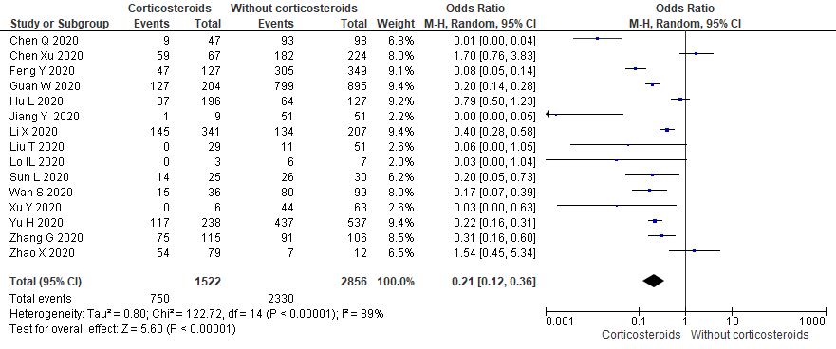
Figure 1. Forest plots of OR among non-severe individuals
Sensitivity analysis on severe individual getting corticosteroids
For sensitivity analysis evaluating the impact of inverse ORs, no changes observed (OR 4.78, 95% CI 2.76 to 8.26; participants = 4378; studies = 15; I² = 89%)
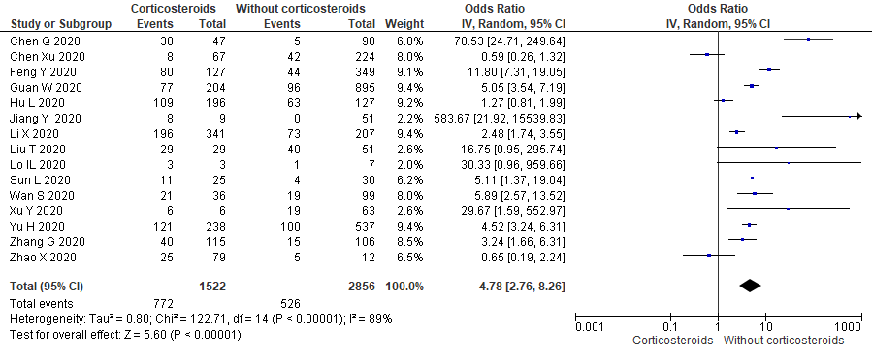
Figure 2. Forest plots of inverse OR among severe individuals
After excluding 4 studies (Guan W 2020, Hu L 2020, Li X 2020, Yu H 2020) with major weight in meta-analysis also did not show any differences in findings (OR 7.64, 95% CI 2.85 to 20.43; participants = 1633; studies = 15; I² = 88%)
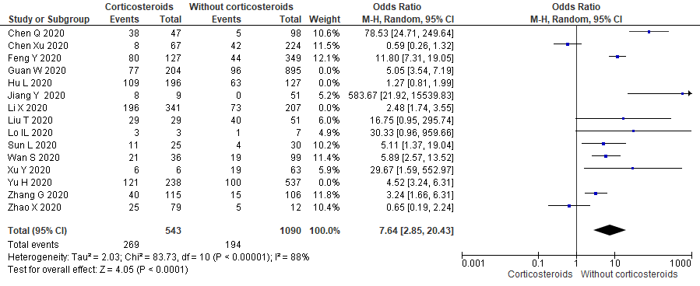
Figure 3. Forest plots of OR excluding 4 studies among severe individuals

Non-ICU patients are having lesser odds for getting corticosteroids (OR 0.24, 95% CI 0.11 to 0.53; participants = 613; studies = 6; I² = 64%).
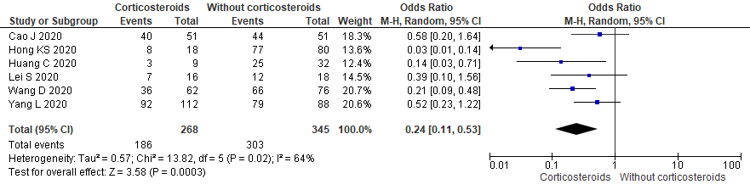
Figure 4. Forest plots of OR among non-ICU admitted individuals
Sensitivity assessment for ARDS after excluding (Cruz AF 2020) (OR 5.64, 95% CI 2.02 to 15.70; participants = 1169; studies = 5; I² = 83%)
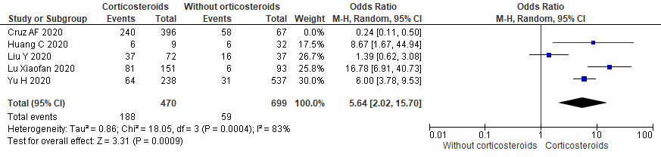
Figure 5. Forest plots of OR among individuals with ARDS excluding Cruz AF

Individuals without ARDS excluding Cruz AF (OR 0.18, 95% CI 0.06 to 0.49; participants = 1169; studies = 5; I² = 83%)
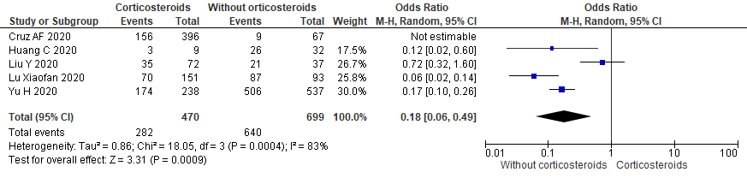
Figure 6. Forest plots of OR among individuals without ARDS excluding Cruz AF
Survival assessment among COVID individuals with or without corticosteroids showed no survival benefits (RR 0.88, 95% CI 0.78 to 0.98; participants = 2275; studies = 8; I² = 77%).
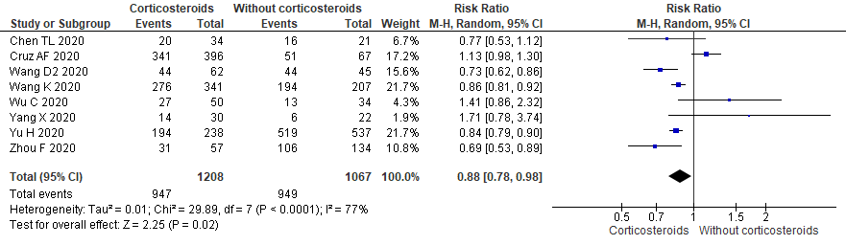
Figure 7. Forest plots of RR for survival with or without corticosteroids
For sensitivity assessment of mortality assessing impact of inverse RRs (RR 2.00, 95% CI 1.13 to 3.53; participants = 4451; studies = 14; I² = 92%)
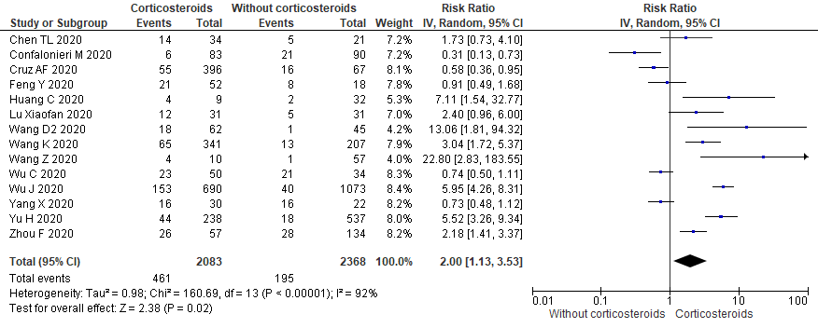
Figure 8. Forest plots of IV RR for mortality
After excluding Wu J 2020; (RR 1.76, 95% CI 1.03 to 3.02; participants = 2688; studies = 14; I² = 89%)
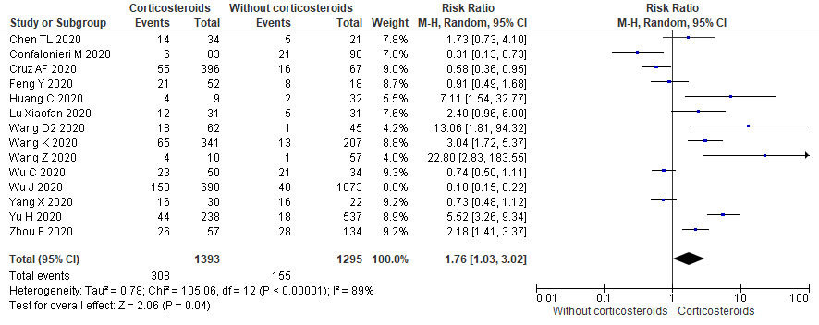
Figure 9. Forest plots after excluding Wu J 2020 for mortality

Assessing effect of additional corticosteroids in clinical deterioration among studies with incomplete follow up showed significant odds of deterioration (OR 3.79, 95% CI 1.93 to 7.46; participants = 3270; studies = 6; I² = 82%)
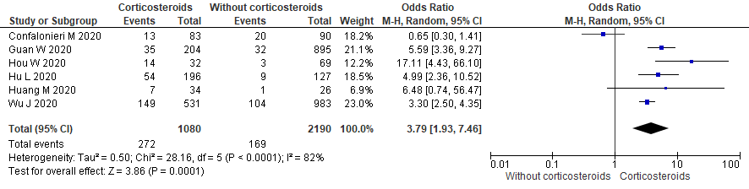
Figure 10. Forest plots of OR for Clinical deterioration with or without corticosteroids

