Supplementary Tables, Supplementary Figures, Appendix

Title: Physical protection in aggregates and organo-mineral associations contribute to carbon stabilization at the transition zone of seasonally saturated wetlands
Running Title: Carbon stabilization in seasonally saturated wetlands
Journal: Biogeochemistry
Authors: Anna Kottkamp, C. Nathan Jones, Margaret A. Palmer, Katherine L. Tully
Corresponding Author Institutional Affiliations:
K. L. Tully (Corresponding Author; 301-405-1469; kltully@umd.edu)
Department of Plant Sciences and Landscape Architecture, University of Maryland, 2108 Plant Sciences Building, College Park, MD 20742.

Supplementary Tables

Supplementary Table 1.
Supplementary Table 1 Hydrologic data across transects for water year 2018, presented as means (standard error). Elevation was surveyed relative to the center of the wetland. Days water level > -0.5 m quantifies duration of saturation within the upper 0.5 m of soil surface (water level > -0.5 m). Saturation events to -0.5 m is the number of instances that water level came within -0.5 m below the soil surface, indicating how dynamic saturation within sampling zone is at each transect point. Maximum percent IRIS removal is the maximum percent of reduced iron oxide paint by area within a 10 cm zone within the upper 0.5 m of soils, indicating relative reducing conditions in the upper soil profile (Appendix A). Lowercase letters represent significant differences among transect points (Analysis of Variance and Tukey’s HSD tests, P < 0.05)
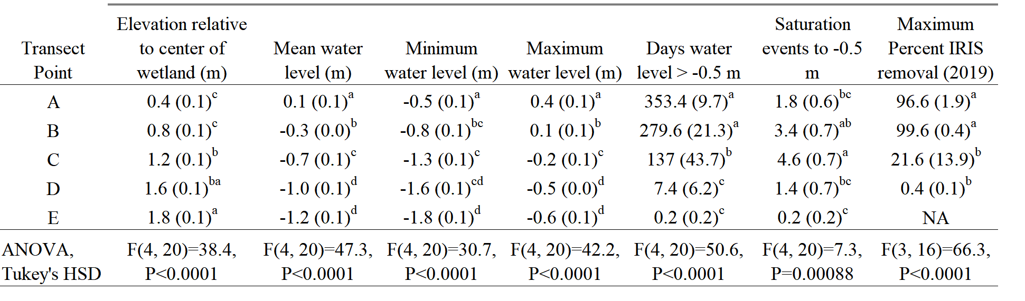

Supplementary Table 2.
Supplementary Table 2 All sample information. An asterisk in C:N indicates N concentrations below the limit of detection for total N ( < 0.02%)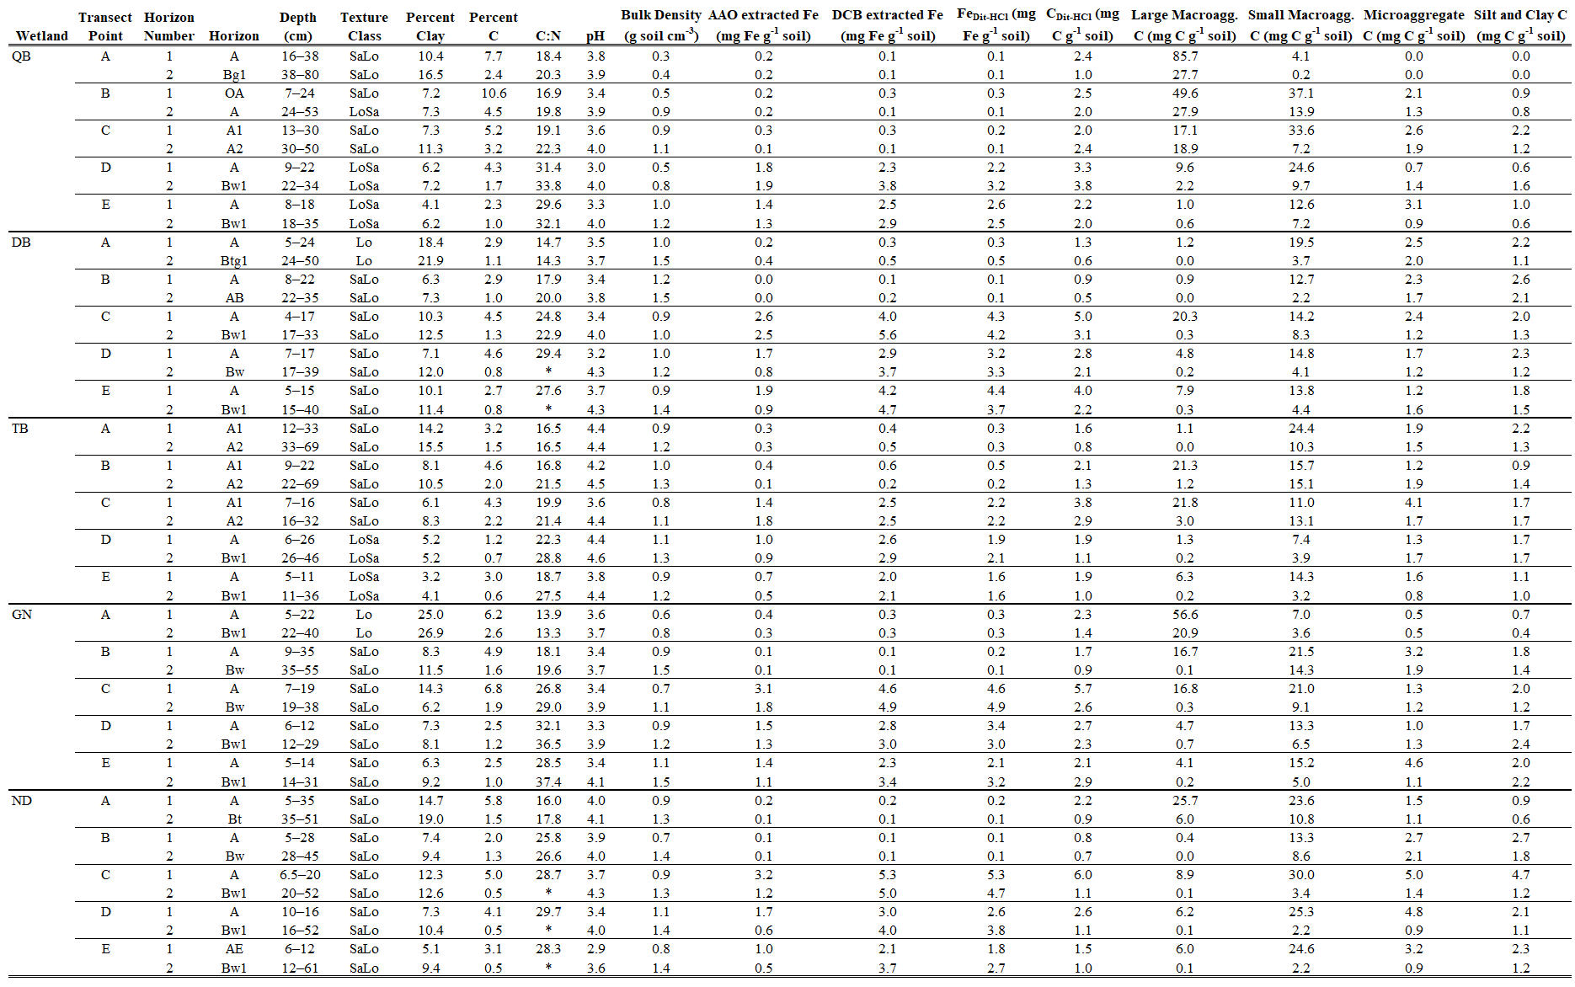

Supplementary Table 3.
Supplementary Table 3 Full LME model results for C_{bulk} concentration, including degrees of freedom (Kenworth-Rogers approximation) for the global and reduced models. Standard error (se) or standard deviation (sd) are presented with parameter estimates. Horizon class indicates comparisons among the first and second mineral horizon
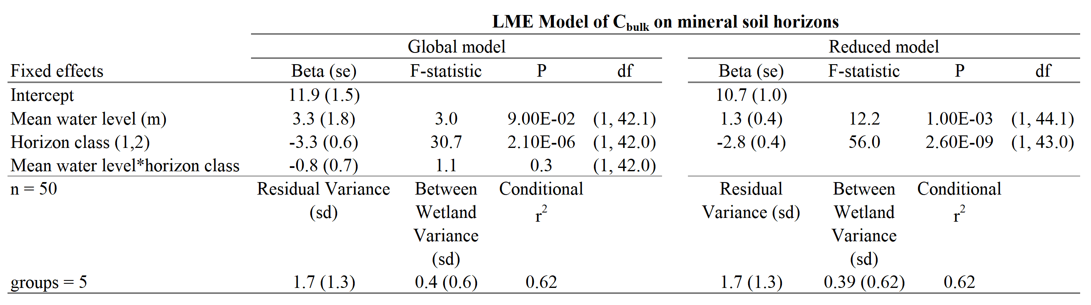

Supplementary Table 4.
Supplementary Table 4 Simple linear regression of SOC stocks across the transect, separated into 0–10 cm (Panel A) and 10–50 cm (Panel B), by mean water level
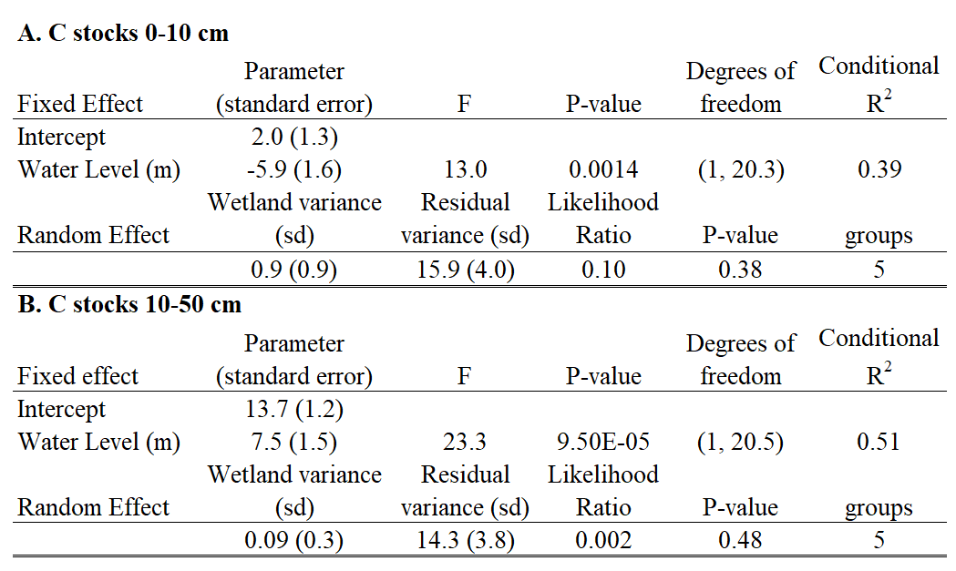

Supplementary Table 5.
Supplementary Table 5 Full LME model results for percent clay content, including degrees of freedom (Kenworth-Rogers approximation) for the global and reduced models. Standard error (se) or standard deviation (sd) are presented with parameter estimates. Horizon class indicates comparisons among the first and second mineral horizon
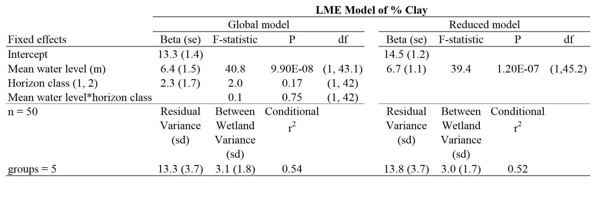

Supplementary Table 6.
Supplementary Table 6 Full LME model results for pH, including degrees of freedom (Kenworth-Rogers approximation) for the global and reduced models. Standard error (se) or standard deviation (sd) are presented with parameter estimates. Horizon class indicates comparisons among the first and second mineral horizon
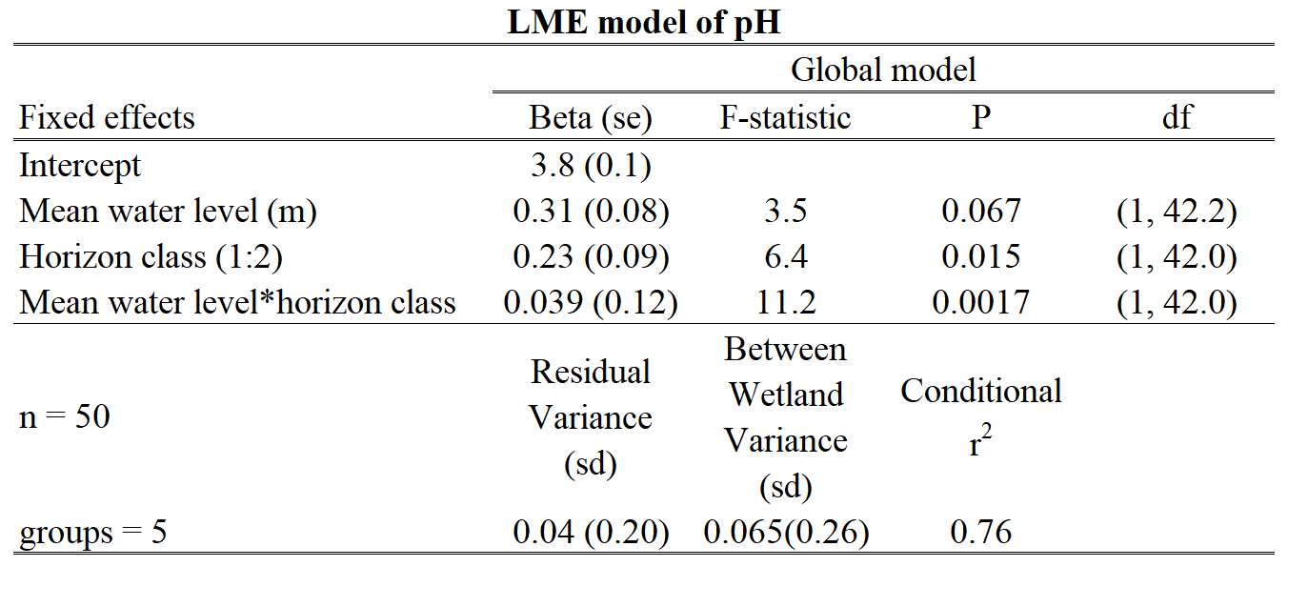

Supplementary Table 7.

Supplementary Table 7 Analysis of Variance and post-hoc Tukey’s Honestly Significant Differences tests on C:N_{aggregate}, C_{aggregate}, and C_{aggregate}/C_{bulk}, by size class
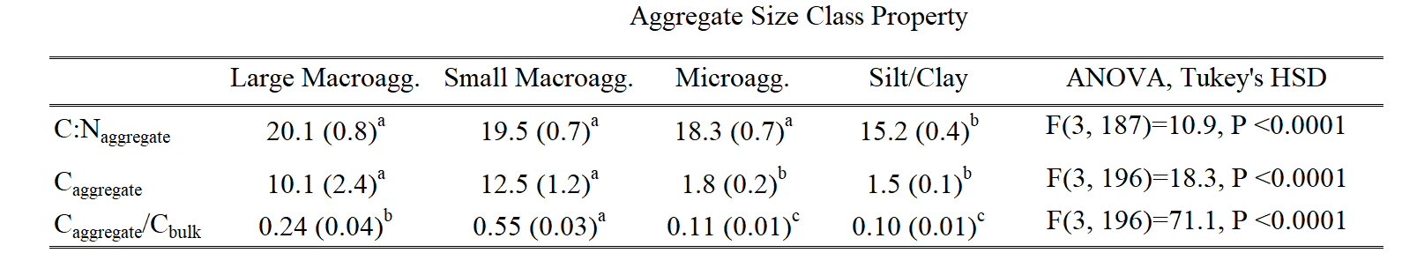

Supplementary Table 8.
Supplementary Table 8 Full LME model results for C_{aggregate}, including degrees of freedom (Kenworth-Rogers approximation) for the global and reduced models for all aggregate size classes. Standard error (se) or standard deviation (sd) are presented with parameter estimates. Horizon class indicates comparisons among the first and second mineral horizon
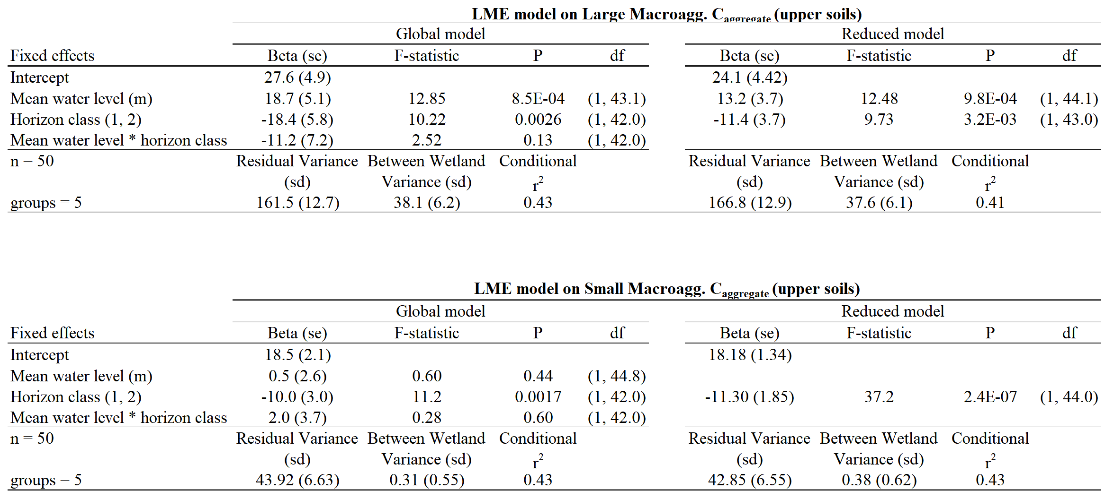
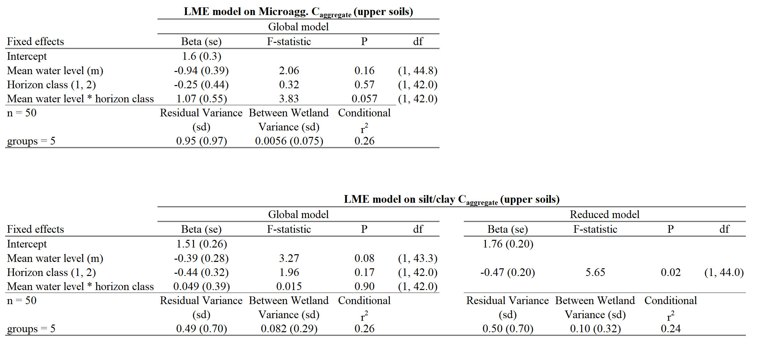

Supplementary Table 9.
Supplementary Table 9 Full LME model results for C_{aggregate}/C_{bulk}, including degrees of freedom (Kenworth-Rogers approximation) for the global and reduced models for all aggregate size classes. Standard error (se) or standard deviation (sd) are presented with parameter estimates. Horizon class indicates comparisons among the first and second mineral horizon
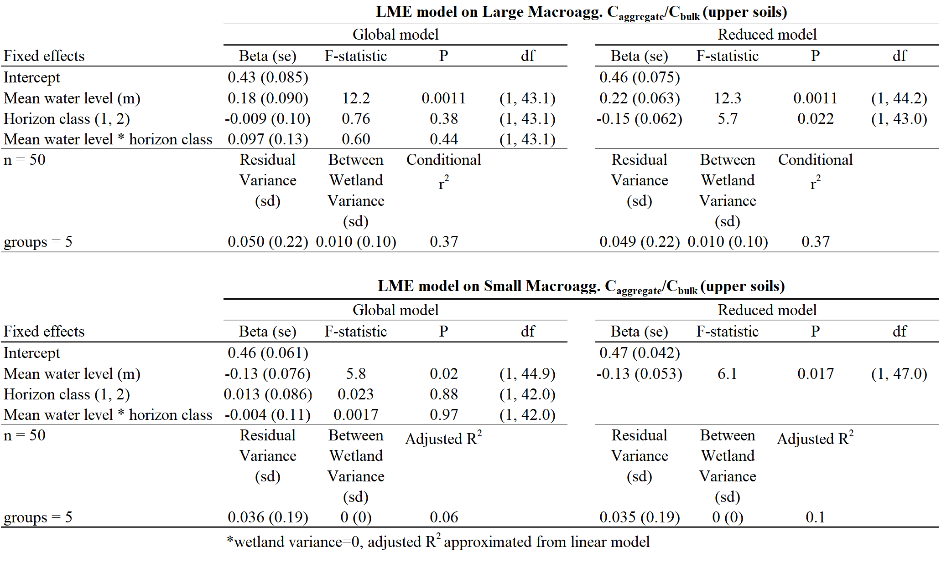
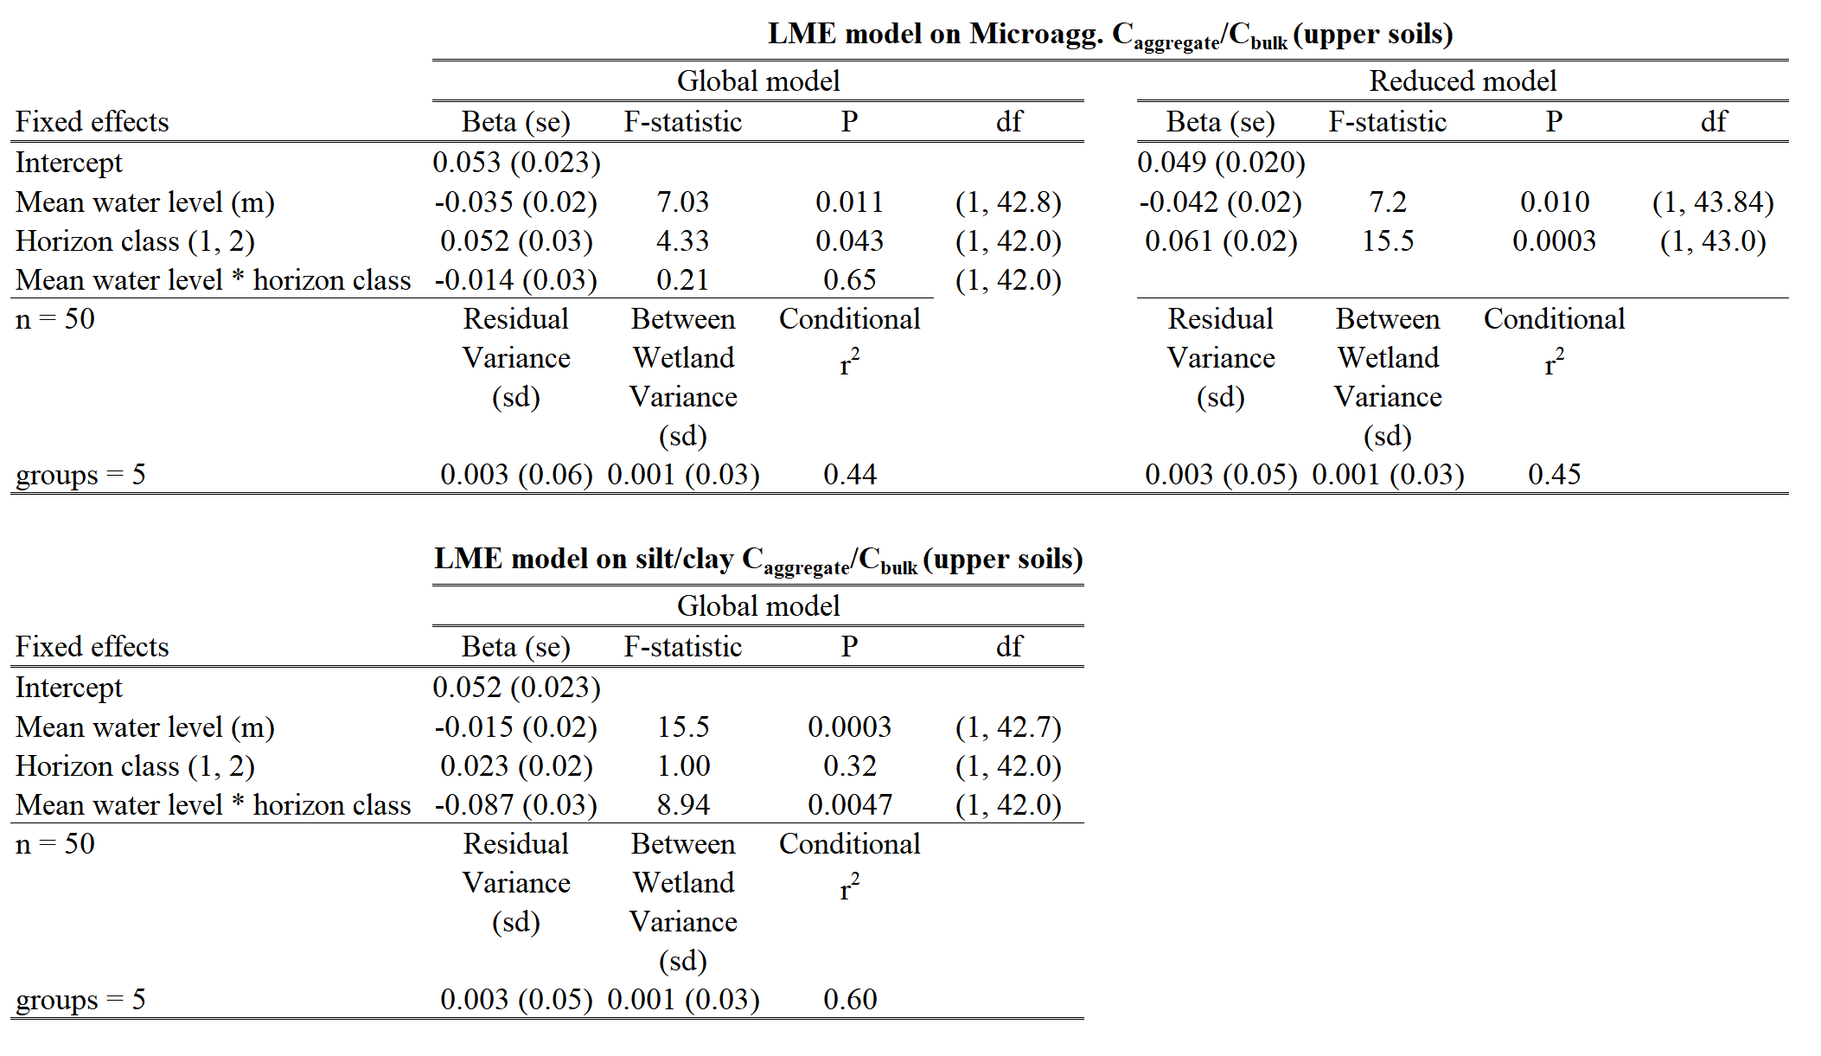

Supplementary Table 10.
Supplementary Table 10 Full LME model results including degrees of freedom (Kenworth-Rogers approximation) for the global and reduced models for FeDit-HCl concentrations, separated into frequently and rarely saturated soils by a mean water level of ≤ -0.5. Standard error (se) or standard deviation (sd) are presented with parameter estimates. Horizon class indicates comparisons among the first and second mineral horizon 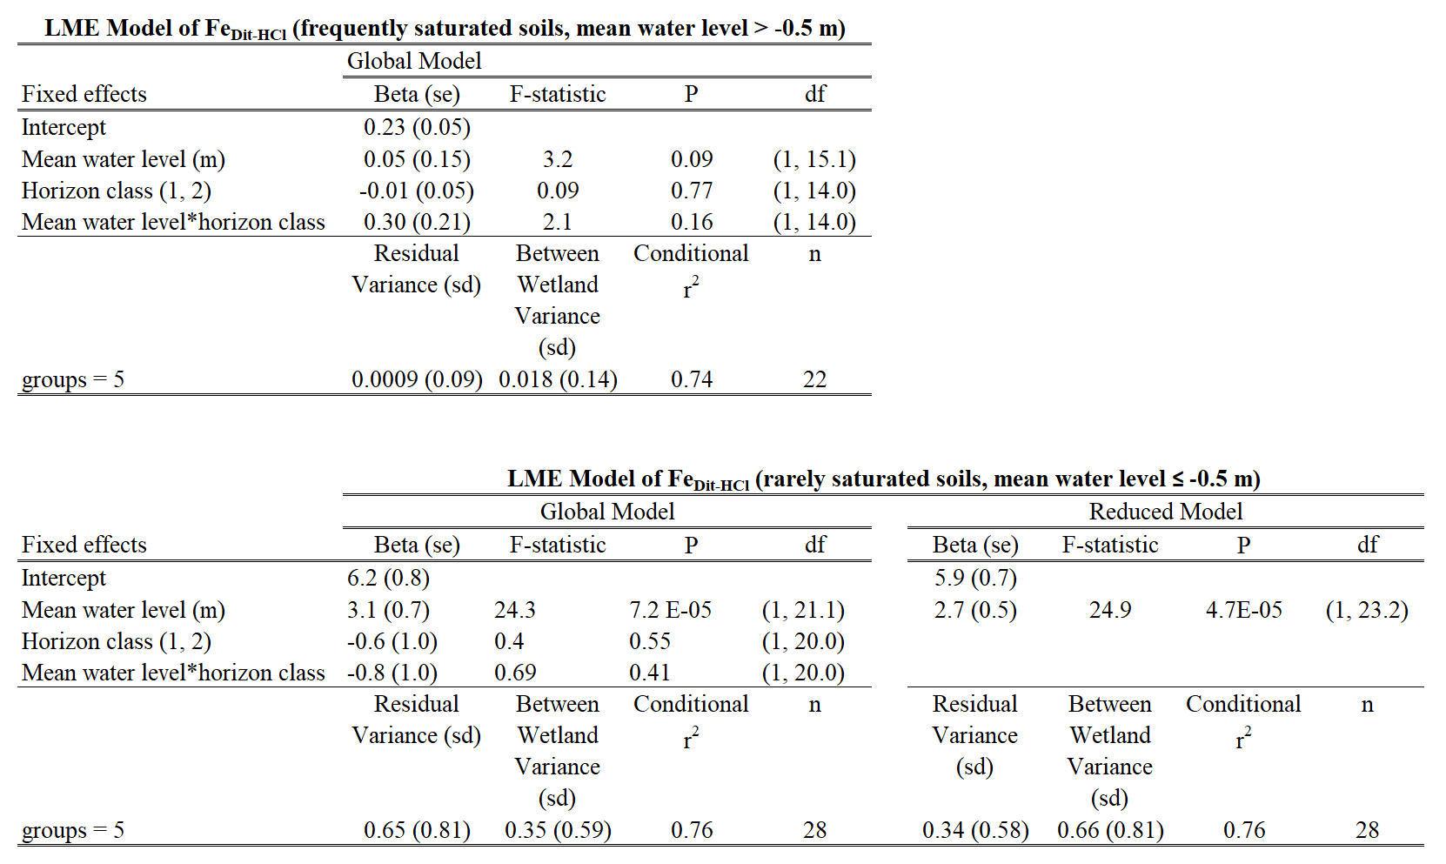

Supplementary Table 11.
Supplementary Table 11 Full LME model results of total Fe_{DCB} concentration, including degrees of freedom (Kenworth-Rogers approximation), separated into frequently and rarely saturated soils by a mean water level of ≤ -0.5. Standard error (se) or standard deviation (sd) are presented with parameter estimates. Horizon class indicates comparisons among the first and second mineral horizon
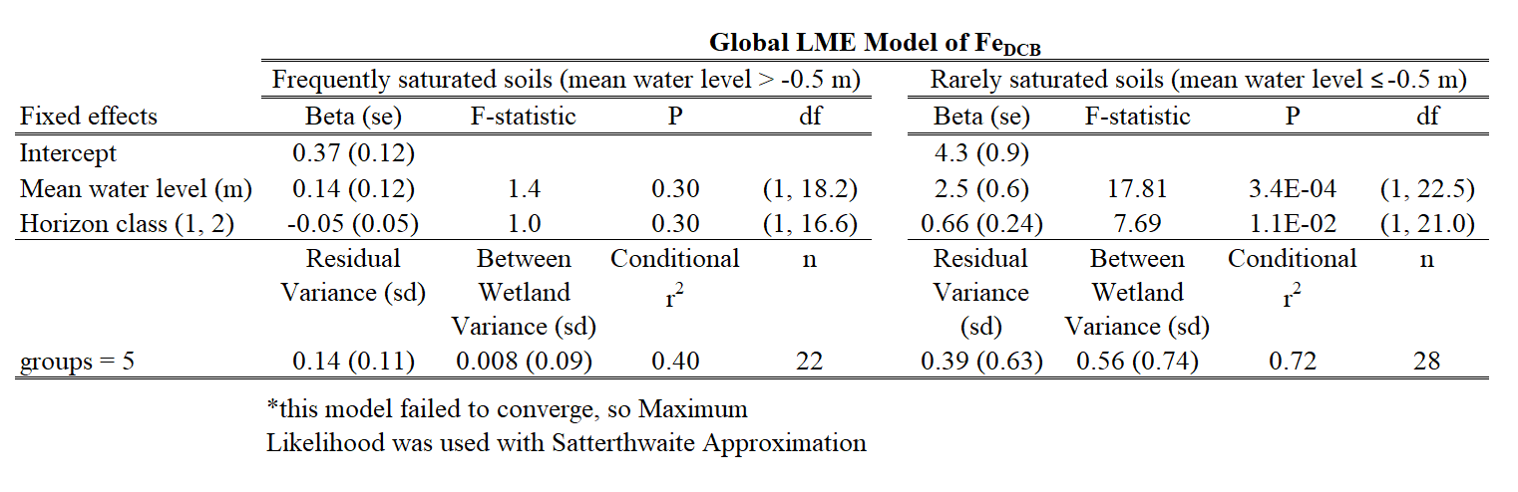

Supplementary Table 12.
Supplementary Table 12 Full LME model results of poorly-crystalline Fe_{AAO} concentration, including degrees of freedom (Kenworth-Rogers approximation), separated into frequently and rarely saturated soils by a mean water level of ≤ -0.5. Standard error (se) or standard deviation (sd) are presented with parameter estimates. Horizon class indicates comparisons among the first and second mineral horizon
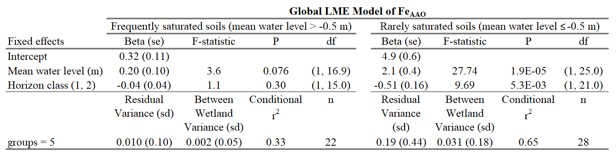

Supplementary Table 13.
Supplementary Table 13 LME global model of Fe_{AAO}/Fe_{DCB} in upper horizons. Results include degrees of freedom (Kenworth-Rogers approximation). Standard error (se) or standard deviation (sd) are presented with parameter estimates. Horizon class indicates comparisons among the first and second mineral horizon
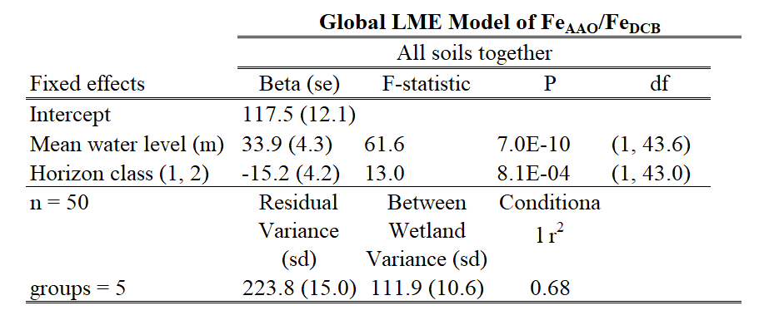

Supplementary Table 14.
Supplementary Table 14 Full LME model results including degrees of freedom (Kenworth-Rogers approximation) for the global and reduced models for concentrations of C_{Dit-HCl}, separated into frequently and rarely saturated soils by a mean water level of ≤ -0.5. Standard error (se) or standard deviation (sd) are presented with parameter estimates. Horizon class indicates comparisons among the first and second mineral horizon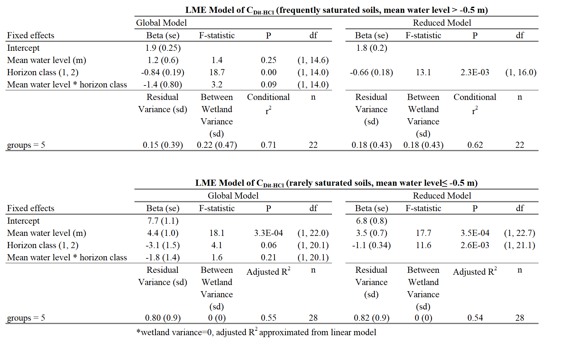

Supplementary Table 15.
Supplementary Table 15 Full LME model results including degrees of freedom (Kenworth-Rogers approximation) for the global and reduced models for normalized C extracted by sodium dithionite-HCl (C_{Dit-HCl}/C_{bulk}), separated into frequently and rarely saturated soils by a mean water level of ≤ -0.5. Standard error (se) or standard deviation (sd) are presented with parameter estimates. Horizon class indicates comparisons among the first and second mineral horizon
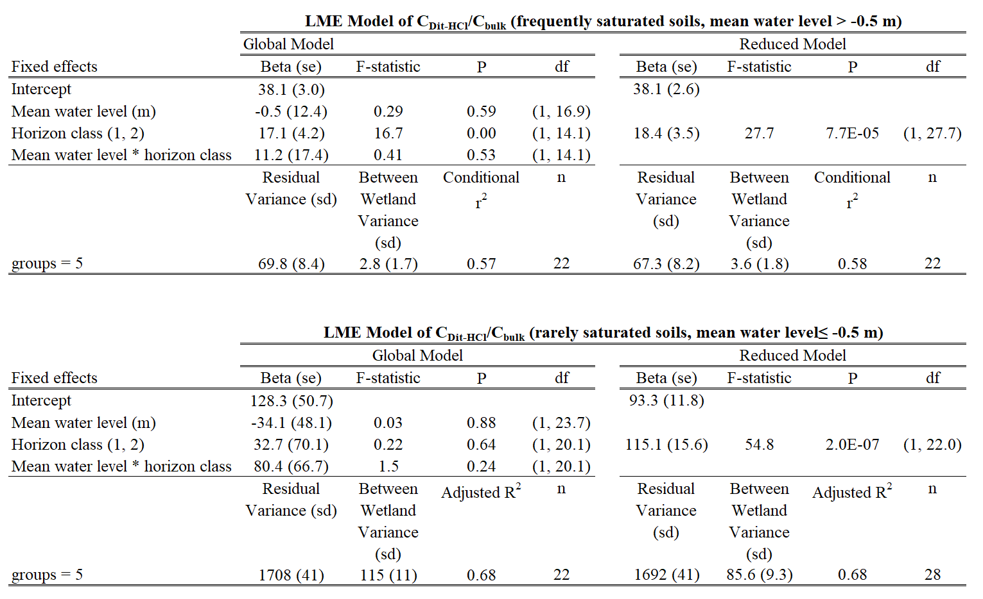

Supplementary Table 16.
Supplementary Table 16 Full model results for the simple linear regression between C and Fe for extraction Fe_{Dit-HCl} separately, separated by mean water level of -0.5 m
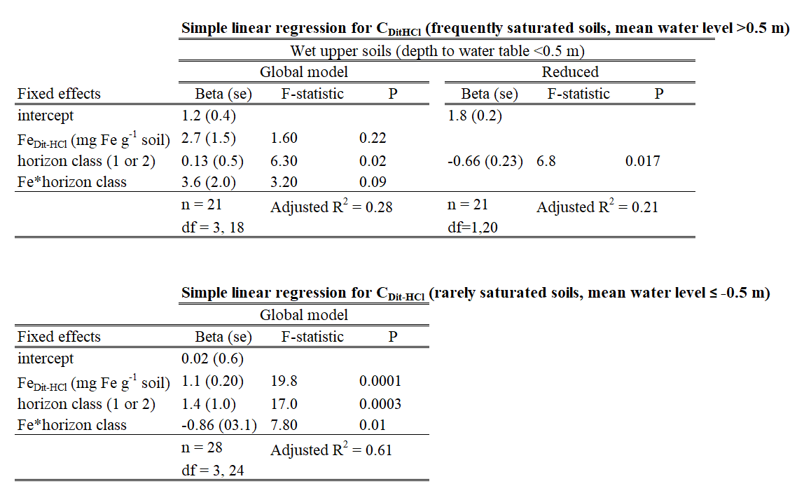

Supplementary Figures

Supplementary Fig. 1.
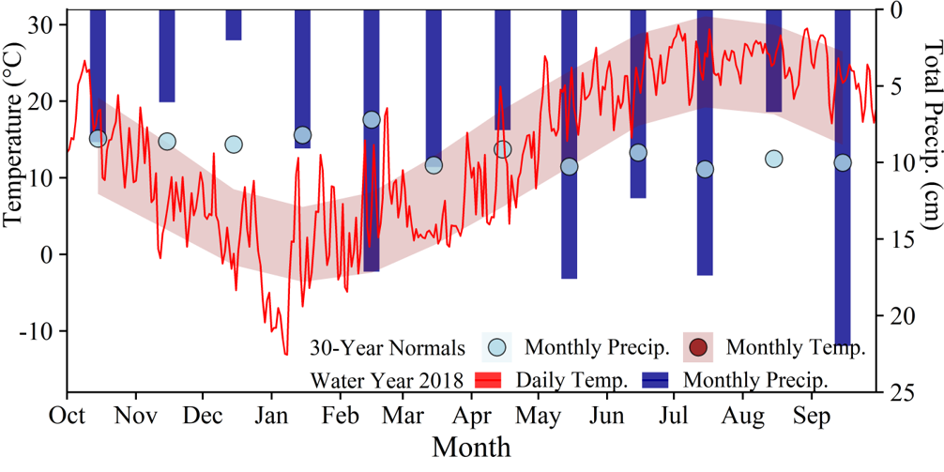
Supplementary Fig. 1 Observed and average temperature and precipitation in water year 2018. Temperature and precipitation were within expected 30-year normals, though rainfall was slightly higher than expected in summer

Supplementary Fig. 2.
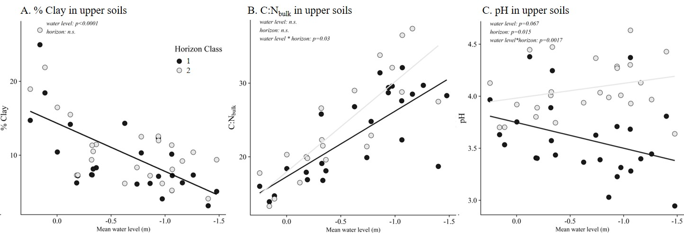
Supplementary Fig. 2 Soil properties by horizon vs. mean water level for % clay, C:N_{bulk}, and pH in 0.01 M calcium chloride solution (Panel C) to 0.5 m soil depth (upper soils). Horizon class is ordered by depth within a core to compare pedogenic horizons across different soil types. Significant models are presented as solid lines (P < 0.05). Where horizon class was not significant, only one model is presented (black line)

Supplementary Fig. 3.
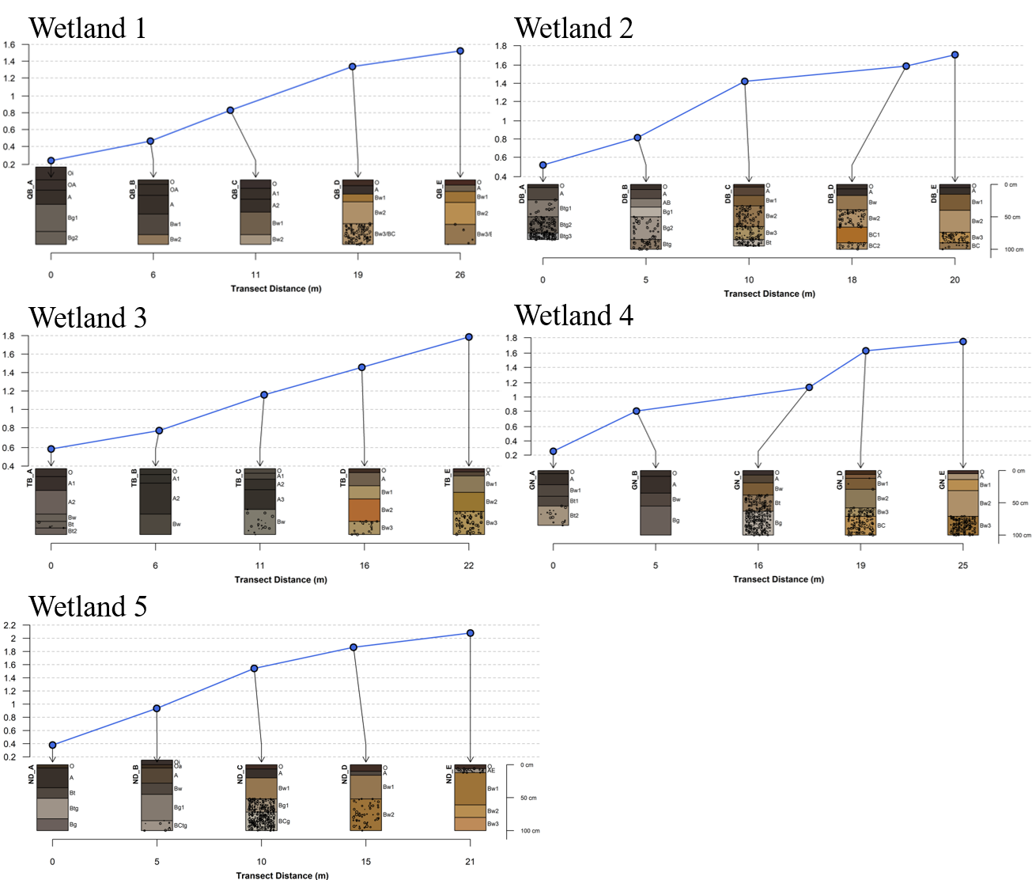
Supplementary Fig. 3 Soil colors and elevations relative to wetland center. Blue dots represent soil sample relative elevation on transect. Horizon designations, colors, and percent redoximorphic concentrations are indicated below each transect point

Supplementary Fig. 4.
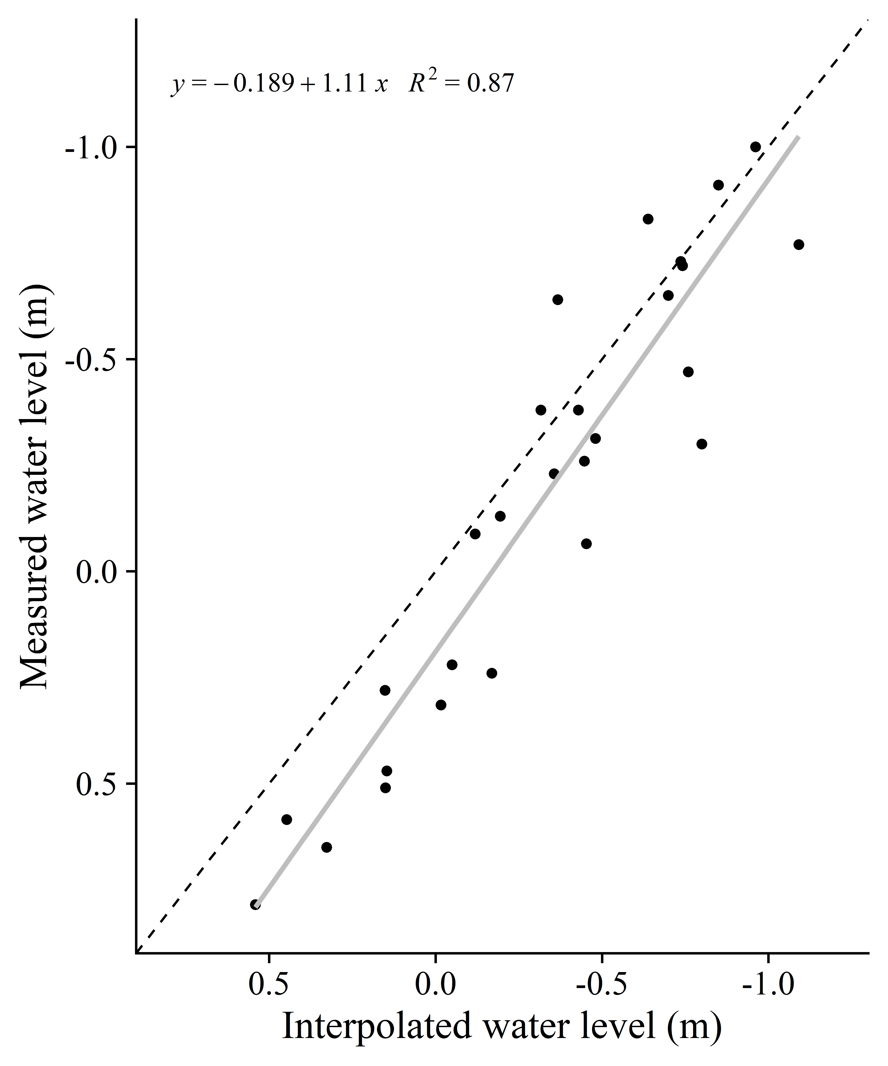
Supplementary Fig. 4 Simple linear regression of water level measured at transect points biweekly from May to August 2018 and interpolated daily water levels to validate mean water level interpolation (Simple linear regression line in gray, F(1,25) = 174, P = 9.0∙10⁻¹³). Dashed line indicates 1:1

Supplementary Fig. 5.
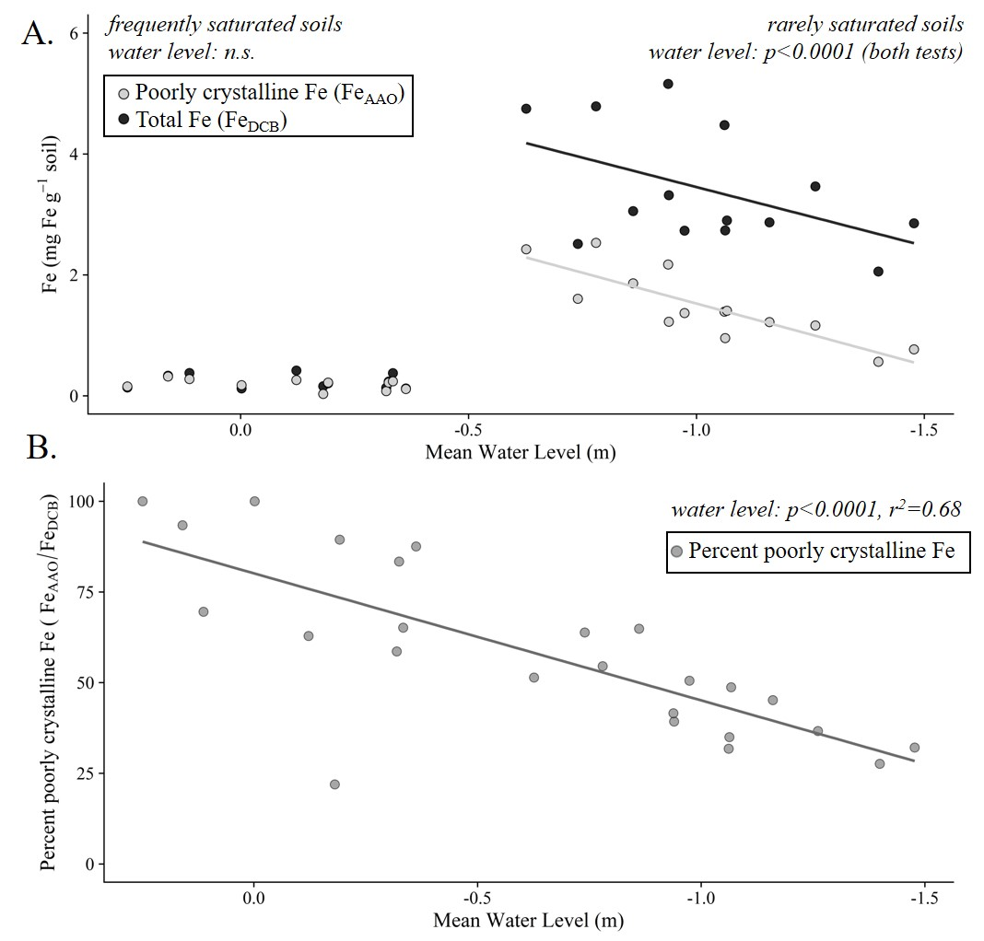
Supplementary Fig. 5 Mean Fe_{AAO} and Fe_{DCB} concentrations for upper horizons (Panel A). Data was separated into two groups for analysis: samples from soils with a mean water level > -0.5 m (frequently saturated soils) and samples from soils with mean water level ≤ -0.5 m (rarely saturated soils). Panel B shows the percent of Fe that is poorly crystalline (Fe_{AAO}/Fe_{DCB}). Non-significant models not shown. Full statistics in Supplementary Tables 11–13

Supplementary Fig. 6.
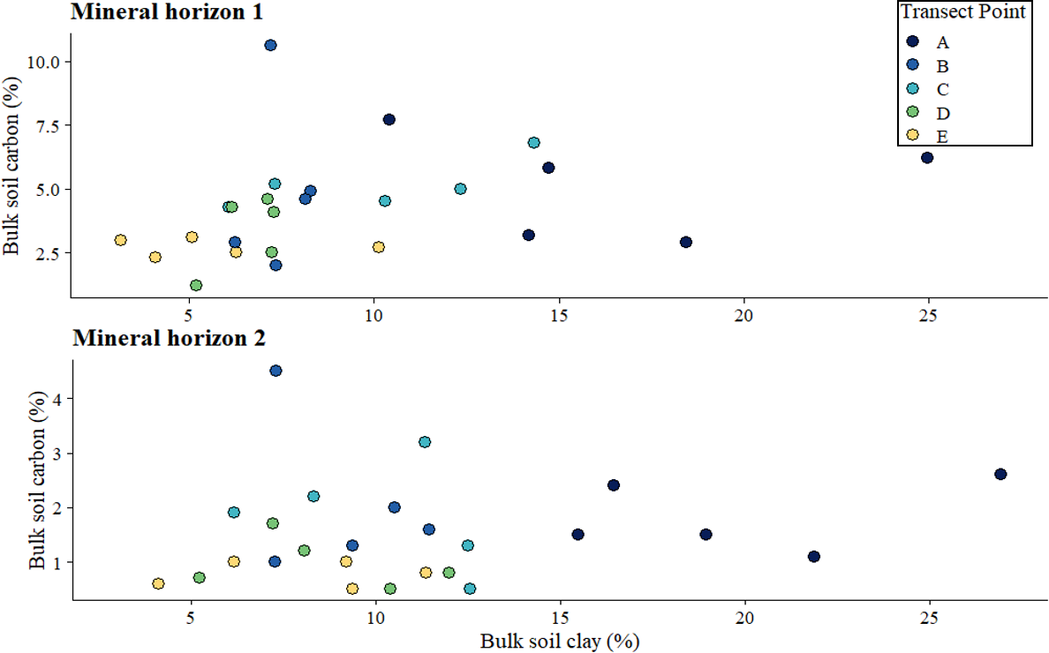
Supplementary Fig. 6 Bulk soil % carbon (C_{bulk}) versus bulk soil % clay for each of the upper mineral horizons, by transect point. All models were non-significant and therefore are not shown

Appendix

Appendix A: IRIS Films Analysis
Reducing conditions were measured by Fe-oxide painted Indicator of Reduction In Soils (IRIS) films installation (Rabenhorst 2018) and analysis (Castenson and Rabenhorst 2006). At transect points A–D, five replicate films were installed to 0.5 m depth on April 5–6, 2019 and removed after 30 days to determine the presence of reducing conditions as indicated by Fe oxide paint removal. A preliminary study in April 2018 found no paint removal at transect points D and E; therefore, we assumed 0% oxide paint removal at transect point E in April 2019.

Appendix B: Calculations with Aggregate Size Classes
For aggregates, we calculated both aggregate mass (mass_{aggregate}) and sand-corrected aggregate mass (mass_{aggregate, sand-free}). Aggregate associated C (C_{aggregate}) is expressed on a mass basis out of bulk soil excluding rocks > 1 mm (mass_{total}), equivalent to the concentration of aggregate-associated C. We also corrected aggregate C measured by dry-combustion (C_{aggregate}) for sand content. Sand correction is useful to interpret C across samples of varying sand content (Márquez et al. 2004); however, we decided not to use sand-free values in calculations to compare aggregate-associated C with Fe-associated C, which is out of bulk soil (e.g., not g C per g “sand-free” soil). To calculate the normalized aggregate associated C proportion out of bulk soil C, we calculated Aggregate C * mass_{aggregate} for each size class, then we divided by the sum (total) of Aggregate C * mass_{aggregate} for the entire sample (C_{aggregate}/C_{bulk}; Table 1, Eq. 2).

Appendix C: Comparison of Fe Extractions
We compared Fe and C removal across extractions on upper soils to better understand extraction efficiency. A paired t-test between Fe_{Dit-HCl} and Fe_{DCB} revealed no significant difference in Fe extracted by the inorganic (Dit-HCl) and organic (DCB) extractions (paired t-test, t(97.6) = -0.51, P = 0.61). The mean extraction efficiency for total Fe (Fe_{Dit-HCl}/Fe_{DCB}) was 88.9% (standard error = 2.3), with a median of 99.4%.

