APPENDICES

Appendex 1: Data Collection Format Date / /2019/20 G.C
Ref.No | District | PA's | Sex | Age | Herd Size | BCS | History of Respiratory disease | CBPP results

Appendex 2: Description of Body Condition Scores (poor, Medium/ Borderline and good)
Core | Body cond. | Features
1 | p⁻ | Marked emaciation (animal could condemned at ante mortem examination)
2 | P | Transverse process project prominently, neural spines appear sharply.
3 | P⁺ | Individual dorsal spines are pointed touch, hips, pins, tail head and ribs are prominent. Transverse process visible, usually individually.
4 | M ⁻ | Libs, hips, spines clearly visible and muscle mass between hook of spines slightly more flesh above the transverse process.
5 | M | Ribs usually visible and little fat cover on dorsal spine barely visible.
6 | M ⁺ | All smooth and well covered, dorsal spine cannot be seen , but are easily felt.
7 | G ⁻ | smooth well covered, but fat deposits are not marked, dorsal spine can be felt with firm pressure but rounded rather than sharp.
8 | G | over in critical areas can be easily seen and felt, transverse process cannot be seen.
9 | G ⁺ | Heavy deposit of fat clearly visible on tail, head ,brisket, and cad, dorsal spine , ribs, hook and spine and spines fully covered and cannot be felt even with the firm pressure.

Note: body condition scores
1,2 and 3 are poor
4, 5 and 6 are medium
7, 8 and 9 are good body condition. Source: Nicolson and Butterworth (1986)

Appendex 3: Age determination based on dental table characteristic change
1 and half I₁ erupts
2-2 and half I₂ erupts
3 I3 erupts
3 and half-4 I4 erupts
5 all incisors are in wear
6 I₁ is level
7 I₂ is level and the neck is visible
8 I₃ is level, the neck is visible and I₄ may be level
9 I₄ is level and the neck is visible
10 The dental star is square in I₁ all the teeth
15 The teeth that have not fallen out are reduced to small round
Source: De Lahunta and Habel (1989)

Appendex 4: Questionnaire Format
A questionnaire survey was based on the formula recommended by Arsham (2002). N= 0.25/SE² Where N=sample size, SE=standard error, assuming the standard error of 5% at a precision level of 0.05 and the confidence interval of 95%. Accordingly, 100 volunteer individuals were selected and interviewed considering different age, sex and working conditions.
Participant ID Number: Date of Interview: / / 2019/20 G.C
Section 1: Demographic Characteristics of Respondents
1. Name of respondent:
1.1. Gender of the respondent: 1. Male 2. Female
1.2. Age (years):
1.3. Marital status: 1. Single, 2. Married, 3.Widowed ,4. Divorced
1.4. Respondent’s educational background:
1. Primary school,2. Secondary school, 3.Vocational school.4.College/University,5.No formal Education

Section 2: Size and Herd Structure of Cattle that Respondent Owned
2.1. Total number of cattle of respondent owned
2.2. Sex: Male (No) and Female (No)
2.3. Age: young (0.6-3 years) (No): ,adult (>3years) (No): ,& calf <0.6 years (No):__
Section 3: Farmers Knowledge on name of CBPP diseases that found in their area.

3.1. Can you list name of CBPP diseases in your area?
1 | Local name | 1.1
 |  | 1.2
 |  | 1.3
2  4 | Scientific name

3.2. Have you know or encountered any of the following major signs of CBPP disease?
No. | CBPP symptoms | Yes | No | I don’t know
1 | Depression
2  2 | Anorexia
3 | Chest pain
4 | Stand with the elbows abducted
5 | Standing with back arched
6 | Head extended coughing
7 | Laboured&painful breathing
8 | Grunting when exhaling  (coughing)
9 | Frothy saliva at the mouth
10 | Dilation of nostril & mucoid discharge
11 | Swelled throat and dewlap
12 | Epistaxis/bleeding
13 | Poly arthritis particularly on young

3.3. What are the possible transmission methods of RD or CBPP disease among cattle?
No. | Transmission methods | Yes | No | I don’t know
1 | Through contaminated feed or water
2 | Close contact with diseased animal
3 | Through fetal membrane&uterine discharge
4 | Through coughing of infected animal

3.4. Farmers‟ knowledge regarding importance of respiratory disease specific emphasis to CBPP.
No. | Impacts of CBPP | Yes | No | I don’t know
1 | Can cause mortality of cattle
2 | Can cause loss of body weight
3 | Reduced work  ing abilityof cattle
4 | Reduced fertility of cattle
5 | Reduced growth rate of cattle

3.5. What worries you most felt if your animal diseased with respiratory disease/CBPP?
1. Transmission to others 2. Cost of treatment
3. Death due to disease 4. Loss of production, 5. No worries
3.6. Which ways do you want to receive knowledge about the disease?
1. Through Wereda expert 2. Through kebele DA
3. Veterinarian/animal health workers 4. Media 5. Local cultural healers
3.7. Which part of CBPP knowledge do you want to know more?
1. Its causes 2. Symptoms 3. Transmission methods
4. Diagnosis methods
5. Prevention and controlling methods

3.8. What do you think the effective way of prevention and controlling methods of CBPP?
No. | Prevention and controlling methods | Yes | No | I don’t know
1 | Vaccination
2 | Treatment of symptomize animal
3 | Test and slaughter or stamping out policy
4 | Movement control or quarantine
5 | Isolation of new purchased animal from herd
6 | Decontamination of infected premises

Appendex 5: C- ELISA principles and procedures
No. | Reagents | Volume
1 | MmmSC antigen coated Plate | 10
2 | Positive Control (Lyophilized) | 1x1.0  Ml
2a | Strong positive control (Lyophilized) | 1x1.0 mL
3 | Negative control (Lyophilized) | 1x1.0 mL
4a | Conjugate concentrate (100x) | 1x1.2 mL
5 | Dilution Buffer N. 24 | 3x120 mL
A | TMB substrate N. 13 | 1x120 mL
B | Stop solution N. 13 | 1x120 mL
C | Wash Concentrate (20x) | 2x100 mL
D | Detection Solution (Mab 117/5, Lyophilized) | 1x1.0  mL

Note: See table at the end of the insert for a description of symbols used on the insert and tables of this kit.
Storage: Store the reagents at 2-80c. Reagents are stable until expiration date, provided they have been stored properly.
Wash Solution
The wash concentrate (20 xs) must be diluted 1.20 with distilled/demonized water before use (e.g. 15 ml of wash concentrate (20 xs) in285 ml of distilled water). This solution is hereafter called “wash solution”
Note: The wash concentrate (20x) should be brought to 18-260c and well mixed to ensure dissolution of any precipitated salts. Wash solution is stable for up to 3 days when stored at 2-80c.
Conjugate: The conjugate concentrate (100x) must be dilution buffer N. 24
Note: - Diluted conjugate solution is stable for up to 8 hours at 18-26⁰C
Controls: The lyophilized controls must be reconstituted one day in advance with 1 ml of sterile distilled water, liquated and kept at -16⁰C. SPC = Strong positive control /PC = positive control / NC = Negative control.
Note: - reconstituted controls can be frozen and thawed no more than 3 times.
Tow SPC control wells can be replaced by your own internal reference control material (IRC).
Control wells: CC = conjugate control wells (Dilution Buffer N.24 only).
MabC = detection solution (Mab 117/5) control wells (Dilution Buffer N.24 and detection Solution only).
Preparation of Samples: Samples and controls are pre-diluted on the prelate (uncoated) (see test procedure).
Note:-Samples should not be de-complemented prior to the analysis.
Test Procedure
All reagents must be allowed to come to 18-26⁰C before use. Reagents should be mixed by gentle inverting or swirling. Controls may be dispensed anywhere on the micro plate (as an example
CC =A1, A2,
SPC = B1, B2,
IRC = C1, C2;
PC =D1,D2,E1, E2;
MabC =F1, F2, G1, G2;
NC =H1, H2).

1. Obtain the required number of coated micro plates and uncoated micro plate for sample preparation and record the position of each sample.
2. Dispense the dilution buffer, controls, samples and detection solution:
a. Dispense 100 µl of dilution N. 24 into each well of the prep late (S).
b. Dispense another 110 µl of dilution buffer N.24 into two appropriate wells (CC)
Note:-total volume of dilution buffer N.24 in CC wells: 210
c. Dispense 11 µl of undiluted strong positive control in four appropriate wells.
Note: The supplied strong positive controls can be replaced in two wells by your own IRC.
d. Dispense 11 µl of undiluted positive control in two or four appropriate wells.
e. Dispense 11 µl of undiluted negative control in two appropriate wells.
f. Dispense 11 µl of undiluted sample per well into remaining wells of the prelates
g. Dispense 11 µl of undiluted detection solution into each well of the preplate except in CC wells.
3. Homogenize the content of the wells and transfer 100 µl from each well of the prep late (S) to the appropriate wells of coated micro plate(S).
4. Cover the micro plate and incubate 1 hour (±5 min.) at +370C (±30C) under gentle agitation avoiding desiccation of the plates.
5. Remove the solution and wash each well with approximately 300 µl of wash solution 2 times. Avoid plate drying between plate washings and prior to the addition of the next reagent. Tap each plate onto absorbent material after the final wash to remove any residual wash fluid.
6. Add 100 of Diluted conjugate in each well.
7. Cover the Microplate and incubate 30 minutes (± 3 min) at +370C (± 30C) under gentle agitation, avoiding desiccation of the plates.
8. Repeat step 5 but this time washing three times.
9. Add 100 µl of TMB substrate N.13 in each well.
10. Incubate 20 minutes (± 3 min) at +370C (± 30C) away from direct light.
11. Dispense 100 µl of stop solution N.3 per well.
12. Measure and record the absorbance value of samples and controls at 450 nm.
Note: when using robotics, incubation of micro plates in an incubation chamber allows working without plate covers.
Use of robots is also not compatible with gentle microplate tapping or wiping. Plate can be held up to 1 hour in the dark prior to reading. The duration of substrate incubating can be adjusted to yield and) OD of 1.000 in the MabC wells.
13. Calculation: Controls Calculate conjugate control mean Absorbance (CCx) and Mab control mean Absorbance (mabCx)
CCx= (CC1 A (450) + CC2 A (450)) /2
Mab = (MabCx = (MabC1 A(450) +MabC2 A (450) +MabC A(450)) /4
Samples and controls: Calculate the percentage of inhibition (S Pl) for each sample and control. S PI % = 100x (MabCx –S A(450)) / (MabCx –CCx)
Validity criteria:
MabCx 0.500 to 2.000
CCx < 0.300
NC pl <40% ,
PC PI>50% to 80 % ,
SPPI >60 % to< 90 %
For invalid assays, technique may be suspect and the assay should be repeated following a thorough review of the package insert
- Interpretation:
Negative S PI < 35 % ,
Doubt >35% and <50%
Positive S PI >50 %
Note: For this test, the positivity threshold is set at 50% of inhibition. However, every measurement has a certain uncertainty which depends from the kit itself and of the capabilities of the testing laboratory. Sera with PI values within the range 50 % ± uncertainty of measurement should be consider with care and distinguished from the others that are positive or negative with certainty. It is advisable to perform this ELISA testing under quality assurance and, whenever possible, with an accreditation (i.e. ISO 17025).
Note: IDEXX has instrument and software systems available which calculate results and provide data summaries

Note: photograph during Laboratory processing of CBPP result by. C- ELISA technique.
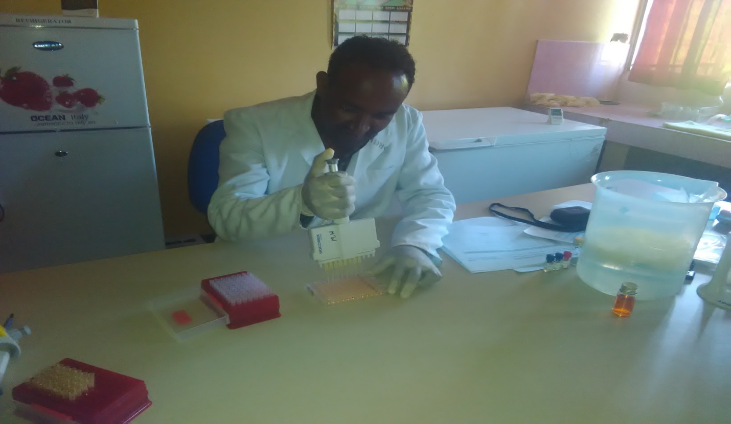

Appendex 6: Letter of result report from Bedele Regional Veterinary Laboratory

