Support information
Nanobelts-constructed porous TiO₂-B@SnS₂ heterostructure hybrids for enhance lithium storage performance
Chao Cai,¹ Meiyu Song,¹ Qixiang Ou,³ Jianmei Li,^{1*} Changsheng An^{2*}
¹ School of Chemistry and Chemical Engineering, Ningxia university, Yinchuan,750001, China
² School of Biological and Environmental Engineering, Changsha University, Changsha 410022, China
³ Chemistry BA, University of Minnesota, Twin Cities, 100 Church St. SE, Minneapolis MN 55455
*Corresponding Authors:
Jianmei Li, E-mail: 2029883@qq.com
Changsheng An, E-mail: z20190628@ccsu.edu.cn

Experimental section
The preparation of TiO₂-B nanobelts: TiO₂-B nanobelts with potholed surface was prepared by a simple hydrothermal method followed by acid corrosion process. Briefly, P25 (0.2 g) was dispersed into 80 ml of 8 M NaOH aqueous solution. The mixture was magnetically stirred and ultrasonic treatment for other 1 h. Then, the mixture was transferred into 80 ml Telfon-lined stainless steel autoclave for hydrothermal treatment at 160 °C for 48 h. After cooling down, the resulted suspension was filtered, washed thoroughly with deionization water and 0.1 M HCl solution to obtain the H-titanate (H₃TiO₇) nanobelts. In order to get the rough surface of the TiO₂, the H-titanate (H₃TiO₇) nanobelts was poured into 0.06 M H₂SO₄ aqueous solution and maintained at 120 ºC for 10 h. Finally, the product was centrifuged, washed, dried, and calcined at 600 ºC for 4 h to obtain TiO₂-B nanobelts.
The preparation of TiO₂-B@SnS₂ Heterostructures: TiO₂-B@SnS₂ nanosheets was prepared through a hydrothermal approach. Typically, the as-prepared TiO₂-B nanobelts (0.06 g) was dispersed in ethanol (35 mL) via ultrasonic agitation. After 2 h, tin (Ⅳ) chloride pentahydrate (SnCl₄·5H₂O, 1.2 mmol) and thioacetamide (10 mmol, TAA) was further dissolved in the above dispersion solution and then transferred into a 50 mL of Teflon-lined stainless steel autoclave to heat at 180 ºC for 10 h. The final product was washed with deionized water and ethanol for three times, respectively, and then dried at 60 ºC overnight. For comparison, pure SnS₂ without adding TiO₂-B nanobelts was performed to investigate the influence of the TiO₂-B nanobelts in the electrochemical performance of the samples.
Characterization: Powder X-ray diffraction (XRD) was performed by a Rigaku X-ray diffractometer with Cu Kα radiation(λ = 1.5418Å) at40 kV and100 mA. The scanning rate is 5° min⁻¹ and the scanning range of diffraction angle (2θ) is 10°-80°. The morphology and microstructures of all samples are analysed by scanning electron microscopy (SEM, Nova NanoSEM-230). Transmission electron microscopy (TEM) was performed with a FEI Tecnai G2 F20 S-Twin electron microscopeperating at an accelerating voltage of 200 k V. Raman spectra were acquired on a NEXUS 670 Raman spectrometer, using an excitation at 632 nm at room temperature. XPS spectra were performed on a PHI Quantera SXM scanning X-ray microprobe with 100 nm beam size, using an Al Kα(λ=0.83 nm, hν=1486.7 eV) X-ray source operated at 2 kV and 20 Ma. Density functional theory (DFT) calculations were performed using VASP
software package by the plane-wave pseudopotential method.
Electrochemical measurements: The electrochemical performance of SnS₂ and TiO₂-B@SnS₂ anode materials was evaluated by using 2025 coin cells assembled in an argon-filled glove box. The as-prepared material was mixed with carbon black and polyvinylidene fluoride (PVDF) in a weight ratio of 8:1:1 in N-methyl pyrrolidone (NMP) until slurry was formed. Then, working electrodes were fabricated by pasting the blended slurry onto an aluminum foil which was used as a current collector, and the electrodes were dried at 120 °C for 4 h in vacuum and cut into circular sheets with a diameter of 14 mm. The areal density of active material for each electrode is ~1.2 mg cm⁻². The metallic lithium was used as the counter electrode. The electrolyte was 1 M LiPF₆ in the mixed solution of ethylene carbonate, dimethyl carbonate, and ethyl methyl carbonate (1:1:1 in volume). A porous polypropylene film was used as the separator. Electrochemical tests were carried out using an automatic galvanostatic charge-discharge unit in a battery cycler (BTS-5V 5mA, NEWWARE, China) in the potential range of 0.01-3 V versus Li/Li⁺ at room temperature. The cyclic voltammetry (CV) and electrochemical impedance spectroscopy (EIS) were performed with an electrochemical analyzer (CHI660D, CH Instruments, USA). The CV curves were recorded in the potential range of 0.01–3 V. The EIS was carried out by applying an amplitude of 5 mV over a frequency range from 0.01 Hz to 100 kHz.

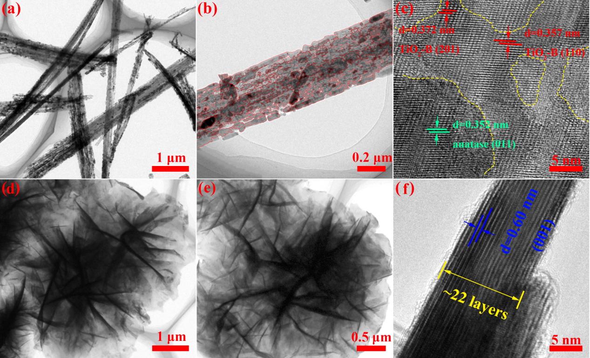
Fig. S1 High-magnification TEM images (a, b), HRTEM image (c) of TiO₂-B nanobelts, and TEM images (d, e), HRTEM image (f) of SnS₂ nanosheets.

Fig. S2 Cyclic voltammetry (CV) curves at a scanning of 0.1 mV s⁻¹ in the voltage range of 0.01-3.0 V versus Li⁺/Li of TiO₂-B@SnS₂.

Fig. S3 Discharge/charge profiles during three cycles at a rate of 0.1 C (a), and the first discharge/charge cycle at different discharge current densities (b) of SnS₂ electrode.

Fig. S4 The first discharge/charge cycle (a), and rate performance at various discharge current densities from 0.1 to 15 C (1 C=300 mAh g⁻¹) (b) of TiO₂-B nanobelts.
The corresponding Li⁺ diffusion coefficient at various lithiation-delithiation states are calculated according to Eq. 1:
(S1)
Where V_{m}, S, z_{i} and I₀ is the molar volume, electrode surface area, number of lithium ions involved during the electrode reaction process and current, respectively. dE/dx is the slope of coulomb titration curve, while, dE/dt^{1/2} is the relationship between potential and time.

