Patients and Methods
1\Study Design
The study was a multicenter randomized trial involving two study groups. Patients of eligible surgeons were randomly assigned to one of MALND or CALND by a central registration system. This study was overseen by a scientific steering committee and an independent data monitoring committee. .
2\Patients
Patients of either sex younger than 80 years of age with operable breast cancer were eligible for enrollment. Inclusion criteria were that the lymph nodes in axilla were negative or less than 1cm by clinical examination or color-ultrasonic inspection. Exclusion criteria were history of another cancer; preexisting limb disease causing swelling; previous surgery in iplateral axilla.
All the patients were informed of the aims of the study, the potential effects of the procedures, the risks associated with surgery, and the meaning of the randomization. Written informed consent was required from all patients according to a protocol approved by local ethics committees and in accordance with the Declaration of Helsinki before operation. This trial has been registered (Number ChiCTR-TRC-11001477).
Between Jan 2003 and Dec 2005, 1108 of 1267 consecutive patients with operable breast cancer from 16 surgeons at 15 centers in china were randomly assigned to one of the two study groups.
Of the other 250 patients, 161 were deemed ineligible, 89 were not randomly assigned to a study group. Of the 1037 randomized patients, 41 were not able to be evaluated (Table 1). Baseline characteristics did not differ greatly between two groups (Table 2).

Table 1. Patients Eligible for Enrollment, Randomly Assigned to Two Groups, and Able to Be Evaluated.
Patients No. of patients
Initially considered for enrollment 1267
Not eligible 161
Lymph node diameter ＞1cm 110
History of another cancer 43
Previous surgery in ipsilateral axilla 8

Eligible for enrollment 1126
Not randomly assigned to a study group 89
Patient’s decision 44
Bilateral breast cancer 28
Other 17

Randomly assigned to a study group 1037
Not able to be evaluated 41
Patients canceled follow-up 24
Patients refused assigned treatment 17

Able to be evaluated 996
CALND 500
MALND 496

Table 2. Baseline characteristics of the Two Study Groups
Characteristic CALND MALND Total p Value
(n=500) (n=496) (n=996)
no. of patients (%)
Age (years) 47.9 52.2 ＞0.05

Histologic type ＞0.05
Invasive ductal 395(79.0%) 390(78.6%) 785(78.8%)
Invasive lobular 49( 9.8%) 44(8.9%) 93(9.3%)
Other 56(11.2%) 62(12.5%) 118(11.9%)

Tumor grade ＞0.05
Ⅰ 143(28.6%) 150(30.2%) 293(29.4%)
Ⅱ 245(49.0%) 237(47.8%) 482(48.4%)
Ⅲ 112(22.4%) 109(22.0%) 221(22.2%)

Estrogen-receptor ＞0.05
Positive 456(91.2%) 456(91.9%) 912(91.6%)
Negative 44(8.8%) 40(8.1%) 84(8.4%)

Rate of proliferation ＞0.05
＜20% 322(64.4%) 316(63.7%) 638(64.1%)
≥20% 178(35.6%) 180(36.3%) 358(35.9%)

Peritumoral vascular invasion ＞0.05
Yes 129(25.8%) 132(26.6%) 261(26.2%)
No 371(74.2%) 364(73.4%) 735(73.8%)

3\ Quality Control
Participation in this trial was limited to sixteen credentialed surgeons at fifteen institutions. Each surgeon had performed at least 20 MALND. All surgeons in this study took the same standardized operative technique. Surgeons submitted a video of MALND to assess their oncologic technique, including main operative stages, the identification and dissection of critical adjacent structures. They were reviewed by an external monitoring committee. Manoeuvres to prevent port-site metastasis, non-touch technique with the extraction of tissues dissected, washing with mild-hot distilled water were used routinely.
We also published a MALND VCD for China Medical Association textbook invited by China Medical Association (Figure 1).
- Surgical Procedures
1)Surgical sequence
The operation first underwent MALND and then breast operation, whether lumpectomy or mastectomy (If the breast operation is first performed, the formation of the air cavity in axilla may be affected). The advantage of this dissection in lumpectomy showed obviously. The significance of MALND in mastectomy still appeared in another point. It minimized breast operation incision. It is not needed to prolong the breast incision intentionally or unintentionally towards axilla for doing ALND，or the prolonged incision could raise the limit to the functional mobilization of upper limb and this enlarged incision scar on front chest affected the cosmetics. Preoperative antibiotics were used routinely 30min before operation.
2) Operation procedure According to the method reported previously ^{[9~12]}，it is introduced briefly below（Diagram 1）.
①. Establishment of gas-space in axilla Under general anesthesia, the patient was placed in the supine position with ipsilateral arm abducted to 90°. The patient’s forearm was hung to the frame of the bed. A lipolysis liquid (saline 200~250ml, distilled water 200~250ml, lidocaine 800mg, adrenalin 0.5~1mg) was injected into the axilla at several points. After at least 10 minutes, the fat of axilla was aspirated through a 10mm incision located in the mid line of axilla and parallel to the level of the nipple. A 10mm trocar was inserted into the liposuction hole. From this trocar, CO₂ was infused into the axilla to about 8mmHg pressure.
②. Axillary lymph node dissection A 30°10mm endoscope was inserted. Two additional 5mm trocars were placed in the lateral margin of pectoralis major muscle and the anterior margin of latissimus dorsi respectively at the middle of the axilla. The cobweb like cord separations and the remaining fat and lymph nodes attached at the blood vessels and nerves were severed and peeled with diathermy scissors. The dissection of the axillary level I and II or/+ level Ⅲ lymph nodes was accomplished. The axilla was washed with warm distilled-water and continuously drained by a suction tube placed in the inferior trocar hole.
③.“Six-steps” procedure for the lymph node dissection（Diagram 1）
Long thoracic
nerve
dissection
Thoracodosal
nerve & vessels
dissection
Exposure of
axillary vein
Rotter’s LN
dissection
Level II or/+III
dissection
Itercostobrachial
nerve
dissection

Diagram 1 “Six- steps” procedure of MALND
Either type of ALND consisted of a level I to II and/or III (if the swollen node with suspected metastasis was found in level II) axillary dissection. Contemporary surgical treatment includes a modified radical mastectomy or breast-conserving treatment. In the CALND group, breast surgery and ALND were performed by the traditional open method. In the MALND group, the patients first underwent MALND and then breast surgery. The MALND operation was performed according to the method reported previously.
Adjuvant Treatment
Patients were treated with systemic therapy and radiation therapy according to same standard institutional protocols (National Comprehensive Cancer Network Breast Cancer Practice Guideline).
Outcome Evaluation
The primary end points of the study were disease-free survival, defined as absence of any event (specifically axillary metastases, local recurrence, ipsilateral carcinoma or distant metastasis) considered related to the primary cancer, but excluding contralateral breast cancer and any other cancer, and overall survival.
Statistical Analysis
Statistical analysis was performed for the parameters in end points based on an intent-to-treat population. All tests were conducted at the two-sided 5% level of signiﬁcance for treatment effects. Analyses of end results were performed separately for patients in two groups.
P values of 0.05 or lower are considered to indicate statistical significance. For time to event endpoints, Kaplan-Meier plots were presented and log-rank tests were used to test the null hypothesis of no MALND effect. End points were compared between groups using the two-sample t test for continuous outcome variables and the chi-square test for categorical variables. The analysis was performed with missing data left missing. Estimates are provided with their standard errors. Continuous variables were summarized using mean +- SD and categorical variables were summarized using n (%).All calculations were performed using SPSS software package (version 19.0).

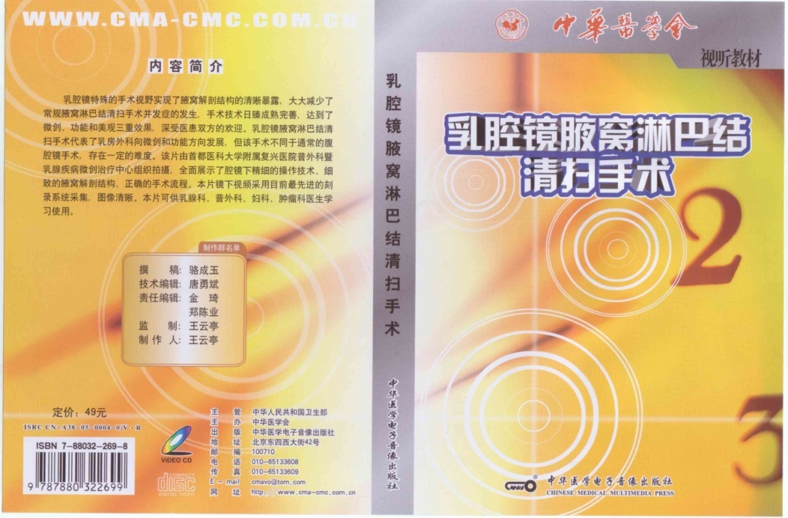
Figure 1 Chengyu L. Mastoscopic axillary lymph node dissection.

