Cytokine release syndrome in a patient with colorectal cancer following vaccination with BNT162b2 (tozinameran)
Lewis Au,^{1,2,13} Annika Fendler,^{1,13} Scott Shepherd,^{1,2} Karolina Rzeniewicz,¹ Maddalena Cerrone,³ Fiona Byrne,¹ Eleanor Carlyle,² Kim Edmonds,² Lyra Del Rosario,² John Shon,⁴ Winston A Haynes,⁴ Barry Ward,¹ Ben Shum,^{1,2} William Gordon,¹ Camille L Gerard,^{1,5} Wenyi Xie,¹ Nalinie Joharatnam-Hogan,² Kate Young,² Andrew Furness,² Lisa Pickering,² James Larkin,² Ruth Harvey,⁶ George Kassiotis,⁷ Sonia Ghandi,⁸ Charles Swanton⁹ on behalf of the Crick COVID-19 Consortium, Charlotte Fribbens,¹⁰ Katalin A Wilkinson,³ Robert J Wilkinson,^{3,11} David K Lau,¹² Naureen Starling,¹² Ian Chau,¹² Samra Turajlic,^{1,2*} on behalf of the CAPTURE Consortium

¹Cancer Dynamics Laboratory, The Francis Crick Institute, London, NW1 1AT, UK
²Skin and Renal Units, The Royal Marsden NHS Foundation Trust, London, SW3 6JJ, UK
³Tuberculosis Laboratory, The Francis Crick Institute, London, NW1 1AT, UK
⁴Serimmune, Inc., Goleta, CA, USA
⁵Precision Oncology Center, Lausanne University Hospital (CHUV), Switzerland
⁶Worldwide Influenza Centre, The Francis Crick Institute, London, NW1 1AT, UK
⁷Retroviral Immunology Laboratory, The Francis Crick Institute, London, NW1 1AT, UK
⁸Neurodegeneration Biology Laboratory, The Francis Crick Institute, London, NW1 1AT, UK
⁹Cancer Evolution and Genome Instability Laboratory, The Francis Crick Institute, London, NW1 1AT, UK
¹⁰Acute Oncology Service, The Royal Marsden NHS Foundation Trust, London, SW3 6JJ, UK
¹¹Department of Infectious Disease, Imperial College London, London, W12 0NN, UK
¹²Gastrointestinal Unit, The Royal Marsden NHS Foundation Trust, London and Surrey SM2 5PT
¹³Equal Contribution
*Corresponding author: Samra Turajlic (samra.turajlic@crick.ac.uk)

Supplementary Files

Supplementary Figures

Figure S1. Gating strategy for T-cell assay

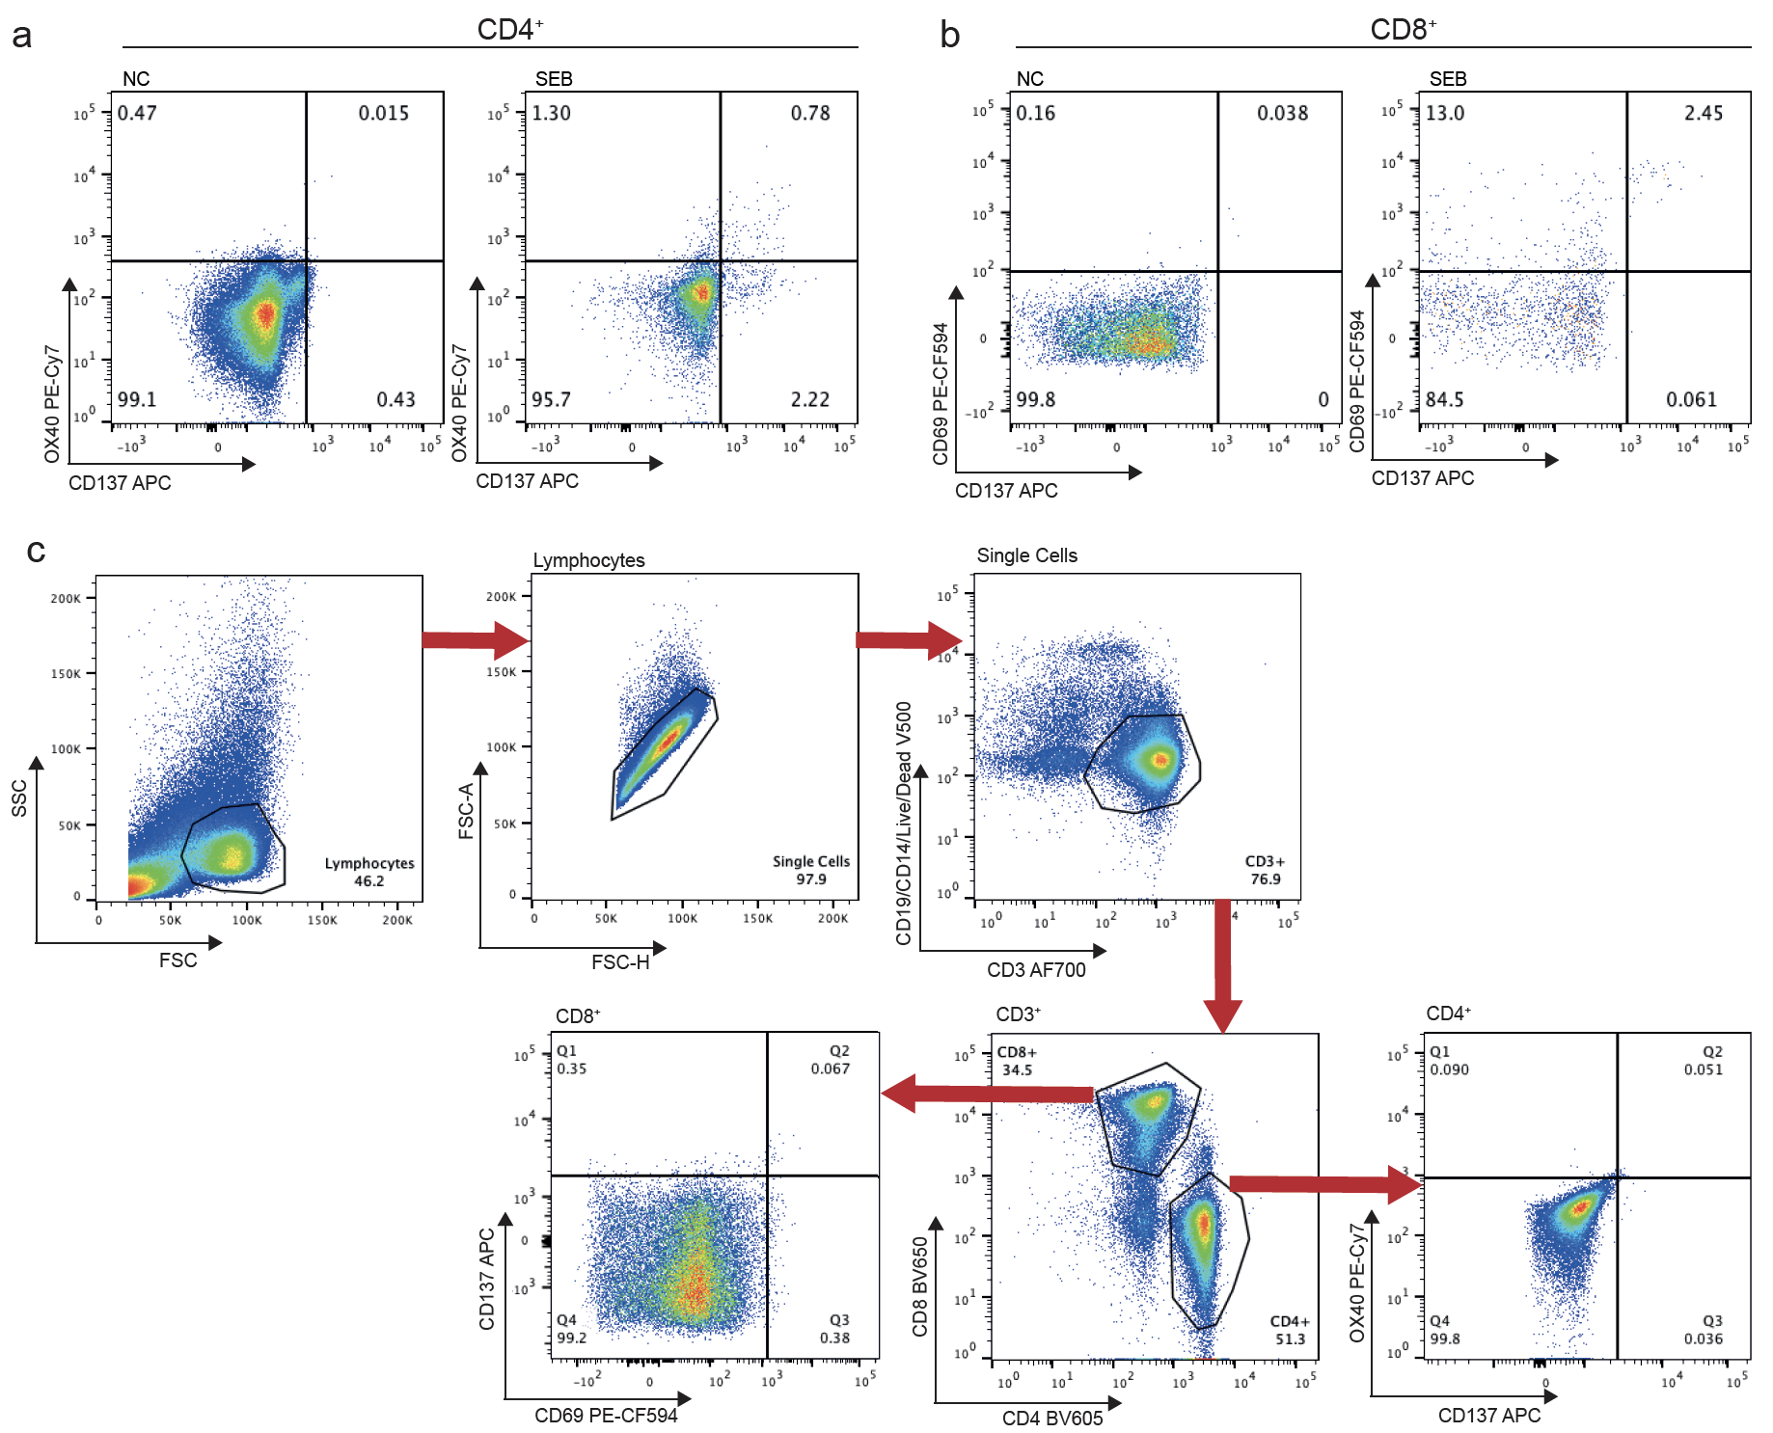

a) CD4+ T-cell response to SEB in exemplary samples. b) CD8+ T-cell response to SEB in exemplary samples. c) Gating strategy for flow analysis of T-cell activation. PBMCs were stimulated with SEB for 24 hrs. SEB, Staphylococcal enterotoxin B
Figure S2. Antibody response to BNT162b2 according to SERA and PIWAS
a) Pre- and post-vaccination antibody levels against SARS-CoV-2 antigenic motifs. b) PIWAS values pre- and post-vaccination against non-spike sequences of the SARS-CoV-proteome compared to patients with SARS-CoV-2 positive subjects¹ (Methods). PIWAS, protein-based immunome wide association study; SERA, serum epitope repertoire analysis
Supplementary Tables

Table S1: List of antibodies used in AIM assay

Antibody | Fluorochrome | Clone | Vendor
CD14 | V500 | M5E2 | BD
CD19 | V500 | HIB19 | BD
CD4 | BV605 | OKT4 | Biolegend
CD8 | BV650 | RPA-T8 | Biolegend
CD69 | PE-CF594 | FN50 | BD
OX40 | PE-Cy7 | Ber-ACT35 | Biolegend
CD137 | APC | 4B4-1 | Biolegend
CD3 | AF700 | OKT3 | Biolegend

Supplementary References

1 Haynes, W. A. et al. High-resolution mapping and characterization of epitopes in COVID-19 patients. medRxiv, 2020.2011.2023.20235002, doi:10.1101/2020.11.23.20235002 (2020).

