Supplementary Information

Dynamic restructuring of coordinatively unsaturated copper paddle wheel clusters drives CO₂ reduction efficiently

Wei Zhang^{1,2}, Chuqiang Huang¹, Jiexin Zhu², Qiancheng Zhou¹, Ruohan Yu², Yali Wang¹, Pengfei An³, Jing Zhang³, Ming Qiu¹, Liang Zhou², Liqiang Mai², Zhiguo Yi⁴ and Ying Yu¹

¹ Institute of Nanoscience and Nanotechnology, College of Physical Science and Technology, Central China Normal University, Wuhan 430079, Hubei, P. R. China. ² State Key Laboratory of Advanced Technology for Materials Synthesis and Processing, Wuhan University of Technology, Wuhan 430070, Hubei, P. R. China. ³ Beijing Synchrotron Radiation Facility, Institute of High Energy Physics, Chinese Academy of Science, Beijing 100049, P. R. China. ⁴ State Key Laboratory of High Performance Ceramics and Superfine Microstructure, Shanghai Institute of Ceramics, Chinese Academy of Sciences, Shanghai 200050, P. R. China. email: mlq518@whut.edu.cn; zhiguo@mail.sic.ac.cn; yuying01@mail.ccnu.edu.cn.

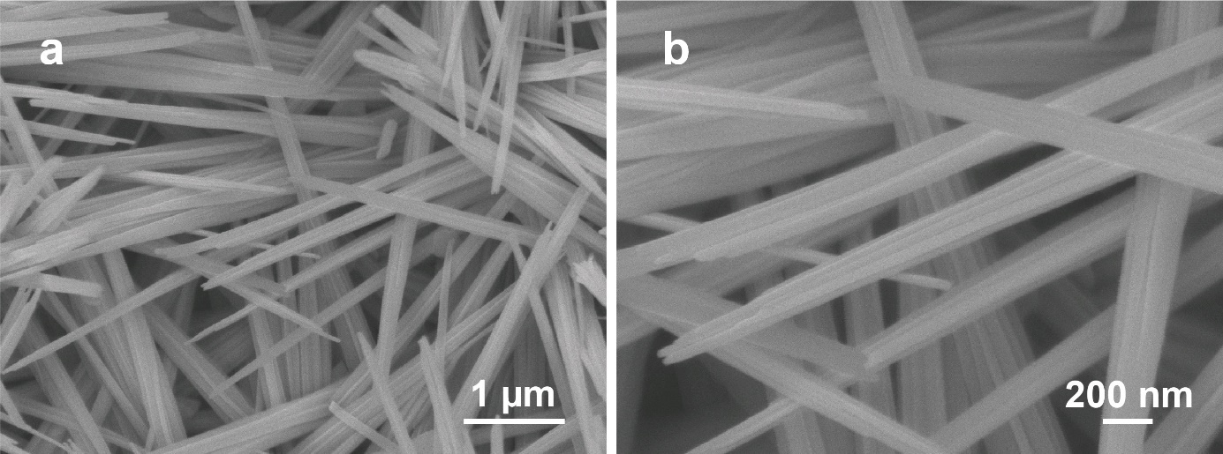
Supplementary Figure 1. SEM images of Cu(OH)₂ NWs

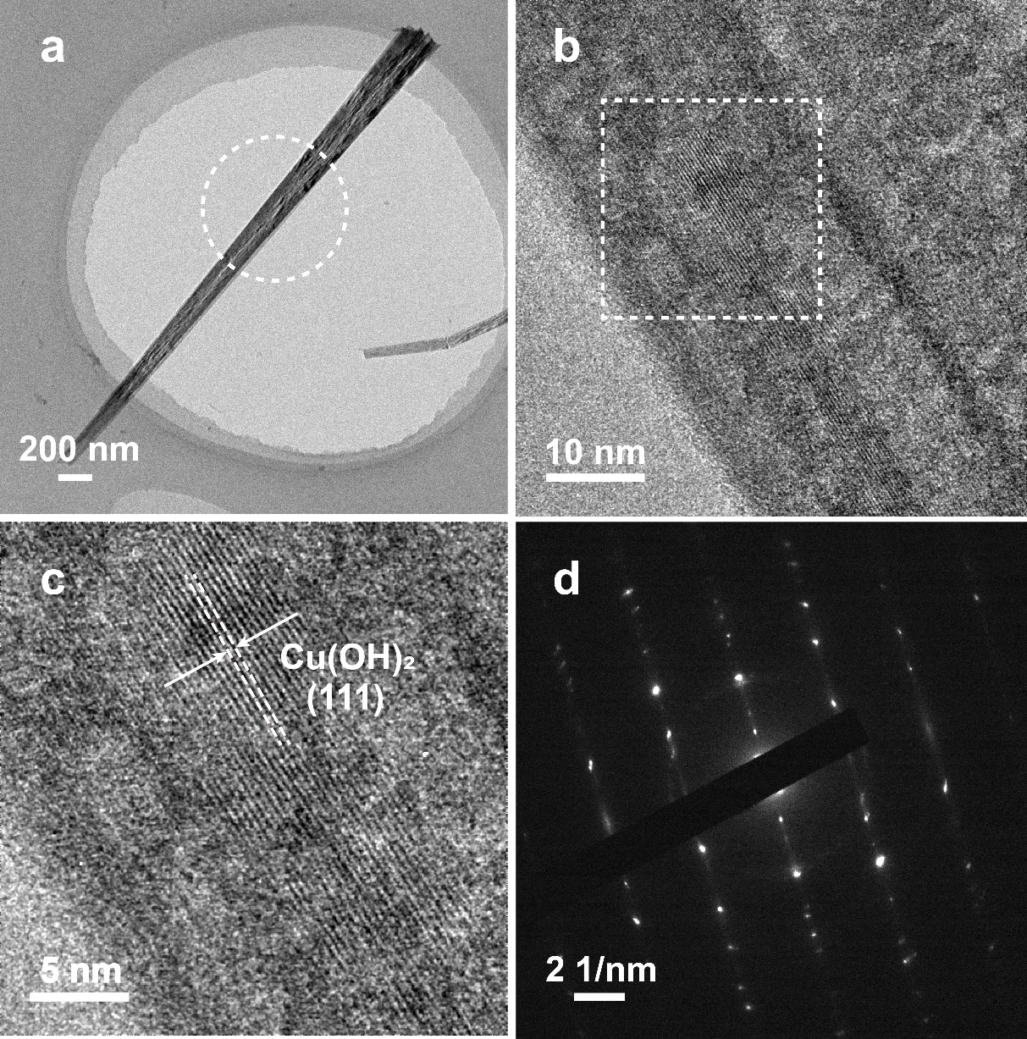
Supplementary Figure 2. (a) Low-magnification TEM image, (b, c) HRTEM images and (d) selected area electron diffraction (SAED) pattern of Cu(OH)₂ NWs.

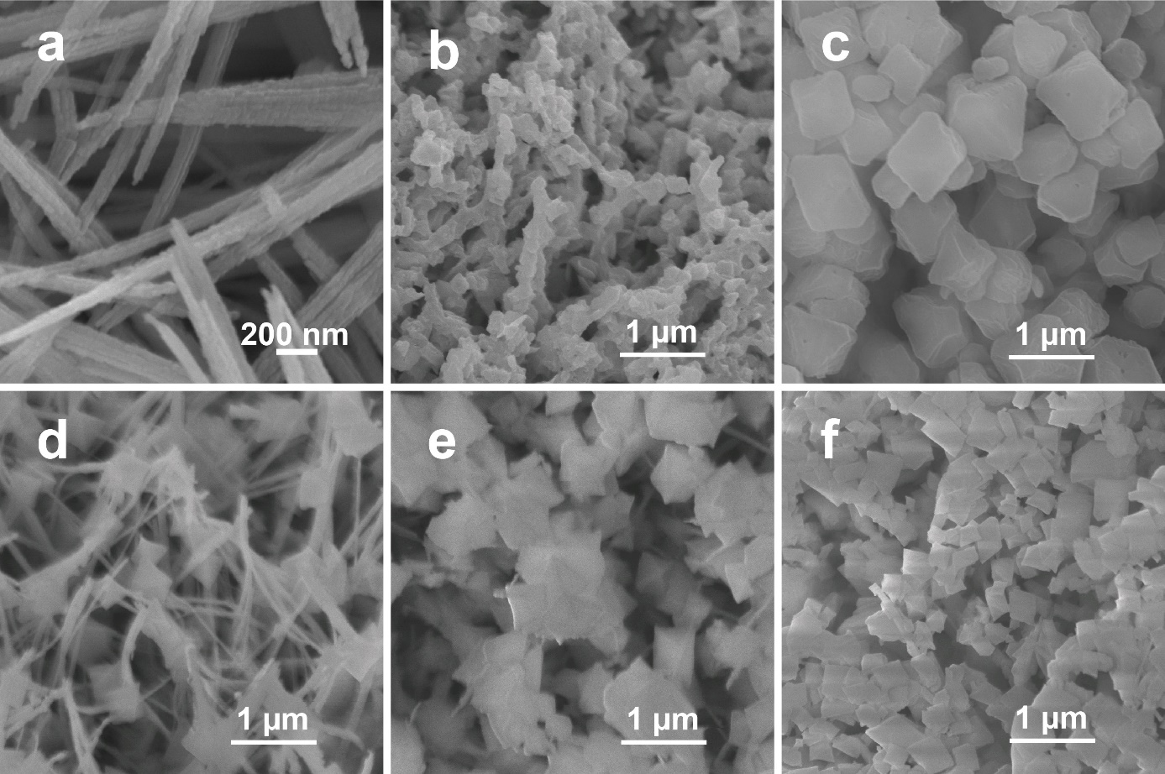
Supplementary Figure 3. (a-c) SEM images of samples prepared through “atomized method”. The reaction time was 120 s (a), 240 s (b), 480 s (c). (d-f) SEM images of samples prepared through “immersed method”. The immersed time was 10 s (d), 60 s (e) and 120 s (f).

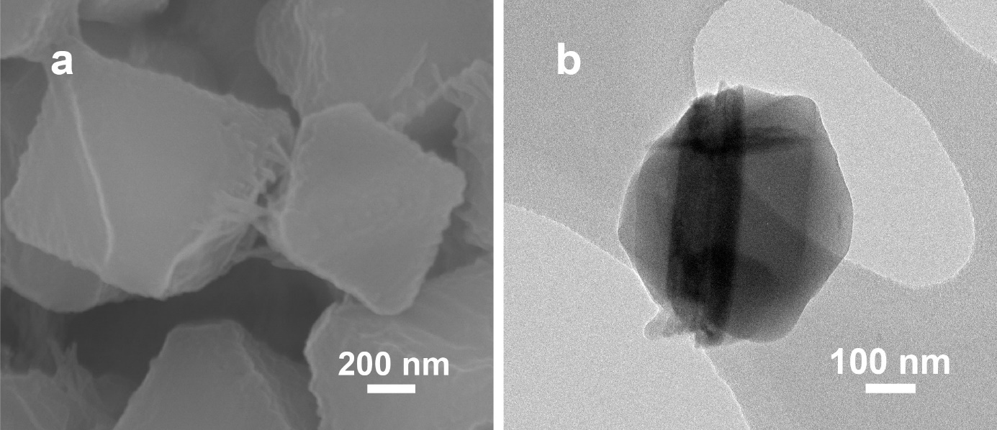
Supplementary Figure 4. (a) SEM image of CMOF. (b) TEM image of CMOF.

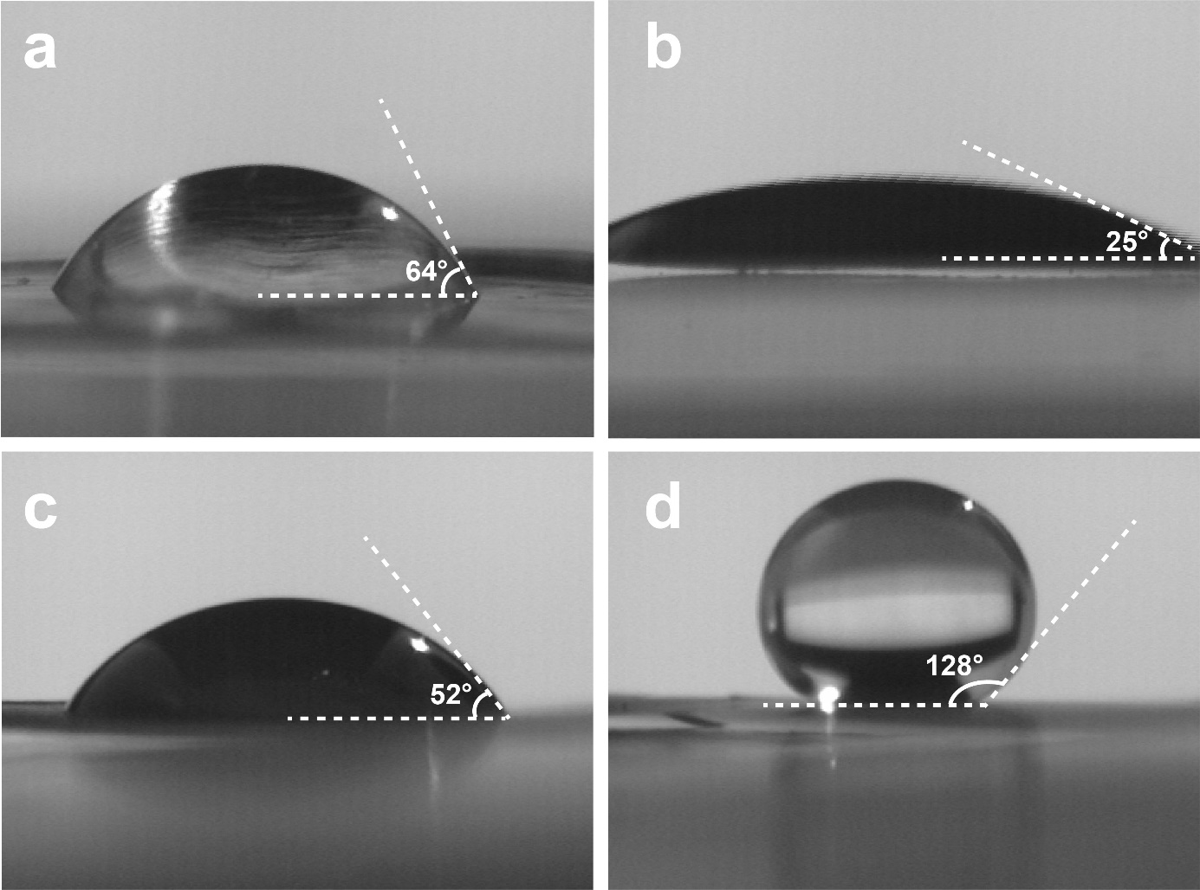
Supplementary Figure 5. (a-d) Contact angle of Cu foil, Cu(OH)₂ NWs, QMOF and CMOF.

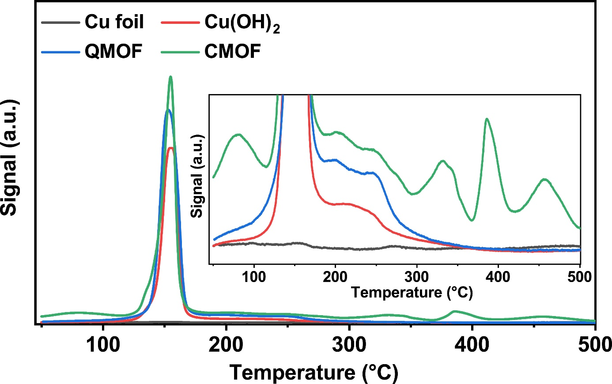
Supplementary Figure 6. CO₂-temperature programmed desorption (TPD) measurement of Cu foil, Cu(OH)₂ NWs, QMOF and CMOF.

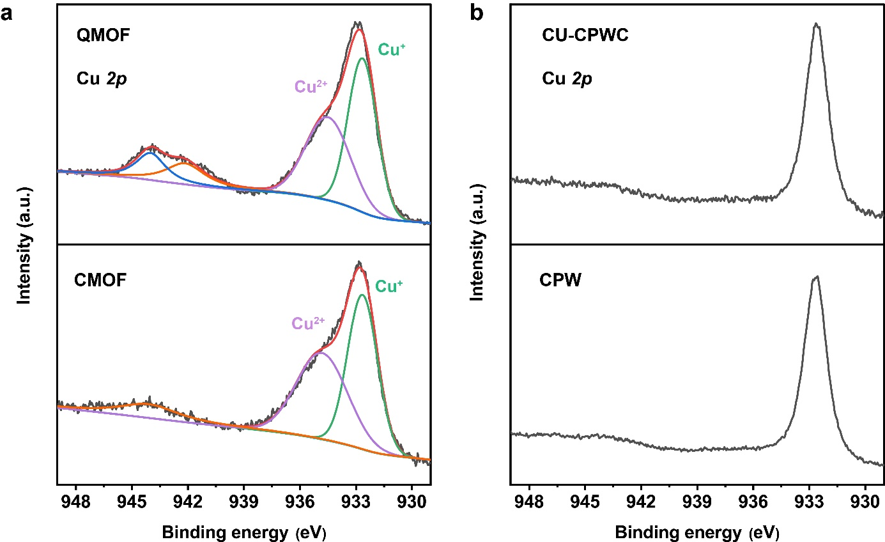
Supplementary Figure 7. (a) High-resolution XPS signals of Cu 2p of QMOF and CMOF. (b) CU-CPWC and CPW.

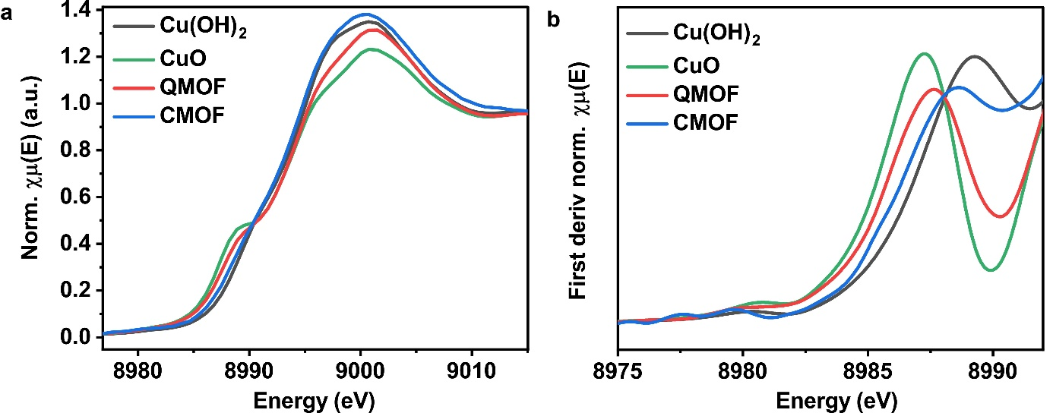
Supplementary Figure 8. (a) Normalized Cu K-edge XANES spectra of Cu(OH)₂ NWs, CuO, QMOF and CMOF. (b) First-derivative spectra obtained from Cu K-edge XANES spectra.

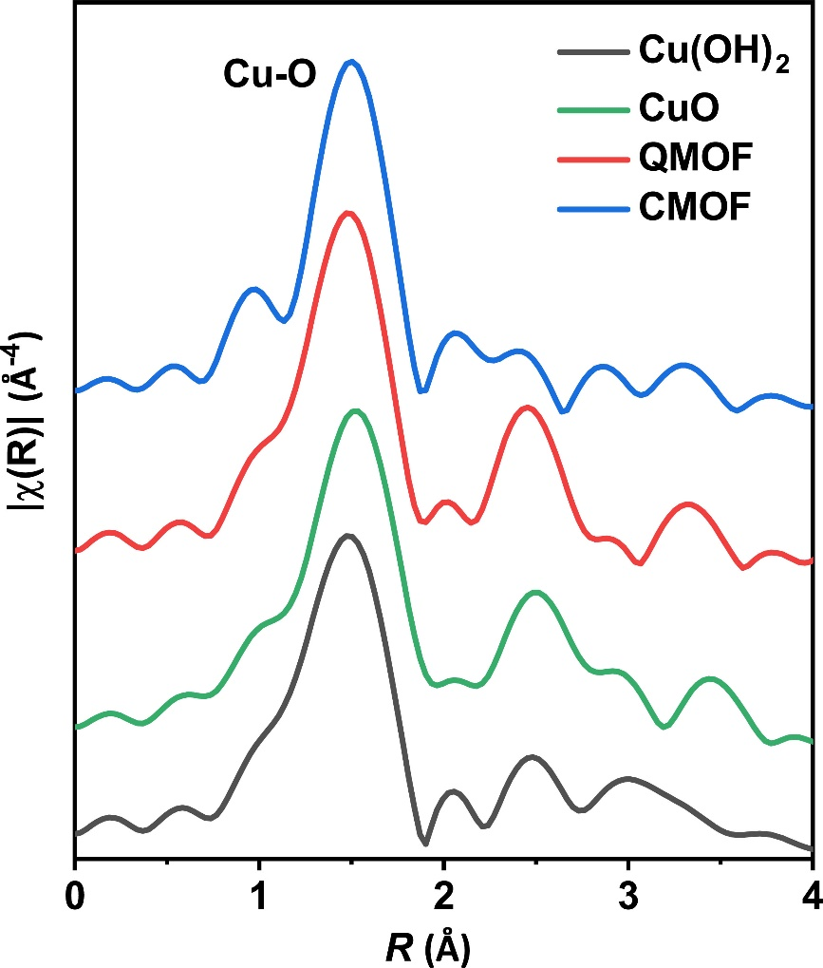
Supplementary Figure 9. K3-weighted FT-EXAFS spectra of Cu(OH)₂ NWs, CuO, QMOF and CMOF.

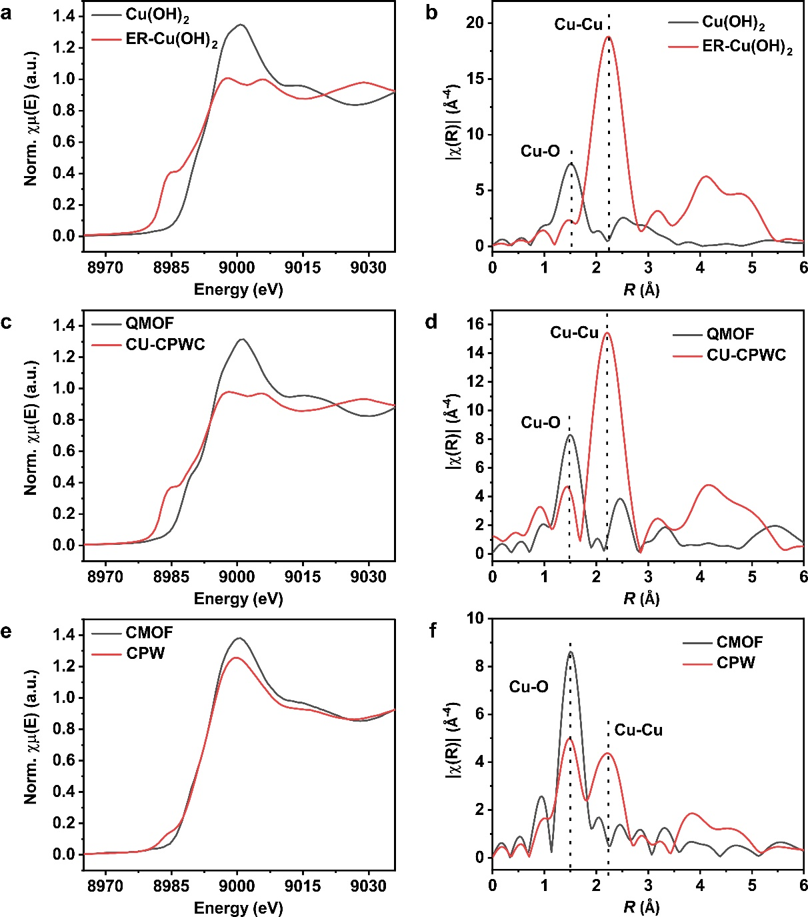
Supplementary Figure 10. Comparison of XAS data before and after electrochemical reconstruction: (a, c and e) Cu K-edge XANES spectra, (b, d and f) Corresponding k3-weighted FT-EXAFS spectra of the four samples.

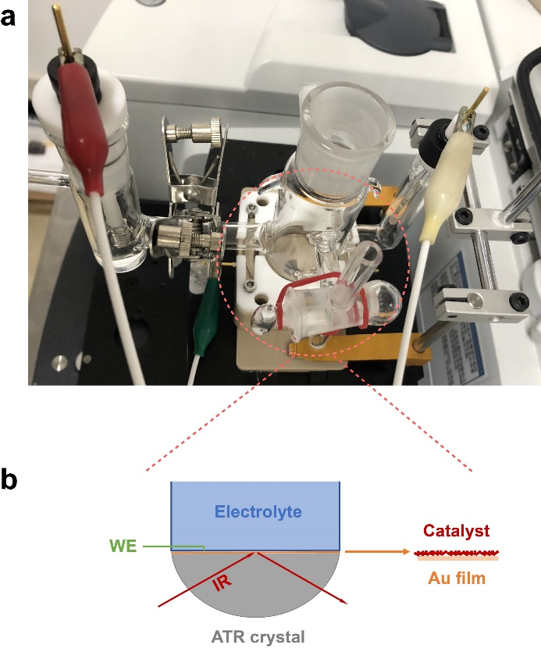
Supplementary Figure 11. (a) Electrochemical cell used for ATR-FTIR measurements. (b) Schematic illustration of ATR-FTIR cell.

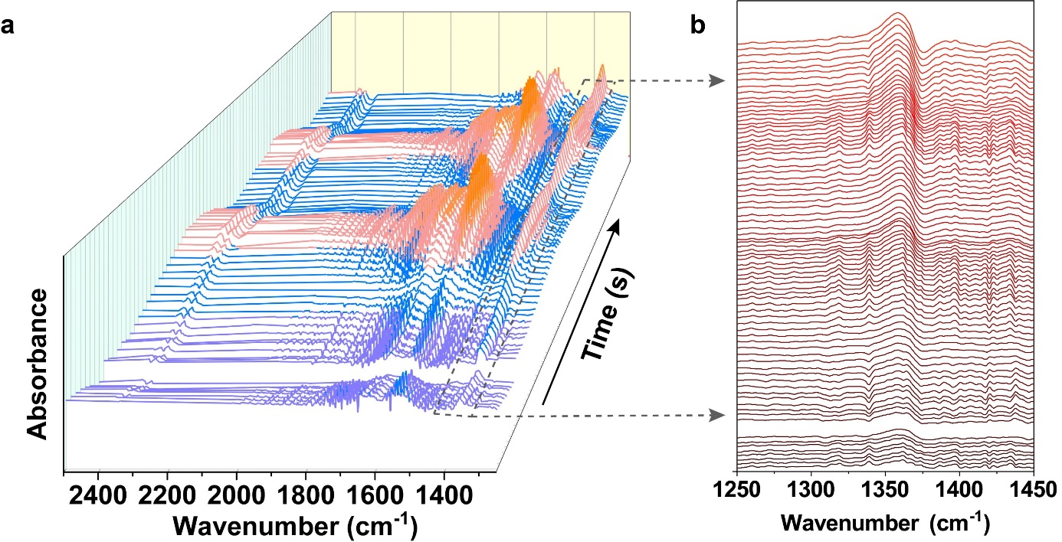
Supplementary Figure 12. (a) In situ ATR-SEIRA spectra collected on a QMOF cast Au/Si prism electrode with a time resolution of 2 s, using a single-beam spectrum at ∼−0.4 V vs RHE.

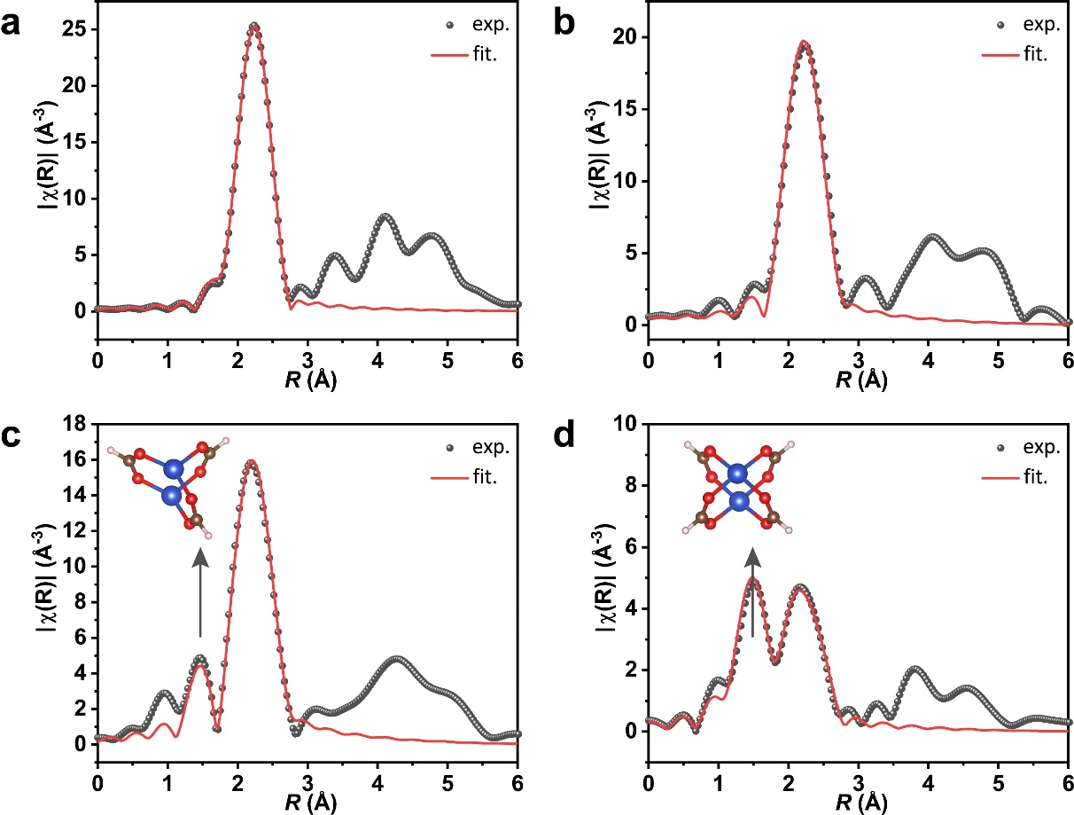

Supplementary Figure 13. Corresponding EXAFS R-space fitting curves of the four samples. (a) Cu foil, (b) ER-Cu(OH)₂, (c) CU-CPWC and (d) CPW.

Table S1. Fitting results of Cu K-edge EXAFS dataª.

Sample | Scattering path | CN | R (Å) | σ² (10⁻³ Å) | R factor
Cu foil | Cu-Cu | 12 (set) | 2.54 | 8.81 | 0.0011
ER-Cu(OH)₂ | Cu-Cu | 9.65 | 2.53 | 8.22 | 0.010
CU-CPWC | Cu-O | 0.51 | 1.88 | 3.22 | 0.0083
 | Cu-Cu | 7.55 | 2.52 | 7.96
CPW | Cu-O | 2.54 | 1.94 | 6.01 | 0.0048
 | Cu-Cu | 3.4 | 2.55 | 10.50
ª The lengths of Cu-Cu and Cu-O bonds and coordination numbers of Cu atoms are extracted from the curve-fitting for Cu K-edge EXAFS data. CN: coordination number; σ²: Debye−Waller factor. Error bounds that characterize the structural parameters obtained by EXAFS spectroscopy were estimated as CN ± 20 %; R ± 1 %; σ² ± 20 %.

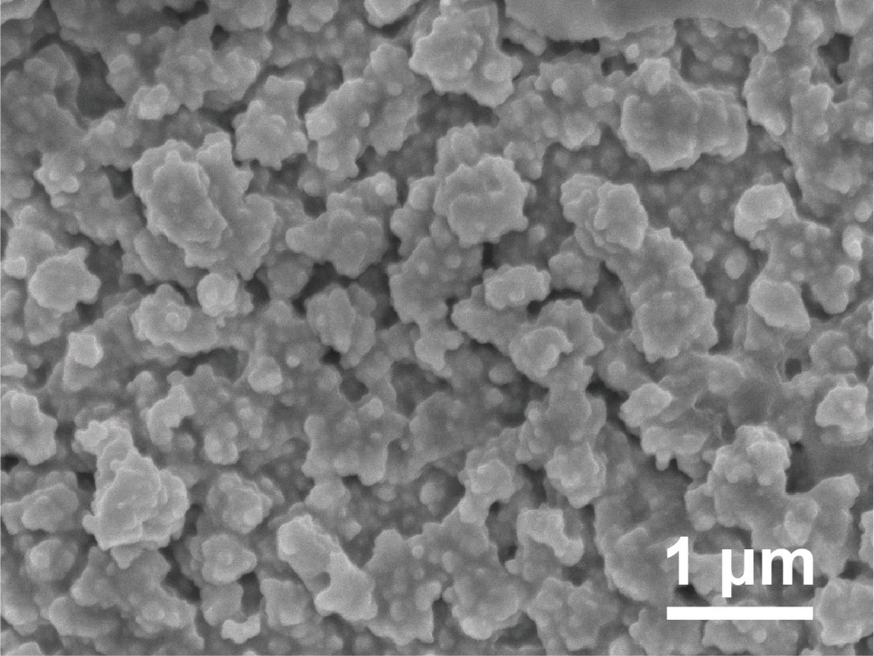
Supplementary Figure 14. SEM image of CPW.

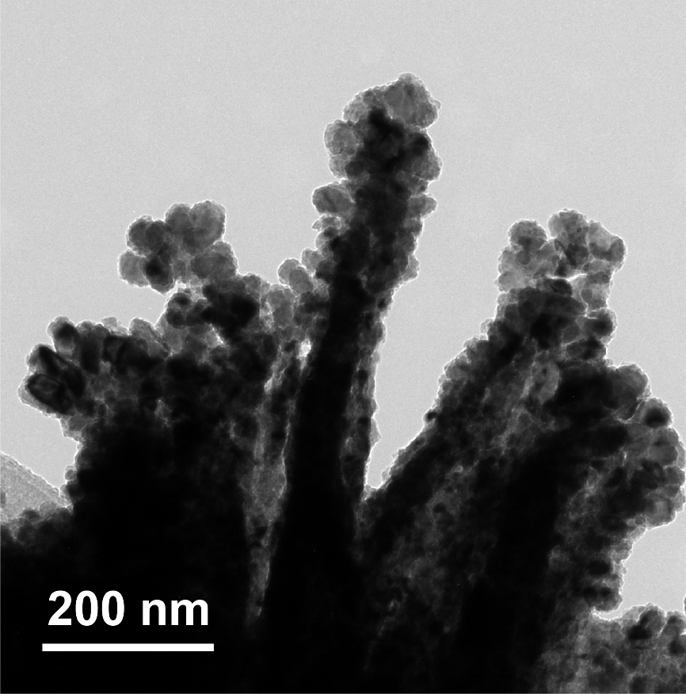
Supplementary Figure 15. TEM image of CU-CPWC.

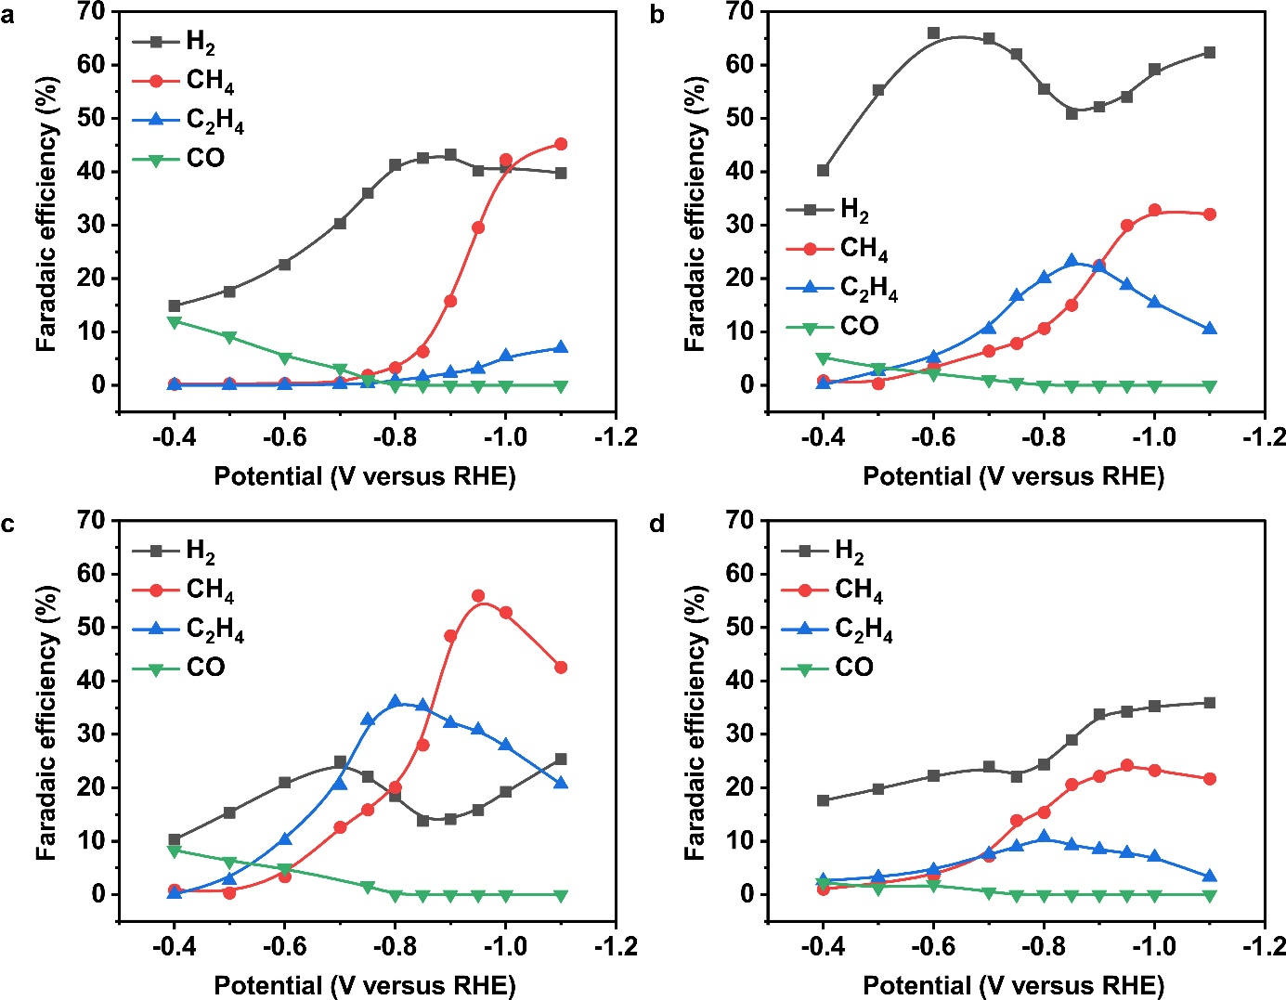

Supplementary Figure 16. Product distribution of CO₂ reduction on Cu foil (a), ER-Cu(OH)₂ NWs (b), CU-CPWC (c), and CPW (d).

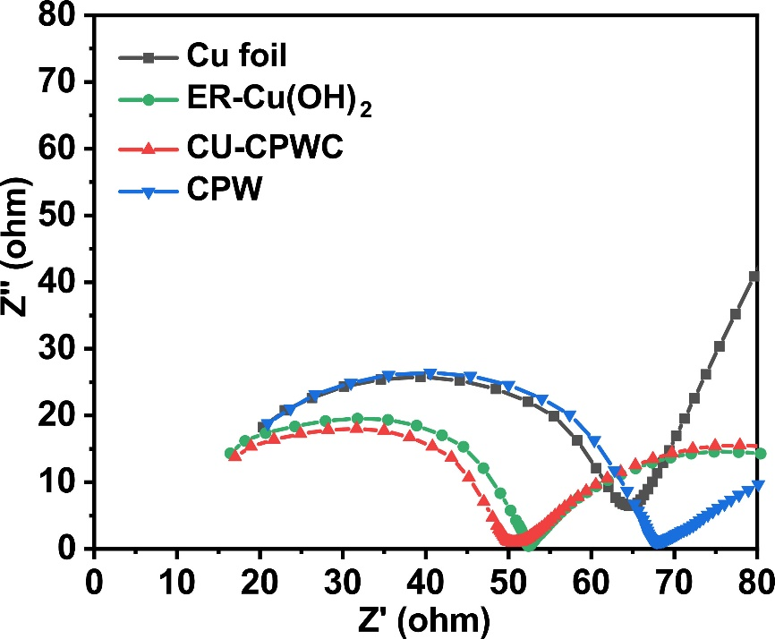
Supplementary Figure 17. Nyquist plots of the four samples in CO₂-saturated KHCO₃ electrolyte.

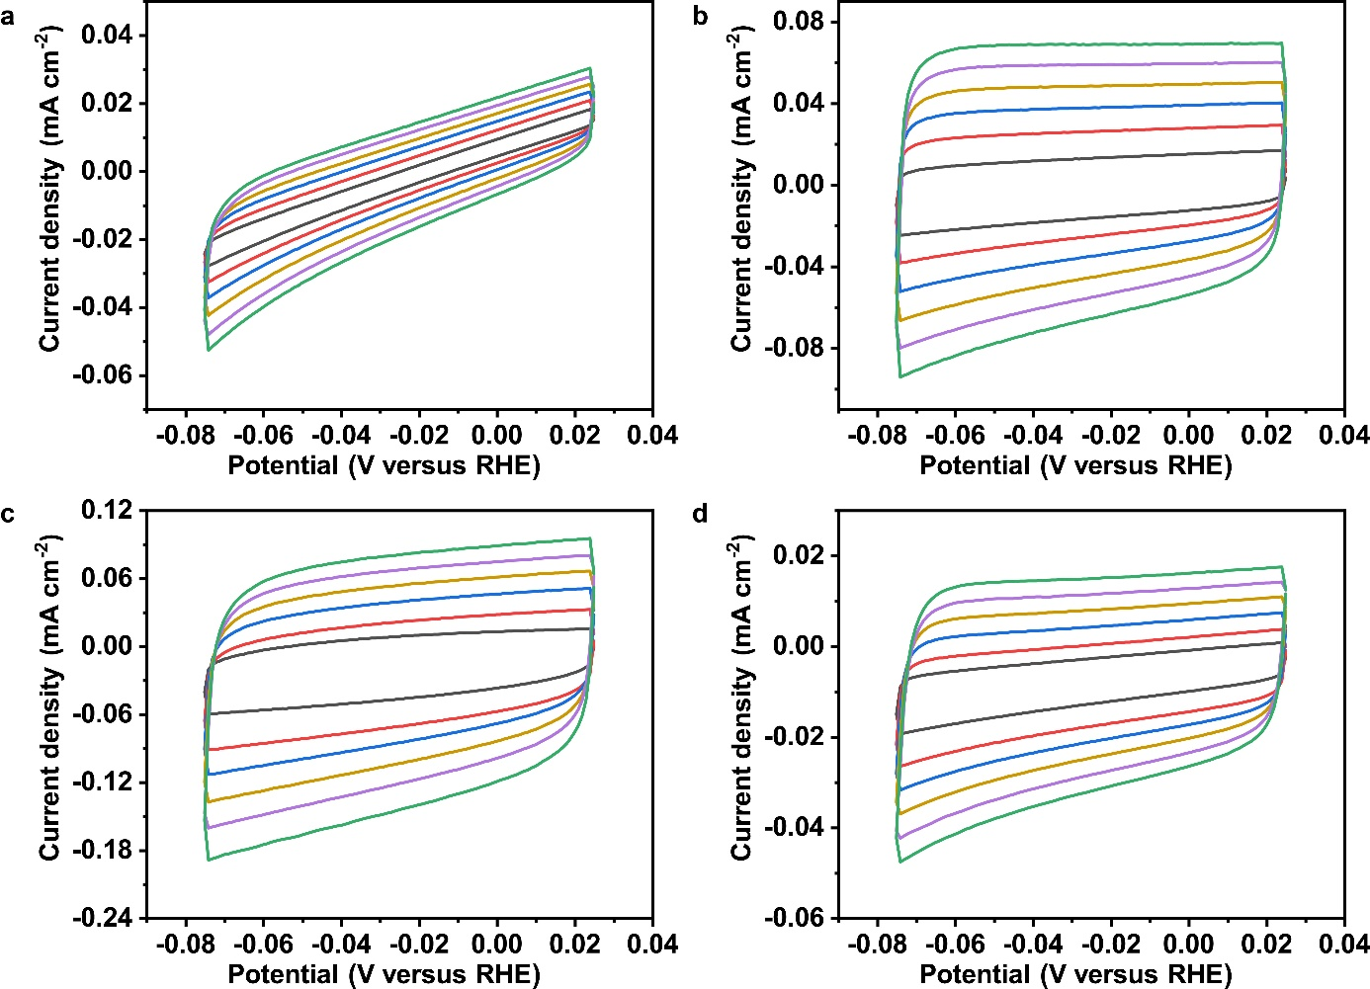
Supplementary Figure 18. Cyclic voltammetry scans on Cu foil (a), ER-Cu(OH)₂ NWs (b), CU-CPWC (c), and CPW (d) between 0.025 and -0.075 V vs. RHE in CO₂-saturated 0.1 M KHCO₃ solution at scan rates of 10, 20, 30, 40, 50 and 60 mV s⁻¹.

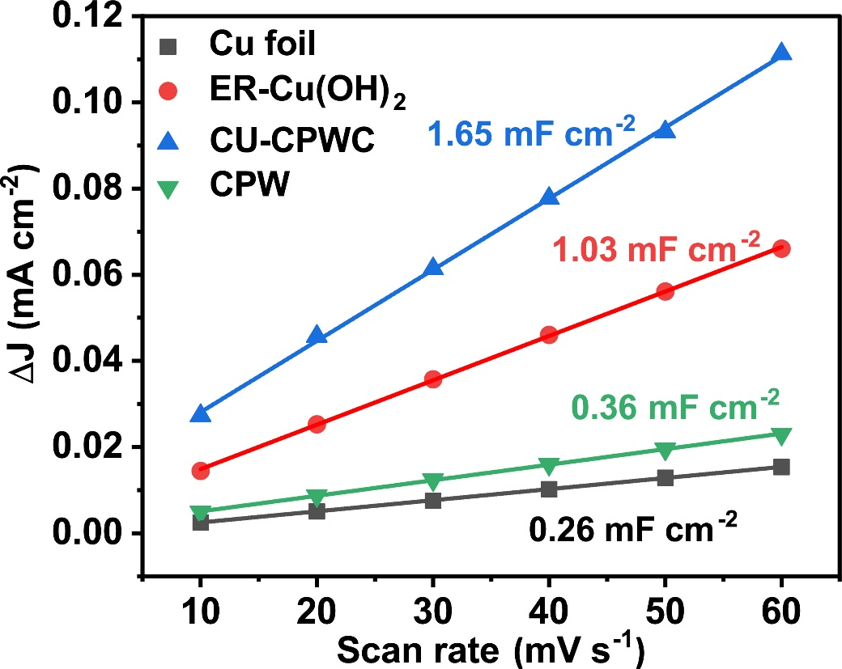
Supplementary Figure 19. Extracted currents at -0.02 V vs. RHE as a function of scan rate, leading to a slope indicating a capacitance of 0.26, 1.03. 1.65 and 0.36 mF cm⁻² for Cu foil, ER-Cu(OH)₂, CU-CPWC and CPW, respectively.

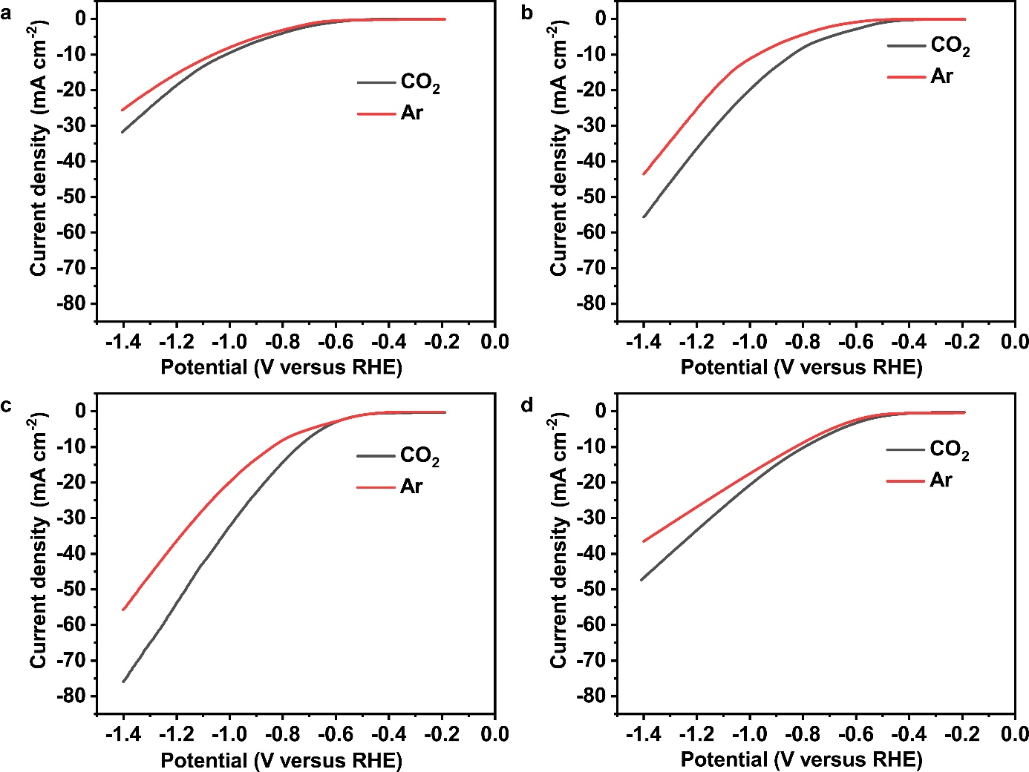
Supplementary Figure 20. Comparison of LSV curves in Ar-saturated and CO₂-saturated KHCO₃ electrolyte for Cu foil (a), ER-Cu(OH)₂ NWs (b), CU-CPWC (c) and CPW (d).

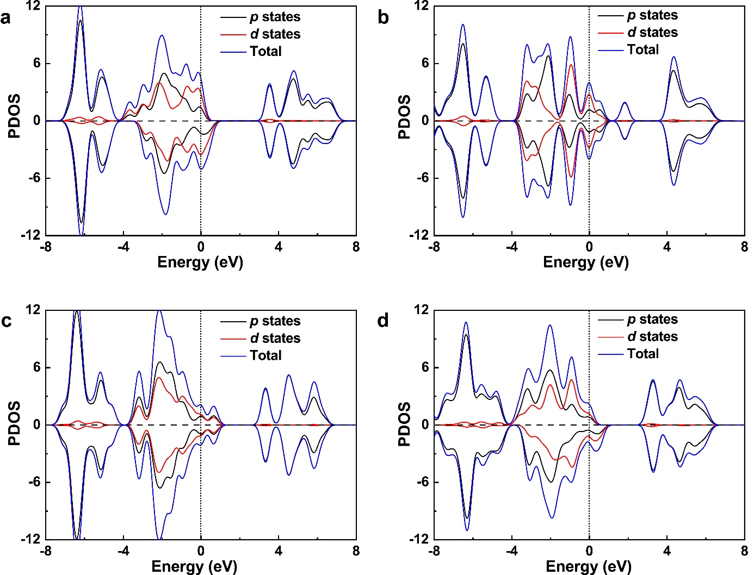
Supplementary Figure 21. Spin-orbit projected density of states of Cu-CPWC with CO (a) and CHO (b) adsorption. Spin-orbit projected density of states of Cu-CPW with CO (c) and CHO (d) adsorption.

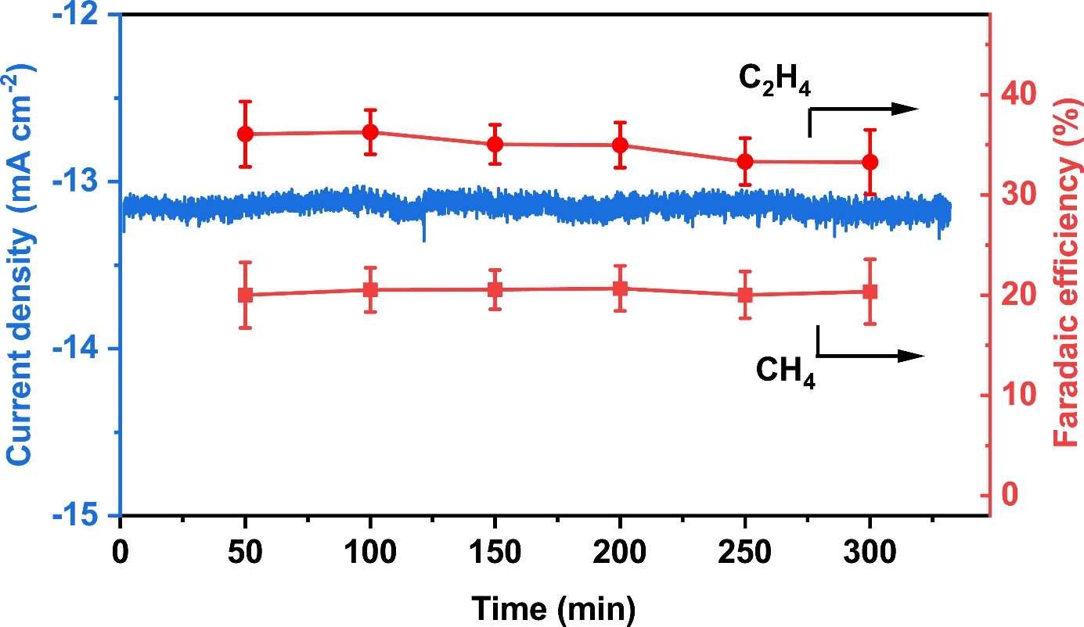
Supplementary Figure 22. Chronoamperometry test of CU-CPWC operated at -0.80 V vs. RHE in 0.1 M KHCO₃.

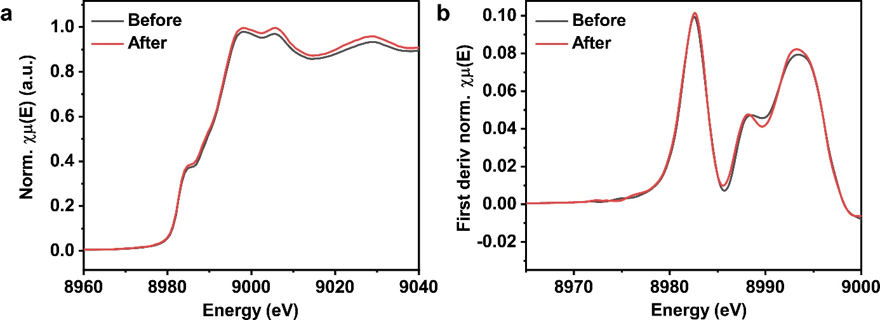
Supplementary Figure 23. (a) Comparison of normalized Cu K-edge XANES spectra before and after stability testing of CU-CPWC. (b) First-derivative spectra obtained from (a).

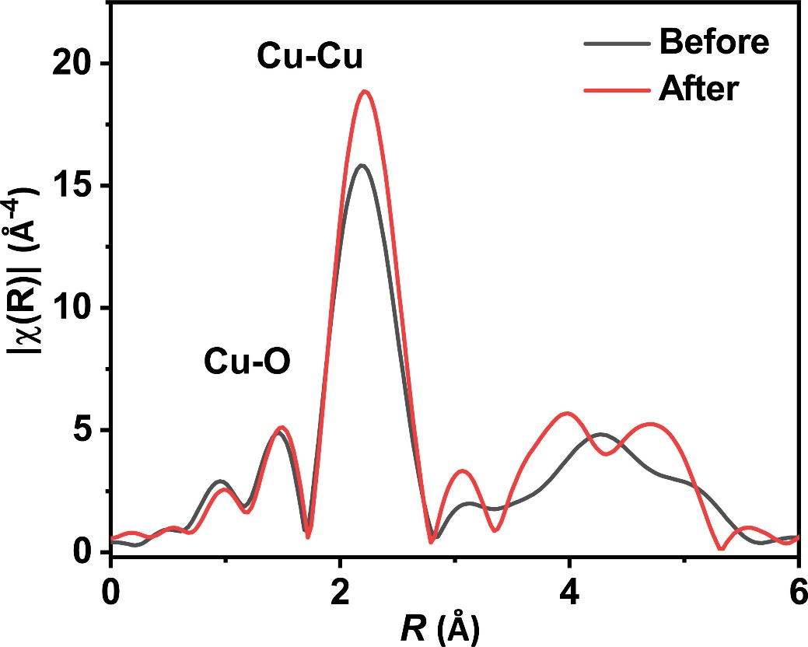
Supplementary Figure 24. Comparison of k3-weighted FT-EXAFS spectra before and after stability testing of CU-CPWC.

