**Supplementary Material**

**Dynamics and mechanisms of bioaccumulation and elimination of Nonylphenol in Zebrafish**

Yinjie Zhanga, Cheng Penga, Wei Zhanga,*, Siyuan Linga, Shuangqing Hub,*

aState Environmental Protection Key Laboratory of Environmental Risk Assessment and Control on Chemical Process, School of Resource and Environmental Engineering, East China University of Science and Technology, Shanghai 200237, China

bShanghai Academy of Environmental Sciences, Shanghai 200233, China

*Corresponding authors:

Email addresses: wzhang@ecust.edu.cn (W. Zhang); husq@saes.sh.cn (S. Hu).

Number of Tables: 1

Number of Figures: 2

Table S1. Spiked recoveries, relative standard deviations, detection limit, quantification limit, method quantification limit.

|  |  |  |  |  |  |  |  |
| --- | --- | --- | --- | --- | --- | --- | --- |
| Objective substance | Spiked recovery (%) (%RSD) (n=7) | | | LOD(μg·L-1) | LOQ(μg·L-1) | | MQL(ng·g-1) |
| 10 ng·g-1 | 50 ng·g-1 | 100 ng·g-1 |
| NP | 84(12.54) | 106(8.05) | 115(5.45) | 0.014 | 0.047 | 0.57 | |

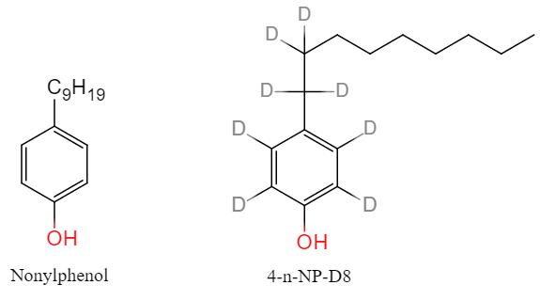

Figure S1. Structure of nonylphenol mixture and internal standard NP-D8.



Figure S2. Standard curve of NP by an internal standard method.