Prospective study on intracranial pressure waveform morphology and its relationship with the development of obesity in rats

Diego Adorna Marine*¹, João Manoel Alves¹, Marcela Sene-Fiorese¹, Cristina Arrais², Stela Marcia Matiello², Jeferson Ancelmo Teixera¹, Vanessa de Oliveira Furino¹, Carla Nascimento dos Santos Rodrigues¹, Ricardo Carneiro Borra³, Ana Claudia Garcia de Oliveira Duarte¹

1. Federal University of São Carlos, Interinstitutional Graduate Program in Physiological Sciences, Department of Physical Education and Human Motricity, Biological Sciences Center, São Carlos, Brazil
2. Federal University of São Carlos, Graduate Program in Physiotherapy, Department of Physiotherapy, Center for Biological Sciences, São Carlos, Brazil
3. Federal University of São Carlos, Graduate Program in Genetics, Department of Genetics, Center for Biological Sciences, São Carlos, Brazil
*diegomarine@gmail.com
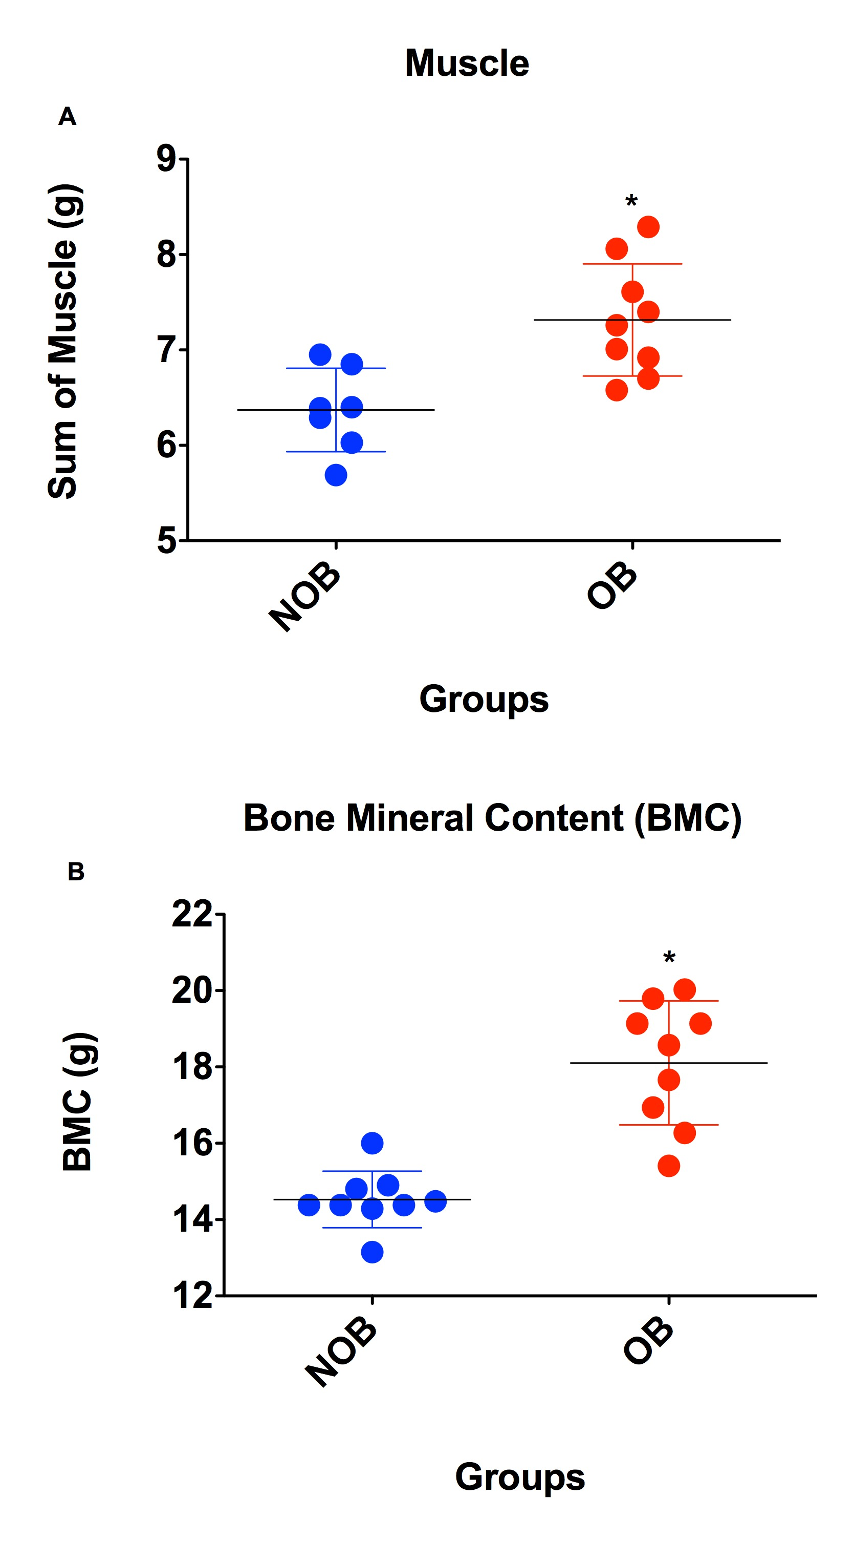
Supplementary figure 1: NOB = Non Obese (blue); OB = Obese (red). 1A Sum of gastrocnemius, EDL and soleus muscles (right and left). 1B Bone Mineral Content (BMC). Independent t-Student test, *p <0.005.

