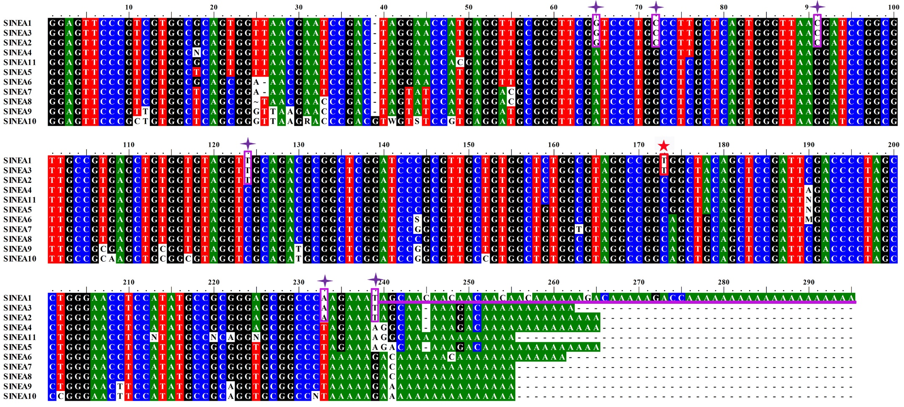
Fig. S1. Alignment of the sequences of SINEA1-A11 subfamilies.

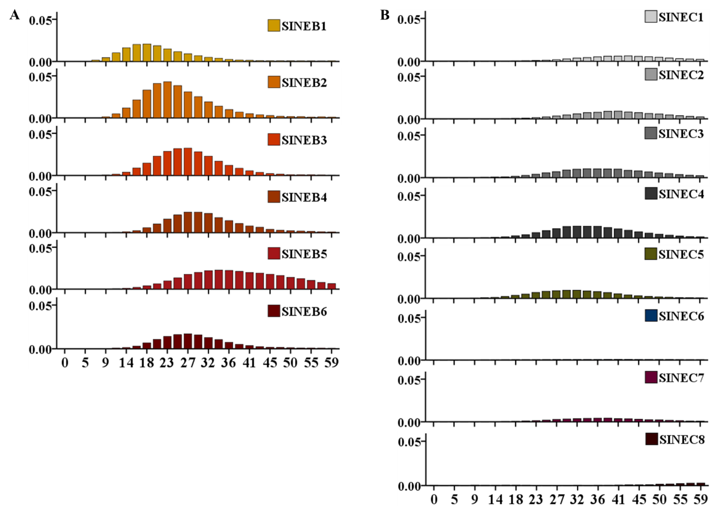
Fig. S2. Insertion ages of SINEB and SINEC families.

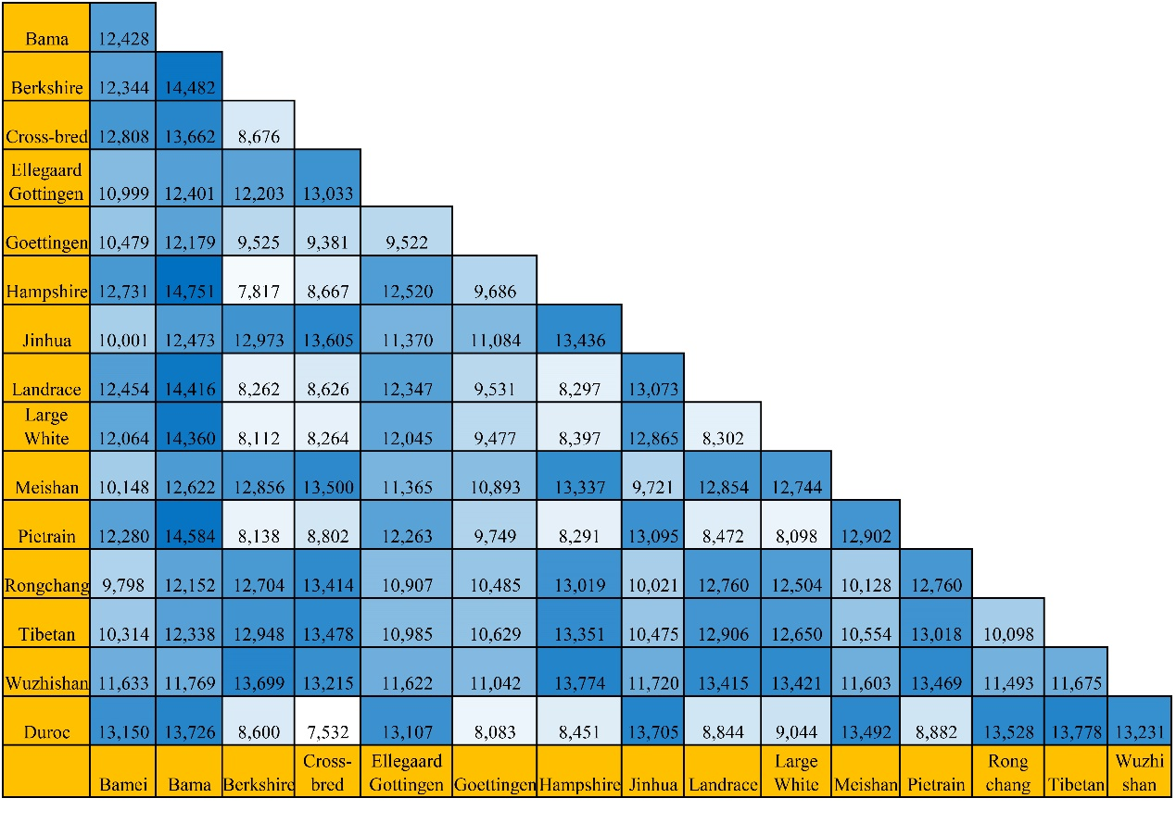
Fig. S3. Distribution of the differential SINE RIP alleles between each pair of genomes.

Table S1. Predicted polymorphic ratio of SINE insertions from different subfamilies located in intergenic and intragenic regions.
Name of SINE subfamily (age) | Intragenic SINE insertions |  |  |  |  | Intergenic SINE insertions
 | No. of blast insertions | No. of predicted  polymorphic insertions |  | The ratio of polymorphisms |  | No. of blast insertions | No. of predicted  polymorphic insertions | The ratio of polymorphisms
SINEA1 （2Ma） | 200 | 45 | 22.5 |  |  | 200 | 53 | 26.5
SINEA2 （5Ma） | 200 | 18 | 9.0 |  |  | 200 | 21 | 10.5
SINEA3 （5Ma） | 200 | 10 | 5.0 |  |  | 200 | 25 | 12.5
SINEA4 （11Ma） | 200 | 4 | 2.0 |  |  | 200 | 1 | 0.5
SINEB2 （23Ma） | 200 | 0 | 0.0 |  |  | 200 | 0 | 0.0
SINEB6 （27Ma） | 200 | 0 | 0.0 |  |  | 200 | 1 | 0.5
SINEC4 （32Ma） | 200 | 0 | 0.0 |  |  | 200 | 0 | 0.0

Table S2. Polymorphic ratio of randomly selected polymorphic and non-polymorphic SINE insertions following PCR verification.
SINE type | No. of randomly selected polymorphic or non-polymorphic insertions
 | Predicted polymorphic by Blast | Confirmed polymorphic by PCR |  | Predicted non-polymorphic by Blast | Confirmed polymorphic by PCR
SINEA1-A3 | 18 | 16 (83.33%) |  | 5 | 2 (40.00%)
SINEA4-A11 | 4 | 4 (75.00%) |  | 9 | 2 (22.22%)
SINEB | 1 | 1 (100.00%) |  | 2 | 0 (0.00%)
SINEC | 2 | 1 (100.00%) |  | 9 | 0 (0.00%)
Total | 25 | 22 (88.00%) |  | 25 | 4 (16.00%)

Table S3. Summary of the number of SINE insertions in the protocol used for annotating SINE RIPs.
Genome | No. of SINE insertions
 | Repeatmasker result¹ | Successfully mapped | Differential between genomes | Verified by Blast | Finally remained
Bama | 104260 | 100074 | 17641 | 6714 | 6603
Bamei | 89114 | 86939 | 13555 | 4306 | 4306
Berkshire | 92230 | 90415 | 9746 | 2856 | 2856
Cross-bred | 102103 | 98412 | 9388 | 3054 | 2995
Ellegaard Gottingen minipig | 81923 | 80073 | 13588 | 4222 | 4215
Goettingen | 71314 | 68595 | 6395 | 736 | 736
Hampshire | 93288 | 91538 | 9965 | 2994 | 2993
Jinhua | 90567 | 88377 | 14522 | 4916 | 4915
Landrace | 92016 | 90259 | 9991 | 2962 | 2961
Large White | 91345 | 89580 | 10008 | 2893 | 2893
Meishan | 88877 | 86708 | 14108 | 4714 | 4714
Pietrain | 92023 | 90267 | 9984 | 2990 | 2990
Rongchang | 88655 | 86424 | 13713 | 4426 | 4423
Tibetan | 90277 | 87734 | 14916 | 4567 | 4536
Wuzhishan | 91357 | 88602 | 15815 | 5272 | 5260
Duroc | 103065 | 103065 | 80502 | 36452 | 13223
Total | 1462414 | 1427062 | 263837 | 94074 | 70619
¹: Repeatmasker result filtered with (1) SINEA1-3, (2) score≥1000, (3) length:100-330.

Table S4. Positive ratios of SINE RIPs obtained by PCR verification for rare SINE RIPs.
Rare SINE RIPs type | No. of genome | No. of SINE RIPs be verified | No. of polymorphic sites | No. of Non- polymorphic sites | Positive ratio
Deletion | 2 | 28 | 9 | 19 | 32.14%
 | 3 | 32 | 12 | 20 | 37.50%
 | 4 | 32 | 26 | 6 | 81.25%
Insertion | 1 | 30 | 24 | 6 | 80.00%
 | 2 | 30 | 25 | 5 | 83.33%
 | 14 | 18 | 15 | 3 | 83.33%
 | 15 | 3 | 3 | 0 | 100.00%

Table S5. Positive ratios of the 36,284 SINE RIPs obtained by PCR verification with limited samples.
Source of SINE RIPs | Total No. of SINE RIPs | No. of SINE RIPs show polymorphic | Positive ratio | No. of uncertain SINE RIPs | No. of SINE RIPs show non-polymorphic
Meishan to Duroc | 27 | 24 | 88.89% | 2 | 1
Duroc to Meishan | 28 | 22 | 78.57% | 4 | 2
Landrace to Duroc | 30 | 24 | 80.00% | 4 | 2
Duroc to Landrace | 28 | 23 | 82.14% | 3 | 2
Large White to Duroc | 30 | 28 | 93.33% | 0 | 2
Duroc to Large White | 30 | 18 | 60.00% | 9 | 3
Duroc to Bama | 28 | 26 | 92.86% | 1 | 1
Bama to Duroc | 29 | 20 | 68.97% | 7 | 2
Total | 230 | 185 | 80.43% | 30 | 15

Table S6. Density of SINE RIPs in each chromosome.
Chr | No. of SINE RIPs | Density(/1Mb)
Chr1 | 3095 | 11.28
Chr2 | 2139 | 14.08
Chr3 | 1925 | 14.49
Chr4 | 1902 | 14.53
Chr5 | 1805 | 17.27
Chr6 | 2247 | 13.15
Chr7 | 2014 | 16.53
Chr8 | 2076 | 14.94
Chr9 | 2291 | 16.42
Chr10 | 1500 | 21.63
Chr11 | 1449 | 18.30
Chr12 | 1195 | 19.40
Chr13 | 2416 | 11.60
Chr14 | 1972 | 13.91
Chr15 | 1826 | 13.00
Chr16 | 1169 | 14.62
Chr17 | 1158 | 18.24
Chr18 | 1047 | 18.70
ChrX | 1610 | 12.78
Others | 1448 | 13.14
Total | 36284 | 14.50

Table S7. Characterization of 16 SINE RIPs analysed in 23 pig populations.
Locus | Chr | Genotype frequency |  |  | Ne | Obs_Het | Exp_Hetª | PIC | F_{IS} | F_{ST} | No. of populations not comply with the Hardy–Weinberg equilibrium
 |  | +/+ | +/- | -/-
ESA1-98 | chr1 | 0.115 | 0.238 | 0.648 | 1.557 | 0.238 | 0.358 | 0.294 | 0.013 | 0.311 | 9
REF-11172 | chr2 | 0.186 | 0.349 | 0.465 | 1.856 | 0.349 | 0.461 | 0.355 | 0.013 | 0.209 | 2
REF-14902 | chr4 | 0.051 | 0.392 | 0.557 | 1.592 | 0.392 | 0.372 | 0.303 | -0.178 | 0.117 | 5
DR-68328 | chr5 | 0.186 | 0.166 | 0.648 | 1.649 | 0.166 | 0.394 | 0.316 | 0.328 | 0.339 | 20
REF-16266 | chr6 | 0.648 | 0.253 | 0.099 | 1.537 | 0.253 | 0.350 | 0.288 | -0.028 | 0.270 | 6
REF-17668 | chr7 | 0.087 | 0.417 | 0.496 | 1.714 | 0.417 | 0.417 | 0.330 | -0.254 | 0.203 | 5
ESA2-58 | chr8 | 0.487 | 0.395 | 0.118 | 1.760 | 0.395 | 0.432 | 0.339 | -0.195 | 0.221 | 4
DR-93949 | chr9 | 0.113 | 0.327 | 0.561 | 1.666 | 0.327 | 0.400 | 0.320 | -0.177 | 0.284 | 4
ESA1-16 | chr11 | 0.287 | 0.436 | 0.277 | 2.000 | 0.436 | 0.500 | 0.375 | -0.315 | 0.336 | 7
REF-3992 | chr12 | 0.299 | 0.468 | 0.233 | 1.991 | 0.468 | 0.498 | 0.374 | -0.248 | 0.254 | 9
ESA1-25 | chr13 | 0.530 | 0.332 | 0.139 | 1.734 | 0.332 | 0.423 | 0.334 | -0.049 | 0.241 | 6
ESA2-18 | chr14 | 0.268 | 0.433 | 0.299 | 1.998 | 0.433 | 0.500 | 0.375 | -0.167 | 0.256 | 3
ESA1-33 | chr15 | 0.149 | 0.268 | 0.583 | 1.683 | 0.268 | 0.406 | 0.323 | -0.037 | 0.369 | 3
REF-9432 | chr16 | 0.192 | 0.448 | 0.361 | 1.944 | 0.448 | 0.486 | 0.368 | -0.057 | 0.128 | 6
ESA1-42 | chr17 | 0.246 | 0.422 | 0.332 | 1.986 | 0.422 | 0.496 | 0.373 | -0.158 | 0.259 | 5
ESA1-43 | chr18 | 0.079 | 0.323 | 0.598 | 1.575 | 0.323 | 0.365 | 0.298 | -0.183 | 0.242 | 6
Mean |  | 0.245 | 0.354 | 0.401 | 1.765 | 0.354 | 0.429 | 0.335 | -0.106 | 0.252 | 6.250
St. Dev |  | 0.173 | 0.088 | 0.193 | 0.172 | 0.088 | 0.055 | 0.031 | 0.153 | 0.069 | 4.155
a Nei's (1973) expected heterozygosity
Table S8. The pig genomes used for the SINE RIP screen protocol.
Genome Name | WGS Name | Size (Mb) | Scaffolds | Rele-ase Date | Level | Sequence depth | Sequence technology | Assembly method | Sex | Submitter | Website
Duroc （susScr11.1） | AEMK02 | 2501.91 | 706 | 2017-2-7 | Chromosome | 65.0x | PacBio | Falcon v. OCT-2015 | female | The Swine Genome Sequencing Consortium (SGSC) | https://www.ncbi.nlm.nih.gov/assembly/GCA_000003025.6
Cross-bred(Yorkshire_Landrace_Duroc) | NPJO01 | 2755.44 | 14157 | 2017-12-20 | Chromosome | 65.0x | PacBio; Illumina NextSeq 500 | Celera Assembler v. 8.3rc2 | male | USDA ARS | https://www.ncbi.nlm.nih.gov/assembly/GCA_002844635.1
Goettingen | LIDP01 | 2611.36 | 5206 | 2015-9-16 | Scaffold | 20.0x | 454; SOLiD | GMAP v. DEC-2012; BioScope v. 1.2; Newbler v. 2.7 | female | F. Hoffmann - La Roche AG | https://www.ncbi.nlm.nih.gov/assembly/GCA_001292865.1
Wuzhishan | AJKK01 | 2508.91 | 137577 | 2015-3-18 | Scaffold | 120x | Illumina HiSeq2000 | SOAPdenovo v. 2.03 | male | BGI-shenzhen | https://www.ncbi.nlm.nih.gov/assembly/GCA_000325925.2
Ellegaard Gottingen minipig | AOCR01 | 2358.02 | 231585 | 2013-1-10 | Contig | 79.0x | Illumina HiSeq | SOAPdenovo v. September 2011 | female | GlaxoSmithKline | https://www.ncbi.nlm.nih.gov/assembly/GCA_000331475.1
Tibetan | AORO02 | 2437.74 | 72068 | 2016-8-8 | Scaffold | 131.0x | Illumina HiSeq | SOAPdenovo v. 2.0 | female | Novogene | https://www.ncbi.nlm.nih.gov/assembly/GCA_000472085.2
Large White | LUXX01 | 2457.91 | 102342 | 2016-8-5 | Scaffold | 95.48x | Illumina HiSeq | SOAPdenovo v. 2.0 | female | Novogene | https://www.ncbi.nlm.nih.gov/assembly/GCA_001700135.1
Rongchang | LUXR01 | 2459.03 | 120246 | 2016-8-5 | Scaffold | 93.54x | Illumina HiSeq | SOAPdenovo v. 2.0 | female | Novogene | https://www.ncbi.nlm.nih.gov/assembly/GCA_001700155.1
Hampshire | LUXS01 | 2437.11 | 82206 | 2016-8-5 | Scaffold | 100.88x | Illumina HiSeq | SOAPdenovo v. 2.0 | female | Novogene | https://www.ncbi.nlm.nih.gov/assembly/GCA_001700165.1
Meishan | LUXQ01 | 2467.5 | 133833 | 2016-8-5 | Scaffold | 111.13x | Illumina HiSeq | SOAPdenovo v. 2.0 | female | Novogene | https://www.ncbi.nlm.nih.gov/assembly/GCA_001700195.1
Landrace | LUXT01 | 2440.98 | 94659 | 2016-8-5 | Scaffold | 91.23x | Illumina HiSeq | SOAPdenovo v. 2.0 | female | Novogene | https://www.ncbi.nlm.nih.gov/assembly/GCA_001700215.1
Bamei | LUXV01 | 2460.76 | 129335 | 2016-8-5 | Scaffold | 88.72x | Illumina HiSeq | SOAPdenovo v. 2.0 | female | Novogene | https://www.ncbi.nlm.nih.gov/assembly/GCA_001700235.1
Bama | SIDA01 | 2491.05 | 6610 | 2019-8-1 | Chromosome | 361x | Illumina; PacBio; Oxford Nanopore MinION; 10x Genomics; Hi-C | supernovo v. Dec-2016; SOAPdenovo v. Jan-2017; PBJelly v. Feb-2017; LACHESIS v. Feb-2017 | male | Novogene | https://www.ncbi.nlm.nih.gov/assembly/GCA_007644095.1
Pietrain | LUXU01 | 2438.32 | 88436 | 2016-8-5 | Scaffold | 96.22x | Illumina HiSeq | SOAPdenovo v. 2.0 | female | Novogene | https://www.ncbi.nlm.nih.gov/assembly/GCA_001700255.1
Jinhua | LUXY01 | 2453.7 | 115554 | 2016-8-5 | Scaffold | 109.05x | Illumina HiSeq | SOAPdenovo v. 2.0 | female | Novogene | https://www.ncbi.nlm.nih.gov/assembly/GCA_001700295.1
Berkshire | LUXW01 | 2434.71 | 94468 | 2016-8-5 | Scaffold | 113.47x | Illumina HiSeq | SOAPdenovo v. 2.0 | female | Novogene | https://www.ncbi.nlm.nih.gov/assembly/GCA_001700575.1

