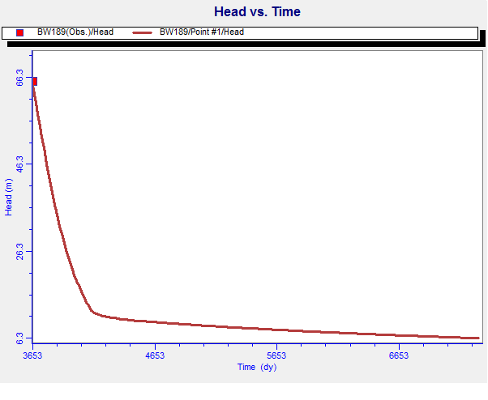
Fig. 48. Head Vs time graph of BW 189 (Tirurangadi) after prediction
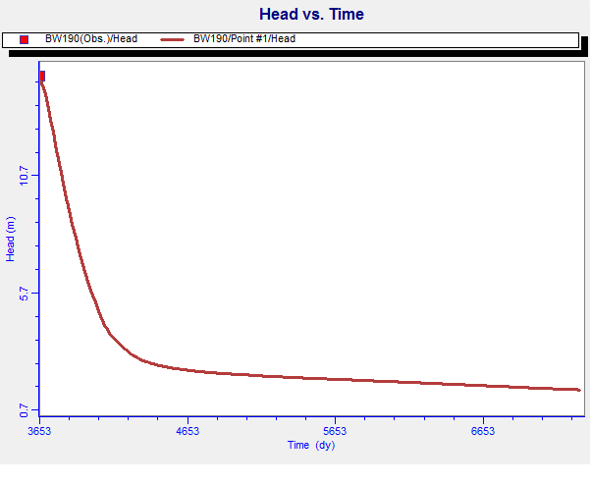
Fig. 49. Head Vs time graph of BW 190 (Tanur) after prediction

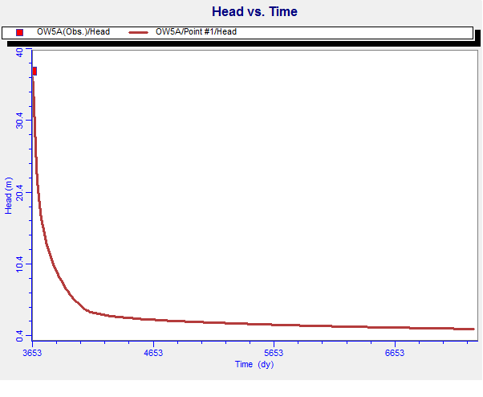
Fig. 50. Head Vs time graph of OW 5A (Parappanangadi) after prediction
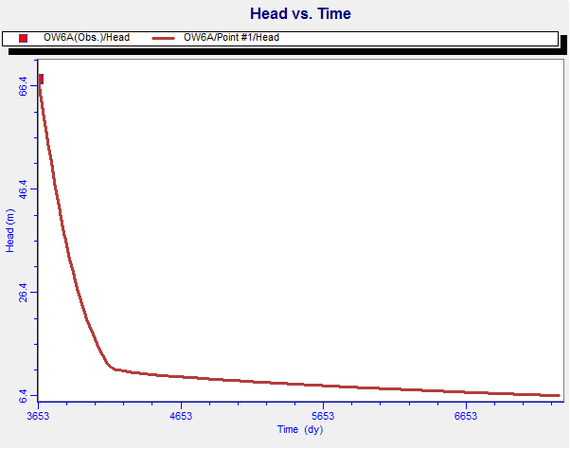
Fig. 51. Head Vs time graph of OW 6A (Tirurangadi) after prediction

