Supplementary Information
Microbial adaptation in vertical soil profiles contaminated by antimony smelting plant
Rui Xu^{1,2}, Xiaoxu Sun^{1,2}, Feng Han^{1,2}, Enzong Xiao³, Baoqin Li^{1,2}, Lang Qiu^{1,2}, Benru Song^{1,2}, Zhaohui Yang⁴, and Weimin Sun^{1,2,*}
¹ Guangdong Key Laboratory of Integrated Agro-environmental Pollution Control and Management, Guangdong Institute of Eco-environmental Science & Technology, Guangdong Academy of Sciences, Guangzhou 510650, P.R. China
² National-Regional Joint Engineering Research Center for Soil Pollution Control and Remediation in South China, Guangzhou 510650, P.R. China
³ Innovation Center and Key Laboratory of Waters Safety & Protection in the Pearl River Delta, Ministry of Education, Guangzhou University, Guangzhou 510006, P.R. China
⁴ College of Environmental Science and Engineering, Hunan University, Changsha 410082, P.R. China

*Corresponding authors:
Weimin Sun (W.M. Sun)
808 Tianyuan Road, Guangzhou, Guangdong, China
Email: wmsun@soil.gd.cn
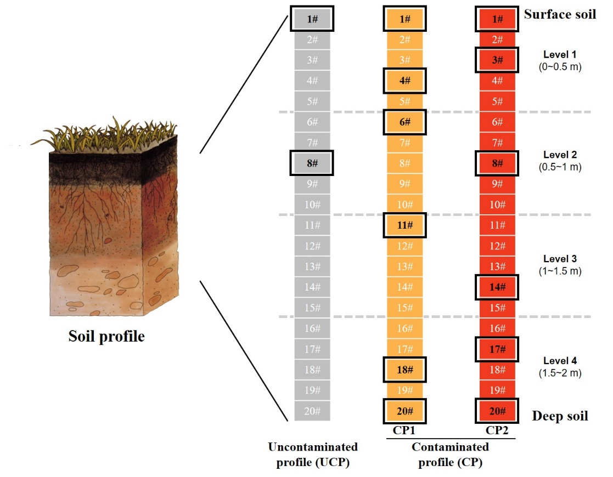

Figure S1. Collection of soil samples from three profiles in this study (n = 60). Samples were marked as 1#–20# from surface to deep soil throughout the profiles (0–2 m) with an interval of 0.1 m. 20 samples in each profile were further grouped into level 1–4. All 60 samples were subjected to geochemical measurement and 16S rRNA sequencing analysis. 14 out of 60 samples (2 samples for UCP, 6 samples for CP1 and 6 samples for CP2, marked by black squares) were sent for shotgun metagenomic sequencing analysis.

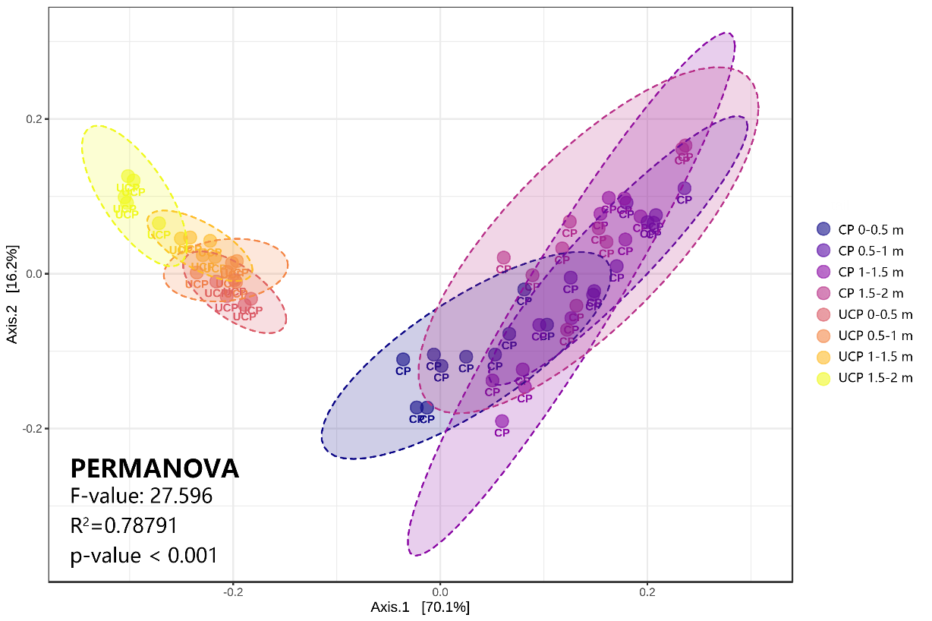

Figure S2. Bray-Curtis based principal coordinate analysis (PCoA) revealed the distribution of microbial community at each profile depth. CP samples distinctly separated from UCP due to the smelting contamination. Permutational MANOVA (PERMANOVA) test was used to indicate the group difference.
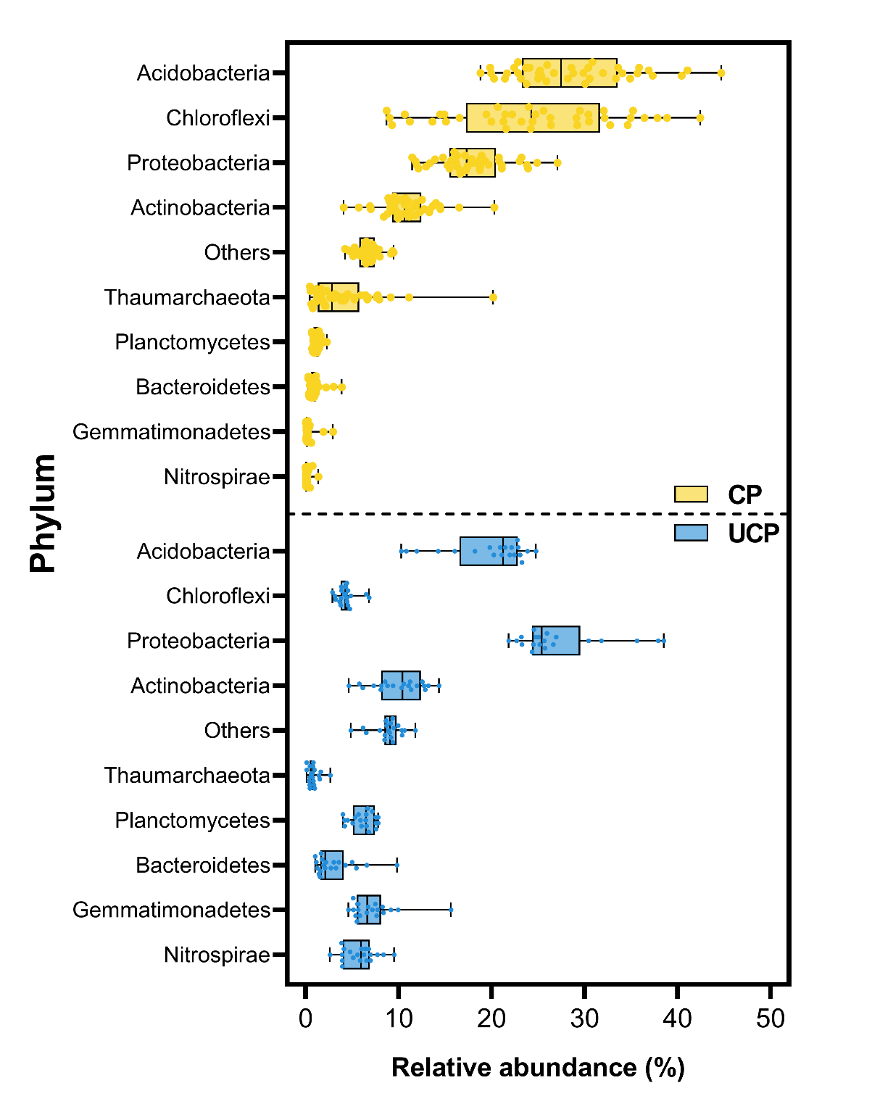

Figure S3. The box charts show the relative abundnace of the top 10 phyla in two contaminated profiles (CP = CP1 + CP2) and one uncontaminated profile (UCP) throughout soil depths.

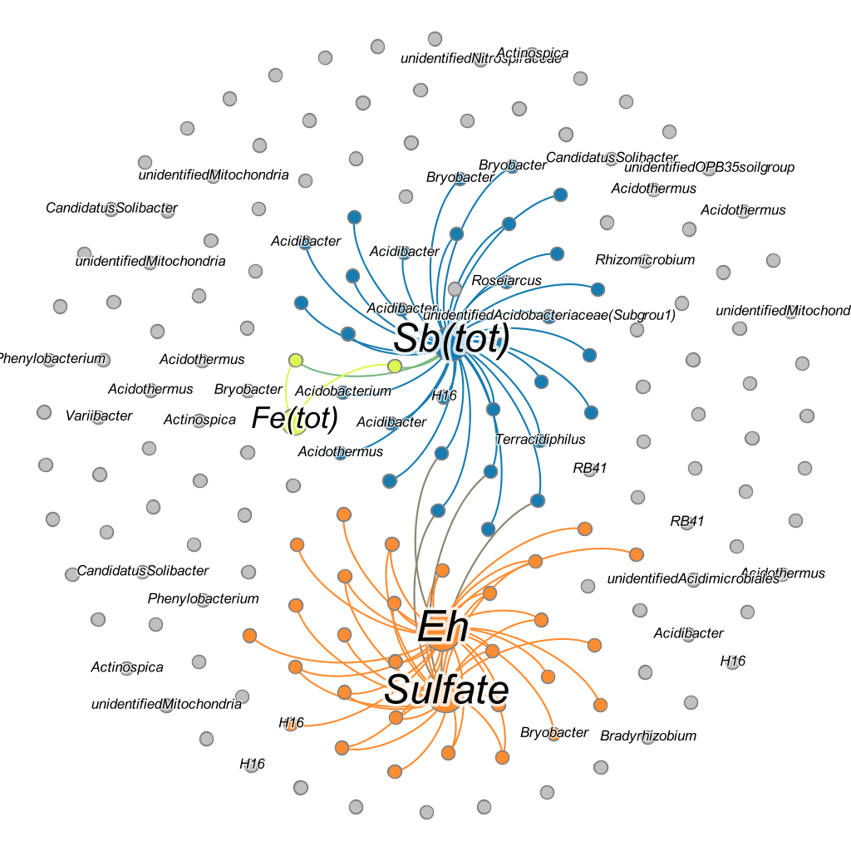

Figure S4. Co-occurrence network showed the strong correlation of geochemical parameters and microorganisms (|R| > 0.7, p < 0.05). Nodes’ color represents their modularity. Nodes’ size is proportional to the degree of connection.
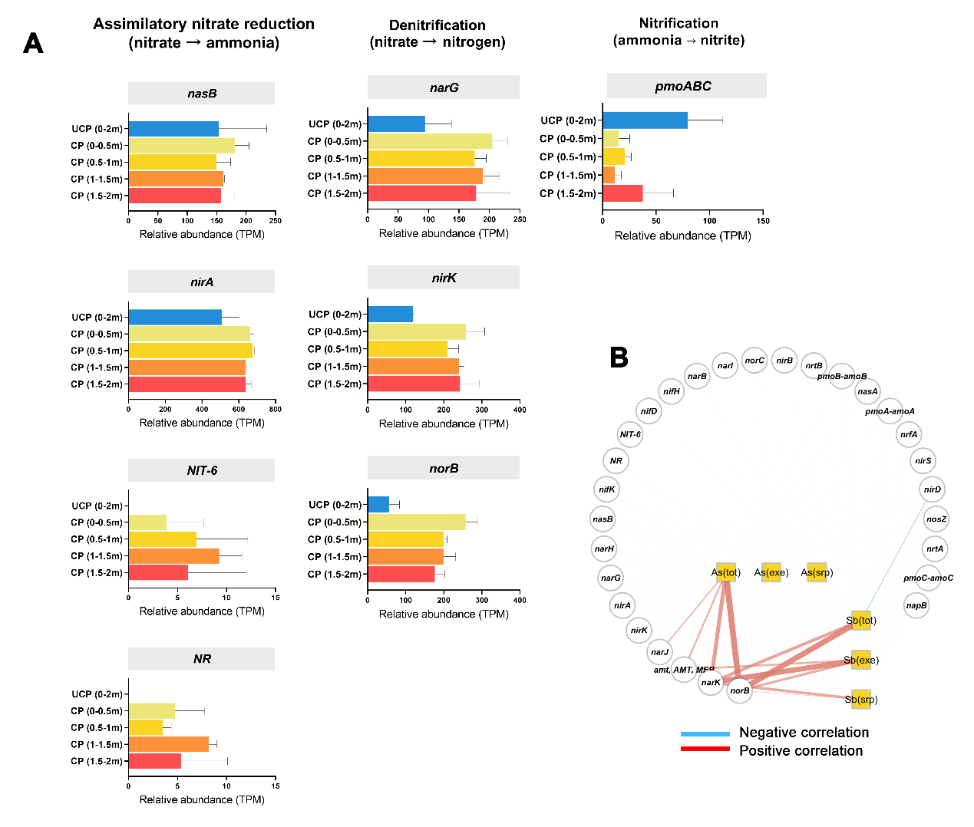

Figure S5. (A) Distribution of genes encoding nitrogen metabolism pathways, including assimilatory nitrate reduction, denitrification and nitrification process. (B) Correlation of functional genes abundance and geochemical parameters. Red and blue lines indicates the positive and negative Spearman’s correlations (|R| > 0.7, p < 0.05), respectivley. Edge width is proportional to the correlation value.

Table S1. Summary of topological properties of networks at each depth level (UCP vs. CP).
Network | UCP networks |  |  |  |  | CP networks
 | Level 1  (0–0.5 m) | Level 2  (0.5–1 m) | Level 3  (1–1.5 m) | Level 4  (1.5–2 m) | Overall | Level 1  (0–0.5 m) | Level 2  (0.5–1 m) | Level 3  (1–1.5 m) | Level 4  (1.5–2 m) | Overall
Edges number | 992 | 465 | 486 | 621 | 720 | 60 | 56 | 596 | 215 | 218
Positive edges number | 506 | 264 | 278 | 313 | 466 | 43 | 41 | 332 | 150 | 174
Negative edges number | 486 | 201 | 208 | 308 | 254 | 17 | 15 | 264 | 65 | 44
Nodes number | 182 | 192 | 199 | 169 | 157 | 68 | 64 | 141 | 108 | 95
Clusters number | 36 | 45 | 44 | 35 | 7 | 18 | 16 | 10 | 11 | 17
Centralization degree | 0.106 | 0.032 | 0.041 | 0.087 | 0.166 | 0.048 | 0.052 | 0.140 | 0.094 | 0.175
Connectance | 0.060 | 0.025 | 0.025 | 0.044 | 0.059 | 0.026 | 0.028 | 0.060 | 0.037 | 0.049
Average degree | 10.901 | 4.844 | 4.884 | 7.349 | 9.172 | 1.765 | 1.750 | 8.454 | 3.981 | 4.589

Details for the Material and Methods section

2.2 Geochemical parameter measurement
pH and oxidation reduction potential (Eh) was measured by a pH meter (HACH, Loveland, USA). Nitrate and sulfate measurements were performed by the ion chromatography (DIONEX ICS-40, Sunnyvale, CA, USA). Total organic carbon (TOC) were measured by an elemental analyzer (Vario MACRO cube, Elementar, Hanau, Germany). To determine the Fe(II) and total Fe iron (Fe(II)+Fe(III)), one gram ground soil samples were mixed with 10 ml HCl (1 M) for 30 min with constant shake, followed by 4 h of equilibration. The supernatants were collected after centrifuging at 3500 rpm for 10 min, and then filtered through a 0.45-mm membrane. Fe(II) and total Fe concentrations were determined spectrophotometrically by UV-9000s (METASH, Shanghai, China) with 1,10-phenanthroline at 510 nm (Tamura et al., 1974).
For the determination of total concentration of As (As_{tot}) and Sb (Sb_{tot}), soil samples were completely digested with HNO₃ and HF (5: 1, volume ratio). Then digested samples were analyzed with an atomic fluorescence spectrometer (AFS-920, Jitian, Beijing, China).
In addition, according to the binding strengths between the soil matrix and different species of metal(loid)s, the metal distribution of Sb and As within a sediment sample could be classified into: (1) the non-specifically absorbed metal(loid)s in exchangeable forms (extracted by MgCl₂, pH=7)); (2) the specifically absorbed fractions (extracted by NaH₂PO₄); (3) the Sb/As in the form of Fe-Mn oxides (extracted by ammonium oxalate, pH=3); (4) organic matter/amorphous sulfide fraction (extracted by HNO₃+H₂O₂+NH₄OAc), and (5) the residual fraction (digested by HNO₃/HF) (Buanuam and Wennrich 2010; Wang et al. 2011). The associations with these fractions of Sb and As in soil usually influenced their mobility and bio-accessibility. Above fractions of Sb and As in the soil samples were evaluated using a modified sequential extraction procedure (SEP) (Tessier et al. 1979). Notably, the current study only considered the non-specifically absorbed and easily exchangeable fraction (-exe, Sb_{exe} and As_{exe}), as well as the specifically absorbed surface-bound fraction (-srp, Sb_{srp} and As_{srp}), due to their bio-accessibility to soil microorganisms (Sun et al. 2019a). These two fractions indicate the potential of releasing and availability of Sb and As to the environment (Filella 2011). The details of extraction conditions, such as the reagents and reaction times, were described elsewhere (Savonina et al. 2012; Sun et al. 2019b). After extraction, the supernatant was centrifuged (4000 g, 15 min) and filtered (0.45 μm membrane) for the analysis at the end of each extraction state using a hydride generation atomic fluorescence spectrometer (HG-AFS-920, Jitian, China). The standard reference material was utilized to control the quality, according to the Chinese National Standard (GBW07310). More detail methods are provided in our previous work (Sun et al. 2016; Xiao et al. 2017).

2.4 Illumina MiSeq sequencing of 16S rRNA amplicons
The PCR amplification of 16S rRNA was conducted with a final volume of 20 μL with the barcoded primer set 515F (5′-GTGYCAGCMGCCGCGGTAA-3′) and 907R (5′-CCYCAATTCMTTTRAGTTT-3′). The amplification cycles followed with an initial denaturation at 98 °C for 1 min, 30 cycles of denaturation at 98 °C for 10 s, 50 °C annealing for 30 s and 72 °C for 30 s extension. A final extension at 72 °C for 5 min was included before holding at 4 °C. PCR raw products were purified using the GENECLEAN Turbo Kit (MP Bio, USA). The qualified PCR pure products were sent for Illumina Hiseq sequencing. Each sample generated 82151 reads (by averaged value) and achieved stationary phase.
For the bioinformatic analysis of 16S rRNA amplicons sequencing (n=60), the forward and reverse raw reads were merged to paired-end reads by FLASH. QIIME (v1.7.0) was used to remove the barcoded primer sequences from the paired-end reads, and chimeric sequences were then removed using UCHIME. Operational taxonomic units (OTUs) were clustered at 97% sequence similarity using UPARSE. A total of 10982 OTUs were determined based on the threshold of sequence similarity. The taxonomic assignment of each OTU was performed using the RDP classifier (v2.2) and confirmed by the latest version of GreenGenes Database (v13.5). The OTU counts were normalized in R (v 3.5.2) before statistical analysis. Alpha diversity indices of microbial community, including Shannon, observed species number, Simpson, ACE, Chao 1, and PD whole tree index, were determined with R package ‘MicrobiomSeq’.

2.5 Shotgun metagenomic sequencing
Quality of raw sequences were evaluated by FastQC toolkit (http://www.bioinformatics.babraham.ac.uk/projects/fastqc/). Quality control and trimming of sequences were conducted by Kneaddata toolkit (‘--trimmomatic -options 'SLIDINGWINDOW:4:20 MINLEN:70' ’ and ‘--bowtie2 -options "--very-sensitive --dovetail" ’). Sequences with high quality were de novo assembled by Megahit toolkit (Li et al., 2015a). Gene annotation and quantification was conducted by Prokka (Seemann, 2014) and Salmon (Patro et al., 2017) toolkits with default settings. The generated FASTA file was used to search the functional gene database against the COGs and KEGG Orthology terms.

References
- Buanuam, J.; Wennrich, R. Dynamic flow-through sequential extraction for assessment of fractional transformation and inter-element associations of arsenic in stabilized soil and sludge. J Hazard Mater 2010;184:849-854
- Filella, M. Antimony interactions with heterogeneous complexants in waters, sediments and soils: A review of data obtained in bulk samples. Earth-Sci Rev 2011;107:325-341
- Savonina, E.Y.; Fedotov, P.S.; Wennrich, R. Fractionation of Sb and As in soil and sludge samples using different continuous-flow extraction techniques. Analytical & Bioanalytical Chemistry 2012;403:1441-1449
- Sun, W.; Sun, X.; Li, B., et al. Bacterial response to antimony and arsenic contamination in rice paddies during different flooding conditions. Sci Total Environ 2019a;675:273-285
- Sun, W.; Xiao, E.; Krumins, V., et al. Characterization of the microbial community composition and the distribution of Fe-metabolizing bacteria in a creek contaminated by acid mine drainage. Applied Microbiology & Biotechnology 2016;100:8523-8535
- Sun, X.; Li, B.; Han, F., et al. Impacts of arsenic and antimony co-contamination on sedimentary microbial communities in rivers with different pollution gradients. Microb Ecol 2019b:1-14
- Tessier, A.; Campbell, P.G.C.; Bisson, M. Sequential extraction procedure for the speciation of particulate trace metals. Anal Chem 1979;51:844-851
- Wang, X.; He, M.; Xi, J., et al. Antimony distribution and mobility in rivers around the world's largest antimony mine of Xikuangshan, Hunan Province, China. Microchem J 2011;97:4-11
- Xiao, E.; Krumins, V.; Xiao, T., et al. Depth-resolved microbial community analyses in two contrasting soil cores contaminated by antimony and arsenic. Environ Pollut 2017;221:244-255

