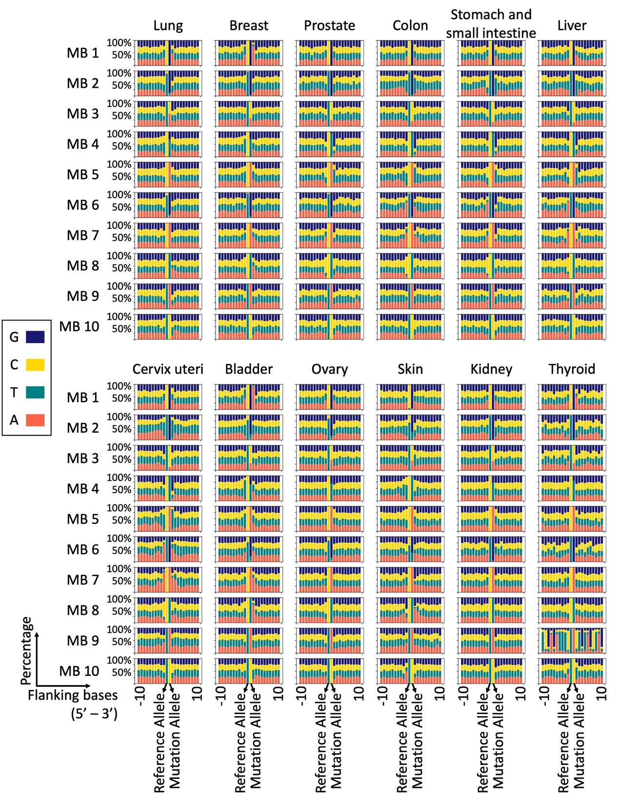
Figure S1. Mutation type and composition of flanking bases of each MB in cancers with high incidence.
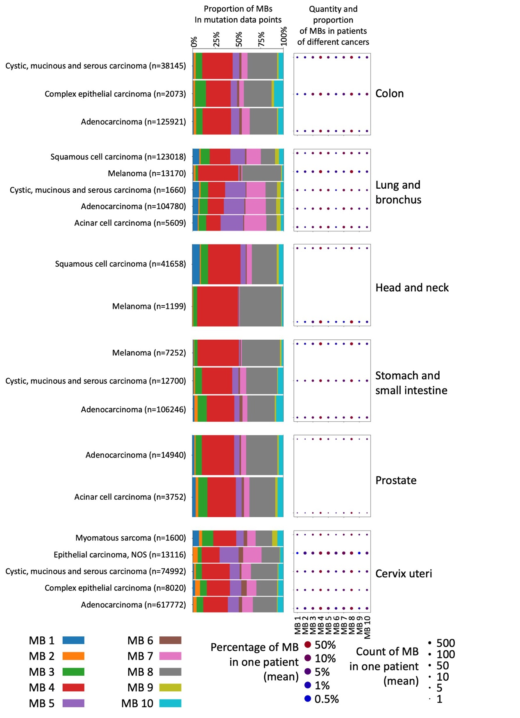
Figure S2. Quantity and proportion of MBs in cancers with high incidence and multiple types of pathology. For each cancer, the left subgraph shows the proportion of different MBs in SBS mutation data points, and the right subgraph shows the quantity and proportion of different MBs in patients. Differences in quantity are reflected in the size of the point, and differences in proportion are reflected in the color of the point.

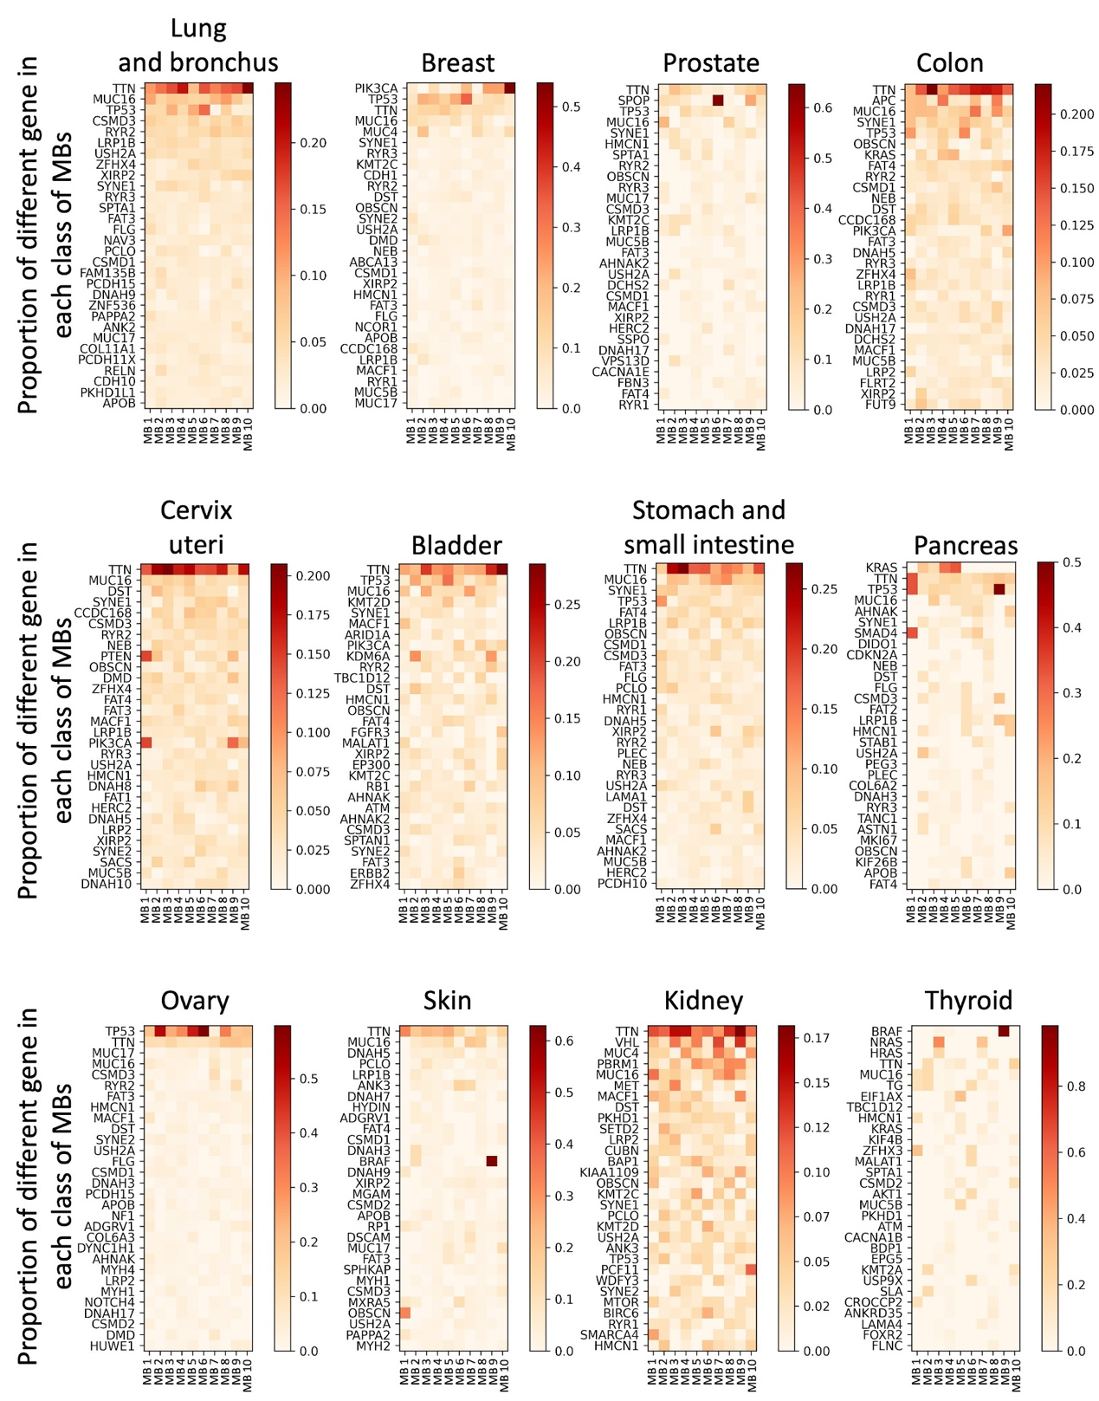
Figure S3. Genes with high mutation frequency in different MBs in cancers with high incidence.
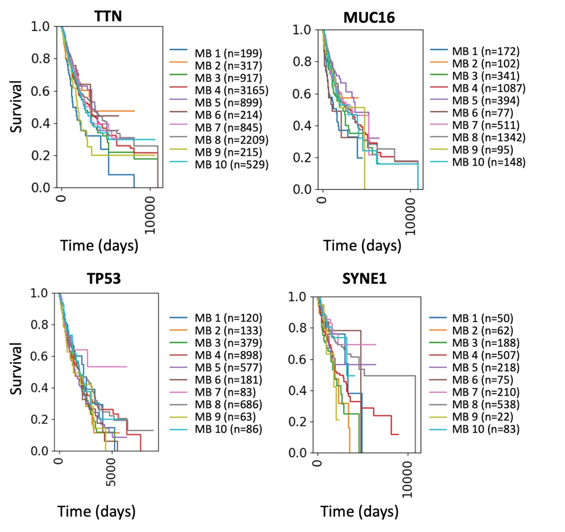
Figure S4. Survivorship curve of patients with different MBs in TTN, MUC16, TP53, and SYNE1.
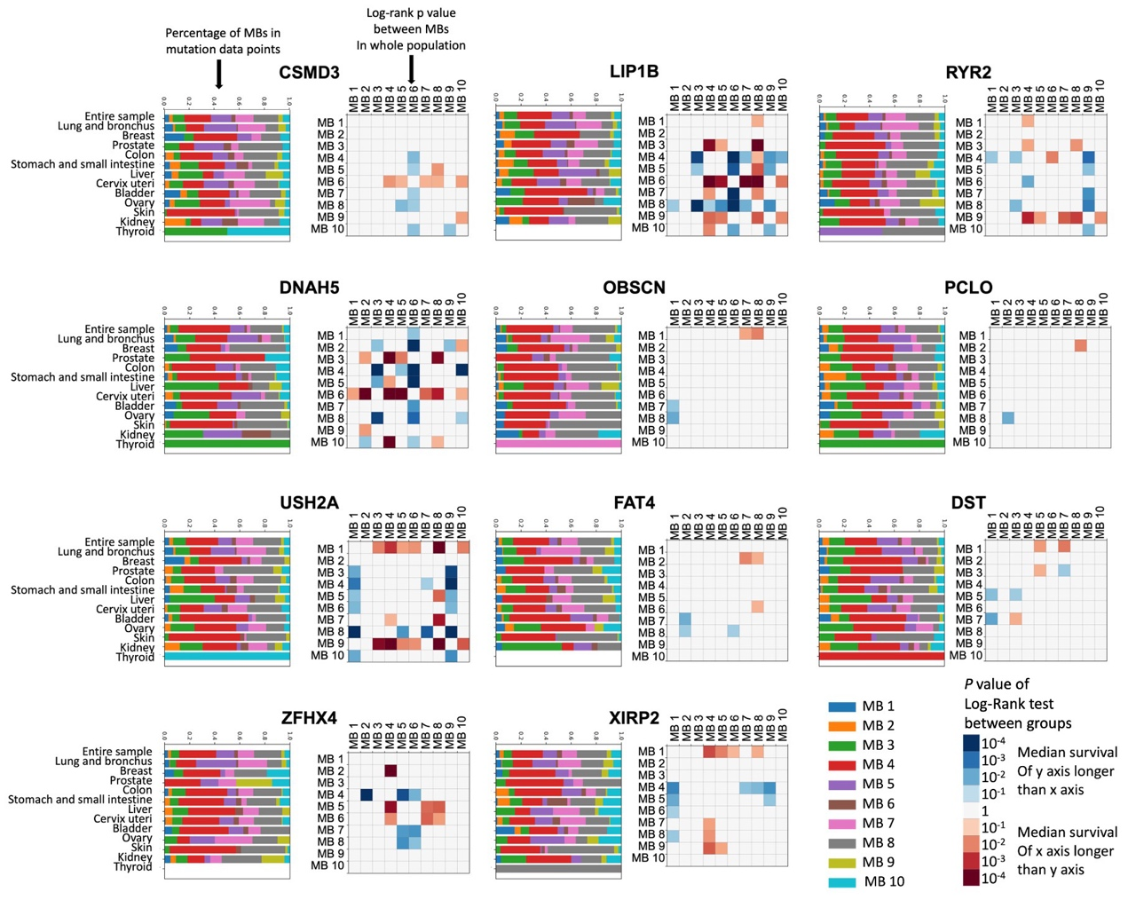
Figure S5. Relationship between patient survival and MB in genes with high mutation frequencies. Genes ranked 5-15 in mutation frequency are shown. For each gene, the left subgraph shows the proportion of MB in all mutation data points from different cancers; and the right subgraph shows the P value of the log-rank test between groups in the whole population. Only P values less than 0.05 are shown in the heat map.
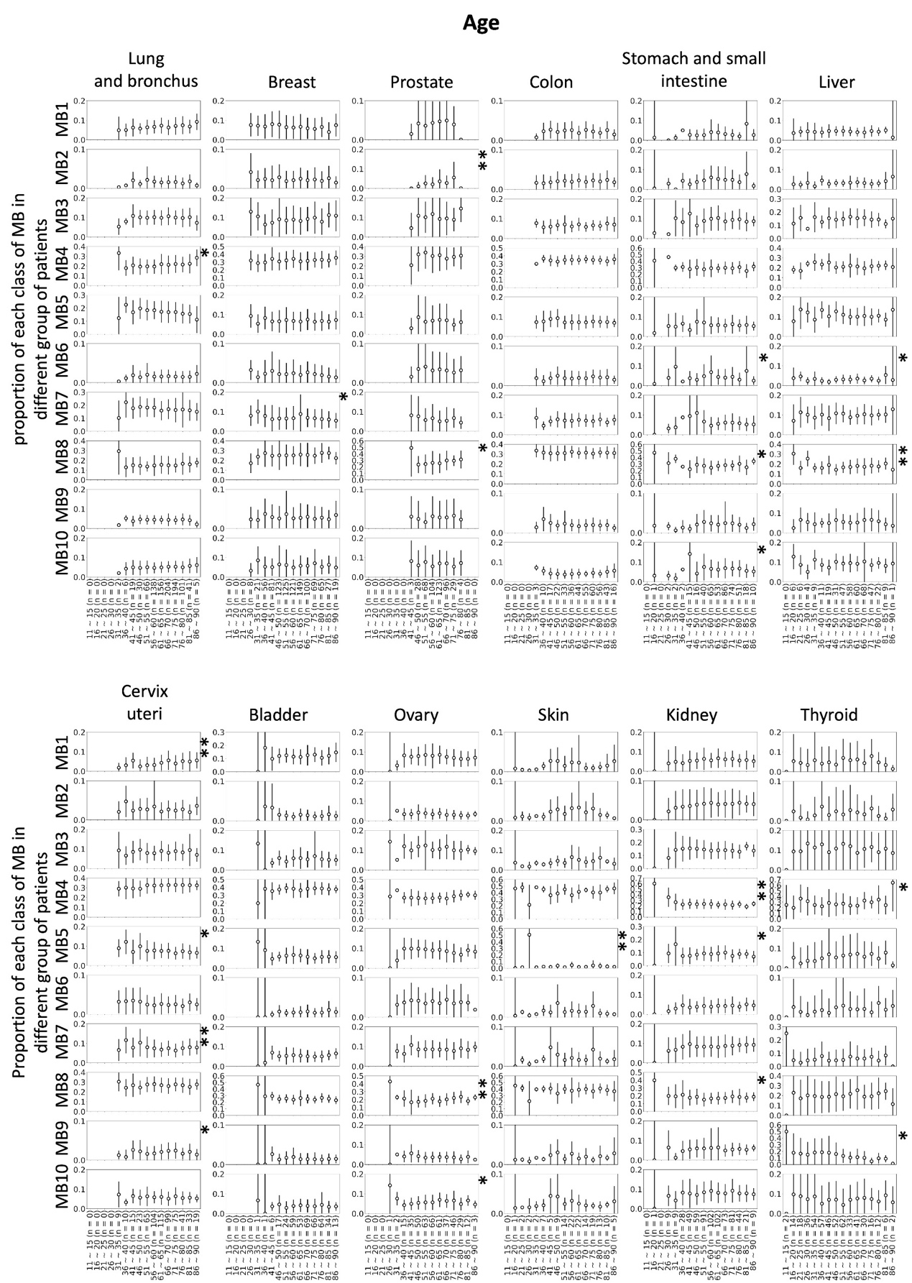
Figure S6. Statistics of the proportion of each MB by age in cancers with high incidence. *: P < 0.05 in the t test or ANOVA between groups; ** P < 0.005 in the t test or ANOVA between groups.
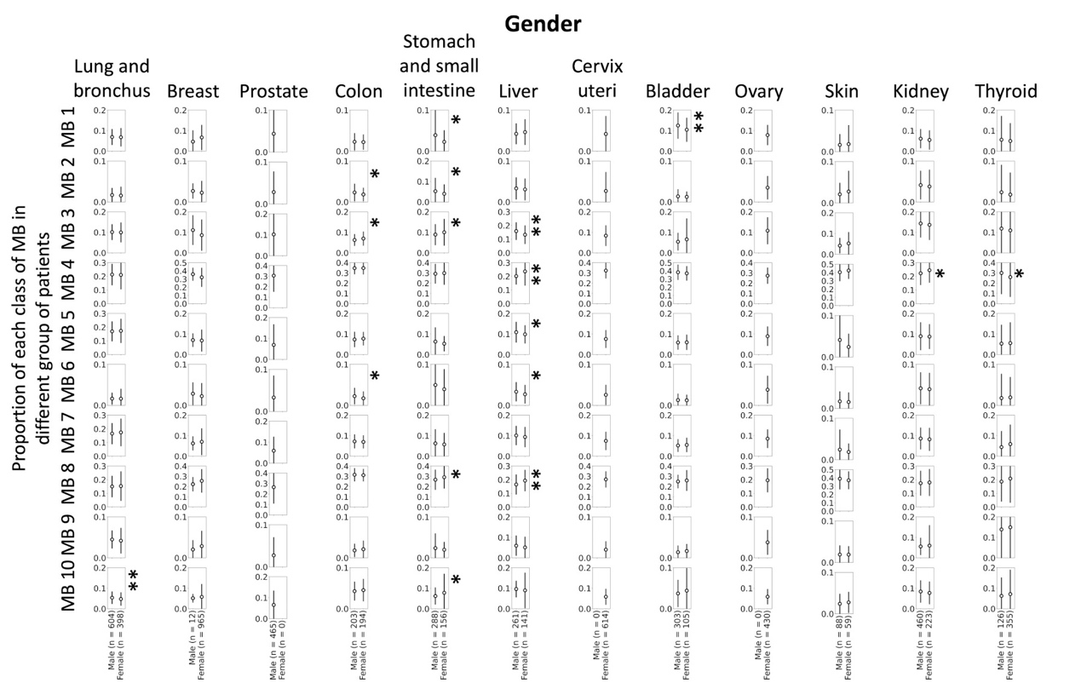
Figure S7. Statistics of the proportion of each MB by gender in cancers with high incidence. *: P < 0.05 in the t test or ANOVA between groups; ** P < 0.005 in the t test or ANOVA between groups.
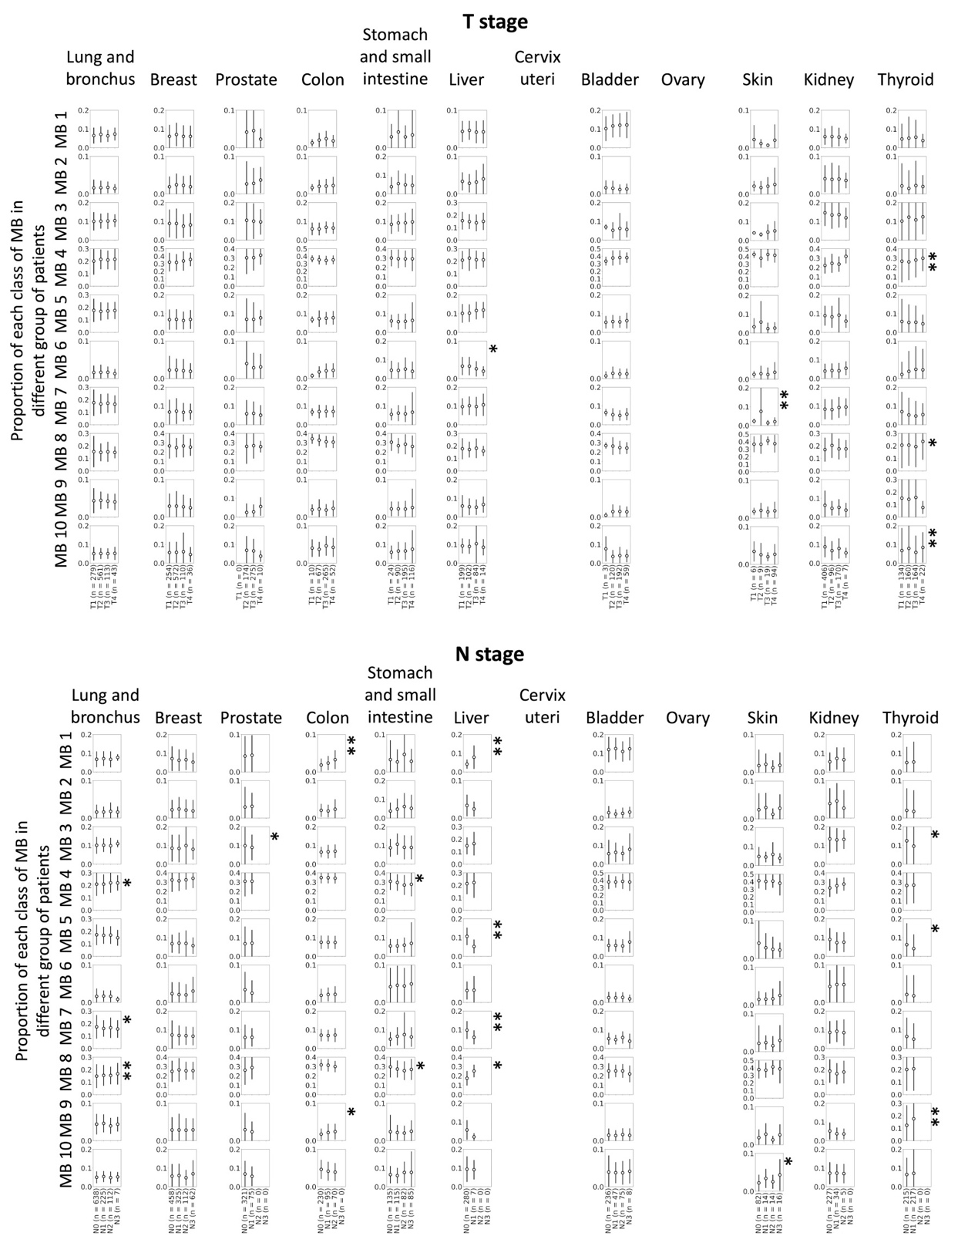
Figure S8. Statistics of the proportion of each MB by T stage and N stage in cancers with high incidence. *: P < 0.05 in the t test or ANOVA between groups; ** P < 0.005 in the t test or ANOVA between groups.
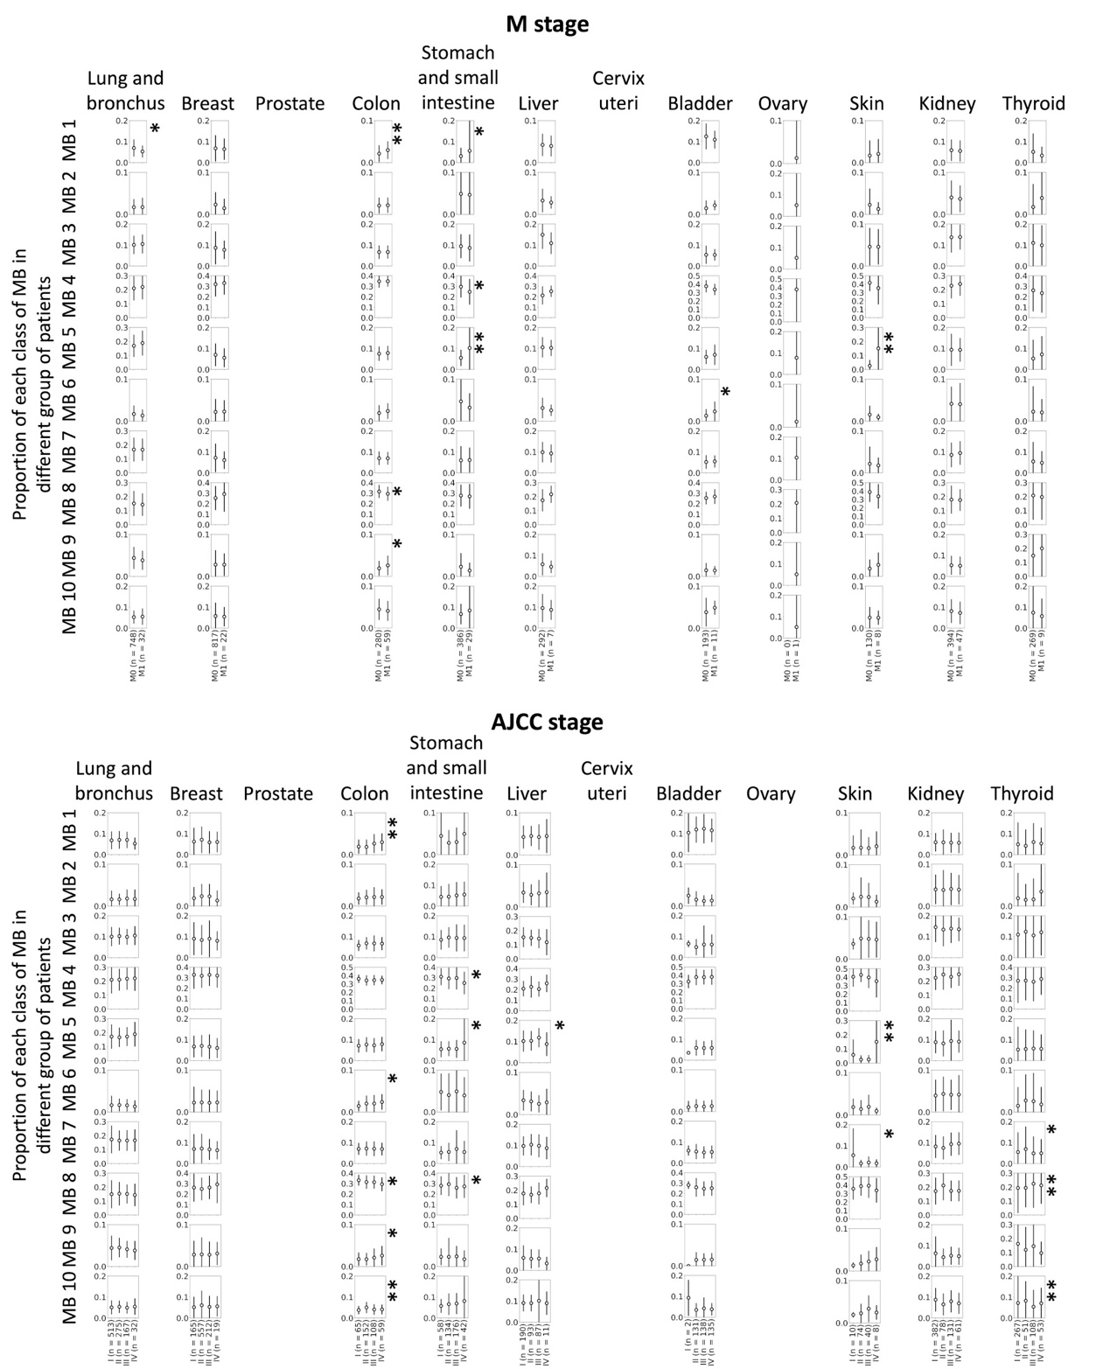
Figure S9. Statistics of the proportion of each MB by M stage and AJCC stage in cancers with high incidence. *: P < 0.05 in the t test or ANOVA between groups; ** P < 0.005 in the t test or ANOVA between groups.
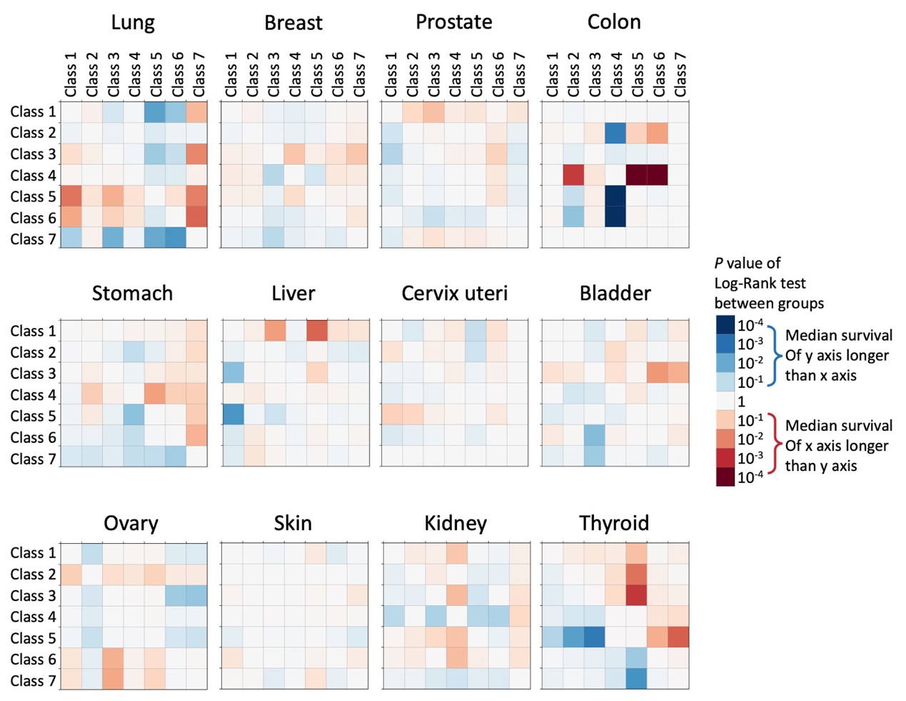
Figure S10. Log-rank test between different classes of patients in different cancers. Differences in the P value are reflected in color.

