Supplementary material

Fig.S1. Radiologic images obtained by CT scan one year ago
Fig.S2. Radiologic images obtained by CT scan at day-30 post-treatment
Fig.S3. Radiologic images obtained by CT scan at day-60 (A, B) and day-74 post-treatment

Fig.S1. Radiologic images obtained by CT scan one year ago. A: CT scan image showed cisterna circinata cerebri presents a high density shadow (red arrow in A). B: CAT scan image showed that the vascular morphology of the intracranial arterial system was normal.
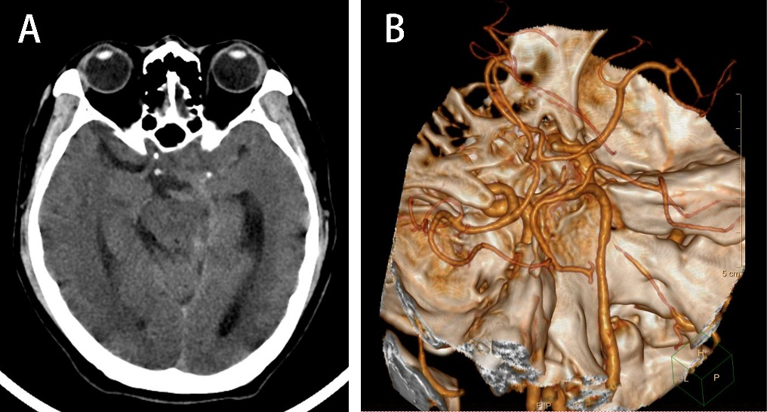

Fig.S2. Radiologic images obtained by CT scan at day-30 post-treatment. A: CT scan image showed that the calcification was seen near the left midbrain without obvious change compared to the image taken before treatment (Fig.S2A). B: CT scan image showed that hydrocephalus was less than before (Fig. 2B).
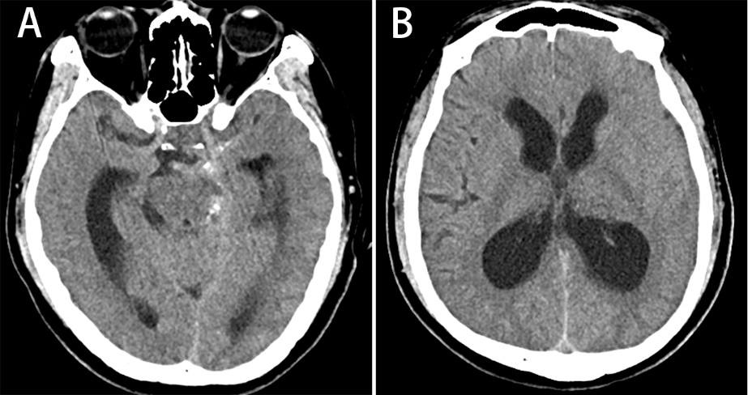

Fig.S3. Radiologic images obtained by CT scan at day-60 (A, B) and day-74 post-treatment (C, D). Calcification is seen near the left cisterns after 60 days treatment (A), bilateral ventricles, and the third ventricle is significantly dilated (B). High density calcification shadows were seen in the thalamus region (B). After ventriculoperitoneal shunt, signs of hydrocephalus were reduced after 10 weeks treatment (C, D).

