SUPPLEMENTARY MATERIAL
FIGURE S1
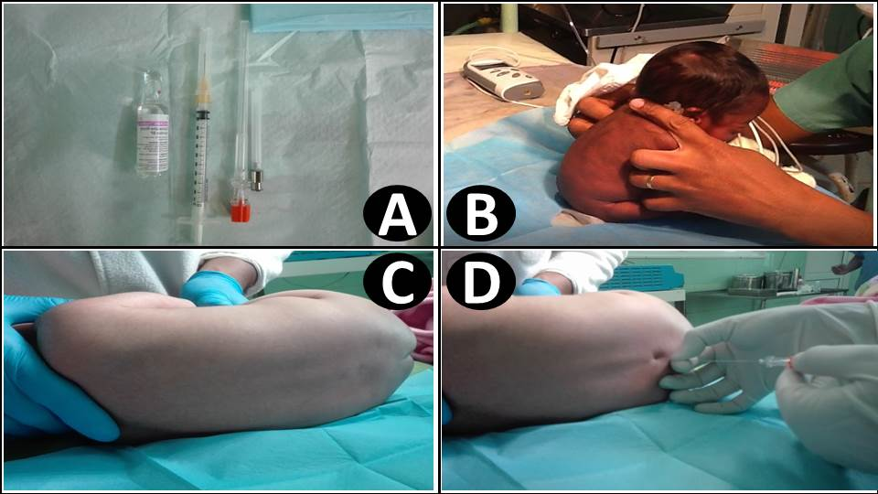
Figure S1: Spinal anesthesia procedure at the CHU JRA.
(A: Materials used = hyperbaric bupivacaine, 1 mL syringe, Q25G spinal needle; B: Sitting position; C: Lateral decubitus position; D: Lumbar puncture).

