Molecular dynamics investigation of structure evolution and thermodynamics of Ni-Fe nanoparticles during inert gas condensation
Bei Li^{a,b,*}, Lei Panª, Changan Liuª, Xu Zhangª
ª School of Materials Science and Engineering, Research Center for Materials Genome Engineering, Wuhan University of Technology, Wuhan 430070, China
^{b} State Key Laboratory of Materials Processing and Die & Mould Technology, Huazhong University of Science and Technology, Wuhan 430074, China
* Corresponding author. E-mail: libei@whut.edu.cn

 | 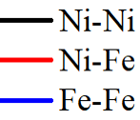
(a) | (b)
(c) | (d)

Fig. S1 Radial distribution function (RDF) profiles for different atomic pairs for Ni-Fe nanoparticles at 200 ns: (a) Fe: 10 wt.%, Ar/Metal = 1:1, (b) Fe: 30 wt.%, Ar/Metal = 1:1, (c) Fe: 30 wt.%, Ar/Metal = 0.75:1 and (d) Fe: 30 wt.%, Ar/Metal = 3:1.
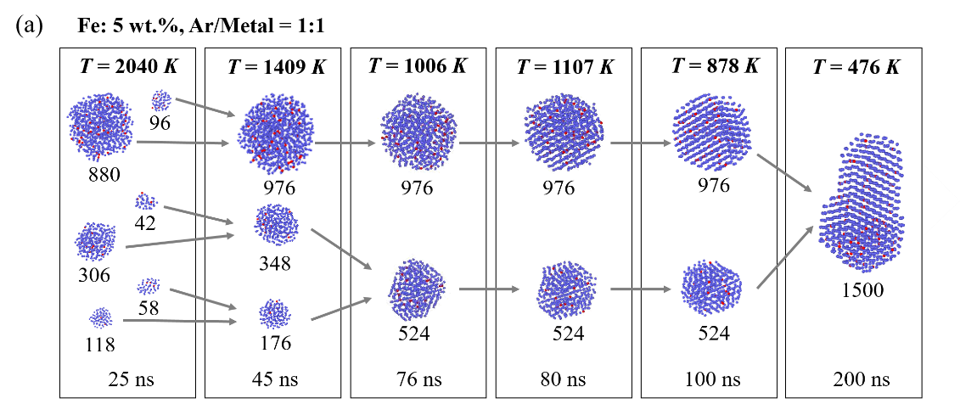
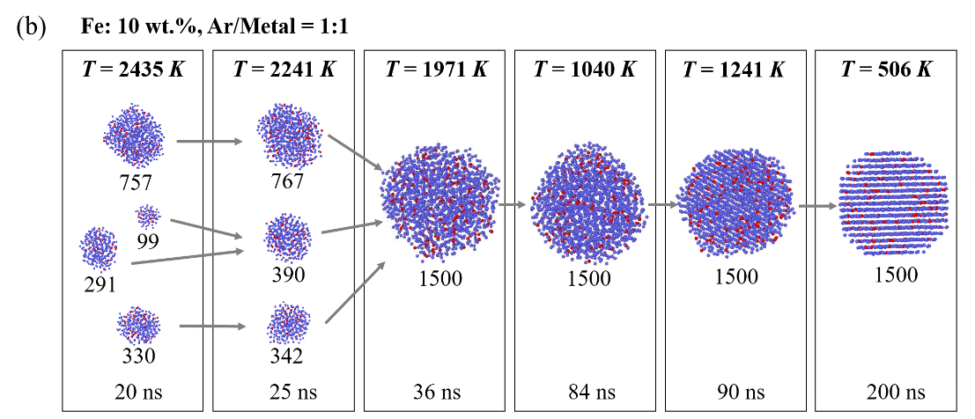
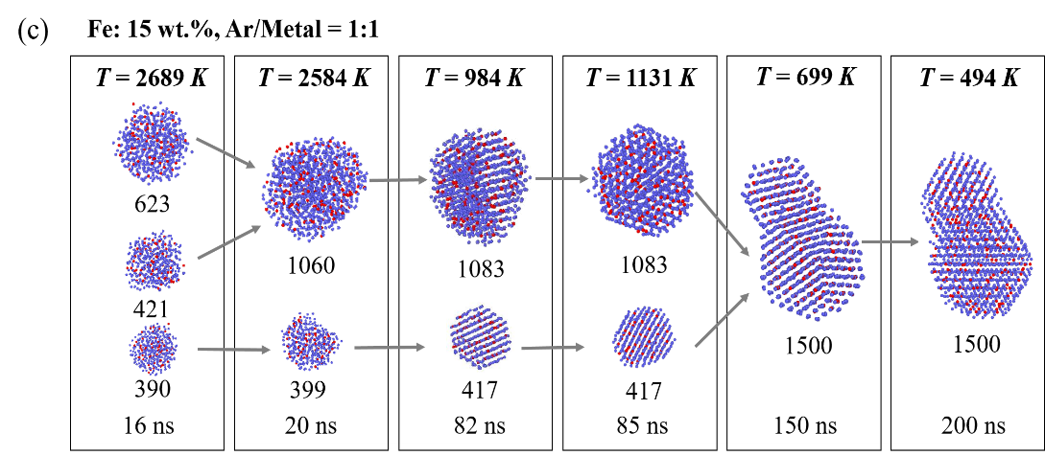
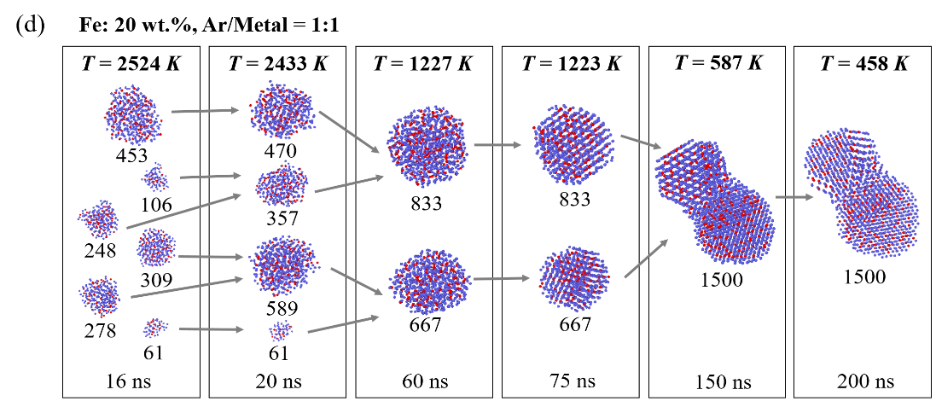
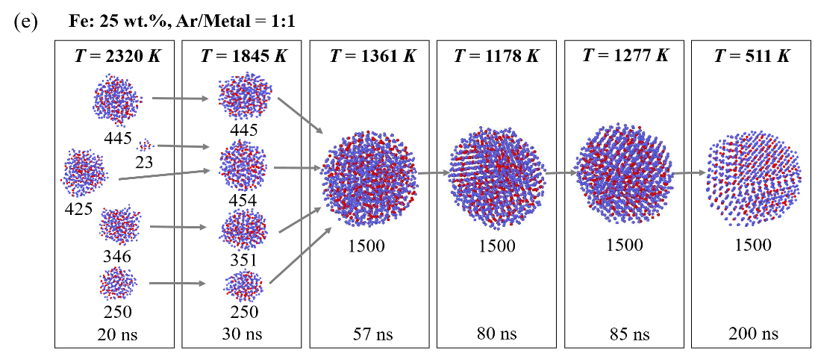
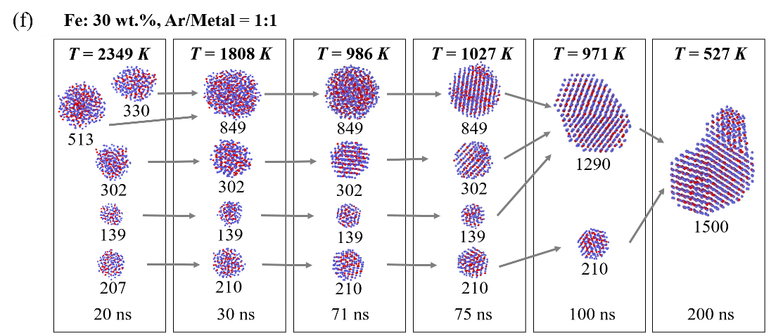
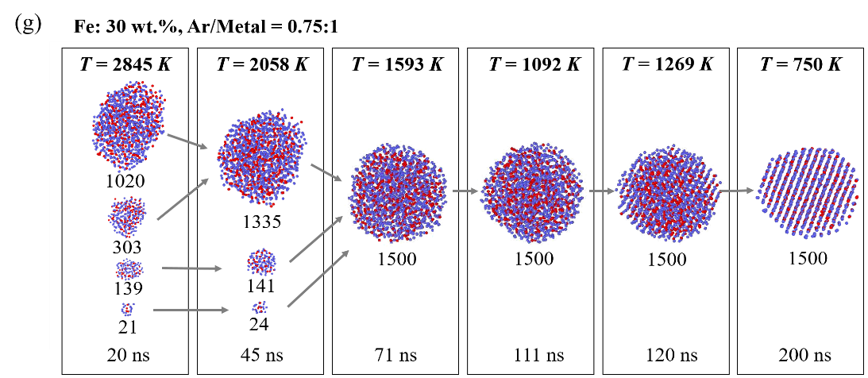
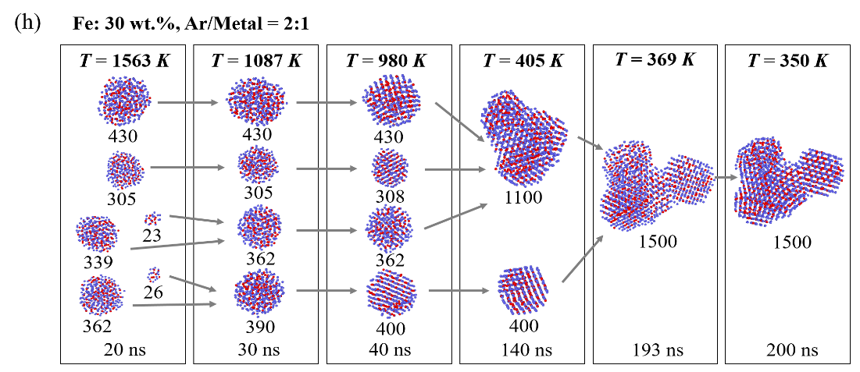
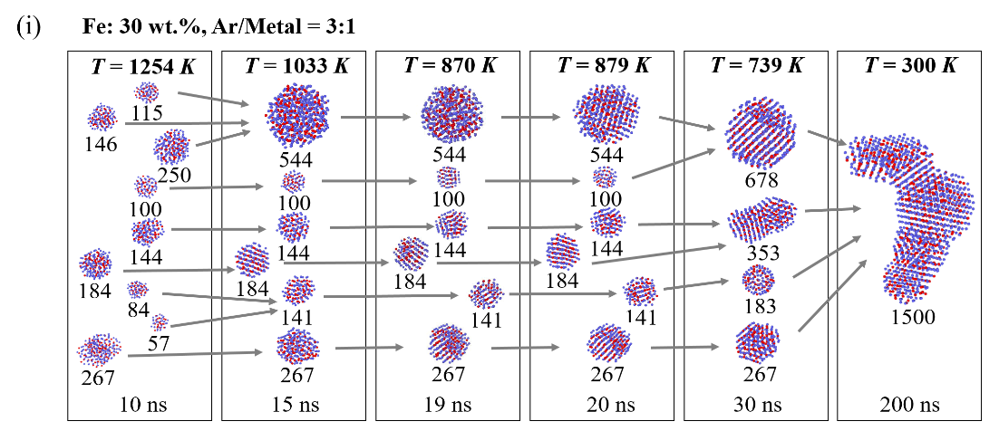
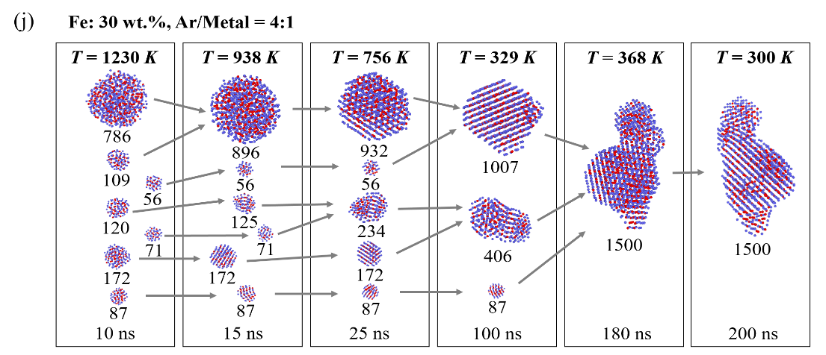

Fig. S2 Snapshots of the growth of Ni-Fe nanoparticles for (a) Fe: 5 wt.%, Ar/Metal = 1:1, (b) Fe: 10 wt.%, Ar/Metal = 1:1, (c) Fe: 15 wt.%, Ar/Metal = 1:1, (d) Fe: 20 wt.%, Ar/Metal = 1:1, (e) Fe: 25 wt.%, Ar/Metal = 1:1, (f) Fe: 30 wt.%, Ar/Metal = 1:1, (g) Fe: 30 wt.%, Ar/Metal = 0.75:1, (h) Fe: 30 wt.%, Ar/Metal = 2:1, (i) Fe: 30 wt.%, Ar/Metal = 3:1 and (j) Fe: 30 wt.%, Ar/Metal = 4:1 at different metal temperatures T and simulation time t. The number indicates the amount of metal atoms for each cluster. Fe and Ni atoms are colored red and purple, respectively.

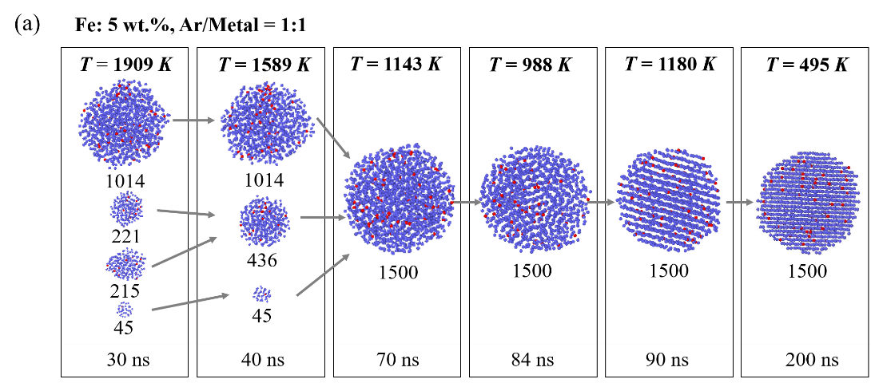
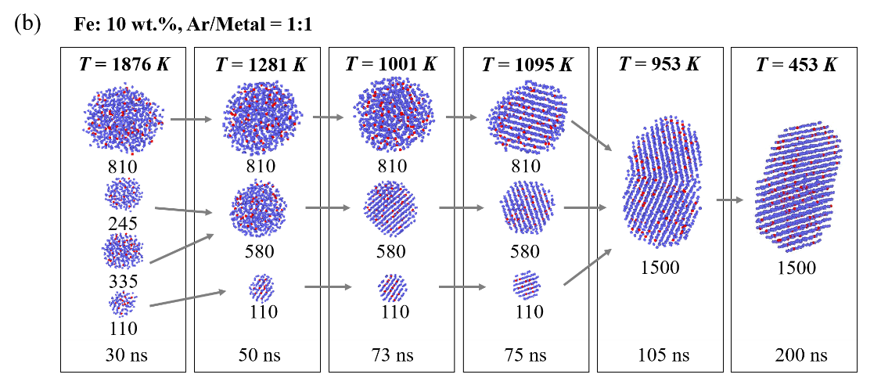

Fig. S3 Snapshots of the growth of Ni-Fe nanoparticles using different initial configurations for (a) Fe: 5 wt.%, Ar/Metal = 1:1 and (b) Fe: 10 wt.%, Ar/Metal = 1:1. Fe and Ni atoms are colored red and purple, respectively.

Table S1 Fe concentration in metal atoms, number of atoms (N_{s}) and Fe concentration in the cluster S that solidifies at t_{s}, and its corresponding solidification temperature T_{s} obtained from MD simulations for different Fe concentrations.
Fe concentration  in metal atoms (wt.%) | N_{s} | t_{s} (ns) | Fe concentration  in the cluster S (wt.%) | T_{s} (K)
5 | 176 | 54.11 | 2.8 | 849.8
 | 348 | 61.04 | 3.7 | 902.5
 | 976 | 75.95 | 5.8 | 998.1
10 | 1500 | 83.67 | 10.0 | 1038.3
15 | 417 | 60.81 | 16.3 | 985.3
 | 1083 | 81.55 | 14.5 | 1023.1
20 | 667 | 73.26 | 18.9 | 1013.1
 | 833 | 72.68 | 20.9 | 1051.0
25 | 1500 | 78.66 | 25.0 | 1070.4
30 | 139 | 44.57 | 28.1 | 933.4
 | 210 | 54.97 | 29.0 | 952.5
 | 302 | 53.06 | 29.8 | 971.0
 | 849 | 70.78 | 30.6 | 1055.9

Table S2 Ar/Metal ratio, number of atoms (N_{s}) and Fe concentration in the cluster S that solidifies at t_{s}, and its corresponding solidification temperature T_{s} obtained from MD simulations for different amount of inert gas.
Ar/Metal ratio | N_{s} | t_{s} (ns) | Fe concentration  in the cluster S (wt.%) | T_{s} (K)
0.75:1 | 1500 | 110.77 | 30.0 | 1092.5
1:1 | 139 | 44.57 | 28.1 | 933.4
 | 210 | 54.97 | 29.0 | 952.5
 | 302 | 53.06 | 29.8 | 971.0
 | 849 | 70.78 | 30.6 | 1055.9
2:1 | 305 | 30.95 | 30.8 | 989.1
 | 362 | 33.82 | 27.6 | 967.1
 | 390 | 33.40 | 31.0 | 1021.5
 | 430 | 34.57 | 30.4 | 1004.8
3:1 | 100 | 11.28 | 28.0 | 833.5
 | 141 | 15.42 | 33.3 | 885.1
 | 144 | 14.10 | 27.1 | 919.1
 | 184 | 13.48 | 31.0 | 954.0
 | 267 | 16.43 | 31.5 | 963.7
 | 544 | 18.87 | 29.2 | 1033.3
4:1 | 87 | 10.16 | 40.2 | 837.8
 | 109 | 10.87 | 30.3 | 856.8
 | 120 | 10.66 | 27.5 | 859.7
 | 172 | 10.89 | 26.2 | 897.9
 | 896 | 17.53 | 31.0 | 992.6

