Appendix

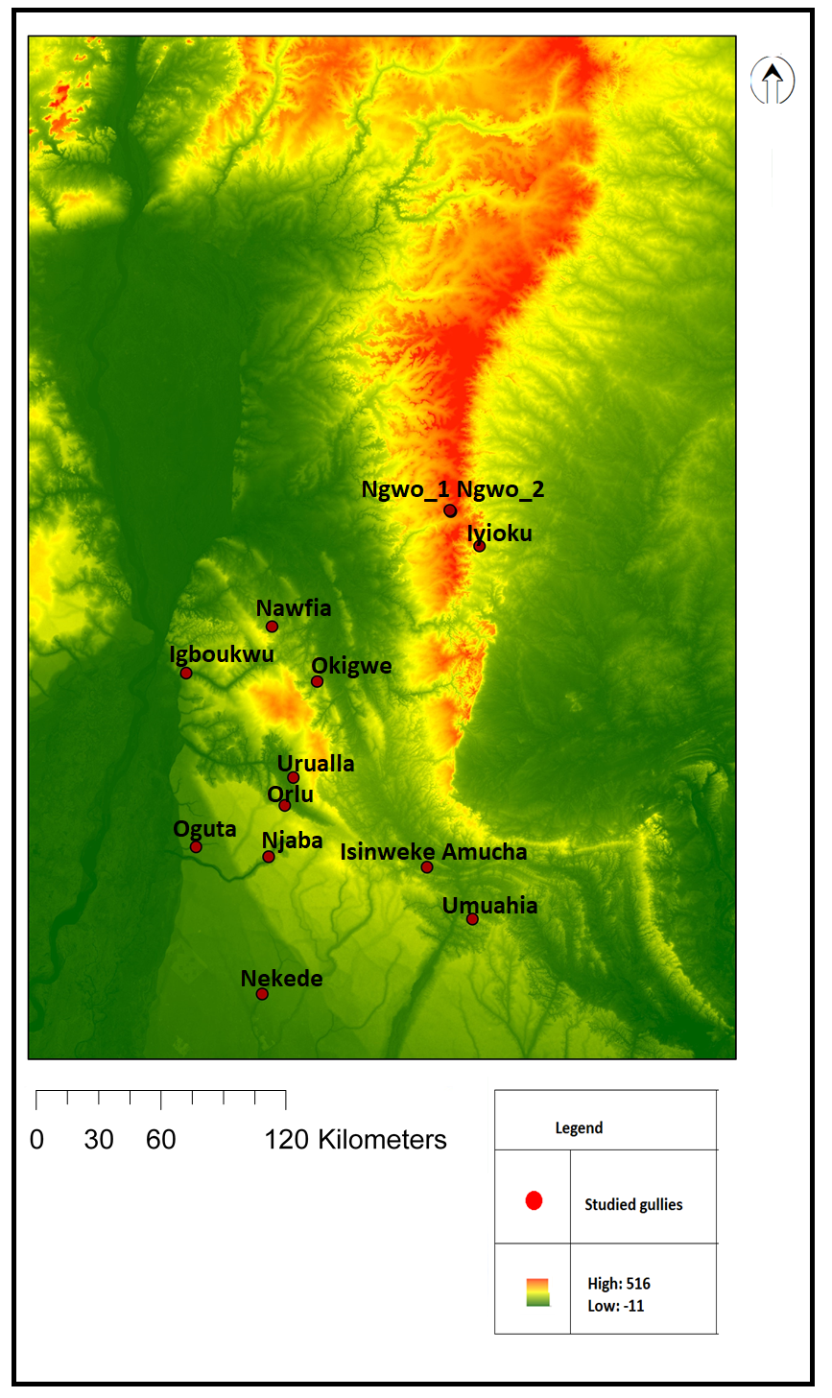
Appendix I: An SRTM DEM image of the 57,758.034km2 study area, cropped to Area of Interest green colour represents low elevation.
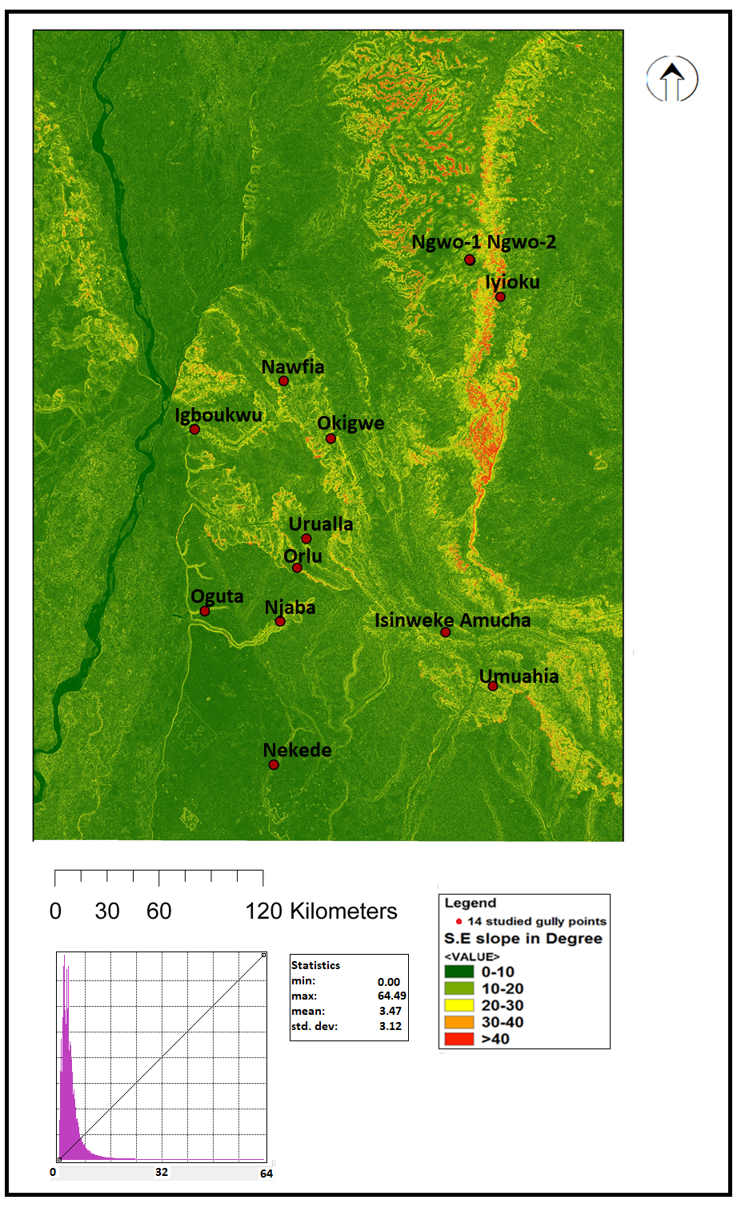
Appendix II: Maximum slope map of the study area shown as a degree gradient (flat areas have 0 – 10, 10 - 20⁰ gentle slope and 20⁰ and greater are higher).
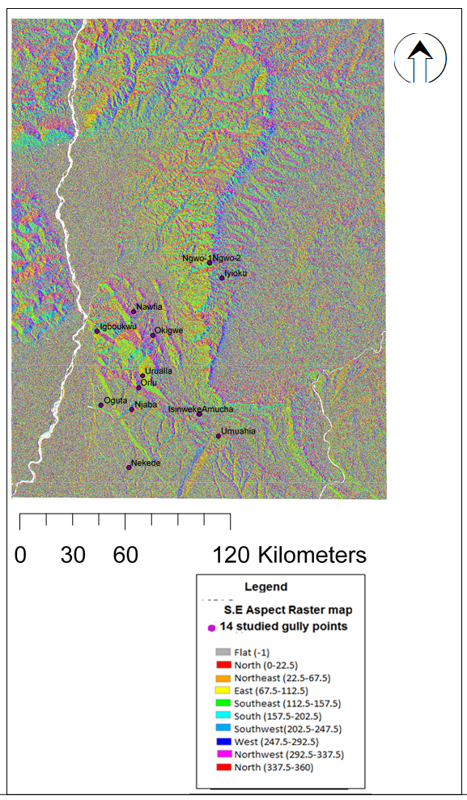
Appendix III: Aspect map overlayed by the gully points observed gully shapefiles and gully points. Flat, N(0 -22.5), NE (22.5 – 67.5), E (67.5 – 112.5), SE (112.5 – 157.5), S (157.5 – 202.5), SW (202.5 – 247.5), W (247.5 – 292.5), NW (292.5 – 337.5 and N (337.5 - 360)

Appendix IV: Figure 59: (Top) Pixel based (pixel count) change over time of Gully/open-land showing from 1986 to 2015 (observed images are in blue circle points while interpolated points are in red circle points). (b): (Bottom) OBIA Area changes over time of Gully/open land. Pixel size is equivalent to 300m².

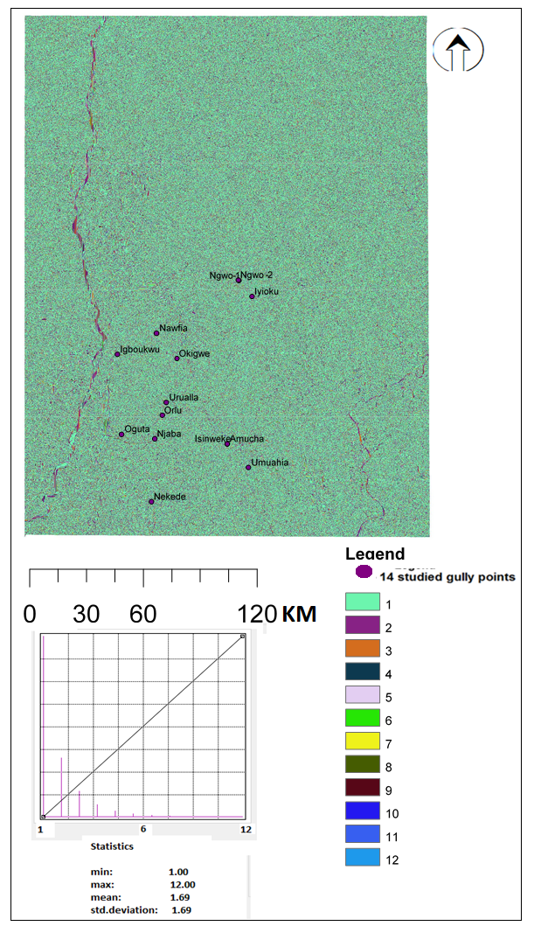
AppendixV: The Strahler stream order Drainage pattern of the study area overlaid by the gully points. From 1 to 12 are stream sizes based on a hierarchy of tributaries in the study area. The cell value shows that stream 1 are more in number than others

