SUPPLEMENTARY INFORMATION

Additional file 1 : Electrophoretic mobility shift assay (EMSA) of EgJUB1 with SNBE1 probe. Lane 1 to 3 consist of EBNA control system. Lane 4 to 8 consist of EgJUB1 test system. Lane 1 and 8 are the blank for EBNA and EgJUB1 systems, respectively. Lane 2 is the positive control for EMSA. EMSA shows direct binding of EgJUB1 to SNBE1 probe in lane 6. EgJUB1 is unable to bind to untransformed yeast and biotinylated mutant SNBE1 (mSNBE1) probe in lane 4 and 5, respectively. Successful binding of 200-fold molar excess of unlabelled SNBE1 (competitor) probe is shown in lane 7.

1 | 2 | 3 | 4 | 5 | 6 | 7 | 8
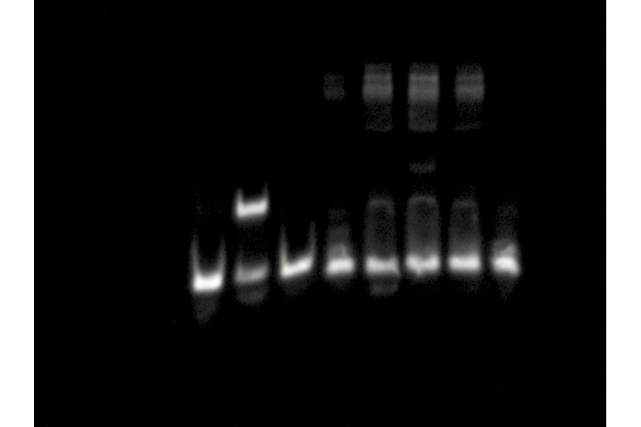

Additional file 2 : Electrophoretic mobility shift assay (EMSA) of EgERF113 with GCC-box probe. Lane 1 to 3 consist of EBNA control system. Lanes 4 to 8 consist of EgERF113 test system. Lane 1 and 8 are the blank for EBNA and EgERF113 systems, respectively. Lane 2 is the positive control for EMSA. EMSA shows direct binding of EgERF113 to GCC-box probe in lane 6. EgERF113 is unable to bind to untransformed yeast and biotinylated mutant GCC-box (mGCC-box) probe in lane 4 and 5, respectively. Successful binding of 200-fold molar excess of unlabelled GCC-box (competitor) probe is shown in lane 7.

1 | 2 | 3 | 4 | 5 | 6 | 7 | 8

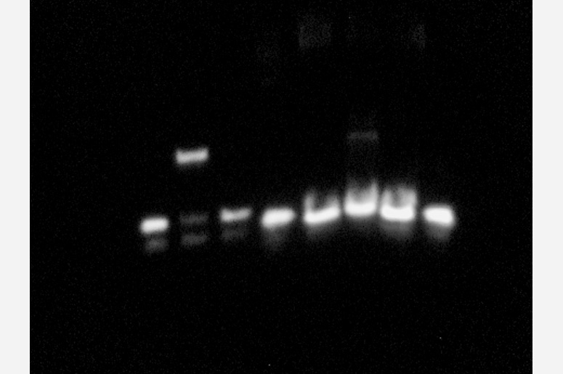

Additional file 3 : Electrophoretic mobility shift assay (EMSA) of EgERF113 with DRE/CRT probe. Lane 1 to 3 consist of EBNA control system. Lane 4 to 8 consist of EgERF113 test system. Lane 1 and 8 are the blank for EBNA and EgERF113 systems, respectively. Lane 2 is the positive control for EMSA. EMSA shows direct binding of EgERF113 to DRE/CRT probe in lane 6. EgERF113 is unable to bind to untransformed yeast and biotinylated mutant DRE/CRT (mDRE/CRT) probe in lane 4 and 5, respectively. Successful binding of 200-fold molar excess of unlabelled DRE/CRT (competitor) probe is shown in lane 7.

1 | 2 | 3 | 4 | 5 | 6 | 7 | 8
