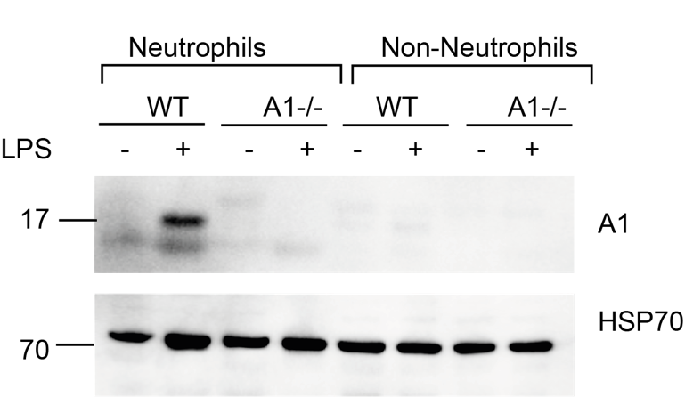

Supplementary Figure 1: Analysis of the A1 protein expression in neutrophils and other cell types from inflamed lungs.
Lung inflammation was induced in WT and A1^{-/-} mice by intranasal administration of LPS. After 24 h mice were sacrificed and lungs were harvested, processed and used for isolation of neutrophils. The isolated neutrophils and non-neutrophils were subjected to Western blot analysis for A1 protein expression. Probing for Hsp70 was used as a loading control.

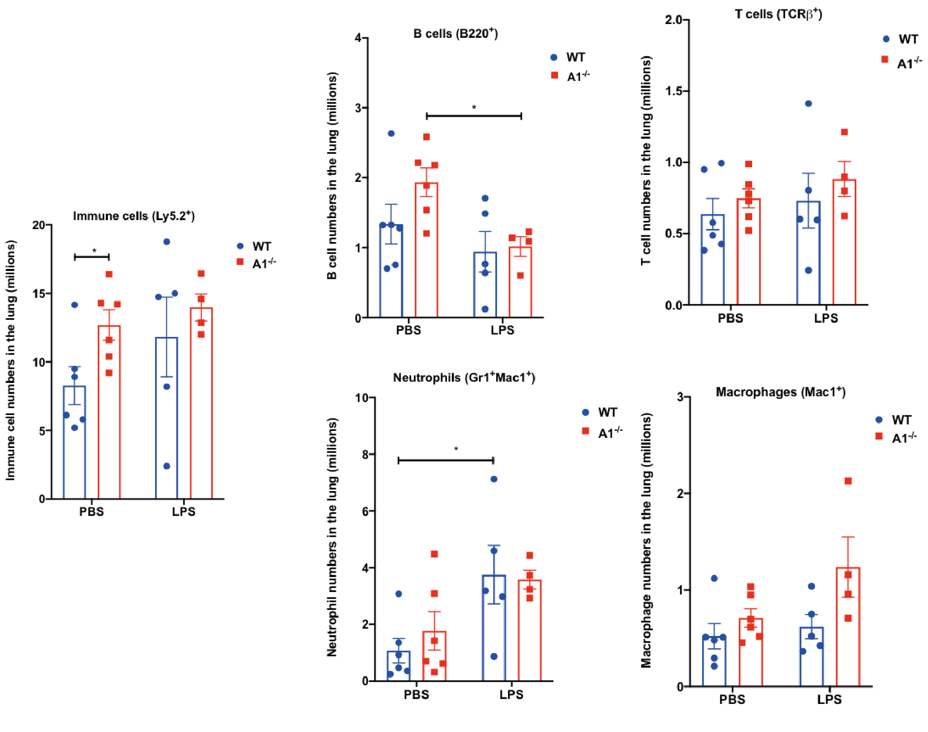Supplementary Figure 2: Analysis of the immune cell populations in the lungs during LPS induced inflammation.
WT and A1^{-/-} mice were intranasally administered LPS (10 µg) or vehicle (PBS). After 24 h mice were sacrificed and lung tissues were harvested, processed and total cell numbers determined. Cells were analysed by flow cytometry following staining for cell subset specific surface markers. Based on the percentage cellularity and the cell counts obtained the cell numbers were calculated. Statistical significance (P < 0.05) was determined using student’s t-test. Each dot represents one mouse. The gating strategy used for flow cytometric analysis is shown in Supplementary Fig. S3.

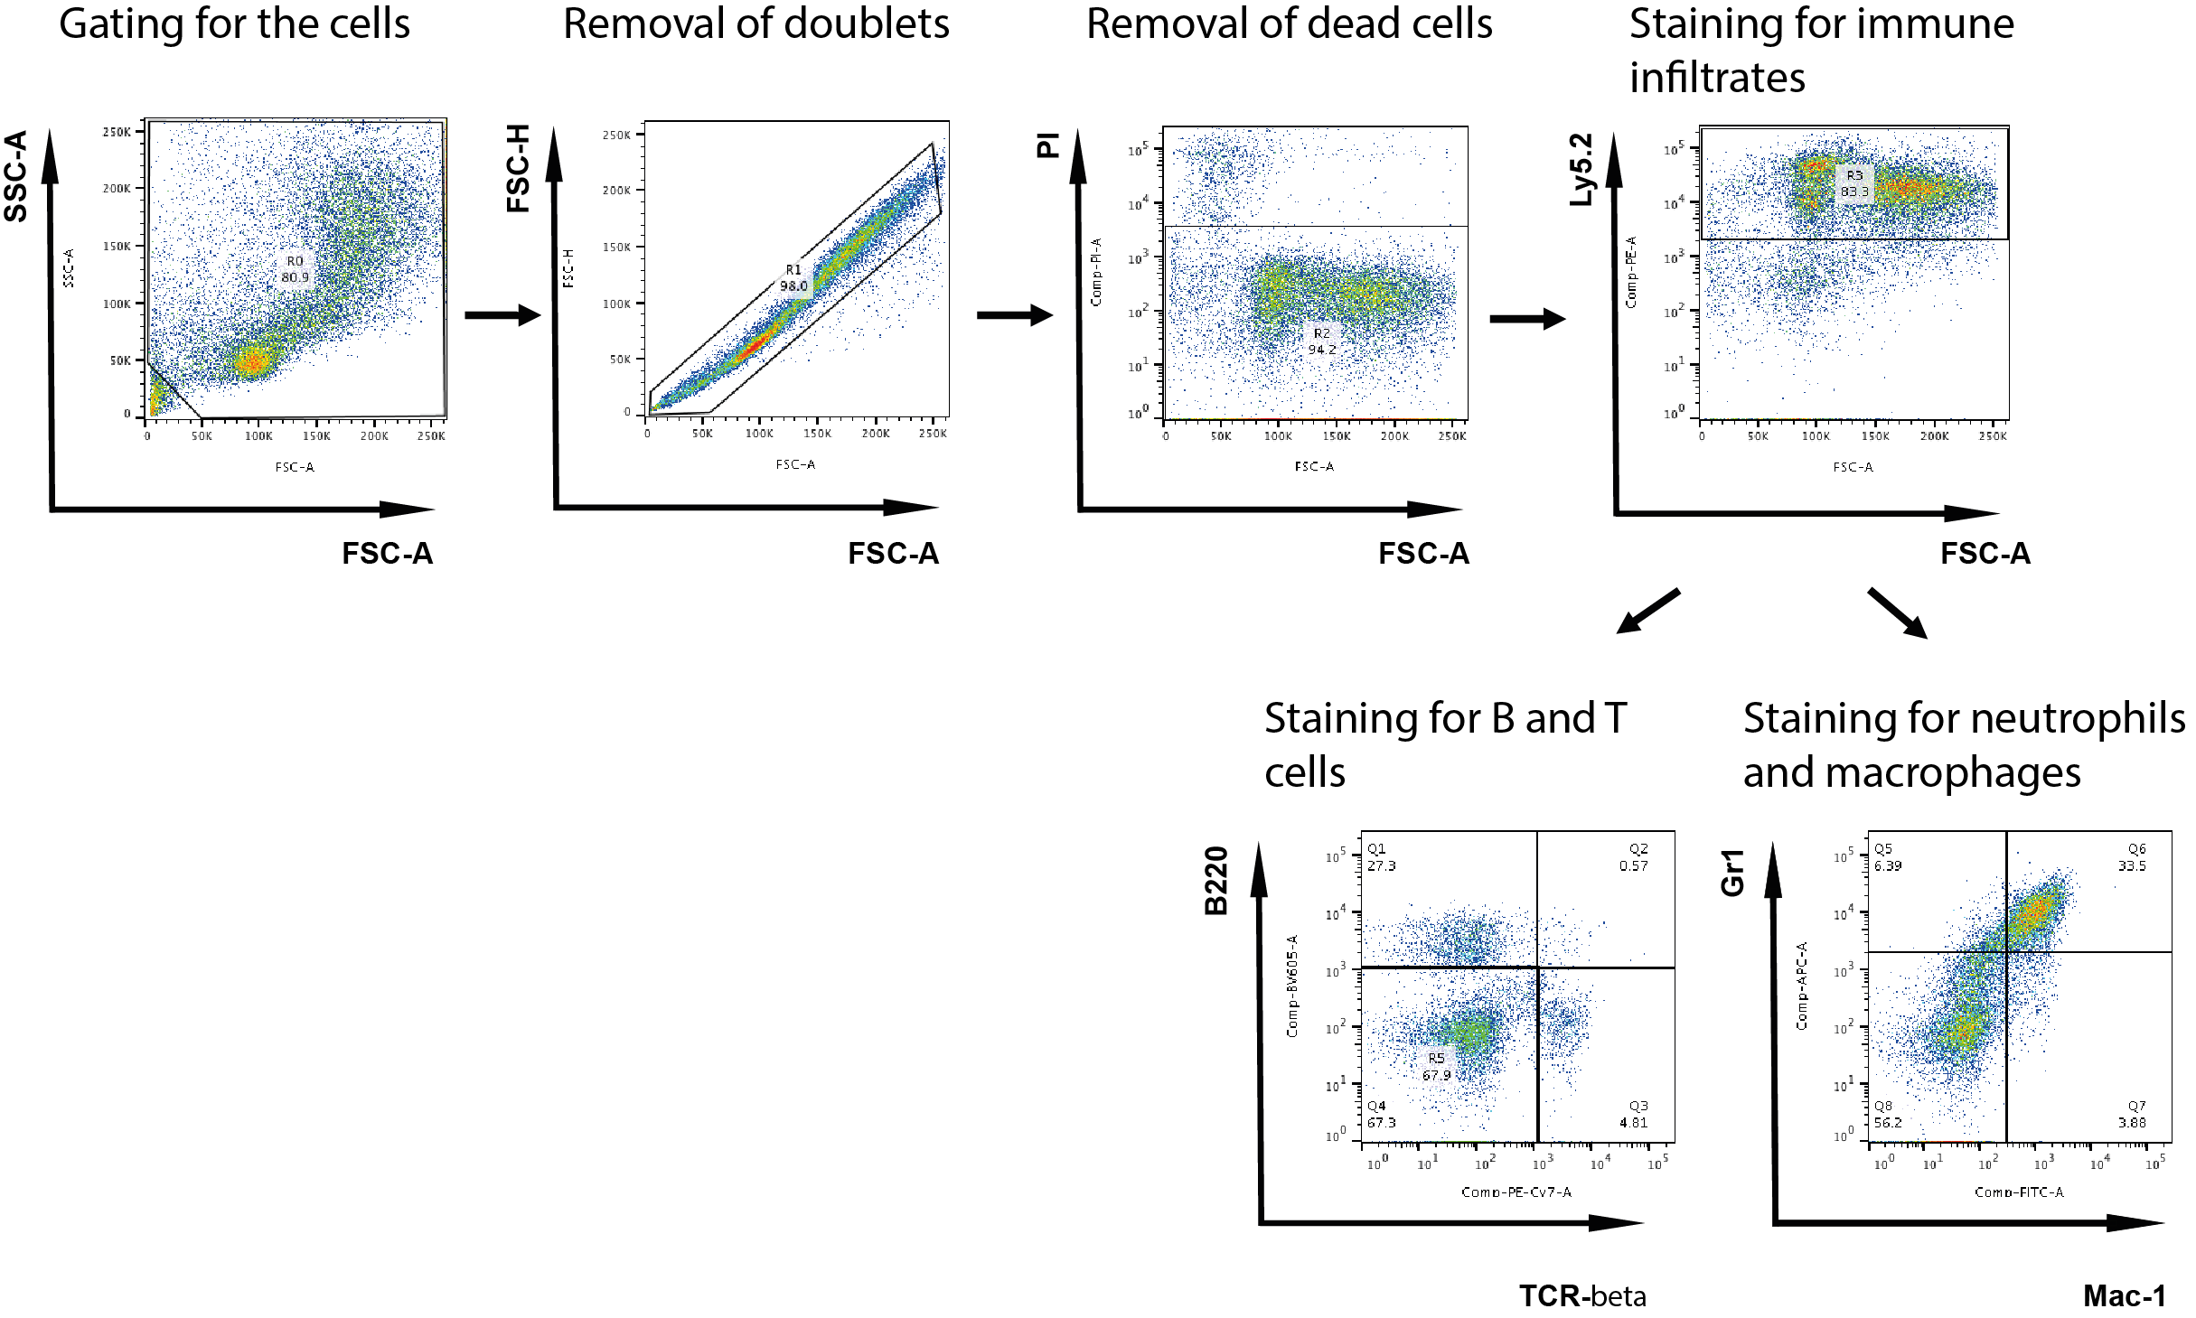

Supplementary Figure 3: Gating strategy used for FACS analysis of immune cells.
The cells harvested from the mice were stained with the following fluorochrome-conjugated monoclonal antibodies: B220 (BV605), TCRβ (PE-Cy7), Mac-1 (FITC), Gr-1 (APC) and Ly5.2 (PE) and propidium iodide (PI) and subjected to flow cytometric analysis using this gating strategy.

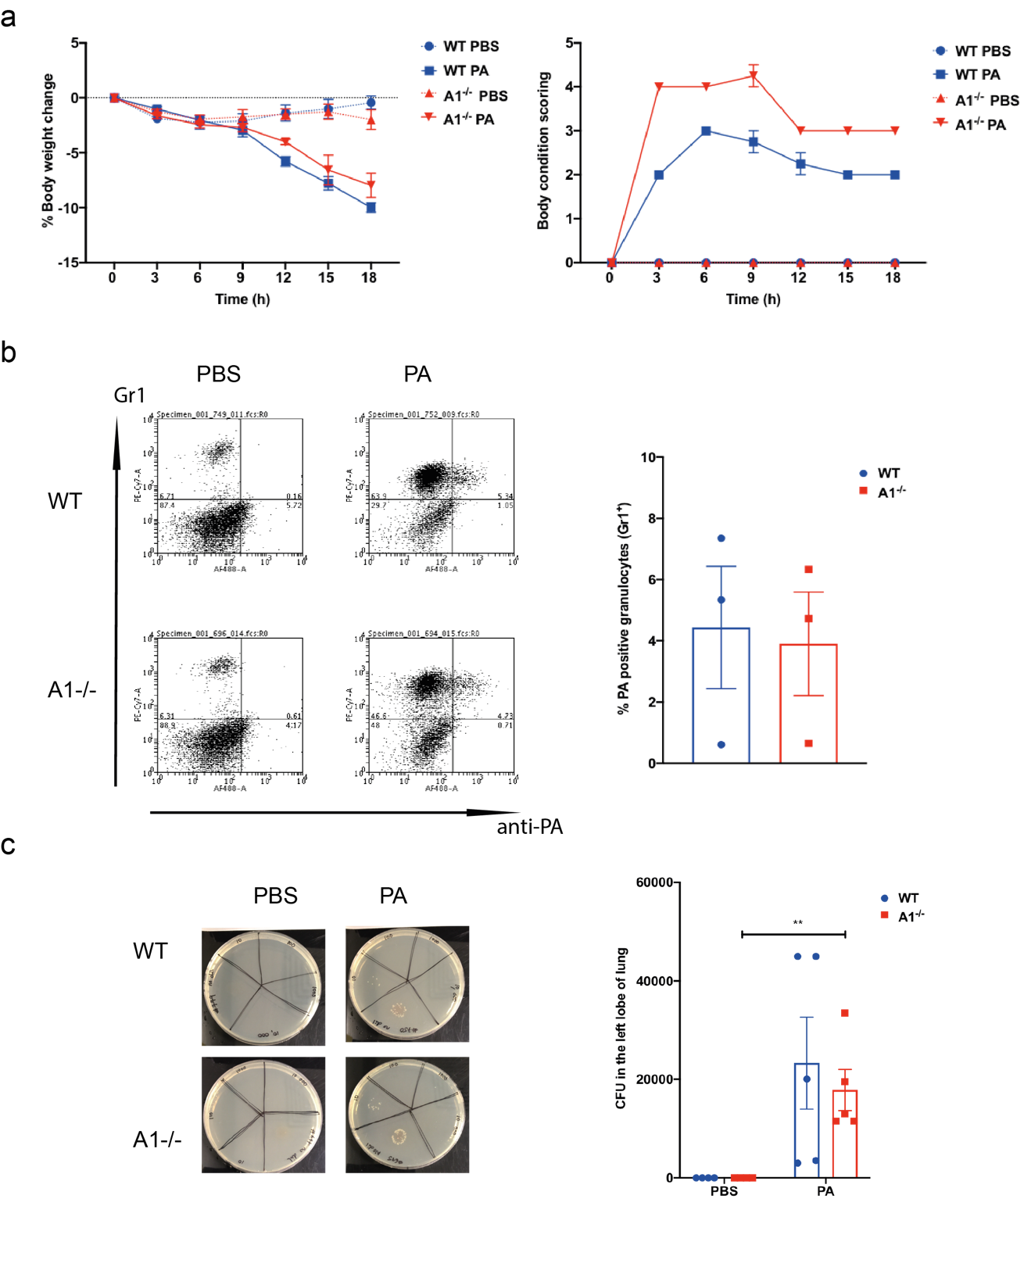Supplementary Figure 4: Assessment of WT and A1^{-/-} mice with P.aeruginosa (PA) induced lung inflammation.
WT and A1^{-/-} mice were intranasally administered P. aeruginosa (PA) or vehicle (PBS). (a) The body weight and the body condition scoring were monitored every 3 h up to the 24 h endpoint of the experiment. (b) At 24 h post PA administration, mice were sacrificed, lungs were harvested, processed and the cells stained for Gr-1 and PA to determine the percentage of neutrophils with internalized pathogen. (c) At 24 h post PA administration lung tissues were homogenized in PBS and serial dilutions of the homogenate plated on LB agar and incubated overnight for P.aeruginosa to form colonies. The colonies were counted and data are presented as colony forming units (CFU). In b and c each dot represents one mouse.

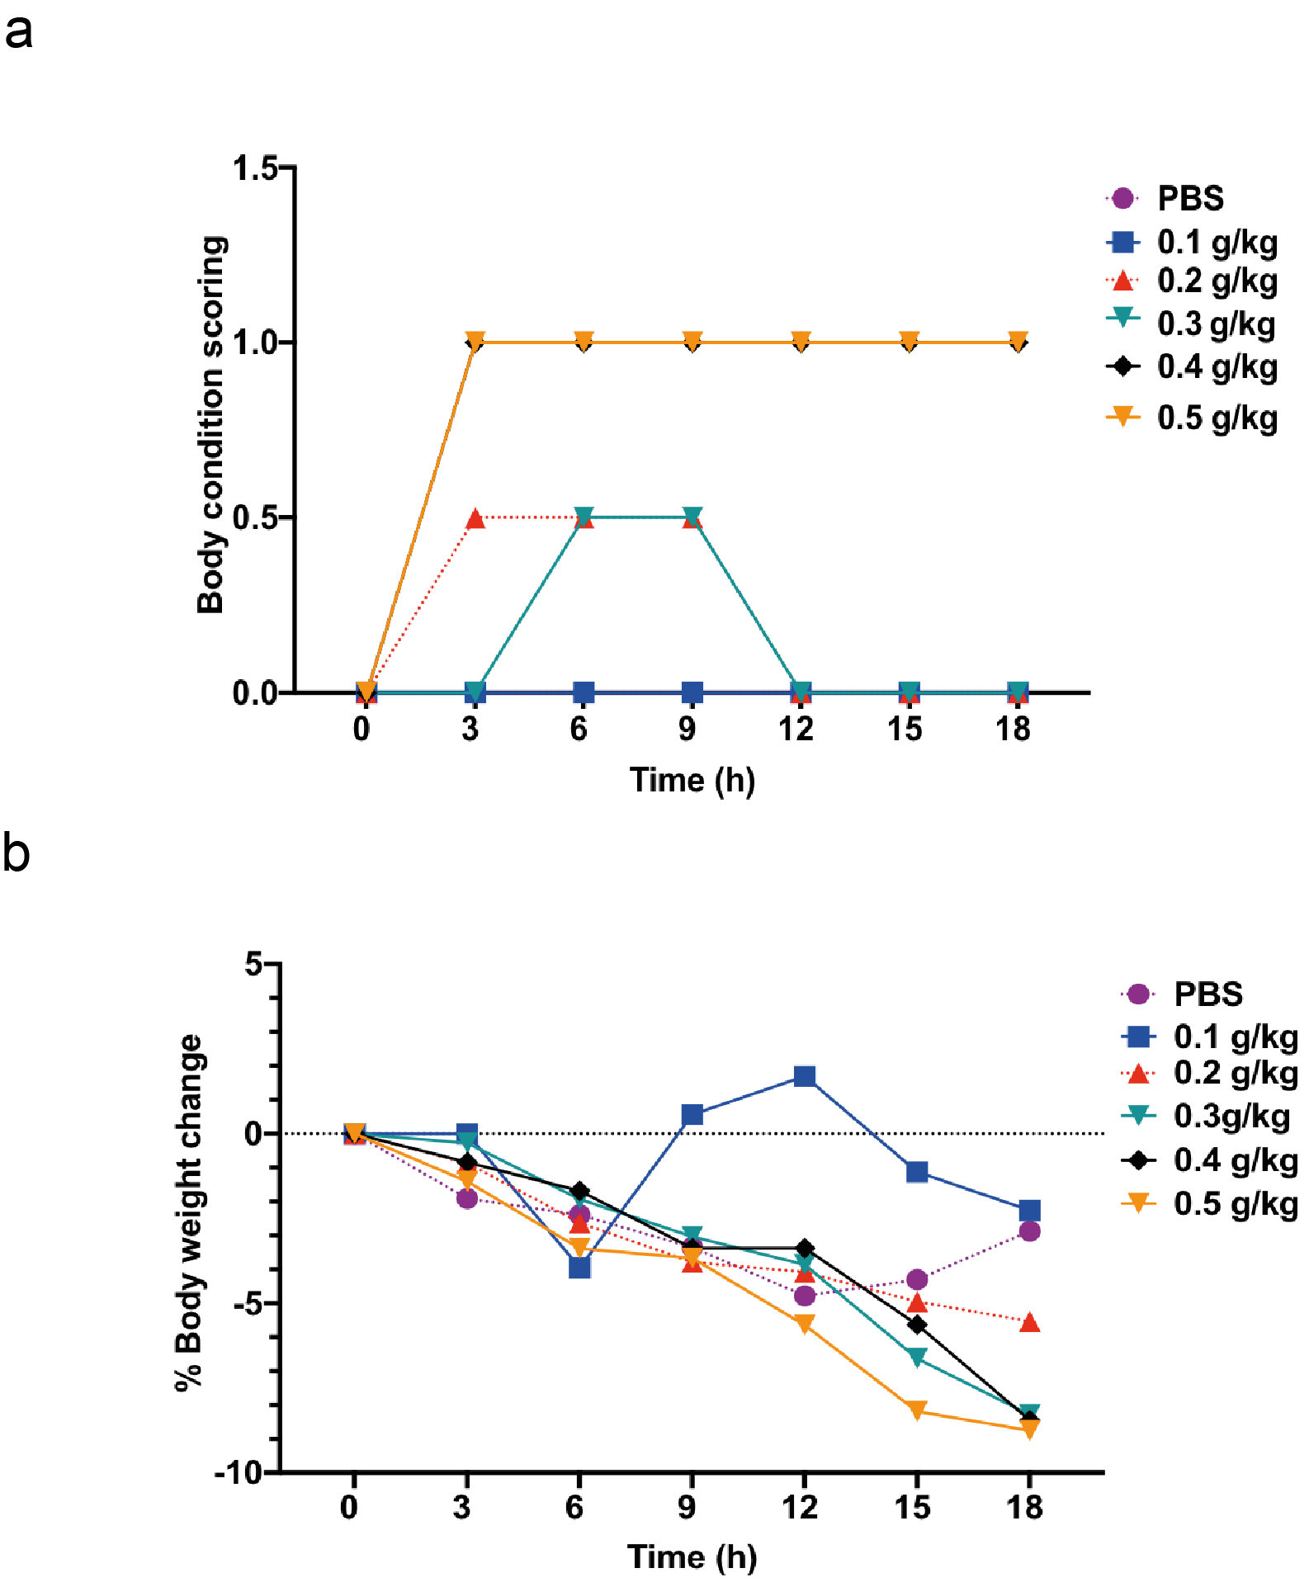

Supplementary Figure 5: Titration of the batch of caecal slurry used in the experiments.
The sub-lethal and lethal dosing of the caecal slurry was determined by titration. This was done by injecting pairs of WT mice with different doses of caecal slurry followed by scoring of their body condition (a) and body weight measurements (b) every 3 h up to the 24 h end point. Each dot represents one mouse.

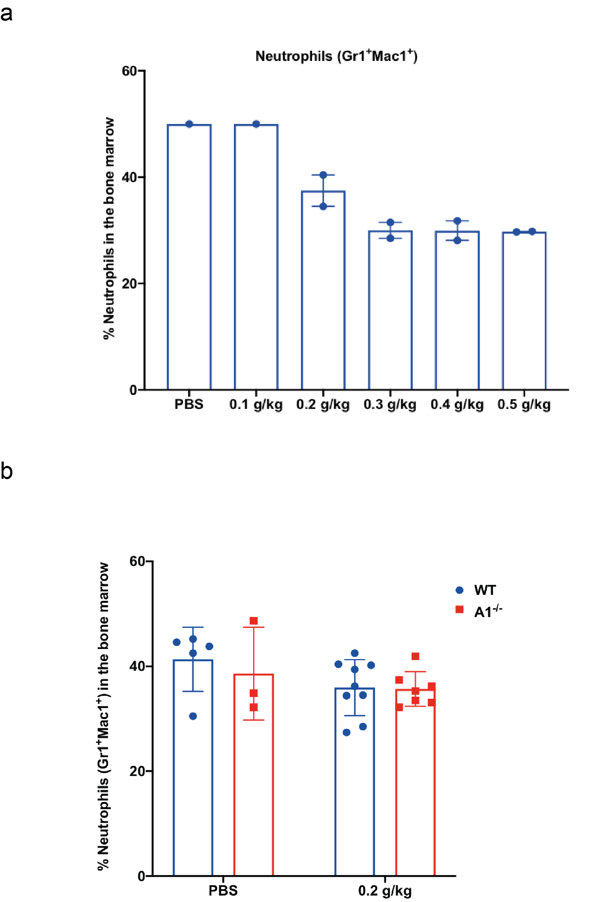

Supplementary Figure 6: Assessing mobilization of neutrophils to the site of inflammation in mice injected with caecal slurry.
(a) The minimum dose of caecal slurry required for neutrophil mobilization was determined by flow cytometric analysis of neutrophils in the bone marrow of mice injected with different doses of caecal slurry at 24 h post-injection. (b) WT and A1^{-/-} mice were injected i.p. with 0.2 g/kg caecal slurry and 6 h later bone marrow was harvested to determine the percentage of neutrophils. Each dot represents one mouse.

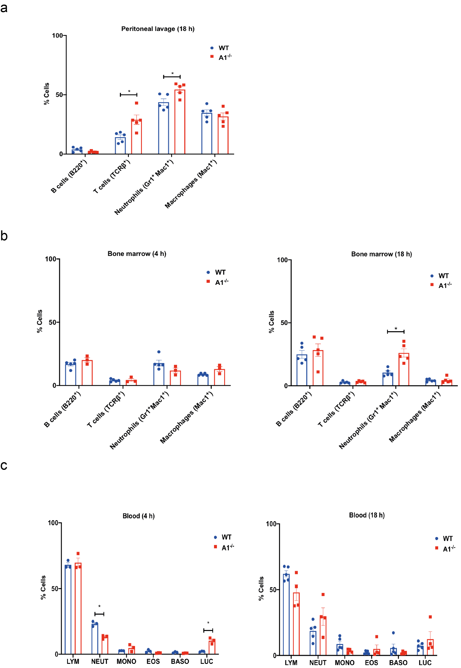

Supplementary Figure 7: Analysis of the bone marrow and blood of the caecal slurry injected mice.
WT and A1^{-/-} mice were injected i.p. with 0.65 g/kg caecal slurry and peritoneal lavage, bone marrow and blood were harvested at 4 and 18 h post-injection. Percentages of the different cell subsets in the (a) peritoneal lavage and (b) bone marrow were determined by flow cytometric analysis following staining for cell subset specific surface markers. The gating strategy used for flow cytometric analysis is shown in Supplementary Fig. S3. (c) Blood was analysed using the ADVIA automated haematology system. Statistical significance (P < 0.05) was determined using student’s t-test. Each dot represents one mouse.

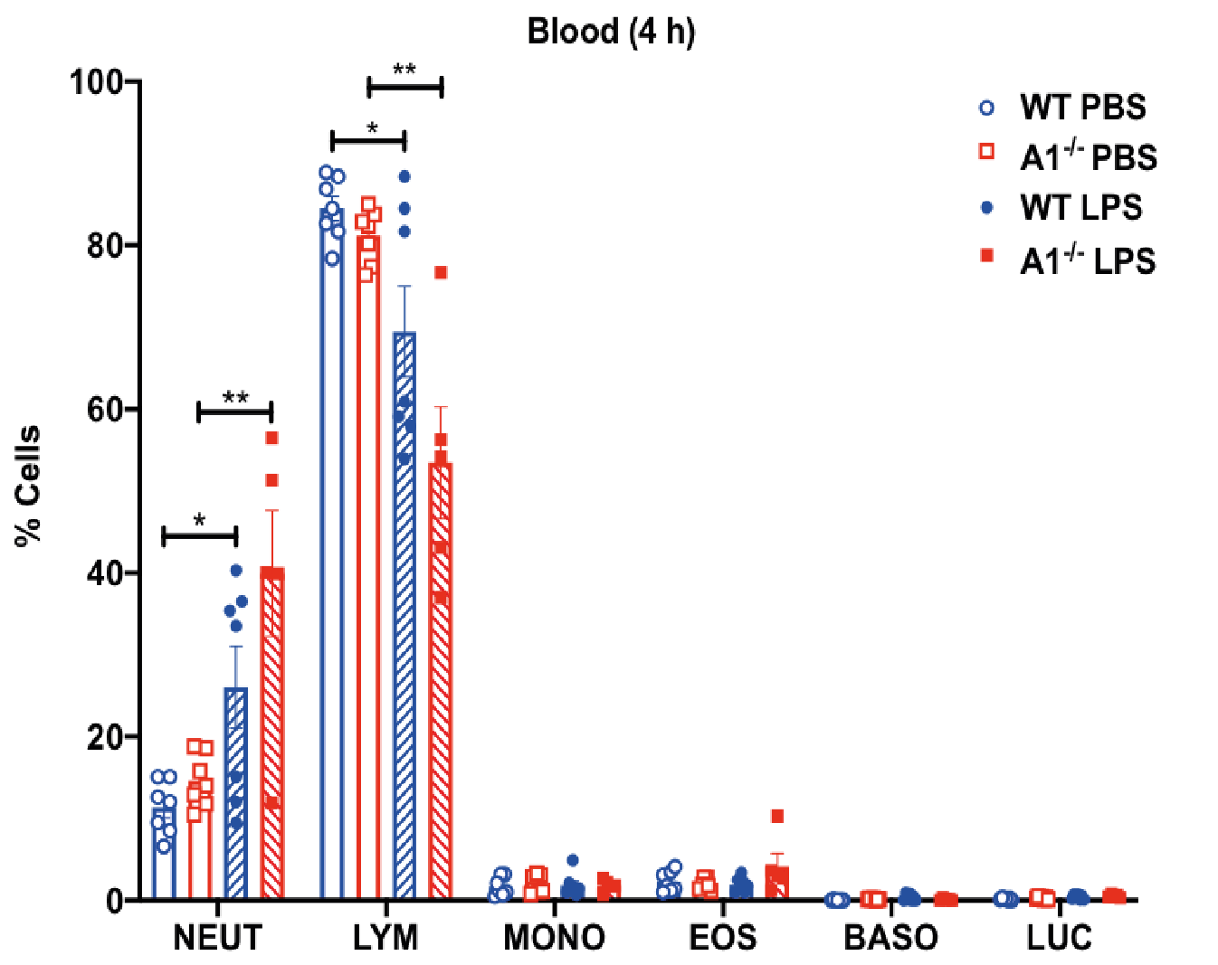

Supplementary Figure 8: Analysis of cells in the blood during LPS induced peritonitis.
WT and A1^{-/-} mice were injected i.p. with 1 mg/kg LPS. Mice were sacrificed at 4 h post-injection due to loss of body temperature. Blood was analysed using the ADVIA automated haematology system. Statistical significance (P* < 0.05, P**<0.01) was determined using student’s t-test. Each dot represents one mouse.

