 

**Fig. S1** Seasonal variation of daily (black bars) and monthly (grey bars) precipitation under ambient environment (a); daily averages of automatically (30 min) measured volumetric soil moisture content (b) and daily averages of automatically (30 min) measured soil temperature (c) to a depth of 40 cm under Control and throughfall reduction (TFR) conditions.

**Table S1** Results (*F* and *P* values) of two-way ANOVA on the effects of throughfall reduction (TFR), year (Y) and their interactions (TFR×Y) on soil and fine root properties.

|  |  |  |  |  |  |  |  |  |
| --- | --- | --- | --- | --- | --- | --- | --- | --- |
| Variables | TFR | |  | Y | |  | TFR×Y | |
| *F* | *P* |  | *F* | *P* |  | *F* | *P* |
| **Soil chemical properties** |  |  |  |  |  |  |  |  |
| SOC | 0.93 | 0.351 |  | 0.27 | 0.610 |  | 0.97 | 0.341 |
| STN | 2.95 | 0.108 |  | 0.40 | 0.540 |  | 2.17 | 0.163 |
| STP | 2.37 | 0.148 |  | 23.40 | **<0.001** |  | 0.05 | 0.826 |
| **Fine root** |  |  |  |  |  |  |  |  |
| Soluble sugar (%) | 4.71 | 0.062 |  | 28.77 | **0.001** |  | 0.45 | 0.523 |
| Starch (%) | 0.17 | 0.688 |  | 116.38 | **<0.001** |  | 0.53 | 0.488 |
| NSC (%) | 2.09 | 0.186 |  | 109.03 | **<0.001** |  | 0.32 | 0.585 |
| RC (g/kg) | 0.02 | 0.883 |  | 9.55 | **0.015** |  | 0.16 | 0.698 |
| RN (g/kg) | 0.58 | 0.470 |  | 2.78 | 0.134 |  | 0.07 | 0.795 |
| RP (g/kg) | 1.16 | 0.313 |  | 84.25 | **<0.001** |  | 0.01 | 0.920 |
| **Microbial biomass** |  |  |  |  |  |  |  |  |
| MBC (mg kg-1) | 0.04 | 0.852 |  | 2.68 | 0.14 |  | 0.11 | 0.75 |
| MBN (mg kg-1) | 0.36 | 0.567 |  | 6.31 | **0.036** |  | 0.05 | 0.826 |
| **Enzymatic activities** |  |  |  |  |  |  |  |  |
| β-glucosidase | 1.79 | 0.218 |  | 25.37 | **0.001** |  | 0.64 | 0.446 |
| Polyphenolase | 4.01 | 0.080 |  | 260.91 | **<0.001** |  | 1.93 | 0.202 |
| Peroxidase | 0.92 | 0.365 |  | 171.88 | **<0.001** |  | 0.64 | 0.449 |
| Amylase | 0.03 | 0.878 |  | 1.30 | 0.286 |  | 0.21 | 0.658 |

SOC: soil organic C, STN: soil total N, STP: soil organic P, NSC: non-structural carbohydrate, RC: root carbon content, RN: root nitrogen content, RP: root phosphorus content.

**Table S2** Pearson correlation (R) between HR and measured variables. ST: soil temperature, SM: soil moisture, BR: bacterial richness, FR: fungal richness, MBC: microbial biomass carbon, MBN: microbial biomass nitrogen, BG: β-glucosidase, POP: polyphenolase, POD: peroxidase, AL: amylase.

|  |  |  |  |  |  |  |  |  |  |  |
| --- | --- | --- | --- | --- | --- | --- | --- | --- | --- | --- |
|  | ST | SM | BR | FR | MBC | MBN | BG | POP | POD | AL |
| SR | 0.181 | 0.051 | 0.019 | -0.559 | -0.110 | -0.046 | 0.216 | -0.048 | 0.029 | -0.311 |
| HR | 0.163 | 0.234 | 0.53 | -0.210 | 0.321 | 0.375 | 0.151 | -0.021 | 0.028 | -0.006 |

**Table S3** Pearson correlation (R) between AR and measured variables. ST: soil temperature, SM: soil moisture, FRB: fine root biomass, NSC: non-structural carbohydrate, RC: root carbon content, RN: root nitrogen content, RP: root phosphorus content.

|  |  |  |  |  |  |  |  |  |  |
| --- | --- | --- | --- | --- | --- | --- | --- | --- | --- |
|  | ST | SM | FRB | Sugar | Starch | NSC | RC | RN | RP |
| SR | 0.245 | -0.045 | 0.610* | 0.095 | -0.101 | -0.098 | 0.115 | -0.132 | -0.101 |
| AR | -0.056 | -0.259 | 0.857** | 0.216 | -0.059 | -0.015 | 0.072 | -0.208 | 0.008 |

**\* *P* < 0.05, ** *P* < 0.01.**

**Table S4** Relative abundance of microbial genera that showed a significant response (*P* < 0.05) to TFR.

|  |  |  |  |  |  |  |  |
| --- | --- | --- | --- | --- | --- | --- | --- |
|  | Relative abundance | |  | Taxa level | |  | treatment |
| group | Control | TFR |  | genus | phylum |  | *P* value |
| bacteria | 0.0234 | 0.0134 |  | norank_o__*Vicinamibacterales* | *Acidobacteriota* |  | 0.002 |
| bacteria | 0.0136 | 0.0060 |  | norank_o__*Rokubacteriales* | *Methylomirabilota* |  | 0.004 |
| bacteria | 0.0050 | 0.0040 |  | norank_f__*Caulobacteraceae* | *Proteobacteria* |  | 0.049 |
| bacteria | 0.0049 | 0.0029 |  | *Haliangium* | *Myxococcota* |  | 0.03 |
| bacteria | 0.0044 | 0.0019 |  | norank_o__*Subgroup_7* | *Acidobacteriota* |  | 0.021 |
| bacteria | 0.0042 | 0.0021 |  | norank_f__*KF-JG30-B3* | *Proteobacteria* |  | 0.048 |
| bacteria | 0.0040 | 0.0021 |  | norank_o__*JG36-TzT-191* | *Proteobacteria* |  | 0.001 |
| bacteria | 0.0039 | 0.0081 |  | *Conexibacter* | *Actinobacteriota* |  | 0.045 |
| bacteria | 0.0035 | 0.0071 |  | *Acidipila* | *Acidobacteriota* |  | 0.015 |
| bacteria | 0.0034 | 0.0017 |  | norank_c__*Subgroup_5* | *Acidobacteriota* |  | 0.006 |
| bacteria | 0.0030 | 0.0020 |  | norank_o__*0319-6G20* | *Bdellovibrionota* |  | 0.008 |
| bacteria | 0.0027 | 0.0015 |  | norank_c__*Lineage_IIa* | *Elusimicrobiota* |  | 0.005 |
| bacteria | 0.0027 | 0.0016 |  | *mle1-7* | *Proteobacteria* |  | 0.045 |
| bacteria | 0.0023 | 0.0012 |  | norank_c__*bacteriap25* | *Myxococcota* |  | 0.032 |
| bacteria | 0.0023 | 0.0005 |  | norank_p__*Latescibacterota* | *Latescibacterota* |  | 0.002 |
| bacteria | 0.0021 | 0.0004 |  | *Nitrospira* | *Nitrospirota* |  | 0.003 |
| bacteria | 0.0018 | 0.0008 |  | norank_f__*Sutterellaceae* | *Proteobacteria* |  | 0.013 |
| bacteria | 0.0017 | 0.0009 |  | norank_o__*Subgroup_13* | *Acidobacteriota* |  | 0.002 |
| bacteria | 0.0016 | 0.0030 |  | norank_c__*Acidimicrobiia* | *Actinobacteriota* |  | 0.003 |
| bacteria | 0.0014 | 0.0028 |  | *Actinospica* | *Actinobacteriota* |  | 0.011 |
| bacteria | 0.0013 | 0.0006 |  | *Dongia* | *Proteobacteria* |  | 0.021 |
| bacteria | 0.0012 | 0.0003 |  | norank_f__*Microscillaceae* | *Bacteroidota* |  | 0 |
| bacteria | 0.0010 | 0.0003 |  | norank_o__*Omnitrophales* | *Verrucomicrobiota* |  | 0.021 |
| bacteria | 0.0010 | 0.0005 |  | norank_f__*env.OPS_17* | *Bacteroidota* |  | 0.027 |
| bacteria | 0.0010 | 0.0003 |  | norank_p__*MBNT15* | *MBNT15* |  | 0.006 |
| bacteria | 0.0009 | 0.0004 |  | norank_o__*Chitinophagales* | *Bacteroidota* |  | 0.038 |
| bacteria | 0.0009 | 0.0005 |  | norank_o__*Lineage_IV* | *Elusimicrobiota* |  | 0.05 |
| bacteria | 0.0009 | 0.0015 |  | *FCPS473* | *Chloroflexi* |  | 0.02 |
| bacteria | 0.0008 | 0.0003 |  | norank_f__*Anaerolineaceae* | *Chloroflexi* |  | 0.031 |
| bacteria | 0.0007 | 0.0003 |  | *Novosphingobium* | *Proteobacteria* |  | 0 |
| bacteria | 0.0007 | 0.0002 |  | norank_c__*BD7-11* | *Planctomycetota* |  | 0.02 |
| bacteria | 0.0007 | 0.0002 |  | *Lacunisphaera* | *Verrucomicrobiota* |  | 0.002 |
| bacteria | 0.0007 | 0.0002 |  | norank_f__*AKYH767* | *Bacteroidota* |  | 0.04 |
| bacteria | 0.0007 | 0.0002 |  | norank_f__*A4b* | *Chloroflexi* |  | 0.009 |
| bacteria | 0.0004 | 0.0001 |  | norank_o__*11-24* | *Acidobacteriota* |  | 0.017 |
| bacteria | 0.0004 | 0.0001 |  | norank_f__*BIrii41* | *Myxococcota* |  | 0.004 |
| bacteria | 0.0004 | 0.0001 |  | norank_o__*S085* | *Chloroflexi* |  | 0.04 |
| bacteria | 0.0003 | 0.0010 |  | *1959-1* | *Chloroflexi* |  | 0.05 |
| bacteria | 0.0003 | 0.0009 |  | *Tundrisphaera* | *Planctomycetota* |  | 0.043 |
| bacteria | 0.0002 | 0.0001 |  | *KD3-10* | *Myxococcota* |  | 0.036 |
| bacteria | 0.0002 | 0.0001 |  | norank_o__*Subgroup_12* | *Acidobacteriota* |  | 0.038 |
| bacteria | 0.0001 | 0.0004 |  | unclassified_o__*Frankiales* | *Actinobacteriota* |  | 0.014 |
| fungi | 0.0957 | 0.3254 |  | *Russula* | *Basidiomycota* |  | 0.019 |
| fungi | 0.3301 | 0.1933 |  | *Mortierella* | *Mortierellomycota* |  | 0.046 |
| fungi | 0.0007 | 0.0063 |  | *Trechispora* | *Basidiomycota* |  | 0.01 |
| fungi | 0.0002 | 0.0008 |  | *Leptobacillium* | *Ascomycota* |  | 0.008 |
| fungi | 0.0029 | 0.0006 |  | unclassified_p__*Mortierellomycota* | *Mortierellomycota* |  | 0.042 |

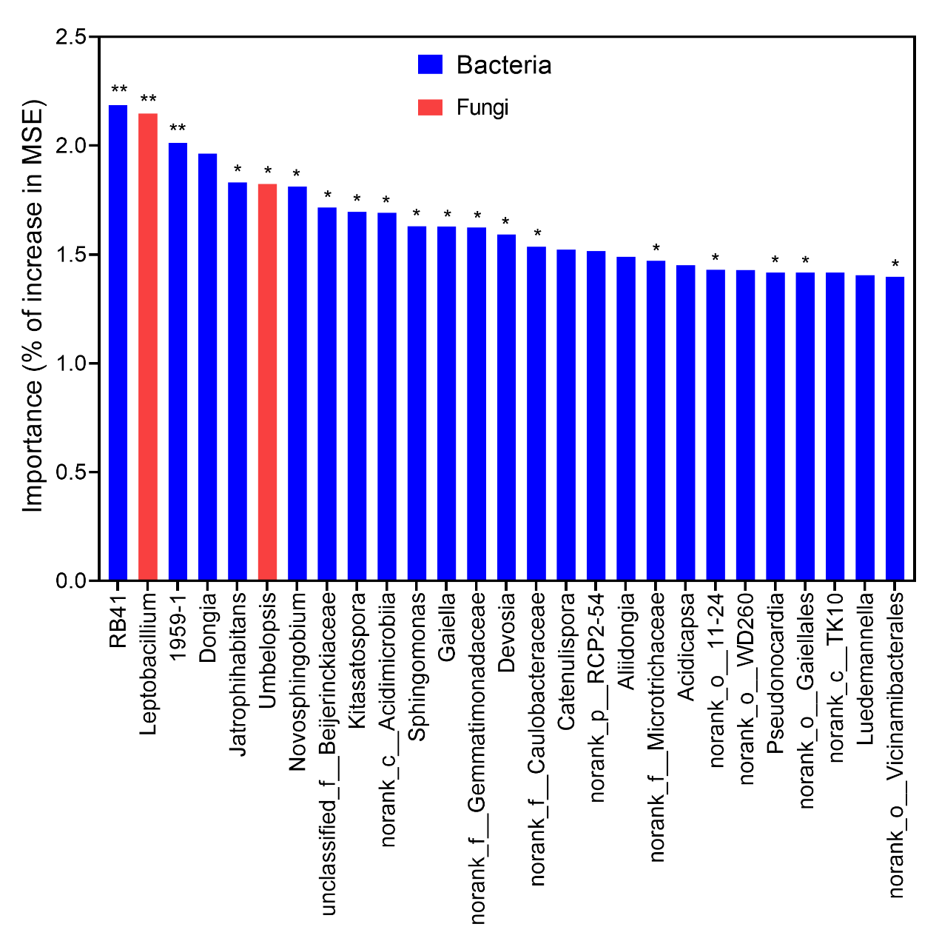

**Fig. S2** Random Forest regression model shows the main microbial drivers of HR. MSE, is the mean square error. \**P* < 0.05, \*\**P* < 0.01.