Supplementary materials

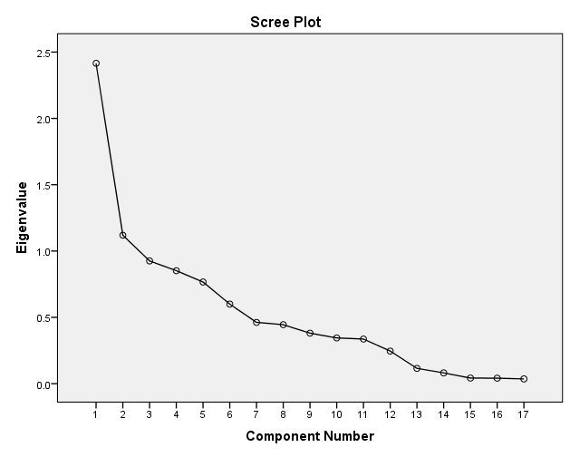

Supplementary figure 1. The scree plot.

Supplementary table 1. Grouping food items into food groups
Food group | Food item
1. Whole grain | Oatmeal, whole wheat bread, wheat gluten
2. Refined grain | Rice, congee, noodles, pasta, plain roll, roll with filling, rice roll
3. Cakes | Pancakes or waffles, cracker, cake, biscuits
4. Poultry | Chicken with or without skin, duck, goose, pigeon, quail
5. Red meat | Beef, pork, lamb, meat ball, liver
6. Processed meat | Processed meat (eg. Bacon, sausages, luncheon meat, ham), Chinese sausage
7. Fish and seafood | Freshwater fish, seawater fish, small fish with edible bone, shrimp, fish ball, seafood ball
8. Eggs | Eggs or preserved eggs
9. Dairy | Whole milk, whole milk powder, skim or low-fat milk, skim or low-fat milk powder, cream, ice cream, cheese, condensed milk, milkshake, milk tea, yogurt
10. Leaf vegetables | Dark green leafy vegetable (e.g. including broccoli, Chinese cabbage, ChoiSum, kale, watercress, mustard, mustard, culiflower)
11. Other vegetables | melons, tomato, eggplant, squash, cucumbers, radish and pepper, carrot, fresh corn, allium, fresh beans, mushrooms, fungi
12. Potato | Potato, sweet potato
13. Legumes | Pea, other beans
14. Fruits | Citrus fruits (e.g. oranges, tangerines, grapefruit, kiwi), grapes, bananas, melons (e.g. watermelon, cantaloupe, honeydew), non-citrus fruits (e.g. apple, pear, apricot, peach, plum, mango, pineapple)
15. Soy foods | Firm tofu (with or out brand name), soft tofu, wrapped tofu, bean curd puff, deep-fried bean curd, deep-fried preserved chou tofu, preserved hot bean curd, preserved bean curd with sesame oil, dried tofu, chauchow dried tofu, soybean, miso paste, green soybean, soybean sprout, layered tofu sheet, commercially prepared miso soup, bean curd sheet, deep-fried tofu stick, tofu stick, bean curd skin, vegetarian ham chicken, vegetarian duck, bean curd pudding, homemade or commercial no brand soymilk, commercially prepared brand soymilk, low sugar low fat brand soymilk, soymilk powder
16. Nuts | Peanuts, walnut, almond, cashew nut, pistachio nut, pumpkin seed, sunflower seed
17. Oil and fat | Cooking oil (e.g. com oil, peanut oil, olive oil，safflower oil), mayonnaise, butter, margarine

