Table 1. Proteins structurally close to the spike glycoprotein in the Protein Data Bank (as identified by TM-align).
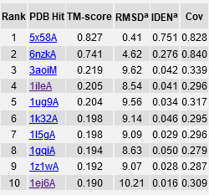

Table 2. Enzyme Commission (EC) numbers and active sites.
