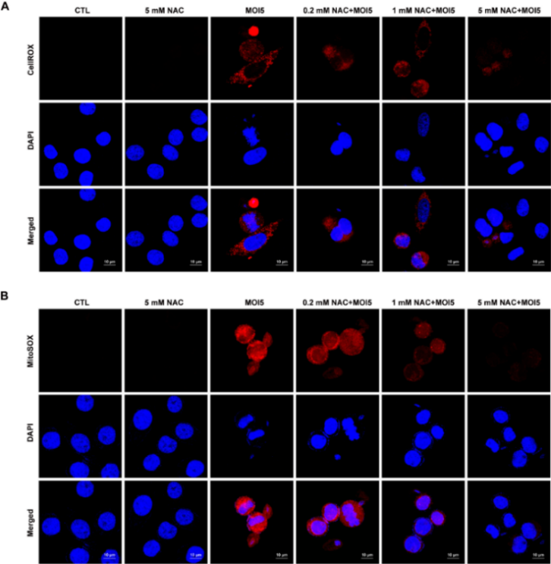

Fig. S2. T. vaginlais-induced ROS production was suppressed with NAC pretreatment in SiHa cells. SiHa cells were pretreated with numerous concentration of NAC and then infected with T. vaginalis at MOI 5 for 6 h. (A) Cellular ROS production was detected by CellROX. Percentages of CellROX positive cells, as determined by densitometric analysis of fluorescence images. (B) Mitochondrial ROS production was detected by MitoSOX reagent. Percentages of MitoSOX positive cells, as determined by densitometric analysis of fluorescence images. Differences were considered significant if *P<0.05, **P<0.01, or ***P<0.001, compared with the untreated control cells. The data shown are representative of three independent experiments with similar results.

